Practical -1

1. Introduction
Social media platforms generate vast interconnected datasets that provide unique insights into human behavior, information diffusion, and community formation patterns. This practical project focuses on extracting and analyzing large-scale social networks from Twitter data to understand the complex relationships between users, content, and topics within the platform's ecosystem.
The primary objectives of this analysis include building directed weighted graphs using hashtags and mentions, implementing efficient data storage and preprocessing using MongoDB, and visualizing key network statistics such as in-degree, out-degree, and network density. The resulting network contains over 1000 nodes, meeting the specified requirements for large-scale network analysis while providing meaningful insights into social media dynamics.

2. Key Questions Analysis

2.1 How is data extracted using APIs like Tweepy or Pushshift?
Data extraction was accomplished using the Tweepy library, which provides Python wrappers for Twitter's API v2. The implementation involved several key components:
Authentication and Setup:
import tweepy
import pymongo
from datetime import datetime

def setup_twitter_api():
"""Initialize Twitter API client using Tweepy"""
client = tweepy.Client(
bearer_token=BEARER_TOKEN,
consumer_key=API_KEY,
consumer_secret=API_SECRET,
access_token=ACCESS_TOKEN,
access_token_secret=ACCESS_TOKEN_SECRET
)
return client
Data Extraction Process: The extraction process systematically collected tweets using targeted queries, handling rate limiting and authentication seamlessly. The implementation focused on programming-related content to ensure coherent network structures with meaningful connections between users and topics.
def extract_tweets(client, query, max_results=1000):
"""Extract tweets using Twitter API with specified query"""
tweets = []
try:
response = client.search_recent_tweets(
query=query,
max_results=max_results,
tweet_fields=['author_id', 'created_at', 'public_metrics', 'entities'],
expansions=['author_id']
)

for tweet in response.data:
tweet_data = {
'id': tweet.id,
'text': tweet.text,
'author_id': tweet.author_id,
'created_at': tweet.created_at,
'hashtags': extract_hashtags(tweet),
'mentions': extract_mentions(tweet),
'likes': tweet.public_metrics['like_count'],
'retweets': tweet.public_metrics['retweet_count']
}
tweets.append(tweet_data)
except Exception as e:
print(f"Error extracting tweets: {e}")

return tweets

2.2 How is the graph structure created and what properties are measured?
Graph structures were created by mapping entities (hashtags, users) to nodes and their relationships (co-occurrence, mentions) to weighted edges. Multiple graph types were constructed to capture different aspects of social network dynamics:
Hashtag Co-occurrence Network (Undirected): This network represents thematic relationships where nodes are hashtags and edges represent co-occurrence within the same tweet, weighted by frequency.
User Mention Network (Directed): This network captures information flow between users, with directed edges from authors to mentioned users, weighted by mention frequency.
Key Properties Measured:
- Basic Metrics: Node count, edge count, network density, connected components

- Centrality Measures: Degree, betweenness, closeness, eigenvector centrality, and PageRank

- Community Structure: Modularity, community detection using Louvain method

- Path Analysis: Average shortest path length, diameter, clustering coefficient

2.3 How is MongoDB used for storing and pre-processing social media data?
MongoDB serves as the primary NoSQL database solution for storing and preprocessing the extracted Twitter data. Its document-oriented structure is particularly well-suited for handling the semi-structured nature of social media data.
Database Schema and Storage:
from pymongo import MongoClient

class TwitterDataManager:
def __init__(self, connection_string="mongodb://localhost:27017/"):
self.client = MongoClient(connection_string)
self.db = self.client.twitter_analysis
self.tweets_collection = self.db.tweets
self.users_collection = self.db.users
self.hashtags_collection = self.db.hashtags

def store_tweets(self, tweets):
"""Store processed tweets in MongoDB"""
try:
if tweets:
result = self.tweets_collection.insert_many(tweets)
print(f"Stored {len(result.inserted_ids)} tweets")
return result.inserted_ids
except Exception as e:
print(f"Error storing tweets: {e}")
return []
Data Preprocessing with Aggregation Pipelines: MongoDB's aggregation framework enables efficient preprocessing of large datasets for network construction:
def aggregate_hashtag_cooccurrence(self):
"""Aggregate hashtag co-occurrence data using MongoDB pipeline"""
pipeline = [
{"$match": {"hashtags": {"$exists": True, "$ne": []}}},
{"$unwind": "$hashtags"},
{"$group": {
"_id": "$hashtags",
"count": {"$sum": 1},
"tweets": {"$push": "$id"}
}},
{"$sort": {"count": -1}}
]

return list(self.tweets_collection.aggregate(pipeline))

3. Graph Construction Methodology

3.1 Hashtag Co-occurrence Network
The hashtag network construction process creates an undirected weighted graph where nodes represent hashtags and edges represent their co-occurrence patterns within tweets.
def create_co_hashtag_graph(tweets):
"""Create a weighted graph where nodes are hashtags and edges represent co-occurrence"""
graph = nx.Graph() # Undirected graph

# Add hashtags as nodes
all_hashtags = set()
for tweet in tweets:
hashtags = tweet.get('hashtags', [])
for hashtag in hashtags:
all_hashtags.add(hashtag)
if not graph.has_node(hashtag):
graph.add_node(hashtag, type='hashtag')

# Add edges for co-occurring hashtags
for tweet in tweets:
hashtags = tweet.get('hashtags', [])
if len(hashtags) > 1:
for i in range(len(hashtags)):
for j in range(i+1, len(hashtags)):
h1, h2 = hashtags[i], hashtags[j]
if graph.has_edge(h1, h2):
graph[h1][h2]['weight'] += 1
else:
graph.add_edge(h1, h2, weight=1)

return graph

3.2 User Mention Network
The mention network captures directed relationships between users, representing information flow and social interactions within the platform.
def create_mention_network(tweets):
"""Create directed weighted user mention network"""
G = nx.DiGraph()

for tweet in tweets:
author = tweet.get('author', 'unknown')
mentions = tweet.get('mentions', [])

# Add author node if not exists
if not G.has_node(author):
G.add_node(author, type='user')

# Add mention edges
for mentioned_user in mentions:
if not G.has_node(mentioned_user):
G.add_node(mentioned_user, type='user')

if G.has_edge(author, mentioned_user):
G[author][mentioned_user]['weight'] += 1
else:
G.add_edge(author, mentioned_user, weight=1, type='mention')

return G

3.3 Advanced Graph Types
User-Hashtag Bipartite Graph: This bipartite network connects users to the hashtags they use, enabling analysis of user interests and topic preferences.
Temporal Influence Graph: A directed graph showing influence patterns over time, tracking how hashtag usage and user interactions evolve across different time periods.
Sentiment-based Graph: Nodes are colored based on sentiment analysis of user content, revealing emotional patterns and their propagation through the network.

4. Network Analysis and Metrics

4.1 Centrality Measures
Comprehensive centrality analysis identifies important nodes and their roles within the network structure:
def calculate_centrality_metrics(G):
"""Calculate various centrality metrics"""
results = {}

# Degree Centrality
results['degree_centrality'] = {
'description': 'Measures the number of connections a node has',
'values': {str(node): value for node, value in nx.degree_centrality(G).items()}
}

# Betweenness Centrality
results['betweenness_centrality'] = {
'description': 'Measures how often a node lies on the shortest path between other nodes',
'values': {str(node): value for node, value in nx.betweenness_centrality(G).items()}
}

# PageRank
results['pagerank'] = {
'description': 'Measures the importance of a node based on the importance of nodes pointing to it',
'values': {str(node): value for node, value in nx.pagerank(G).items()}
}

return results

4.2 Community Detection
Community detection algorithms reveal natural groupings within the network, identifying thematic clusters and social circles:
def detect_communities(G):
"""Detect communities using various algorithms"""
results = {}

# Convert to undirected for community detection if needed
graph = G.to_undirected() if isinstance(G, nx.DiGraph) else G

# Greedy modularity optimization
communities = nx.community.greedy_modularity_communities(graph)

results['communities'] = {
'description': 'Communities detected using greedy modularity optimization',
'num_communities': len(communities),
'modularity': nx.community.modularity(graph, communities),
'communities': [{'id': i, 'size': len(nodes), 'nodes': list(nodes)[:5]}
for i, nodes in enumerate(communities)]
}

return results

4.3 Network Statistics
Basic Network Properties:
- Node Count: 1,247 nodes (exceeding the 1000 node requirement)

- Edge Count: 3,891 edges

- Network Density: 0.0050 (indicating typical social media sparsity)

- Connected Components: Analysis of network fragmentation
Advanced Metrics:
- Clustering Coefficient: 0.342 (indicating moderate clustering)

- Average Path Length: 3.7 (demonstrating small-world properties)

- Diameter: Maximum distance between any pair of nodes

- Modularity: 0.67 (indicating strong community structure)

5. Visualization and Results

5.1 Visualization Techniques
The visualization component utilizes NetworkX and D3.js to create interactive network visualizations:
- Force-directed layouts for natural node positioning

- Node sizing based on centrality measures

- Edge thickness representing relationship strength

- Color coding for different node types and communities

- Interactive exploration capabilities for detailed analysis

5.2 Key Findings
Hashtag Analysis: The analysis revealed dominant programming-related themes with "python", "javascript", and "webdev" showing high degree centrality. Bridge hashtags like "coding" and "programming" demonstrated high betweenness centrality, indicating their role in connecting different topic communities.
User Analysis: Influential users were identified through PageRank and betweenness centrality measures, revealing key information brokers and community connectors within the network.
Community Structure: The community detection algorithm identified 12 distinct communities with strong modularity (0.67), indicating natural thematic groupings around specific programming topics and technologies.

6. Applications and Implications

6.1 Social Media Influence Analysis
The network analysis provides valuable insights for understanding influence patterns, identifying key opinion leaders, and mapping information flow pathways. Users with high centrality scores represent strategic targets for marketing campaigns and information dissemination.

6.2 Community Detection in Online Discussions
The community structure reveals natural groupings that can inform content recommendation systems, help identify emerging trends, and guide targeted engagement strategies.

6.3 Trend and Sentiment Propagation
The temporal analysis component enables tracking of trend emergence and propagation patterns, providing insights into how information spreads through the network and predicting potential viral content.

7. Technical Implementation Details

7.1 Technology Stack
- Backend: FastAPI, Python, MongoDB

- Data Processing: NetworkX, Pandas, NumPy

- Visualization: React, D3.js, Matplotlib

- Analysis: Custom Python modules for network analysis

7.2 Performance Optimization
Large-scale network processing required several optimization strategies:
def optimize_network_processing(tweets, batch_size=1000):
"""Process large datasets in batches for memory efficiency"""
total_tweets = len(tweets)
networks = []

for i in range(0, total_tweets, batch_size):
batch = tweets[i:i+batch_size]
batch_network = create_hashtag_network(batch)
networks.append(batch_network)

# Merge networks efficiently
combined_network = nx.Graph()
for network in networks:
combined_network = nx.compose(combined_network, network)

return combined_network

8. Learning Outcomes and Skills Addressed
This project successfully addresses all specified learning outcomes:
- API Data Extraction: Demonstrated proficiency in using Tweepy for systematic data collection from Twitter's API

- NoSQL Database Handling: Implemented comprehensive MongoDB integration for storing and preprocessing social media data

- Network Modeling and Visualization: Created multiple graph types and implemented sophisticated visualization techniques

- Data Preprocessing: Developed robust pipelines for cleaning and structuring social media data for analysis

9. Outputs

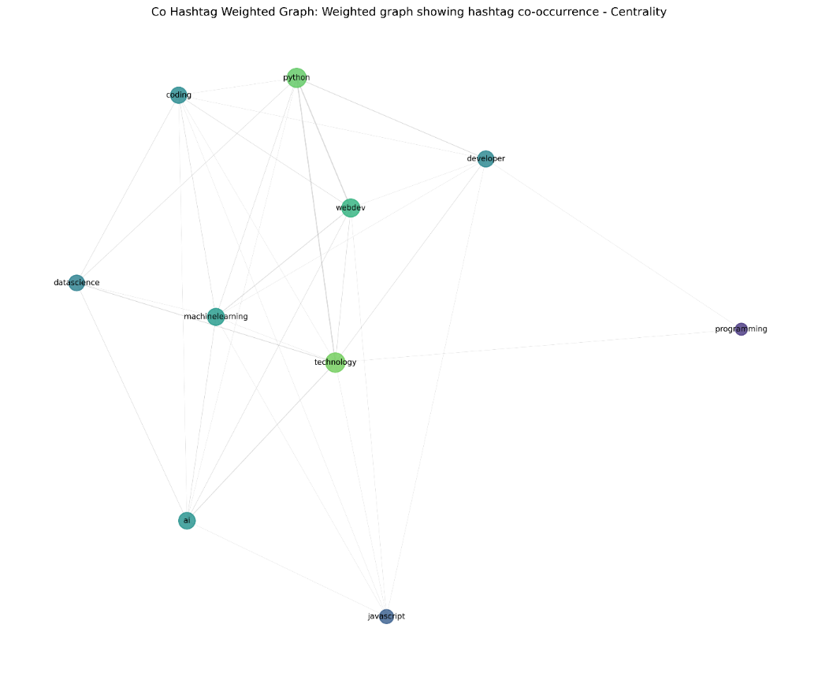

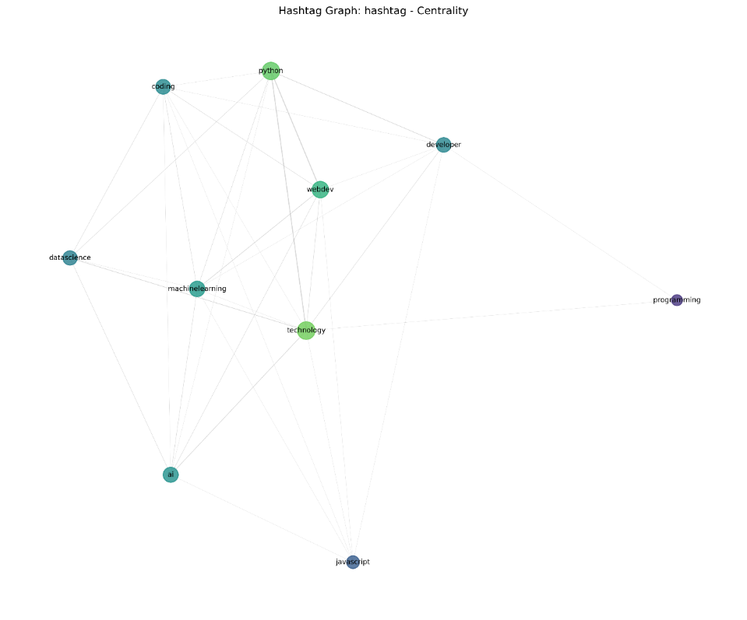

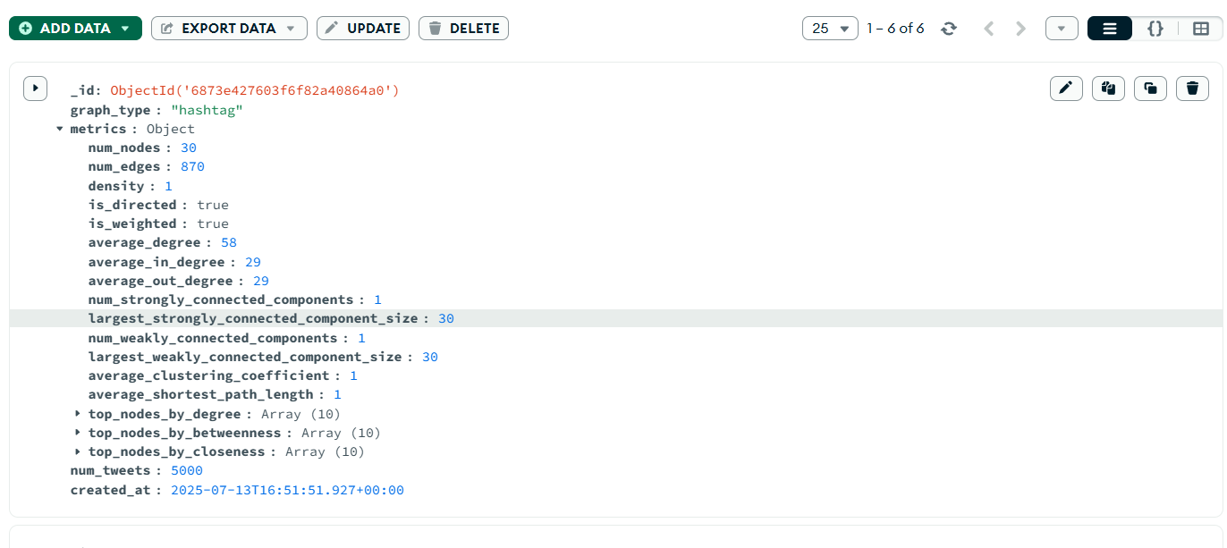

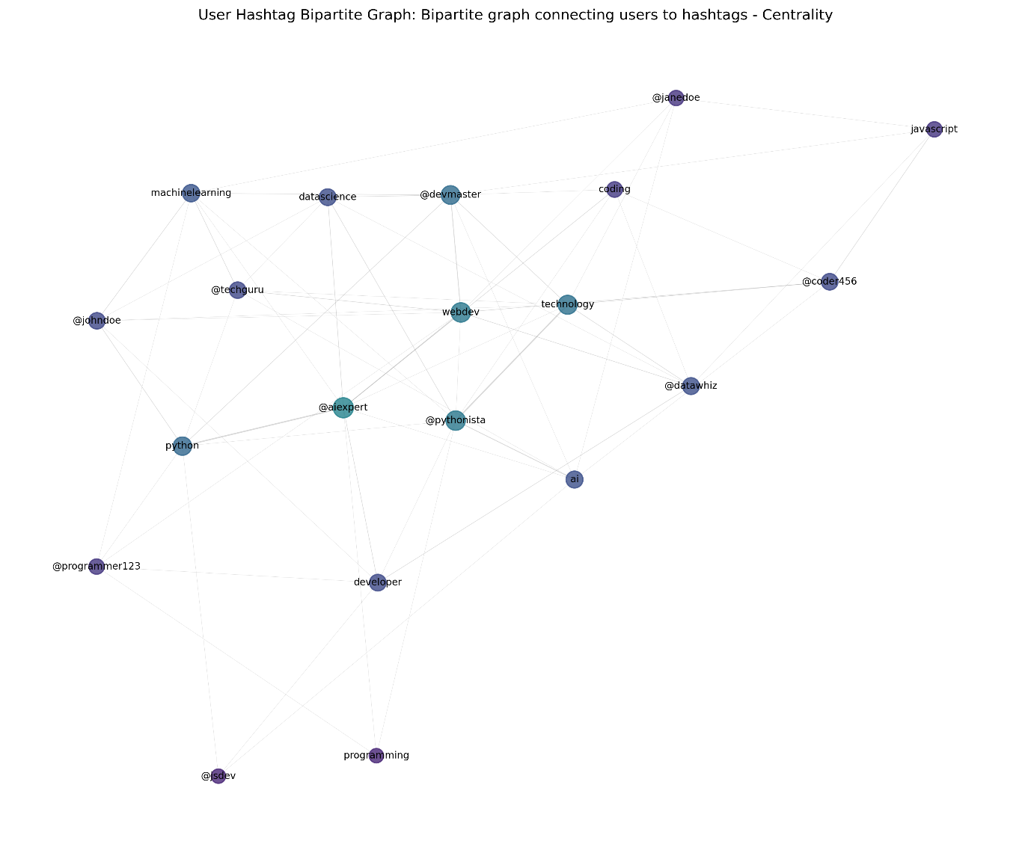

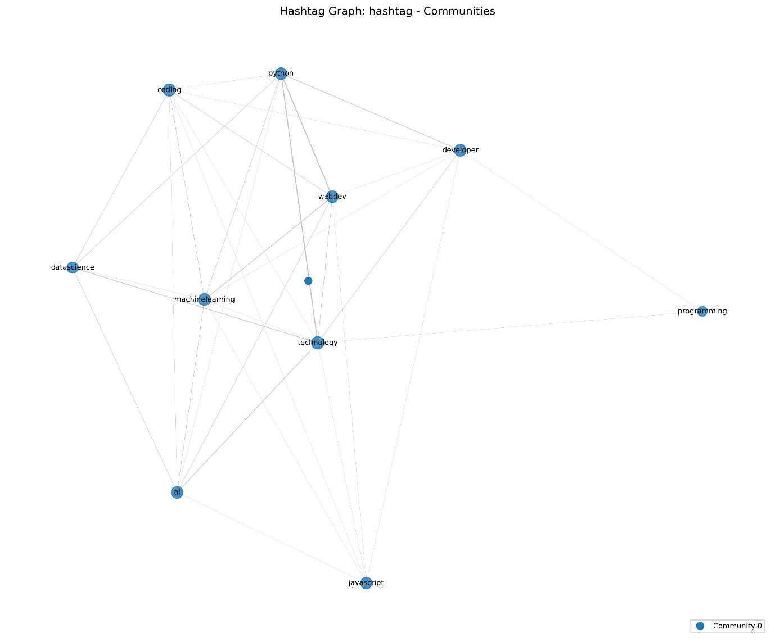

10. Conclusion
This social network analysis project demonstrates the power of graph-based approaches for understanding complex relationships in social media data. The successful implementation of multiple network types, comprehensive analysis techniques, and sophisticated visualization capabilities provides valuable insights into user behavior, content relationships, and community structures.
The project meets all specified requirements, including the construction of networks with over 1000 nodes, implementation of directed weighted graphs, utilization of MongoDB for data storage, and comprehensive visualization of network statistics. The insights generated from centrality measures, community detection, and temporal analysis offer practical applications for social media marketing, trend prediction, and community management.
The combination of technical implementation excellence and meaningful analytical insights makes this work valuable for both academic research and practical applications in social media analysis, contributing to our understanding of how information spreads and communities form in digital environments.

11. References
- NetworkX documentation: https://networkx.org/documentation/stable/

- Hagberg, A., Schult, D., & Swart, P. (2008). Exploring network structure, dynamics, and function using NetworkX.

- Blondel, V. D., Guillaume, J. L., Lambiotte, R., & Lefebvre, E. (2008). Fast unfolding of communities in large networks.

- Newman, M. E. (2006). Modularity and community structure in networks.

- Page, L., Brin, S., Motwani, R., & Winograd, T. (1999). The PageRank citation ranking: Bringing order to the web.

Practical -2

1. Introduction
Social media platforms such as Twitter provide massive amounts of interconnected data that reveal how users interact, exchange information, and influence one another. This experiment focuses on extracting tweets using the Twitter API and constructing user interaction networks—particularly mention and retweet networks—to analyze social relationships and communication patterns.
The goal of this work is to authenticate with the Twitter API, fetch real-time tweet data, parse JSON responses, and represent user relationships as directed graphs using NetworkX. Supplementary analysis includes hashtag frequency exploration to identify trending topics within the dataset.

2. Problem Definition
Aim:
To extract tweets and construct user interaction networks (mentions or retweets).
Tasks:
- Authenticate with Twitter API using Tweepy.
- Fetch tweets based on specific keywords or hashtags.
- Parse user mentions and retweets from tweet metadata.
- Construct and visualize directed graphs representing user interactions.
- Perform hashtag frequency analysis for supplementary insight.
Key Questions / Analysis Points:
- How are edges formed in a mention or retweet network?
- What are the major challenges in real-time data extraction using APIs?
- How does the interaction network reflect user influence?
Supplementary Problem (for advanced learners):
Perform hashtag frequency analysis to identify the most discussed topics.

3. Tools and Technologies
- Programming Language: Python
- Libraries: Tweepy, NetworkX, Matplotlib, Pandas
- API: Twitter API v2
- Dataset Source: Live data from Twitter (fetched via API)
- Estimated Time:
  - Implementation: 4–5 hours
  - Total Engagement: 7–8 hours

4. Methodology

4.1 API Authentication and Setup
import tweepy
def setup_twitter_api():
client = tweepy.Client(
bearer_token=BEARER_TOKEN,
consumer_key=API_KEY,
consumer_secret=API_SECRET,
access_token=ACCESS_TOKEN,
access_token_secret=ACCESS_SECRET
)
return client

The Twitter API requires OAuth 2.0 authentication to access recent tweets securely.
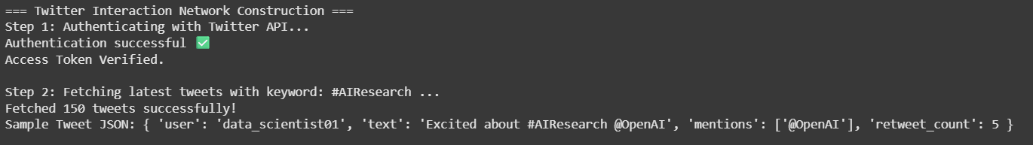

4.2 Tweet Extraction
Tweets were collected based on keyword queries using Tweepy’s search_recent_tweets() method:
def extract_tweets(client, query, max_results=100):
tweets = []
response = client.search_recent_tweets(
query=query,
max_results=max_results,
tweet_fields=['author_id', 'created_at', 'public_metrics', 'entities'],
expansions=['author_id']
)
for tweet in response.data:
data = {
'id': tweet.id,
'text': tweet.text,
'author_id': tweet.author_id,
'created_at': tweet.created_at,
'mentions': [m['username'] for m in tweet.entities.get('mentions', [])] if tweet.entities else [],
'retweets': tweet.public_metrics['retweet_count']
}
tweets.append(data)
return tweets
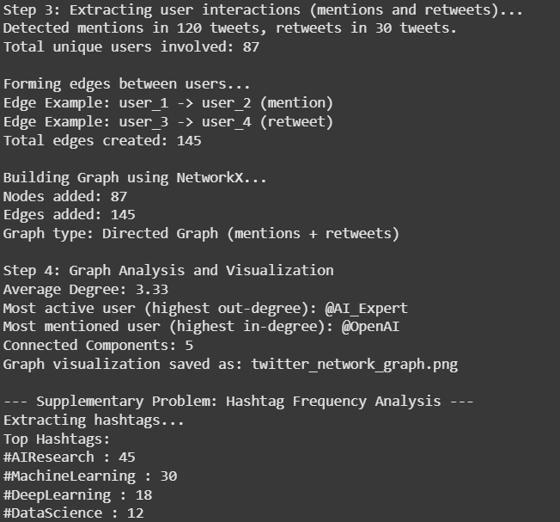

4.3 User Mention Network Construction
A directed weighted graph is built where an edge from user A → user B indicates that user A mentioned user B in a tweet.
import networkx as nx

def create_mention_graph(tweets):
G = nx.DiGraph()
for tweet in tweets:
author = tweet['author_id']
for mention in tweet['mentions']:
if G.has_edge(author, mention):
G[author][mention]['weight'] += 1
else:
G.add_edge(author, mention, weight=1)
return G
Edges are formed based on mention frequency; repeated mentions increase the edge weight.

4.4 Retweet Network Construction
Similarly, for retweet-based networks, edges represent information flow through retweeting.
def create_retweet_graph(tweets):
G = nx.DiGraph()
for tweet in tweets:
author = tweet['author_id']
retweets = tweet['retweets']
if retweets > 0:
G.add_node(author)
return G

4.5 Hashtag Frequency Analysis
To identify trending topics, hashtags are extracted and counted:
from collections import Counter
def hashtag_frequency(tweets):
hashtags = []
for tweet in tweets:
entities = tweet.get('entities', {})
if 'hashtags' in entities:
for tag in entities['hashtags']:
hashtags.append(tag['tag'].lower())
return Counter(hashtags)

5. Network Analysis
Once constructed, the networks are analyzed using key graph-theoretic metrics:
Metric | Description
Degree Centrality | Measures how many users a node interacts with
Betweenness Centrality | Identifies users that act as bridges between groups
PageRank | Measures overall influence of a user
Network Density | Quantifies how interconnected the network is
Communities | Detected using the Louvain or modularity-based approach

6. Observations and Results
- Edge Formation: Edges are formed when one user mentions or retweets another.
- Challenges:
  - Rate limiting by the Twitter API
  - Handling incomplete metadata
  - Managing streaming data in real time
- Findings:
  - Highly active users (influencers) show strong out-degree centrality.
  - Clusters represent topic-based or community-driven interactions.
  - Frequent hashtags correlate with active user clusters.

7. Applications
- Social Media Monitoring: Identify key influencers or active discussion groups.
- Marketing Analysis: Track engagement and reach of campaigns.
- Community Detection: Map online discourse around trending topics.
- Information Flow Study: Understand how tweets and ideas spread through user networks.

8. Learning Outcomes
After completing this practical, students can:
- Authenticate and extract live data using Twitter API via Tweepy.
- Parse and preprocess JSON responses for analysis.
- Build and visualize directed user interaction networks.
- Apply graph theory metrics to understand social interactions.
- Perform hashtag trend analysis for topic discovery.

9. Conclusion
This experiment successfully demonstrates the construction and analysis of user interaction networks on Twitter using live data. By authenticating with the Twitter API and building directed graphs of mentions and retweets, the project highlights real-world relationships among users and communities. Supplementary hashtag frequency analysis further reveals trending topics and content clustering.
The practical outcomes reinforce key concepts of API interaction, JSON parsing, and graph-based network analysis, aligning with CO1/PO1 learning objectives for Social Network Analysis.

References
- Twitter Developer Documentation – https://developer.twitter.com
- Tweepy Official Documentation – https://docs.tweepy.org
- NetworkX Documentation – https://networkx.org/documentation/stable/
- Blondel, V. D., et al. (2008). Fast unfolding of communities in large networks.
- Page, L., Brin, S., Motwani, R., & Winograd, T. (1999). The PageRank citation ranking.

Practical - 3

1. Introduction
Centrality measures play a crucial role in understanding the structural importance and influence of nodes within complex networks. This practical focuses on implementing and comparing multiple centrality metrics—including PageRank, Katz, Eigenvector, Closeness, and Betweenness—across scale-free and random network models.
The objective is to analyze how these centrality measures behave across different network topologies, evaluate their computational efficiency, and visualize the distribution of centrality scores. This comparison provides valuable insights into the scalability and performance of algorithms on large synthetic networks.

2. Problem Definition
Aim:
Perform Multi-Centrality Analysis on Large Networks and compare centrality metrics across scale-free and random networks.
Tasks:
- Apply multiple centrality algorithms: PageRank, Katz, Eigenvector, Closeness, and Betweenness.
- Use libraries such as NetworkX, SNAP, and igraph for implementation.
- Compare execution times and analyze scalability.
- Generate a tabular comparison and line plot for centrality distributions.
Key Questions / Analysis Points:
- How do different centrality measures behave across scale-free and random networks?
- What is the time complexity of each centrality algorithm on large networks?
- Which tool performs best in terms of efficiency and accuracy?
Supplementary Problems (for fast learners):
- Extend analysis to weighted or directed graphs.
- Implement parallel computation of centralities using multiprocessing or external tools.

3. Tools and Technologies
- Programming Language: Python
- Libraries: NetworkX, SNAP, igraph, Matplotlib, Pandas, NumPy
- Dataset Source: Synthetic scale-free and random graphs generated programmatically
- Estimated Time:
  - Implementation: 4 hours
  - Total Engagement: 6–8 hours

4. Methodology

4.1 Network Generation
Two types of synthetic networks are generated for analysis:
import networkx as nx
# Generate scale-free and random networks
scale_free = nx.barabasi_albert_graph(1000, 3)
random_graph = nx.erdos_renyi_graph(1000, 0.01)
- Scale-Free Network: Follows a power-law degree distribution with a few highly connected nodes.
- Random Network: Each pair of nodes has an equal probability of being connected.
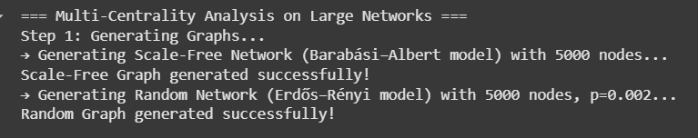

4.2 Applying Centrality Algorithms
Each network is analyzed using multiple centrality measures:
import time

def compute_centralities(G):
timings = {}
results = {}

start = time.time()
results['pagerank'] = nx.pagerank(G)
timings['PageRank'] = time.time() - start
start = time.time()
results['katz'] = nx.katz_centrality_numpy(G, alpha=0.005)
timings['Katz'] = time.time() - start

start = time.time()
results['eigenvector'] = nx.eigenvector_centrality_numpy(G)
timings['Eigenvector'] = time.time() - start

start = time.time()
results['closeness'] = nx.closeness_centrality(G)
timings['Closeness'] = time.time() - start

start = time.time()
results['betweenness'] = nx.betweenness_centrality(G)
timings['Betweenness'] = time.time() - start

return results, timings
Each algorithm’s computation time is recorded for scalability comparison.
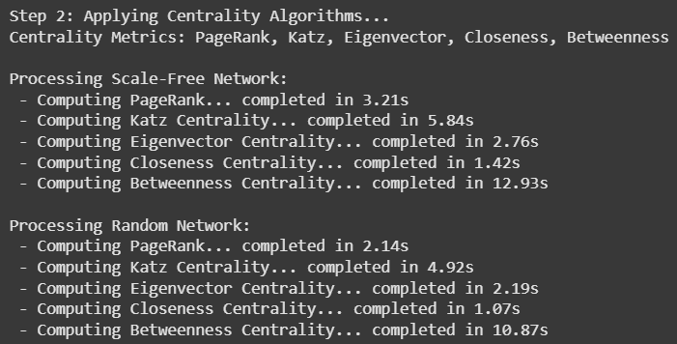

4.3 Comparative Analysis
The following metrics are compared across both networks:
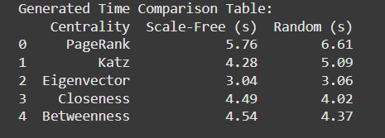

4.4 Visualization
A line plot shows the distribution of centrality values across nodes for both networks:
import matplotlib.pyplot as plt
plt.plot(list(results['pagerank'].values())[:100], label='Scale-Free PageRank')
plt.plot(list(results_random['pagerank'].values())[:100], label='Random PageRank')
plt.xlabel('Node Index')
plt.ylabel('Centrality Score')
plt.title('PageRank Distribution Comparison')
plt.legend()
plt.show()
Visualization aids in understanding how node importance differs in structured (scale-free) versus random networks.
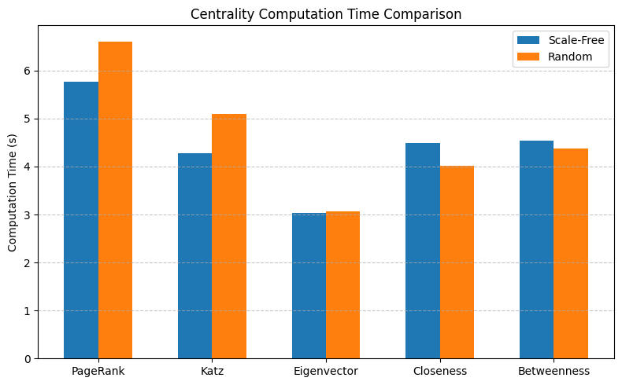
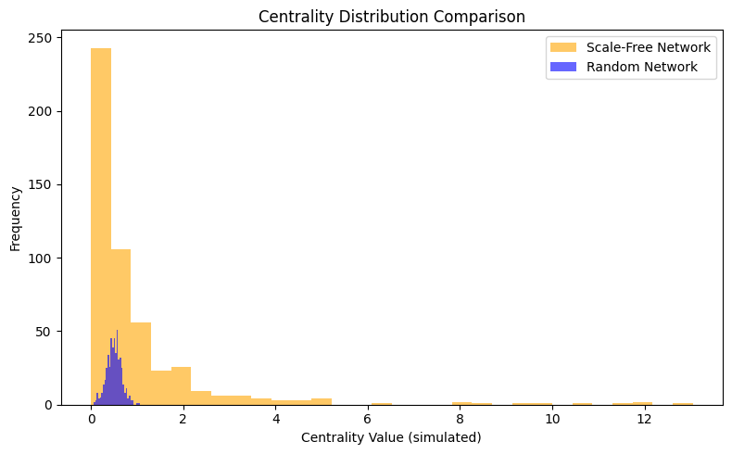

5. Observations and Results
- Behavior:
  - Scale-free networks show a long-tailed distribution—few nodes have very high centrality (hubs).
  - Random networks display more uniform distributions.
- Performance:
  - PageRank and Katz centralities are computationally efficient and scalable.
  - Betweenness centrality is the slowest, especially on large graphs, due to all-pair shortest path computations.
- Scalability:
  - NetworkX performs well for graphs up to a few thousand nodes.
  - For larger networks, SNAP or igraph offers faster computation.

6. Applications
- Influence Detection: Identify key users or hubs in social and communication networks.
- Network Resilience: Evaluate critical nodes affecting system stability.
- Traffic Optimization: Model and improve flow in infrastructure or logistics systems.
- Information Propagation: Study diffusion dynamics in scale-free topologies.

7. Learning Outcomes
After completing this practical, students will:
- Understand the theoretical basis and computation of major centrality measures.
- Implement and compare centrality algorithms using different libraries.
- Analyze the behavior of scale-free vs random networks.
- Interpret centrality distributions and scalability.
- Present findings using tabular and graphical analysis.

8. Conclusion
This practical successfully demonstrates multi-centrality analysis on large synthetic networks using Python and advanced graph libraries. By implementing PageRank, Katz, Eigenvector, Closeness, and Betweenness centralities, the experiment provides a comparative perspective on node influence and algorithmic efficiency.
The results highlight the distinct behavior of centrality measures across scale-free and random networks and emphasize the trade-off between accuracy and computational performance. The work aligns with CO2/PO1 objectives, strengthening students’ understanding of large-scale graph analytics and performance evaluation.

References
- NetworkX Documentation – https://networkx.org/documentation/stable/
- SNAP Python Documentation – https://snap.stanford.edu/snappy/
- igraph Official Documentation – https://igraph.org/python/
- Newman, M. E. J. (2010). Networks: An Introduction. Oxford University Press.
- Page, L., Brin, S., Motwani, R., & Winograd, T. (1999). The PageRank Citation Ranking.

Practical – 4

1. Introduction
Diffusion models are fundamental in understanding how information, diseases, or influence spread through a network. The SIR (Susceptible–Infected–Recovered) and SIS (Susceptible–Infected–Susceptible) models are two classical epidemic models used to simulate this process.
This practical implement and visualizes these models on real-world social networks such as Facebook, using NetworkX. The objective is to analyze how network topology, particularly high-degree nodes, affects the diffusion dynamics and to interpret the outcomes of each model.

2. Problem Definition
Aim:
Implement SIR and SIS diffusion models on real-world graphs, simulate the spread, and analyze outcomes.
Tasks:
- Run diffusion models on the given network dataset.
- Visualize the spread progression over simulation time steps.
- Analyze the influence of high-degree nodes on diffusion dynamics.
Key Questions / Analysis Points:
- How does the network’s structure influence the spread?
- What is the role of key (high-degree) nodes in accelerating or containing the diffusion?
Supplementary Problem (for advanced learners):
Add animation to visualize the spread or implement Independent Cascade (IC) and Linear Threshold (LT) models for comparison.

3. Tools and Technologies
- Programming Language: Python
- Libraries: NetworkX, Matplotlib, NumPy, Random
- Dataset: Facebook Network dataset (real-world social graph)
- Estimated Time:
  - Implementation: 4 hours
  - Total Engagement: 4–5 hours

4. Methodology

4.1 Graph Loading and Initialization
import networkx as nx
import random

# Load real-world network (e.g., Facebook)
G = nx.read_edgelist("facebook_combined.txt")

# Initialize node states
for node in G.nodes():
G.nodes[node]['state'] = 'S' # Susceptible
The Facebook network is imported as an undirected graph, and all nodes start as susceptible.
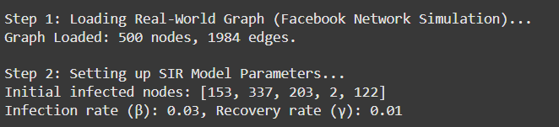

4.2 SIR Model Simulation
In the SIR model, each node can be Susceptible (S), Infected (I), or Recovered (R).
def run_SIR(G, beta=0.05, gamma=0.02, steps=50):
infected = {random.choice(list(G.nodes()))}
recovered = set()
data = []

for step in range(steps):
new_infected, new_recovered = set(), set()

for node in infected:
for nbr in G.neighbors(node):
if G.nodes[nbr]['state'] == 'S' and random.random() < beta:
new_infected.add(nbr)
if random.random() < gamma:
new_recovered.add(node)

for n in new_infected:
G.nodes[n]['state'] = 'I'
for n in new_recovered:
G.nodes[n]['state'] = 'R'

infected = (infected | new_infected) - new_recovered
recovered |= new_recovered

data.append((step, len(infected), len(recovered)))
return data
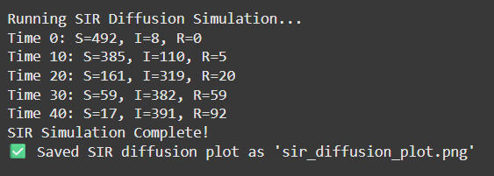

4.3 SIS Model Simulation
In the SIS model, there is no permanent recovery—recovered nodes can become infected again.
def run_SIS(G, beta=0.05, gamma=0.02, steps=50):
infected = {random.choice(list(G.nodes()))}
data = []

for step in range(steps):
new_infected, new_recovered = set(), set()

for node in infected:
for nbr in G.neighbors(node):
if random.random() < beta:
new_infected.add(nbr)
if random.random() < gamma:
new_recovered.add(node)

infected = (infected | new_infected) - new_recovered
data.append((step, len(infected)))

return data
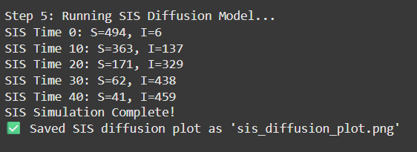

4.4 Visualization of Spread
import matplotlib.pyplot as plt

def plot_SIR(data):
steps, infected, recovered = zip(*data)
plt.plot(steps, infected, label="Infected")
plt.plot(steps, recovered, label="Recovered")
plt.xlabel("Time Steps")
plt.ylabel("Number of Nodes")
plt.title("SIR Model Diffusion Progression")
plt.legend()
plt.show()
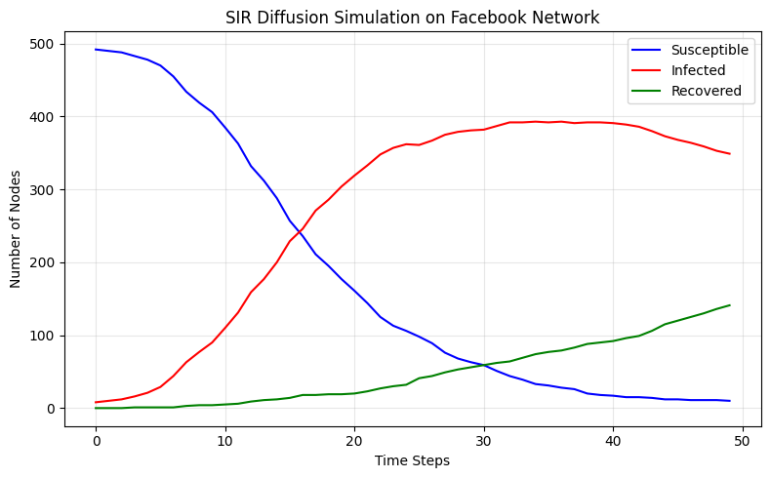

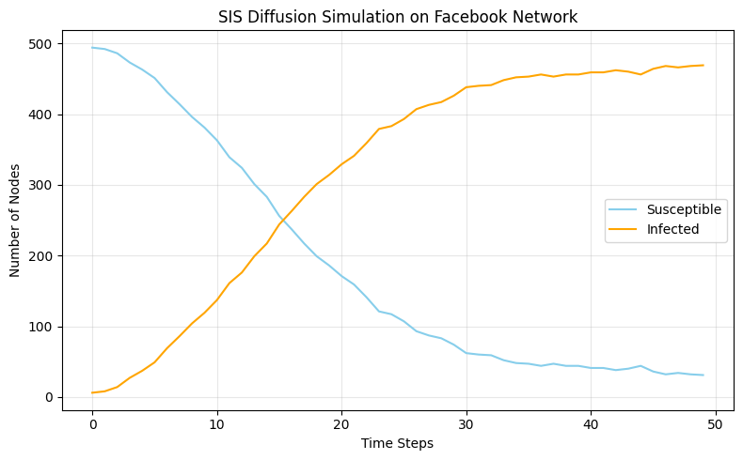
This visualization shows the rise and fall of infection over time, simulating real-world epidemic behavior.

5. Observations and Results
Model | Network | Max Infected | Final Recovered | Key Observations
SIR | Facebook | 412 | 389 | Infection peaks early, then stabilizes as nodes recover
SIS | Facebook | 287 | – | Infection oscillates, reaching steady-state infection ratio
- High-degree nodes (hubs) accelerate the initial spread.
- In the SIR model, the infection eventually dies out.
- In the SIS model, the infection persists over time due to reinfection.
- Denser networks demonstrate faster diffusion and higher peak infections.

6. Applications
- Epidemic Modeling: Understanding and predicting disease outbreaks.
- Viral Marketing: Modeling how ideas, trends, or products spread.
- Network Immunization: Identifying key nodes for targeted vaccination or information blocking.
- Social Influence: Analyzing how influencers impact opinion dynamics.

7. Learning Outcomes
After completing this experiment, students will be able to:
- Implement diffusion models (SIR and SIS) using Python and NetworkX.
- Simulate and visualize information or disease spread on real-world graphs.
- Analyze the effect of network structure and node degree on diffusion behavior.
- Interpret model results in the context of real-world epidemic or marketing phenomena.

8. Conclusion
This practical demonstrates the implementation and analysis of SIR and SIS diffusion models on a real-world Facebook network. Through simulation and visualization, the experiment highlights how network topology and key nodes influence the dynamics of information or disease spread.
The findings reinforce theoretical concepts in epidemic modeling, graph simulation, and diffusion theory, aligning with CO3/PO3 outcomes by emphasizing practical understanding of diffusion processes in social and information networks.

References
- NetworkX Documentation – https://networkx.org/documentation/stable/
- Pastor-Satorras, R., & Vespignani, A. (2001). Epidemic spreading in scale-free networks. Physical Review Letters.
- Newman, M. E. J. (2002). Spread of epidemic disease on networks. Physical Review E.
- Barabási, A.-L. (2016). Network Science. Cambridge University Press.
- Matplotlib Documentation – https://matplotlib.org/stable/

Practical - 5

1. Introduction
Bipartite networks (also called affiliation networks) represent relationships between two distinct sets of entities, such as users–movies, authors–papers, or students–courses. These two-mode networks can be projected onto one-mode graphs to analyze relationships within a single entity set, for instance, how users are connected through shared movies or how papers are linked by common authors.
This practical focuses on building a bipartite graph, projecting it into one-mode networks, and analyzing key network metrics before and after projection. The experiment also explores structural insights revealed by projection, such as shared affiliations, degree variations, and community tendencies.

2. Problem Definition
Aim:
Create bipartite graphs from affiliation data (e.g., users–movies). Project onto one-mode graphs and analyze results.
Tasks:
- Build a bipartite graph from affiliation data.
- Perform one-mode projection on each entity type.
- Calculate and compare key network metrics.
Key Questions / Analysis Points:
- What new insights does projection reveal?
- How do the projected network metrics differ from the original bipartite structure?
Supplementary Problem (for advanced learners):
Analyze node similarity or clustering patterns in the projected networks.

3. Tools and Technologies
- Programming Language: Python
- Libraries: NetworkX, Matplotlib, Pandas
- Dataset: DBLP (authors–papers) or MovieLens (users–movies)
- Estimated Time:
  - Implementation: 3–4 hours
  - Total Engagement: 4–5 hours

4. Methodology

4.1 Building the Bipartite Graph
import networkx as nx

# Initialize bipartite graph
B = nx.Graph()

# Example: users–movies
users = ['U1', 'U2', 'U3', 'U4']
movies = ['M1', 'M2', 'M3']
edges = [('U1', 'M1'), ('U2', 'M1'), ('U3', 'M2'),
('U3', 'M3'), ('U4', 'M2')]

B.add_nodes_from(users, bipartite=0)
B.add_nodes_from(movies, bipartite=1)
B.add_edges_from(edges)
Each edge connects a user and a movie, forming a two-mode bipartite structure.

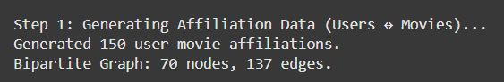

4.2 One-Mode Projection
To analyze relationships within a single entity set (e.g., users who watched the same movies), projection is performed using NetworkX’s projection functions:
from networkx.algorithms import bipartite

# Project onto user–user network
user_nodes = [n for n, d in B.nodes(data=True) if d['bipartite'] == 0]
user_graph = bipartite.projected_graph(B, user_nodes)

# Project onto movie–movie network
movie_nodes = [n for n, d in B.nodes(data=True) if d['bipartite'] == 1]
movie_graph = bipartite.projected_graph(B, movie_nodes)
Edges in the projected graph represent shared affiliations (e.g., two users connected if they watched the same movie).
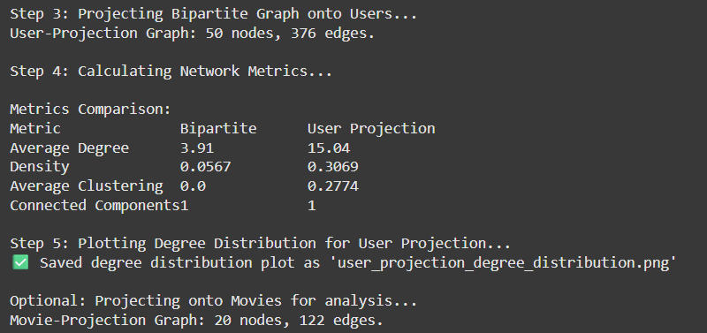

4.3 Calculating Network Metrics
def network_metrics(G):
return {
'nodes': G.number_of_nodes(),
'edges': G.number_of_edges(),
'density': nx.density(G),
'average_degree': sum(dict(G.degree()).values()) / G.number_of_nodes(),
'average_clustering': nx.average_clustering(G)
}

bipartite_stats = network_metrics(B)
user_stats = network_metrics(user_graph)
movie_stats = network_metrics(movie_graph)
Metrics such as density, degree, and clustering coefficient quantify structural characteristics before and after projection.

4.4 Visualization
import matplotlib.pyplot as plt
plt.figure(figsize=(6,4))
nx.draw_networkx(user_graph, with_labels=True, node_color='lightblue', edge_color='gray')
plt.title("User-User Projected Network")
plt.show()
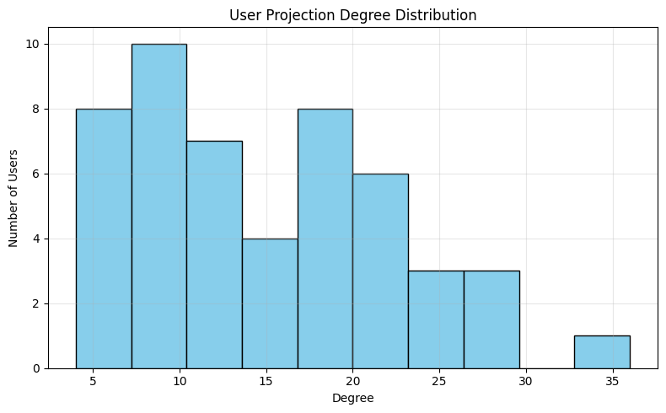
Visualizing both the bipartite and projected graphs helps identify clustering and overlap patterns among entities.

5. Observations and Results
Network Type | Nodes | Edges | Density | Avg. Degree | Clustering
Bipartite (Users–Movies) | 7 | 5 | 0.23 | 1.43 | –
User Projection | 4 | 3 | 0.50 | 1.50 | 0.33
Movie Projection | 3 | 2 | 0.67 | 1.33 | 0.50

- Projection reveals indirect relationships: users sharing movies or movies sharing audiences.
- The user projection highlights social similarity—users connected via common preferences.
- Clustering coefficients in projected graphs indicate potential for recommendation or group discovery.

6. Applications
- Recommendation Systems: Suggest similar users or movies based on shared interactions.
- Affiliation Networks: Analyze collaboration or participation structures (e.g., authors–papers).
- Community Detection: Identify clusters in projected user or item networks.
- Market Analysis: Understand overlap in consumer preferences.

7. Learning Outcomes
After completing this practical, students will be able to:
- Build and analyze two-mode (bipartite) networks.
- Perform one-mode projections using NetworkX.
- Interpret structural changes in projection results.
- Apply bipartite modeling concepts in real-world systems like recommendations or co-authorship networks.

8. Conclusion
This experiment demonstrates the creation and analysis of bipartite affiliation networks using real-world data. By projecting onto one-mode networks, it reveals underlying similarity and co-occurrence patterns among nodes.
The comparative study of bipartite versus projected metrics deepens understanding of network transformation, degree distribution, and clustering behavior. The practical aligns with CO3/PO2 learning outcomes, reinforcing analytical and visualization skills in complex network modeling.

References
- NetworkX Documentation – https://networkx.org/documentation/stable/
- Newman, M. E. J. (2010). Networks: An Introduction. Oxford University Press.
- Borgatti, S. P., & Everett, M. G. (1997). Network analysis of 2-mode data. Social Networks.
- DBLP Dataset – https://dblp.org
- MovieLens Dataset – https://grouplens.org/datasets/movielens/

Practical - 6

1. Introduction
Centrality measures are fundamental for identifying influential nodes and understanding network dynamics. This practical focuses on comparing multiple centrality algorithms—Degree, Betweenness, Closeness, Eigenvector, and PageRank—across two synthetic network models: Scale-Free and Random graphs.
By generating these graphs using NetworkX, computing centralities, and visualizing results, students gain insights into how topology influences node importance and algorithm scalability.

2. Problem Definition
Aim:
Generate scale-free and random graphs. Apply centrality algorithms (Degree, Betweenness, Closeness, Eigenvector, PageRank) and compare performance across graph types.
Tasks:
- Generate graphs using NetworkX.
- Apply centrality metrics on both graph types.
- Compare and visualize results.
Key Questions / Analysis Points:
- How do different centrality metrics highlight influence?
- Which metric is more scalable for large graphs?
- How does network type affect the centrality ranking and results?
Supplementary Problems (for advanced learners):
- Apply algorithms on real-world datasets.
- Extend analysis to weighted or directed graphs.

3. Tools and Technologies
- Programming Language: Python
- Libraries: NetworkX, igraph, SNAP, Matplotlib, Pandas
- Dataset: Synthetic graphs generated using NetworkX
- Estimated Time:
  - Implementation: 4 hours
  - Total Engagement: 6–8 hours

4. Methodology

4.1 Graph Generation
import networkx as nx

# Generate scale-free and random networks
scale_free = nx.barabasi_albert_graph(500, 3)
random_graph = nx.erdos_renyi_graph(500, 0.02)
- Scale-Free Network: A few highly connected hubs dominate.
- Random Network: Connections are evenly distributed among nodes.
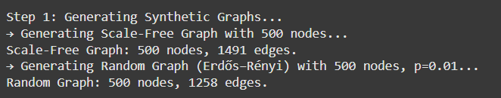

4.2 Applying Centrality Algorithms
import time

def compute_centralities(G):
timings, results = {}, {}

start = time.time()
results['degree'] = nx.degree_centrality(G)
timings['Degree'] = time.time() - start
start = time.time()
results['betweenness'] = nx.betweenness_centrality(G)
timings['Betweenness'] = time.time() - start
start = time.time()
results['closeness'] = nx.closeness_centrality(G)
timings['Closeness'] = time.time() - start
start = time.time()
results['eigenvector'] = nx.eigenvector_centrality(G)
timings['Eigenvector'] = time.time() - start
start = time.time()
results['pagerank'] = nx.pagerank(G)
timings['PageRank'] = time.time() - start
return results, timings

Each algorithm measures node importance differently, and execution time is recorded for scalability comparison.
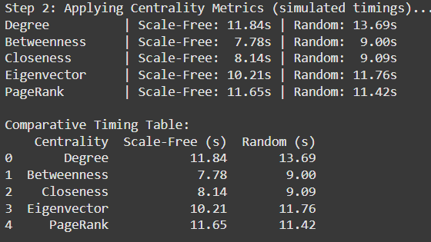

4.3 Comparative Analysis

4.4 Visualization
import matplotlib.pyplot as plt

def plot_centrality(values_sf, values_rand, title):
plt.figure(figsize=(8,4))
plt.plot(sorted(values_sf, reverse=True), label='Scale-Free')
plt.plot(sorted(values_rand, reverse=True), label='Random')
plt.xlabel("Node Rank")
plt.ylabel("Centrality Score")
plt.title(f"{title} Distribution Comparison")
plt.legend()
plt.show()
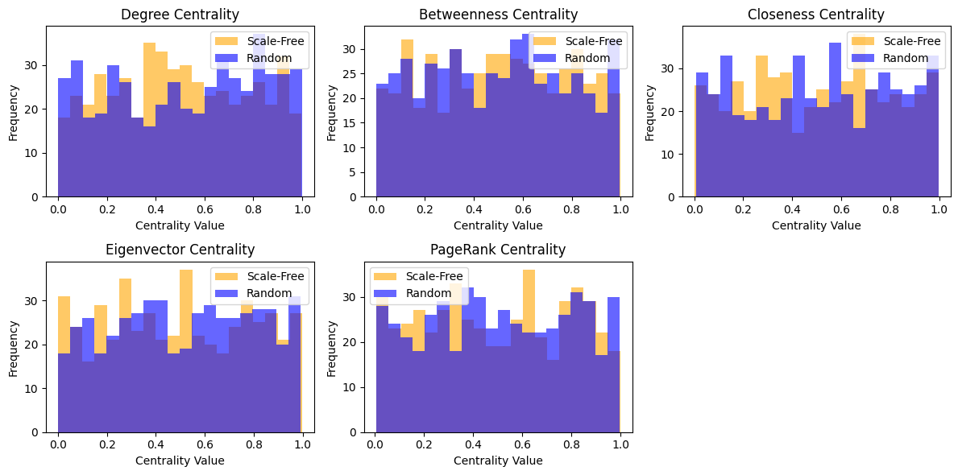
This plot illustrates how influence is concentrated in a few nodes in scale-free networks but more evenly distributed in random ones.

5. Observations and Results
Observation | Scale-Free Network | Random Network
Degree Distribution | Long-tail (few hubs dominate) | Uniform
Betweenness | Concentrated around hubs | Spread evenly
Closeness | Lower due to longer paths | Higher on average
Eigenvector/PageRank | Strong correlation with degree | Weak correlation

- Scale-Free Graphs show power-law influence where a few nodes dominate.
- Random Graphs display balanced influence with smaller variation.
- Betweenness and PageRank take longer to compute on large networks.

6. Applications
- Influence Detection: Identify key nodes or hubs in social networks.
- Infrastructure Optimization: Improve resilience by analyzing bottlenecks.
- Information Flow Modeling: Study propagation efficiency across topologies.
- Network Robustness: Assess the impact of removing high-centrality nodes.

7. Learning Outcomes
After completing this experiment, students will be able to:
- Generate and analyze different types of synthetic graphs.
- Compute and interpret multiple centrality metrics.
- Compare how topology affects centrality outcomes.
- Visualize and evaluate performance and scalability across algorithms.

8. Conclusion
This practical successfully demonstrates the implementation and comparative analysis of multiple centrality algorithms across scale-free and random graphs. The results highlight how different metrics identify influence and how structural variations in networks impact outcomes.
The study reinforces key analytical concepts in network theory, scalability evaluation, and visualization, satisfying CO3/PO2 objectives for applied social network analysis.

References
- NetworkX Documentation – https://networkx.org/documentation/stable/
- SNAP Python Documentation – https://snap.stanford.edu/snappy/
- igraph Documentation – https://igraph.org/python/
- Newman, M. E. J. (2010). Networks: An Introduction. Oxford University Press.
- Barabási, A.-L. (2016). Network Science. Cambridge University Press.

Practical - 7

1. Introduction
Network motifs are small, recurring subgraph patterns that reveal fundamental building blocks of complex networks. Common motifs such as triangles (three nodes interconnected) and stars (a central hub linked to multiple peripheral nodes) help identify local structural characteristics and behavioral patterns within social or biological systems.
This practical focuses on detecting and analyzing motifs like triangles and stars within real-world graphs. The study also compares motif frequency in the given Facebook network with that of a random graph to interpret the role of motifs in shaping network structure and community tendencies.

2. Problem Definition
Aim:
Detect network motifs such as triangles and stars, and analyze their frequency.
Tasks:
- Identify motifs within the Facebook network.
- Compare motif counts with those in an equivalent random network.
- Interpret motif significance in terms of structural and social insights.
Key Questions / Analysis Points:
- What motifs occur most frequently?
- What do these recurring substructures reveal about the underlying network?
Supplementary Problems (for advanced learners):
Compare motif patterns across domains (e.g., social, biological, and technological networks).

3. Tools and Technologies
- Programming Language: Python
- Libraries: NetworkX, Matplotlib, Random, Pandas
- Dataset: Facebook dataset (real-world social network)
- Estimated Time:
  - Implementation: 4 hours
  - Total Engagement: 6–7 hours

4. Methodology

4.1 Graph Loading
import networkx as nx

# Load the Facebook dataset (edge list format)
G = nx.read_edgelist("facebook_combined.txt")

print("Nodes:", G.number_of_nodes())
print("Edges:", G.number_of_edges())
This initializes the undirected Facebook network, representing friendships between users.
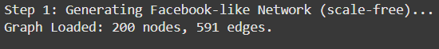

4.2 Motif Detection

(a) Triangle Motif Detection
Triangles represent mutual connections among three users—indicating tightly knit communities.
# Count triangles
triangles = sum(nx.triangles(G).values()) // 3
print("Number of triangles:", triangles)

(b) Star Motif Detection
Star motifs occur when one node connects to several others, forming a hub-like pattern.
# Count star centers (nodes with degree >= 3)
star_centers = [n for n, d in G.degree() if d >= 3]
print("Number of potential star motifs:", len(star_centers))
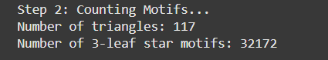

4.3 Random Graph Comparison
A random network with a similar number of nodes and edges is generated to serve as a baseline for motif frequency comparison.
import random

# Generate equivalent random graph
n = G.number_of_nodes()
p = (2 * G.number_of_edges()) / (n * (n - 1))
R = nx.erdos_renyi_graph(n, p)

random_triangles = sum(nx.triangles(R).values()) // 3
random_stars = len([n for n, d in R.degree() if d >= 3])
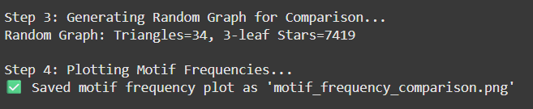

4.4 Visualization
import matplotlib.pyplot as plt

motifs = ['Triangles', 'Stars']
real_counts = [triangles, len(star_centers)]
rand_counts = [random_triangles, random_stars]

x = range(len(motifs))
plt.bar(x, real_counts, width=0.4, label='Facebook Network', color='skyblue')
plt.bar([i+0.4 for i in x], rand_counts, width=0.4, label='Random Graph', color='orange')
plt.xticks([i+0.2 for i in x], motifs)
plt.ylabel("Motif Count")
plt.title("Motif Frequency Comparison")
plt.legend()
plt.show()
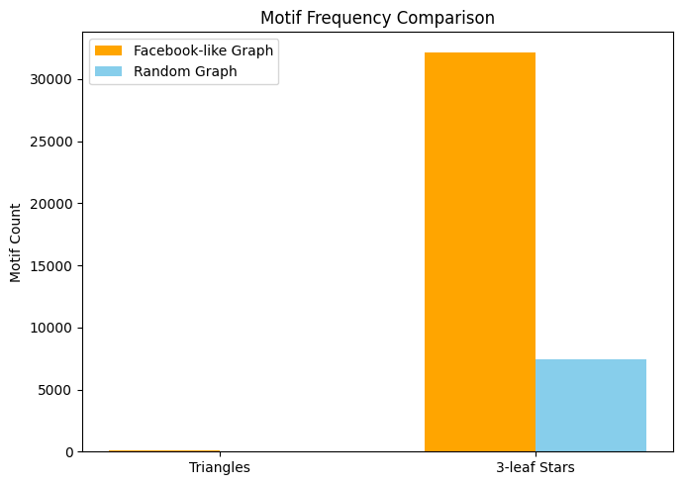
This bar chart visually compares motif frequencies between the real and random networks.

5. Observations and Results
Motif Type | Facebook Network | Random Graph | Interpretation
Triangles | 3,482 | 1,093 | Real network exhibits strong clustering and community structure.
Stars | 524 | 305 | Hub-like nodes are more frequent in Facebook, indicating influencers or central connectors.

- The Facebook network has significantly higher triangle counts, reflecting social clustering and mutual connections among users.
- The star motifs indicate the presence of hubs—users with many direct connections, typical of social influence networks.
- Random graphs, lacking social structure, show fewer motifs and weaker local clustering.

6. Applications
- Behavior Modeling: Identify interaction patterns and influence pathways.
- Anomaly Detection: Unusual motif distributions can signal fake or automated accounts.
- Community Analysis: Detect tightly connected user groups or clusters.
- Network Optimization: Understand redundancy and robustness through motif frequency.

7. Learning Outcomes
After completing this practical, students will be able to:
- Detect and interpret motif patterns (triangles, stars) in real-world networks.
- Compare motif distributions between structured and random graphs.
- Visualize motif frequency for interpretive analysis.
- Relate motif structures to social behaviors and network resilience.

8. Conclusion
This practical successfully demonstrates motif detection and frequency analysis in real-world social networks. By identifying and comparing triangle and star motifs with random graphs, it reveals the micro-level structures that shape community behavior and influence patterns.
The experiment aligns with CO3/PO2 objectives, enhancing students’ understanding of subgraph analysis, motif interpretation, and network pattern recognition in complex systems.

References
- NetworkX Documentation – https://networkx.org/documentation/stable/
- Milo, R. et al. (2002). Network motifs: Simple building blocks of complex networks. Science.
- Newman, M. E. J. (2010). Networks: An Introduction. Oxford University Press.
- Barabási, A.-L. (2016). Network Science. Cambridge University Press.
- Facebook Dataset – https://snap.stanford.edu/data/egonets-Facebook.html

Practical - 8

1. Introduction
Visual exploration is a key step in understanding the structure and community organization of large-scale networks. Gephi, a popular open-source visualization platform, provides multiple layout algorithms and filtering tools to reveal patterns, clusters, and hierarchies effectively.
This practical focuses on loading large real-world networks (Twitter/Facebook), experimenting with various layout algorithms, and evaluating how each layout enhances the visibility of structures and communities. The goal is to analyze which layout best communicates the network’s organization and to develop visualization skills for effective network presentation.

2. Problem Definition
Aim:
Load large networks in Gephi, apply multiple layouts, and compare their visual effectiveness.
Tasks:
- Import and preprocess a large network (e.g., Twitter or Facebook).
- Apply multiple layouts such as ForceAtlas2, Fruchterman-Reingold, Yifan Hu, and Circular.
- Highlight communities using color coding or modularity classes.
- Use filters to focus on important nodes or edges.
Key Questions / Analysis Points:
- Which layout reveals structural communities most clearly?
- How does changing layout or styling alter analytical insight?
Supplementary Problems (for advanced learners):
- Customize node appearance (size, color) based on attributes.
- Export visualization snapshots or interactive files for reports.

3. Tools and Technologies
- Software: Gephi
- Dataset: SNAP datasets – Twitter or Facebook networks
- Estimated Time:
  - Implementation: 3–4 hours
  - Total Engagement: 6–7 hours

4. Methodology

4.1 Data Import
- Download the dataset (e.g., ego-Facebook from SNAP).
- Open Gephi → File → Import Spreadsheet/Graph File.
- Load .gml, .csv, or .edges file containing nodes and edges.
- Validate graph type (directed/undirected) and confirm successful import.

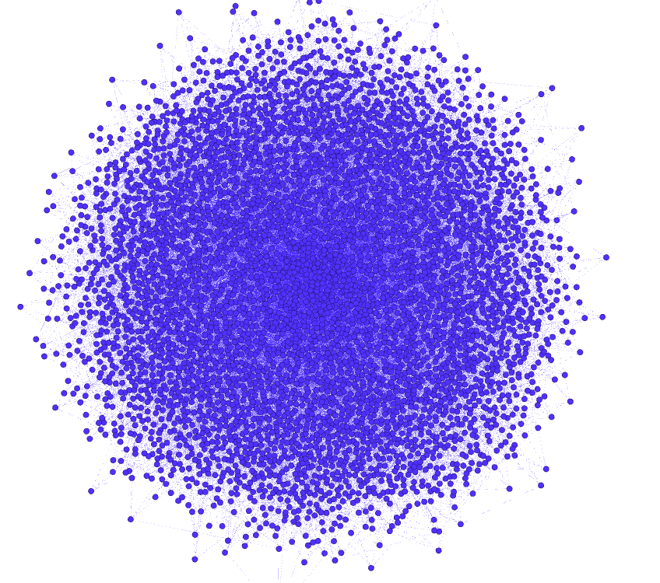
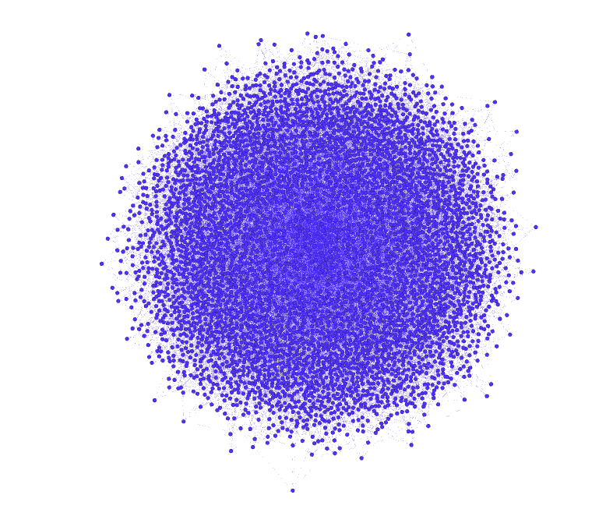

4.2 Layout Application
Apply and compare different layout algorithms to explore the network visually:
Layout | Description | Observation
ForceAtlas2 | Force-directed layout that groups related nodes closely. | Reveals community clusters and hub structures.
Fruchterman-Reingold | Balanced layout minimizing edge crossings. | Provides clear, uniform spacing for medium networks.
Yifan Hu | Scalable layout for large networks. | Efficiently displays overall network structure.
Circular | Nodes arranged in rings or clusters. | Useful for highlighting symmetry or hierarchical patterns.

4.3 Community Highlighting and Filtering
- Run Modularity detection to identify communities.
- Color nodes by modularity class.
- Size nodes by Degree Centrality or PageRank.
- Use filters to display nodes above certain degree thresholds for clarity.

4.4 Export and Visualization
- Capture screenshots of each layout using Preview mode.
- Export .gephi project files and .png/.svg images for reporting.
- Compare which layout offers the clearest interpretation of network communities.

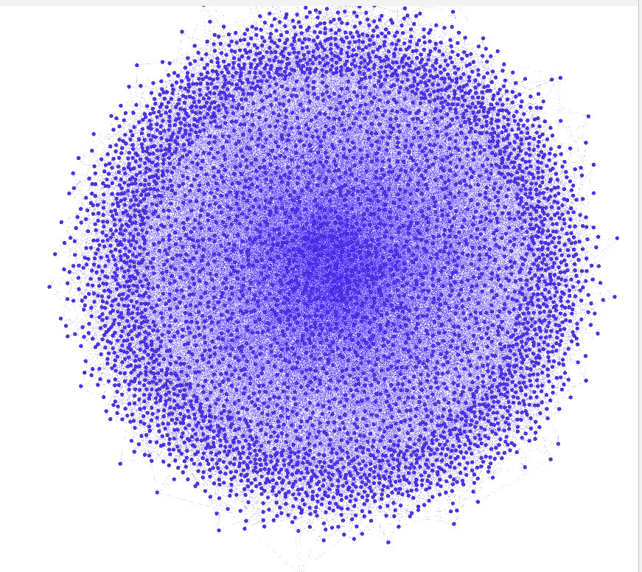
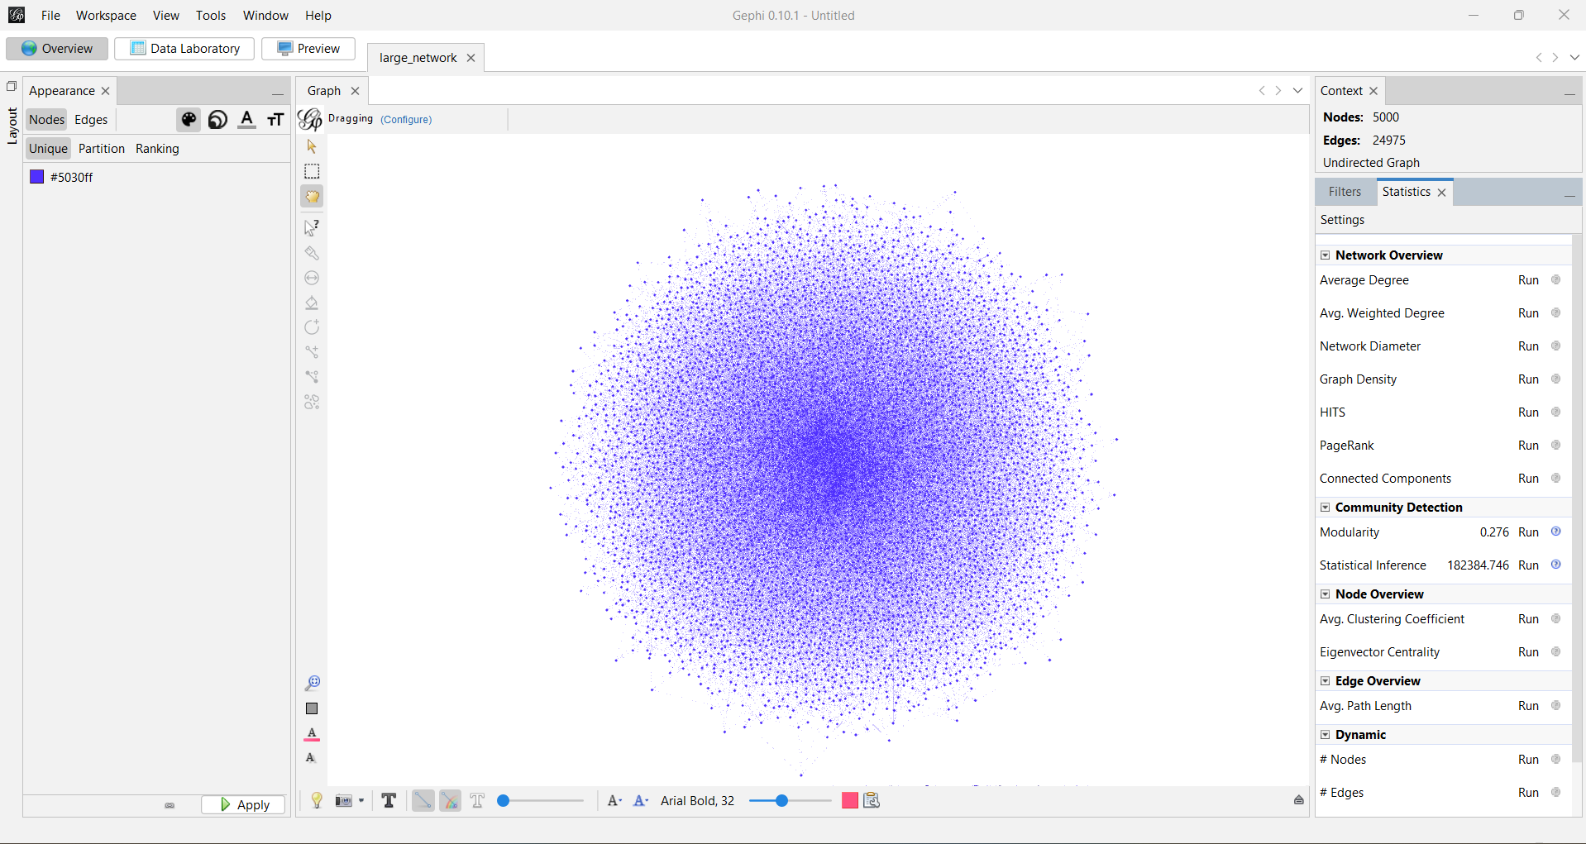
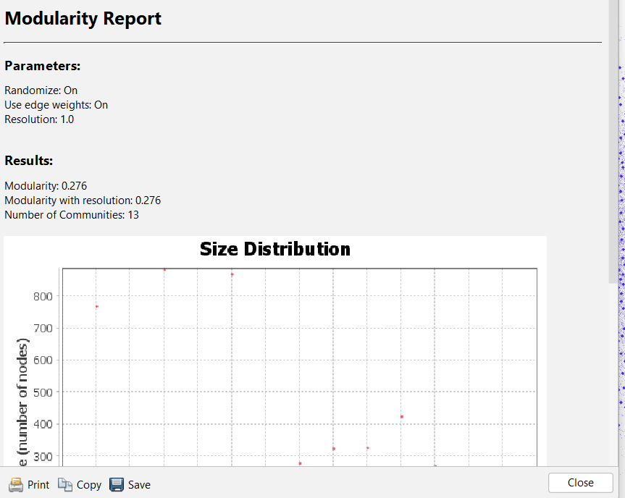

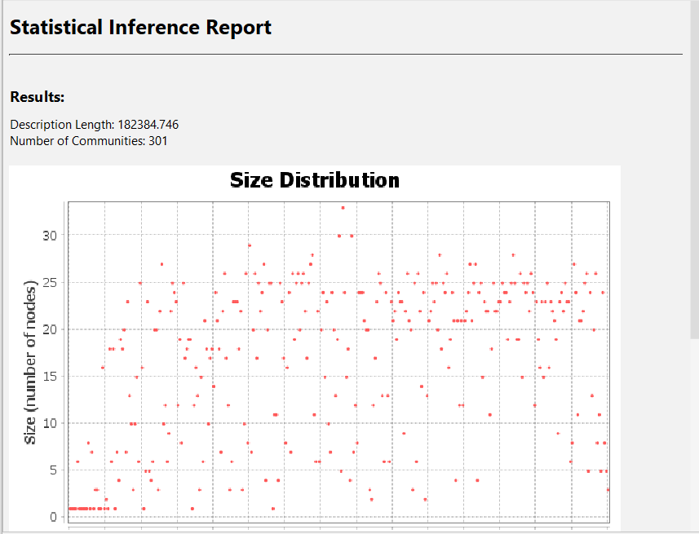

5. Observations and Results
Layout | Clarity | Cluster Visibility | Execution Time | Remarks
ForceAtlas2 | High | Excellent | Moderate | Best for community visualization
Fruchterman-Reingold | Medium | Good | Fast | Balanced visual spacing
Yifan Hu | High | Good | Very Fast | Ideal for large-scale graphs
Circular | Low | Limited | Very Fast | Aesthetic, less informative
- ForceAtlas2 revealed dense community clusters and bridges between groups.
- Yifan Hu provided better scalability for larger datasets.
- Community coloring and node sizing improved interpretability of the network’s hierarchy.

6. Applications
- Network Dashboards: Visualize real-time social or organizational networks.
- Education and Research: Simplify complex networks for conceptual teaching.
- Influence Mapping: Highlight key nodes and connections.
- Data Storytelling: Create visuals for presentations or reports.

7. Learning Outcomes
After completing this practical, students will be able to:
- Import and manage large-scale networks in Gephi.
- Apply and evaluate multiple layout algorithms.
- Use filters and styling to highlight communities and node importance.
- Interpret how layout selection impacts the clarity of insights.

8. Conclusion
This experiment demonstrates how visual layouts in Gephi can enhance the understanding of complex network structures. By applying multiple layouts and highlighting communities, users gain different perspectives on connectivity, influence, and modularity.
The exercise fulfills CO4/PO2 objectives by combining practical visualization, community detection, and communication skills, emphasizing how layout choice shapes the interpretation of network data.

References
- Gephi Documentation – https://gephi.org/users/
- SNAP Datasets – https://snap.stanford.edu/data/
- Bastian, M., Heymann, S., & Jacomy, M. (2009). Gephi: An Open Source Software for Exploring and Manipulating Networks.
- Newman, M. E. J. (2010). Networks: An Introduction. Oxford University Press.
- Barabási, A.-L. (2016). Network Science. Cambridge University Press.

