Name: Probin Bhagchandani
ID: 22DCE006
Subject: OCCSE4002: Social Network Analysis
Department: DEPSTAR Computer Engineering (DCE)
External Practical Exam

Practical-1)
Aim: During a tech event, you are tasked with analyzing Instagram interactions. You must authenticate with the Instagram Graph API, fetch posts using specific hashtags, and build a user interaction graph based on comments and likes.

Implementation Code:
#Practical-1
#Instagram interaction graph

!pip install networkx matplotlib pandas numpy python-louvain seaborn

import random
import string
import numpy as np
import pandas as pd
import networkx as nx
import matplotlib.pyplot as plt
import seaborn as sns
from community import community_louvain

def random_username(length=8):
return ''.join(random.choices(string.ascii_lowercase + string.digits, k=length))

def generate_synthetic_instagram_data(n_users=200, n_posts=150, hashtags=None, avg_likes=50, avg_comments=5, seed=42):
random.seed(seed)
np.random.seed(seed)
if hashtags is None:
hashtags = ['tech', 'ai', 'photography', 'travel', 'food']
users = [random_username(8) for _ in range(n_users)]
posts = []
for pid in range(n_posts):
owner = random.choice(users)
post_hashtags = list(set(random.choices(hashtags, k=random.randint(1,3))))
like_count = max(0, int(np.random.poisson(avg_likes)))
comment_count = max(0, int(np.random.poisson(avg_comments)))
likers = random.choices(users, k=min(len(users), like_count))
commenters = [random.choice(users) for _ in range(comment_count)]
comments = []
for cid, commenter in enumerate(commenters):
text_len = random.randint(3,20)
text = " ".join(random.choices(string.ascii_lowercase, k=text_len))
comments.append({'id': f'{pid}_{cid}', 'username': commenter, 'text': text})
posts.append({
'post_id': f'post_{pid}',
'owner': owner,
'hashtags': post_hashtags,
'like_count': len(likers),
'likers': likers,
'comments': comments
})
return users, posts

def filter_posts_by_hashtag(posts, hashtag):
return [p for p in posts if hashtag in p['hashtags']]

def build_interaction_graph(posts, include_likes=True, include_comments=True, like_weight=0.5, comment_weight=1.0):
G = nx.DiGraph()
for p in posts:
owner = p['owner']
G.add_node(owner)
if include_likes:
for liker in p.get('likers', []):
if liker == owner:
continue
if G.has_edge(liker, owner):
G[liker][owner]['weight'] += like_weight
else:
G.add_edge(liker, owner, weight=like_weight, types=['like'])
if include_comments:
for c in p.get('comments', []):
commenter = c['username']
if commenter == owner:
continue
if G.has_edge(commenter, owner):
G[commenter][owner]['weight'] += comment_weight
if 'comment' not in G[commenter][owner]['types']:
G[commenter][owner]['types'].append('comment')
else:
G.add_edge(commenter, owner, weight=comment_weight, types=['comment'])
return G

def aggregate_to_undirected(G_dir):
G = nx.Graph()
for u, v, data in G_dir.edges(data=True):
w = data.get('weight', 1.0)
if G.has_edge(u, v):
G[u][v]['weight'] += w
else:
G.add_edge(u, v, weight=w)
return G

def compute_metrics(G):
deg = dict(G.degree(weight='weight'))
centrality = nx.betweenness_centrality(G, weight='weight')
clustering = nx.clustering(G, weight='weight')
top_degree = sorted(deg.items(), key=lambda x: x[1], reverse=True)[:10]
top_centrality = sorted(centrality.items(), key=lambda x: x[1], reverse=True)[:10]
return {'degree': deg, 'betweenness': centrality, 'clustering': clustering, 'top_degree': top_degree, 'top_betweenness': top_centrality}

def detect_communities(G):
partition = community_louvain.best_partition(G, weight='weight')
comms = {}
for node, cid in partition.items():
comms.setdefault(cid, []).append(node)
return partition, comms

def draw_graph(G, partition=None, figsize=(12, 8), title='Interaction Graph'):
plt.figure(figsize=figsize)
pos = nx.spring_layout(G, k=0.15, seed=42)
if partition is None:
nx.draw_networkx_nodes(G, pos, node_size=100, node_color='lightblue')
else:
cmap = plt.get_cmap('tab20')
communities = {}
for n, cid in partition.items():
communities.setdefault(cid, []).append(n)
for cid, nodes in communities.items():
nx.draw_networkx_nodes(G, pos, nodelist=nodes, node_size=100, node_color=cmap(cid % 20))
widths = [max(0.1, G[u][v].get('weight',1)*0.3) for u, v in G.edges()]
nx.draw_networkx_edges(G, pos, width=widths, alpha=0.6)
nx.draw_networkx_labels(G, pos, font_size=8)
plt.title(title)
plt.axis('off')
plt.show()

users, posts = generate_synthetic_instagram_data(
n_users=300, n_posts=250, hashtags=['tech','ai','datascience','ml','python'], avg_likes=60, avg_comments=6, seed=123
)

hashtag_to_analyze = 'ai'
filtered_posts = filter_posts_by_hashtag(posts, hashtag_to_analyze)
print(pd.DataFrame(filtered_posts[:5])[['post_id','owner','hashtags','like_count']])

G_dir = build_interaction_graph(filtered_posts, include_likes=True, include_comments=True, like_weight=0.3, comment_weight=1.0)
G_und = aggregate_to_undirected(G_dir)

metrics = compute_metrics(G_und)
partition, communities = detect_communities(G_und)

all_users = set()
for p in filtered_posts:
all_users.add(p['owner'])
all_users.update(p.get('likers', []))
all_users.update(c['username'] for c in p.get('comments', []))

print('Number of users in filtered posts:', len(all_users))
print('Number of nodes in graph:', G_und.number_of_nodes())
print('Number of edges in graph:', G_und.number_of_edges())

print('Top 10 users by weighted degree:')
print(pd.DataFrame(metrics['top_degree'], columns=['User','Weighted Degree']))

print('Top 10 users by betweenness centrality:')
print(pd.DataFrame(metrics['top_betweenness'], columns=['User','Betweenness']))

print('Detected communities (up to 10 shown):')
for cid, members in list(communities.items())[:10]:
print('community', cid, members[:8])

draw_graph(G_und, partition=partition, figsize=(14,10), title=f'Undirected Interaction Graph for #{hashtag_to_analyze}')

plt.figure(figsize=(8,4))
degree_values = sorted([d for n, d in G_und.degree(weight='weight')], reverse=True)
plt.plot(degree_values)
plt.title('Degree Distribution (Weighted)')
plt.xlabel('Rank')
plt.ylabel('Weighted Degree')
plt.show()

plt.figure(figsize=(8,4))
sns.histplot(list(metrics['clustering'].values()), bins=20, kde=True)
plt.title('Clustering Coefficient Distribution')
plt.xlabel('Clustering Coefficient')
plt.ylabel('Frequency')
plt.show()

plt.figure(figsize=(8,4))
sns.scatterplot(x=list(metrics['degree'].values()), y=list(metrics['betweenness'].values()))
plt.title('Degree vs Betweenness Centrality')
plt.xlabel('Weighted Degree')
plt.ylabel('Betweenness Centrality')
plt.show()

community_sizes = [len(members) for members in communities.values()]
plt.figure(figsize=(6,4))
sns.barplot(x=list(range(len(community_sizes))), y=community_sizes)
plt.title('Community Sizes')
plt.xlabel('Community ID')
plt.ylabel('Number of Users')
plt.show()

nodes_df = pd.DataFrame({'node': list(G_und.nodes())})
edges_df = pd.DataFrame([(u,v,data.get('weight',1.0)) for u,v,data in G_und.edges(data=True)], columns=['source','target','weight'])
posts_df = pd.DataFrame([{'post_id': p['post_id'], 'owner': p['owner'], 'hashtags': ','.join(p['hashtags']), 'like_count': p['like_count'], 'comment_count': len(p['comments'])} for p in filtered_posts])

nodes_df.to_csv('Instagram_nodes.csv', index=False)
edges_df.to_csv('Instagram_edges.csv', index=False)
posts_df.to_csv('Instagram_posts.csv', index=False)

print('Exported nodes.csv, edges.csv, posts.csv')

Output:
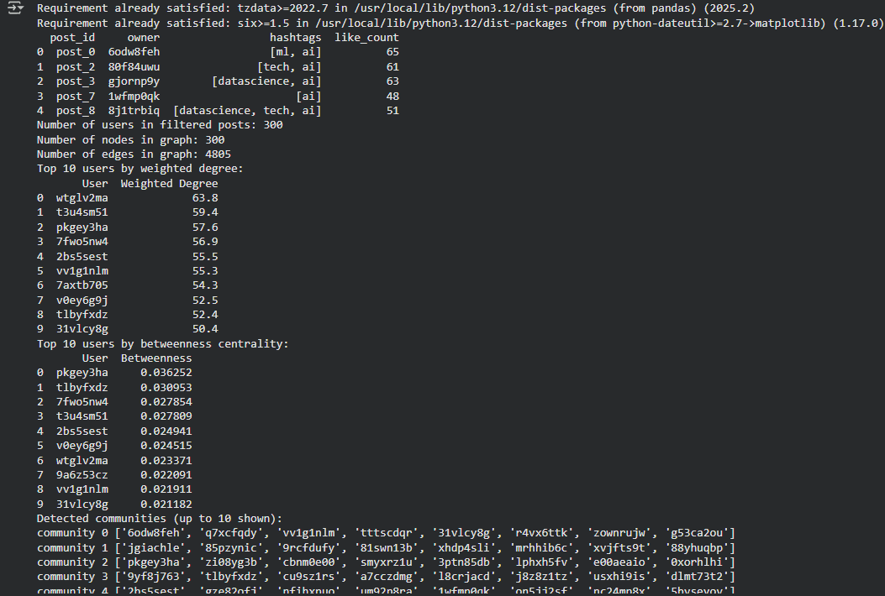

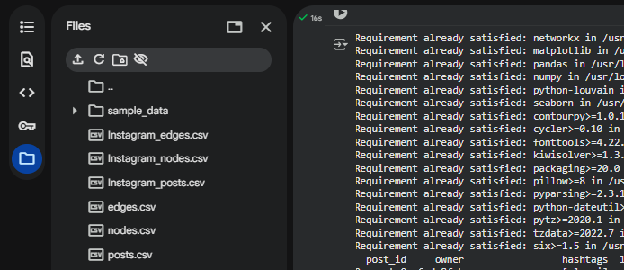

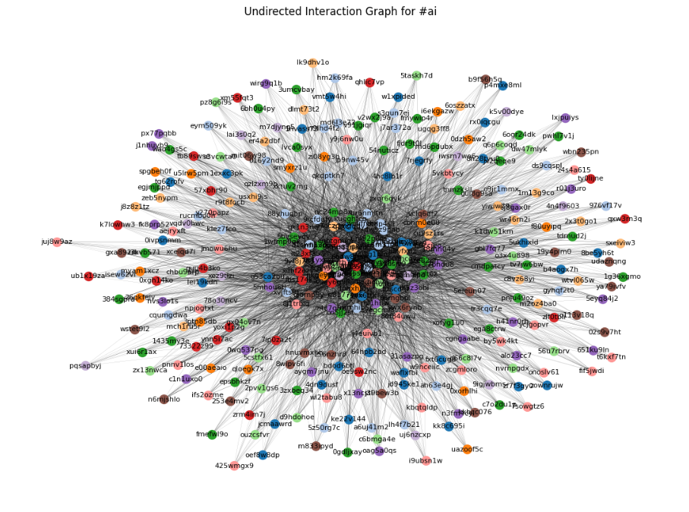
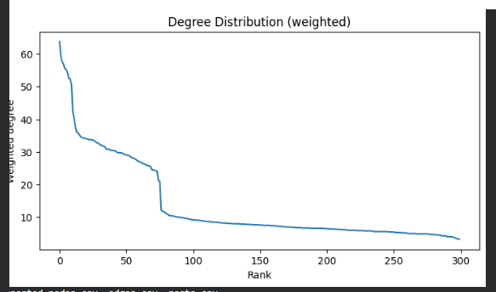
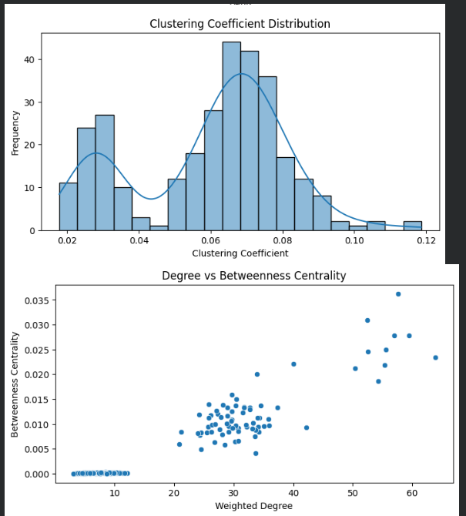

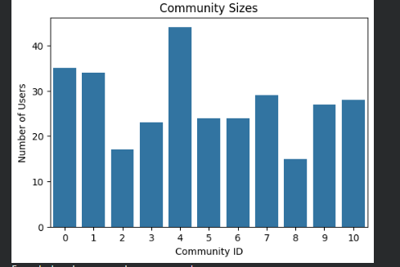
Questions:
1. How will you authenticate and fetch posts from Instagram?

- I will use OAuth 2.0 authentication through the Instagram Graph API by creating a Facebook App and getting the App ID, App Secret, and Access Token.

- I will fetch posts using API endpoints such as:

- GET /ig_hashtag_search?user_id={user_id}&q={hashtag_name}

- GET /{hashtag_id}/recent_media?user_id={user_id}&fields=id,caption,like_count,comments

- This method will help me securely access Instagram data and retrieve hashtag-based posts along with engagement details like likes and comments.

2. How are edges formed in the interaction graph (likes vs comments)?

- In my interaction graph, each node will represent a user, and edges will represent interactions between users. For example- If any user1 likes or comments on user2’s post, I will create an edge between user1 and user2.

- I will give likes a weaker weight and comments a stronger weight, since comments show deeper engagement.

3. State two challenges in real-time data collection from Instagram.

- One major challenge I will face is API Rate Limiting, because Instagram restricts how many requests can be made in a certain time period, which can delay real-time updates.

- Another challenge is Data Sampling/Completeness, since the Hashtag Search API only gives partial data and not every post related to a hashtag.

- Because of these limits, my real-time data might not always be complete or fully up-to-date, which can affect the accuracy of my analysis.

4. How can you identify key influencers on Instagram?

- I will use Degree Centrality to find users who receive the most likes and comments — higher degree means more engagement and popularity.

- I will also apply Betweenness Centrality to find users who act as bridges between different user groups, showing their importance in spreading information.

- To make it more meaningful, I will give comments higher weight than likes, since they represent stronger interaction and real influence.
Practical-2)
Aim: During a tech event, you are tasked with analyzing Reddit community discussions. You must use the Reddit API(PRAW) to collect posts and comments under a specific subreddit and create a discussion network.

Implementation Code:

#Practical-2 Reddit Practical
#Reddit Discussion Network

!pip install networkx matplotlib pandas numpy python-louvain seaborn

import random
import string
import numpy as np
import pandas as pd
import networkx as nx
import matplotlib.pyplot as plt
import seaborn as sns
from community import community_louvain

def random_username(length=8):
return ''.join(random.choices(string.ascii_lowercase + string.digits, k=length))

def generate_synthetic_reddit_data(n_users=300, n_posts=150, avg_comments=8, seed=42):
random.seed(seed)
np.random.seed(seed)
users = [random_username(8) for _ in range(n_users)]
posts = []
for pid in range(n_posts):
author = random.choice(users)
comment_count = max(0, int(np.random.poisson(avg_comments)))
comments = []
for cid in range(comment_count):
commenter = random.choice(users)
text_len = random.randint(3,20)
text = " ".join(random.choices(string.ascii_lowercase, k=text_len))
parent = author if cid == 0 else random.choice([author] + [c['username'] for c in comments])
comments.append({'id': f'{pid}_{cid}', 'username': commenter, 'text': text, 'reply_to': parent})
posts.append({'post_id': f'post_{pid}', 'author': author, 'comments': comments})
return users, posts

def build_reddit_discussion_graph(posts):
G = nx.DiGraph()
for post in posts:
author = post['author']
G.add_node(author)
for comment in post['comments']:
commenter = comment['username']
parent = comment['reply_to']
G.add_node(commenter)
if commenter == parent:
continue
if G.has_edge(commenter, parent):
G[commenter][parent]['weight'] += 1
else:
G.add_edge(commenter, parent, weight=1)
return G

def compute_metrics(G):
deg = dict(G.degree(weight='weight'))
centrality = nx.betweenness_centrality(G, weight='weight')
clustering = nx.clustering(G.to_undirected(), weight='weight')
top_degree = sorted(deg.items(), key=lambda x: x[1], reverse=True)[:10]
top_centrality = sorted(centrality.items(), key=lambda x: x[1], reverse=True)[:10]
return {'degree': deg, 'betweenness': centrality, 'clustering': clustering, 'top_degree': top_degree, 'top_betweenness': top_centrality}

def detect_communities(G):
G_und = nx.Graph()
for u,v,data in G.edges(data=True):
G_und.add_edge(u,v,weight=data.get('weight',1))
partition = community_louvain.best_partition(G_und, weight='weight')
comms = {}
for node, cid in partition.items():
comms.setdefault(cid, []).append(node)
return partition, comms

def draw_graph(G, partition=None, figsize=(12,8), title='Reddit Discussion Graph'):
plt.figure(figsize=figsize)
pos = nx.spring_layout(G, k=0.15, seed=42)
if partition is None:
nx.draw_networkx_nodes(G, pos, node_size=100, node_color='lightblue')
else:
cmap = plt.get_cmap('tab20')
communities = {}
for n, cid in partition.items():
communities.setdefault(cid, []).append(n)
for cid, nodes in communities.items():
nx.draw_networkx_nodes(G, pos, nodelist=nodes, node_size=100, node_color=cmap(cid % 20))
widths = [max(0.1, G[u][v].get('weight',1)*0.3) for u, v in G.edges()]
nx.draw_networkx_edges(G, pos, width=widths, alpha=0.6)
nx.draw_networkx_labels(G, pos, font_size=8)
plt.title(title)
plt.axis('off')
plt.show()

users, posts = generate_synthetic_reddit_data(n_users=300, n_posts=180, avg_comments=7, seed=321)

print("Sample posts (first 5):")
print(pd.DataFrame(posts[:5])[['post_id','author']])

G = build_reddit_discussion_graph(posts)
metrics = compute_metrics(G)
partition, communities = detect_communities(G)

print('Number of users:', len(G.nodes()))
print('Number of edges:', G.number_of_edges())
print('Top 10 users by weighted degree:')
print(pd.DataFrame(metrics['top_degree'], columns=['User','Weighted Degree']))
print('Top 10 users by betweenness centrality:')
print(pd.DataFrame(metrics['top_betweenness'], columns=['User','Betweenness']))
print('Detected communities (showing up to 10):')
for cid, members in list(communities.items())[:10]:
print('community', cid, members[:8])

draw_graph(G, partition=partition, figsize=(14,10), title='Reddit Discussion Graph with Communities')

plt.figure(figsize=(8,4))
degree_values = sorted([d for n, d in G.degree(weight='weight')], reverse=True)
plt.plot(degree_values)
plt.title('Degree Distribution (Weighted)')
plt.xlabel('Rank')
plt.ylabel('Weighted Degree')
plt.show()

plt.figure(figsize=(8,4))
sns.histplot(list(metrics['clustering'].values()), bins=20, kde=True)
plt.title('Clustering Coefficient Distribution')
plt.xlabel('Clustering Coefficient')
plt.ylabel('Frequency')
plt.show()

plt.figure(figsize=(8,4))
sns.scatterplot(x=list(metrics['degree'].values()), y=list(metrics['betweenness'].values()))
plt.title('Degree vs Betweenness Centrality')
plt.xlabel('Weighted Degree')
plt.ylabel('Betweenness Centrality')
plt.show()

community_sizes = [len(members) for members in communities.values()]
plt.figure(figsize=(6,4))
sns.barplot(x=list(range(len(community_sizes))), y=community_sizes)
plt.title('Community Sizes')
plt.xlabel('Community ID')
plt.ylabel('Number of Users')
plt.show()

nodes_df = pd.DataFrame({'node': list(G.nodes())})
edges_df = pd.DataFrame([(u,v,data.get('weight',1)) for u,v,data in G.edges(data=True)], columns=['source','target','weight'])
posts_df = pd.DataFrame([{'post_id': p['post_id'], 'author': p['author'], 'comment_count': len(p['comments'])} for p in posts])
nodes_df.to_csv('reddit_nodes_prac2.csv', index=False)
edges_df.to_csv('reddit_edges_prac2.csv', index=False)
posts_df.to_csv('reddit_posts_prac2.csv', index=False)

print('Exported reddit_nodes_prac2.csv, reddit_edges_prac2.csv, reddit_posts_prac2.csv')

Output:
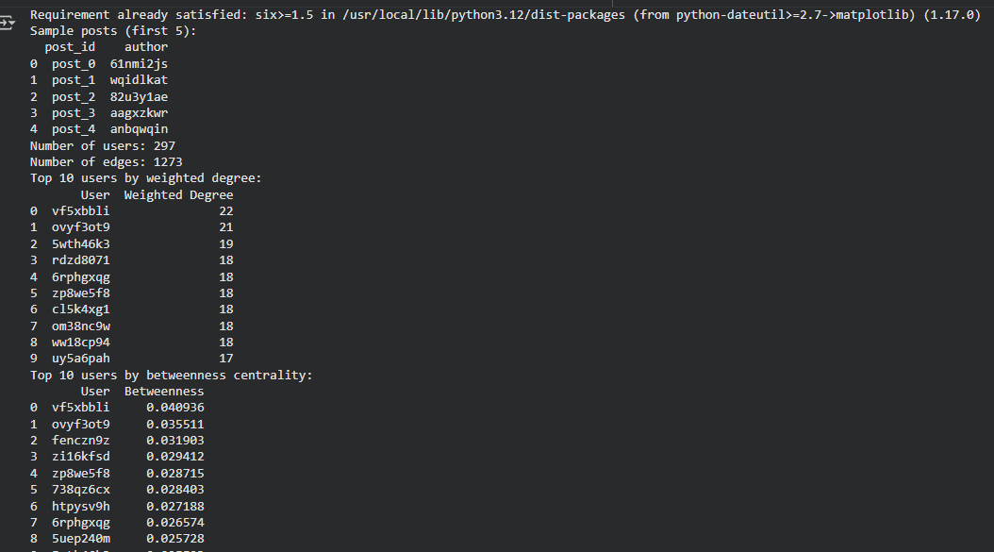
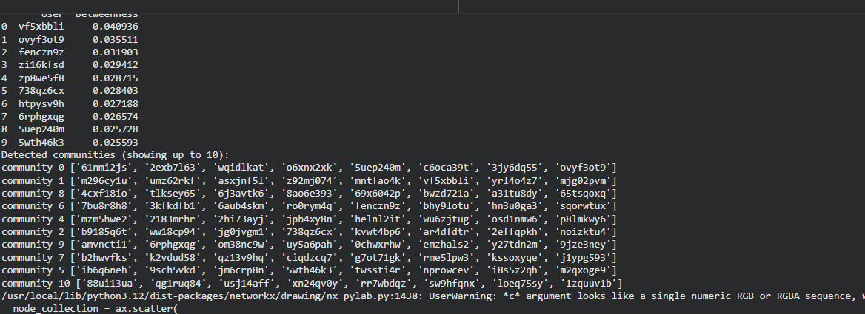
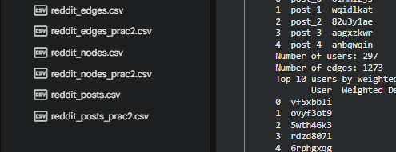
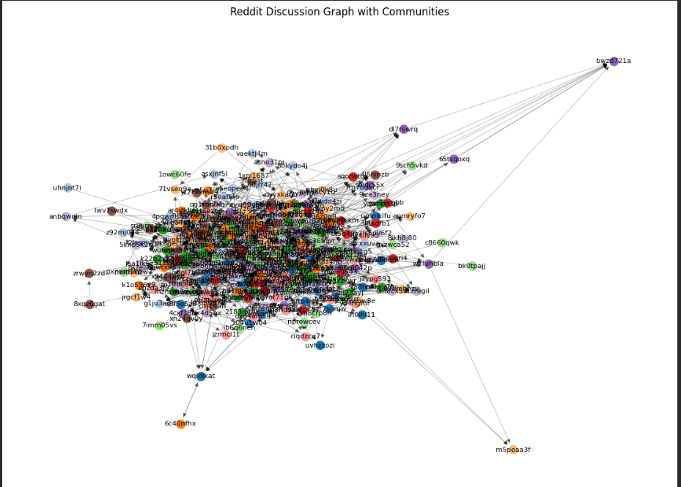
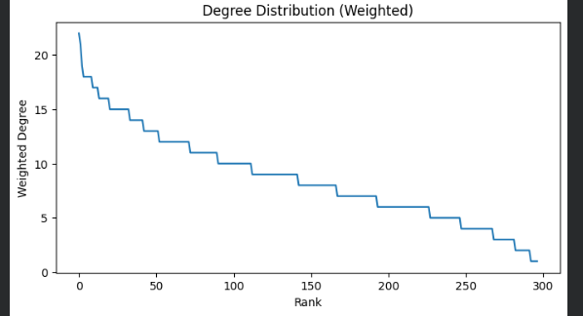

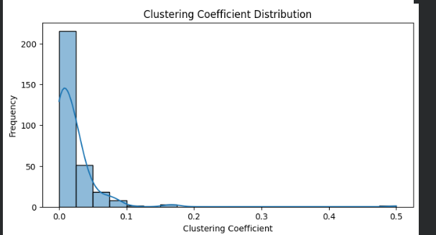

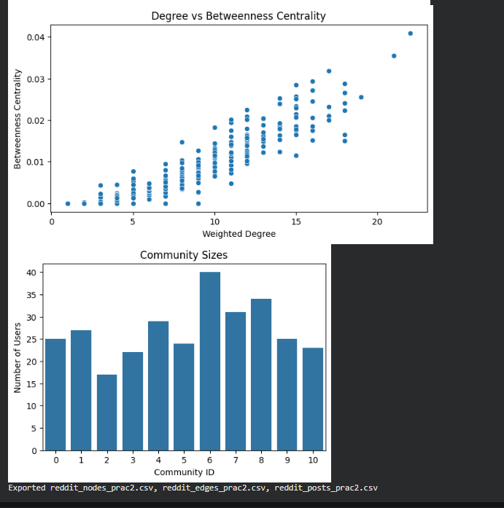

Questions:
1. How will you authenticate and fetch Reddit posts/comments?

- I will use PRAW (Python Reddit API Wrapper) for authentication by registering a Reddit application to get the client ID, client secret, and user agent.

- Using these credentials, I will connect to Reddit’s API and fetch data from a specific subreddit using commands like reddit.subreddit('subreddit_name').hot() or .comments().

- This setup allows me to securely access Reddit data and collect both posts and their related comments for further analysis.

2. How are edges formed in the interaction graph (reply vs mention)?

- In my discussion network, nodes will represent Reddit users, and edges will represent interactions between them.

- If user A replies to user B’s comment, I will create an edge between A and B. If A mentions B (using “u/username”), that will also form an edge.

- I will assign stronger weights to replies since they represent direct engagement, while mentions will have a lighter weight.

3. State two challenges in real-time Reddit data extraction.

- One challenge is API Rate Limiting, since Reddit’s API restricts how many requests can be made per minute, which slows down real-time data collection.

- Another challenge is Dynamic Thread Updates, because Reddit discussions evolve quickly and new comments keep appearing, making it hard to capture a complete snapshot in real time.

- These challenges can cause missing or delayed data, which affects the freshness and accuracy of my discussion analysis.

4. How can you detect the most influential or frequent contributors?

- I will calculate Degree Centrality to identify users who interact the most — those who post or receive many replies are likely key contributors.

- I will also use Betweenness Centrality to find users who connect different conversation threads, showing their influence in bridging discussions.

- By combining these measures, I can highlight users who are either frequent posters or influential participants within the subreddit network.

