**CSCI 571 HW4 Report**

*zhong zheng*

*1029032516*

**Link:**

**http://cs-server.usc.edu:23510/CodeIgniter/index.php/Main_page**

1. Every thing dynamic or javascript in HW3 is now jQuery in HW4. Like Session, validation and some jQuery effect of the page.

2. Use MVC to design the website. Controllers is to validate any session variables, retrieve and validate data, load the model (or models), passing the appropriate data through an associative array, then call one, or more, views to generate the output.

3. Safe from cross-site scripting (XSS) and SQL injection. Alert a message, says not use SQL or Javascript key words. Use regular expression and query binding technology.

4. Responsive Web Design for mobile devices(jQuery mobile). Use user-agent to determine whether it is a mobile device.

**Database:**

cart table:

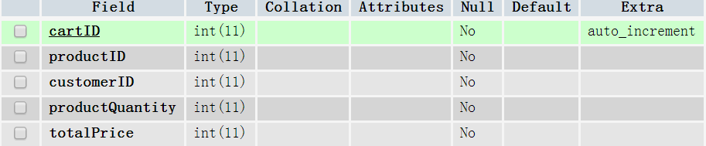

paid table:

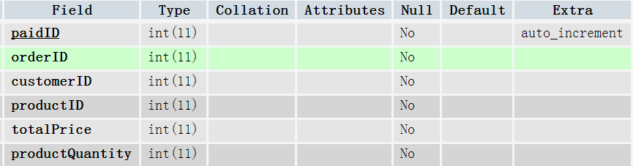

orders table:

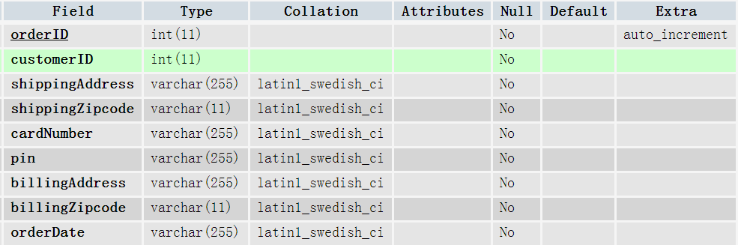

customer table:

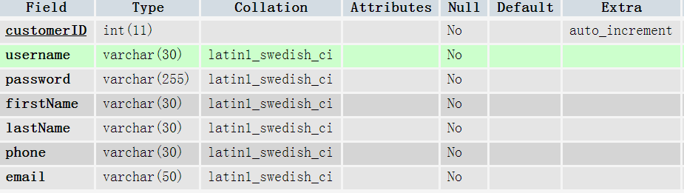

**Controller:**

***Cart_controller.php***

All the functions in this controller is about the order and cart, control the data and view of cart and order. Includes function add(), myCart(), checkOut(), myOrder(), etc.

***Main_page.php***

Control the views and data of home page, and login page. Includes function like info(), login(), logout(), etc.

**Model:**

***user.php***

Deal with the data of user, includes their profile, add or update their data.

***main.php***

Deal with the data from home page, including get product information by its name, check whether it is special, search product or something like that.

***cart.php***

Handle with data of cart and order. Get, add, edit or delete product from cart, and look for data from order table.

**View:**



All the view file name gives a hint of what the view is used for, I think it's easy to know according to its name. If you have some questions about this part, please contact me. I will give a very specific explanation about the view file.