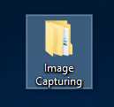CAMERA SETTING PROCEDURE

1. Go to the *Desktop\Image Capturing\Visualization – Matlab Codes*

2. Open ***FindingCameraOrder.m*.** Run the code and you get the figure below, which streams the camera images in real-time.

**1**

You must turn the light sources on and off in order to identify which camera belongs to each erosion box. The orders of the cameras in the same erosion box does not matter.

The camera order is indicated here

The erosion box order is

Frankie 1 (**F1**) – closest to the wall

Frankie 2 (**F2**) – in the middle

Frankie 3 (**F3**) – closest to you

**2**

**3**

**4**

**5**

**6**

3. After identifying the correct order, open ***SavingImages.m*** and update the camera order as well as the desired image capturing rate

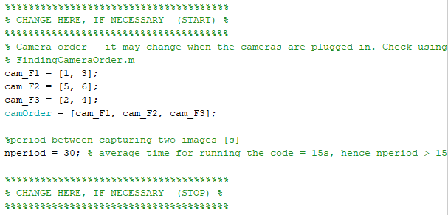

**camera order**

**Image capturing rate**

page 1/2

3. Run the code.

It will create a folder in the current directory containing the images. The folders is named using the current date. If you want to run two experiments in the same day, copy the folder generated in the previous experiment to *Desktop\Image Capturing\Past Experiments*, otherwise the code will not run

4. After running the code, you will get a figure similar to the previous one:

**Title shows the approximated time the pictures were taken**

**The images refresh every *nperiod* seconds. The figure shows the last imaged saved in the folder**

**Images from *Frankie 1***

**Images from *Frankie 2***

**Stop the image capturing here. It captures a final picture before ending the program.**

**Images from *Frankie 3***

page 2/2 *END*