EROSION SHUTDOWN PROCEDURE

1. In LabVIEW, deactivate controllers **CV101**, **CV102** & **CV103.** Make sure the valves remain opened using the control override

2. **Open** recycle valve **V107**

3. Using the control override, close **CV101**, **CV102** & **CV103**

4. Close air valves **FIC104**, **FIC105** & **FIC106**

5. Manually close **V102**, **V103** & **V104**

6. Remove the probe + support from the erosion boxes as follows:

a) Remove the black cover and open the box using the wingnuts

b) Use an L-shaped tool to remove the probe + support (you can find it inside the toolbox)

c) Close the erosion box using the wingnuts

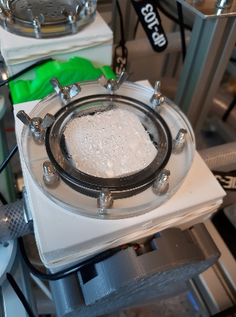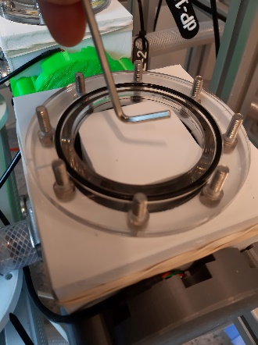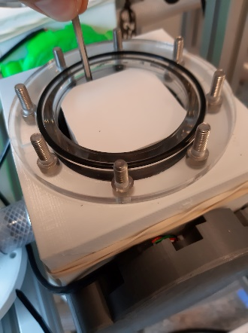

7. Follow the *shutdown procedure*

8. Un-plug the light source

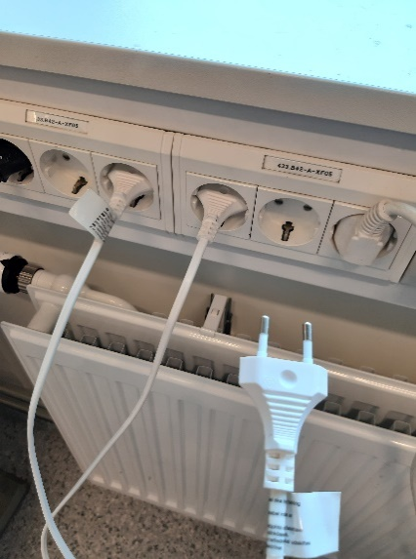

Page 1/1 *END*