EROSION STARTUP PROCEDURE

1. Follow the *start up procedure* all the way to the end

2. Prepare the probe as follows:

1. Get the probe support from the cabinet
2. Place the sample in the support
3. Fixate the probe using a screw (M4-30mm) and a nut

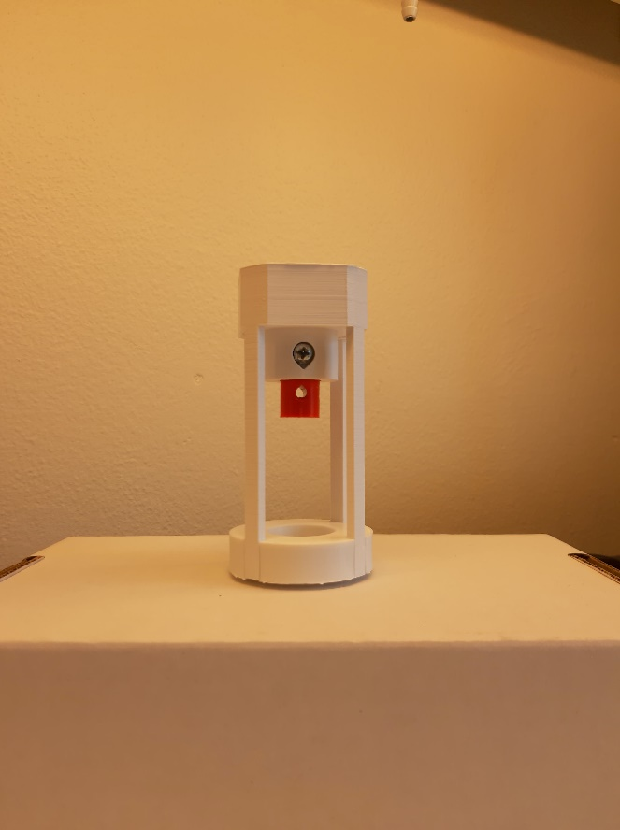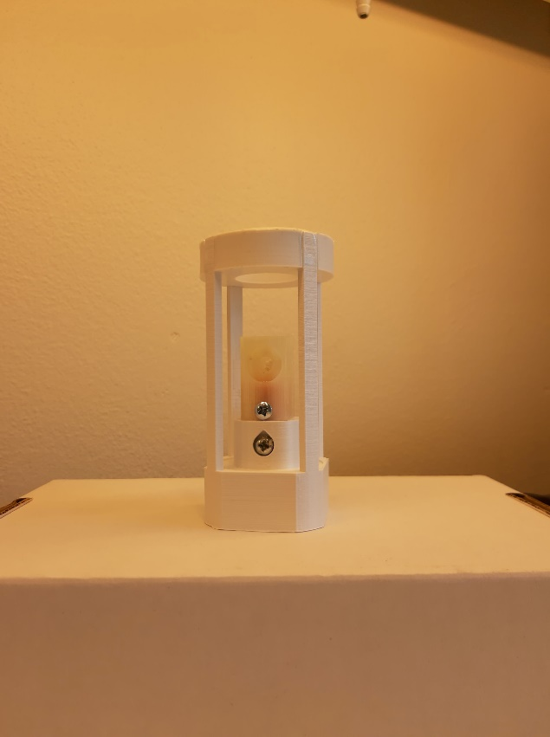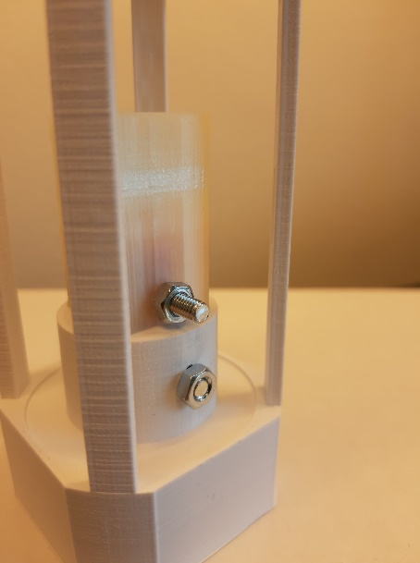

3. Plug in the light source (on the wall to the left)

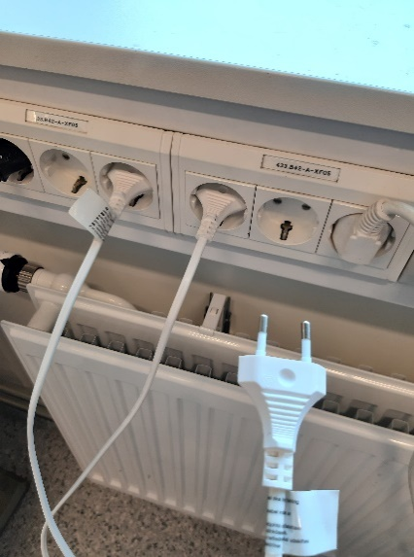

4. Test the cameras (see *Camera Setting Procedure*)

5. In LabVIEW, deactivate controllers **CV101**, **CV102** & **CV103.**

Make sure the valves remain opened using the control override

6. **Open** recycle valve **V107**

7. Using the control override, close **CV101**, **CV102** & **CV103**

8. Close air valves **FIC104**, **FIC105** & **FIC106**

9. Manually close **V102**, **V103** & **V104**

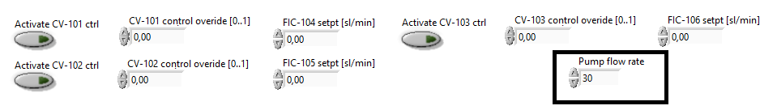

**8.**

**7.**

**6.**

Page 1/2

10. Insert the probe in the erosion boxes as follows:

a) Open the box using the wingnuts

b) Place the probe + support with the big hole facing the inlet

c) Close the box using the wingnuts and put the black cover on it

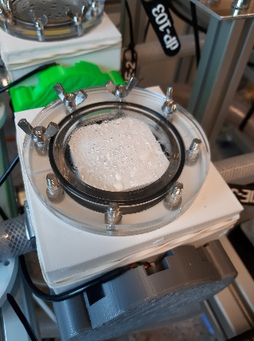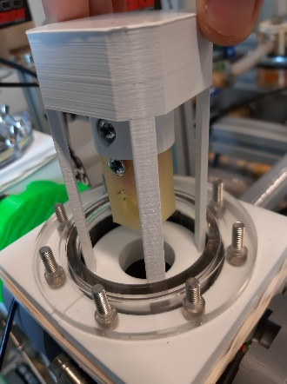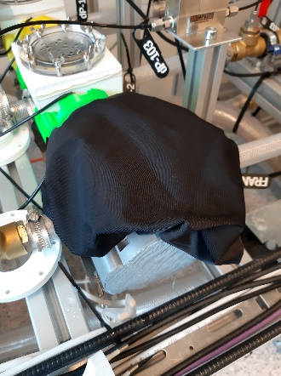

11. In LabVIEW, open **CV101**, **CV102** & **CV103**

12. Open **V102**, **V103** & **V104**

(*any order*)

13. If the flow is normal, close the recycle valve **V107**

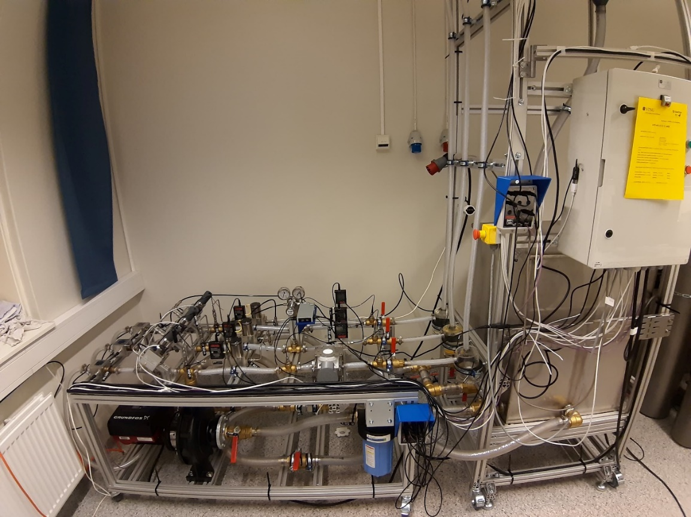

**V102, V103, V104**

**V107**

page 2/2 *END*