EMERGENCY – **MINOR LEAKAGE**

1. **Open** valve **V107**

2. Close valve **V101** (behind the pump)

3. Turn off pressure regulator **V108** (clockwise!)

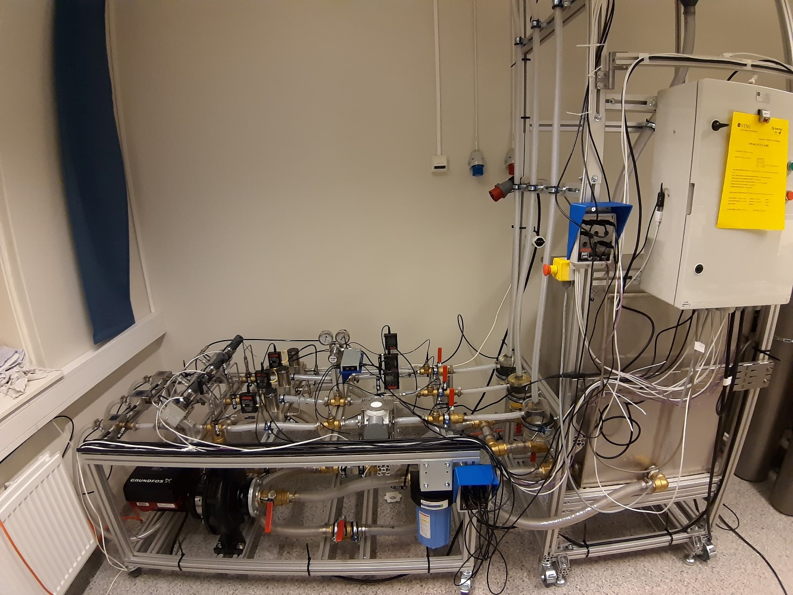

**V108**

**V101**

off

**V107**