# MPC-MAP Assignment No. 1 - Report

## **Author:** Martin Procházka

## **Date:** 26. 02 2025

## Task 2

Based on calculated values, standard deviations across all LiDAR channels could be considered similar (Figure 2). The same conclusion can be made about both axis of GNSS measurements (Figure 1).

## 

Figure 1 – GNSS measurements

Figure 2 – LiDAR measurements

## Task 3

## Values on the main diagonal of covariance matrix correspond to variance i.e. square of standard deviation.

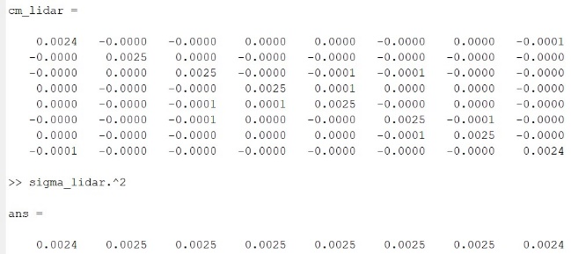

Figure 4 – Covariance matrix and variance of LiDAR measurements

Figure 3 – Covariance matrix and variance of GNSS measurements

## Task 4

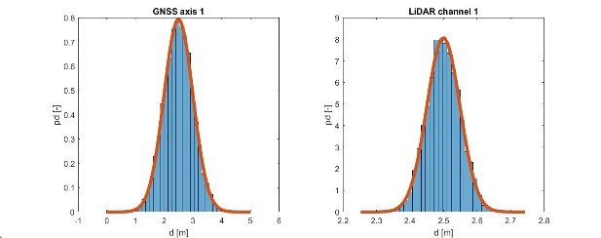Correctness of implementation of normal probability distribution function has been verified against measured data.

Figure 5 – pdf (red) and measured data (blue)

## Task 5

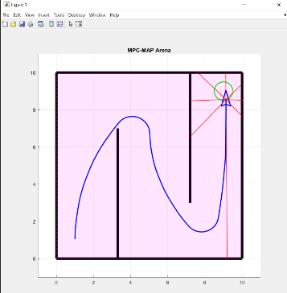An uncertainty of robot motion could be for example be caused by wheel slippage or by diameter difference of the wheels.

Figure 6 – Open loop control