# MPC-MAP Assignment No. 2 - Report

## **Author:** Martin Procházka

## **Date:** 5. 3. 2025

## Task 2

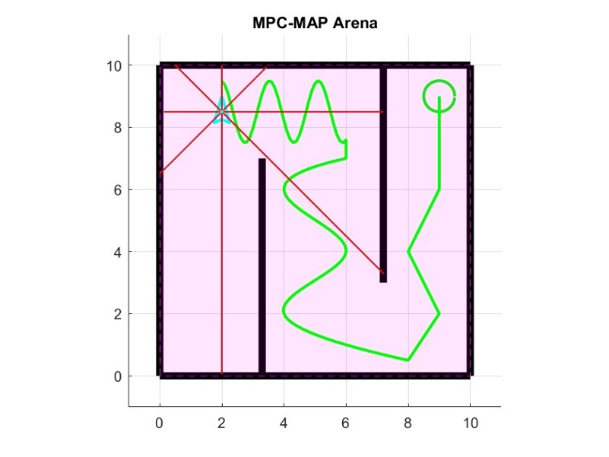In this task, a path for path-following algorithm testing has been created (Figure 1). This path consists of smooth curves, sharp edges and straight lines, allowing us to test the path following implementation under various conditions. The spacing between individual points also varies to verify that the implementation is not dependent on path point density.

Figure 1 – Test path

## Task 3

For the robot to follow the defined path, a feedback linearization path-following algorithm has been chosen and implemented. This algorithm has two parameters that affect its behavior. The first is the gain of the position error. The second parameter is the offset of the holonomic point from the robot itself.

To reduce the complexity of the tuning process, the ratio between the maximum velocity and the point offset has been chosen as the position error gain, thus leaving us with just one parameter—the holonomic point offset epsilon. This parameter affects how closely the path is followed. Larger offsets lead to a looser path following but also result in a smoother trajectory compared to smaller offsets.

Figure 2 – epsilon=0.5

Figure 3 – epsilon=0.1