# MPC-MAP Assignment No. 3 - Report

## **Author:** Martin Procházka

## **Date:** 12. 3. 2025

## Task 1

In this task, pose prediction has been implemented. This prediction based on calculated linear speed and angular speed from control input – velocity of each wheel. To increase variance of particles, noise has been added to the control input. However, for practical reasons, noise has also been added to the predicted position, which lowers the convergence time of the particle filter.

## Task 2

For particle weight calculation, two methods have been implemented – one using normal distribution and the other using Euclidean distance. Experimentally, the method utilizing Euclidean distance performs better and does not require any parameter tuning, compared to the method using normal distribution. In both cases, weights were normalized such their sum equals to 1.

## Task 3

Resampling is performed using systematic resampling methods. Moreover, to address the kidnapped robot problem, a certain number of particles with random poses are also generated.

## Task 4

The most important parameters of my solution are particle count and noise level for pose prediction. Low particle count or low particle variance caused by noise not being too significant leads to poor estimation performance. As the variance increased quite significantly during pose estimation by adding the noise twice, there was no need to increase the variance even more with resampling, thus systematic resampling is used.

As described in Task 2, Euclidean distance was used for weigh calculation as it resulted in more stable estimation. Figure 1 shows estimated trajectory (cyan) using normal distribution for weight calculation against true trajectory (blue) and Figure 2 shows the same using Euclidean distance for weight calculation. For testing purposes, position is plainly estimated using median value of all particles.

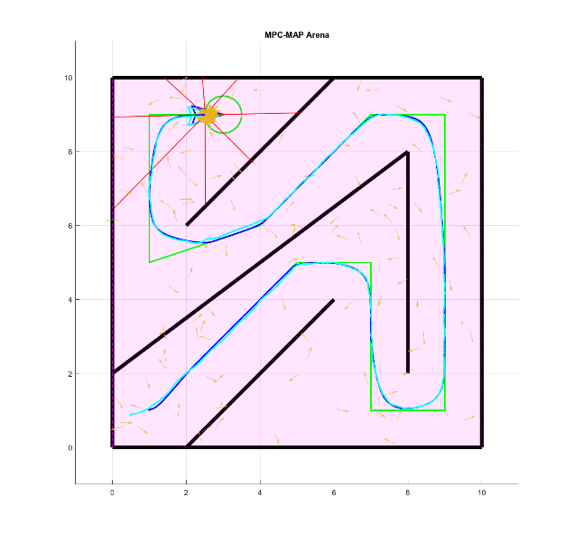 The major issue I had to overcome was the convergence of particles in incorrect locations. This was solved by creating particles with random pose during each resampling.

Figure 2 – Euclidean distance

Figure 1 – normal distribution