# MPC-MAP Assignment No. 4 - Report

## **Author:** Martin Procházka

## **Date:** 19. 3. 2025

## Task 1

In this task, the initialization procedure has been implemented. During this procedure, the robot stands still and collects GNSS position data. After the specified period, the mean and covariance matrix of this measured data are calculated.

## Task 2

Due to the nonlinear nature of the differential wheeled robot, the EKF prediction step has been implemented. However, the linear version has been used for the correction step as the position is measured directly using GNSS.

## Task 3

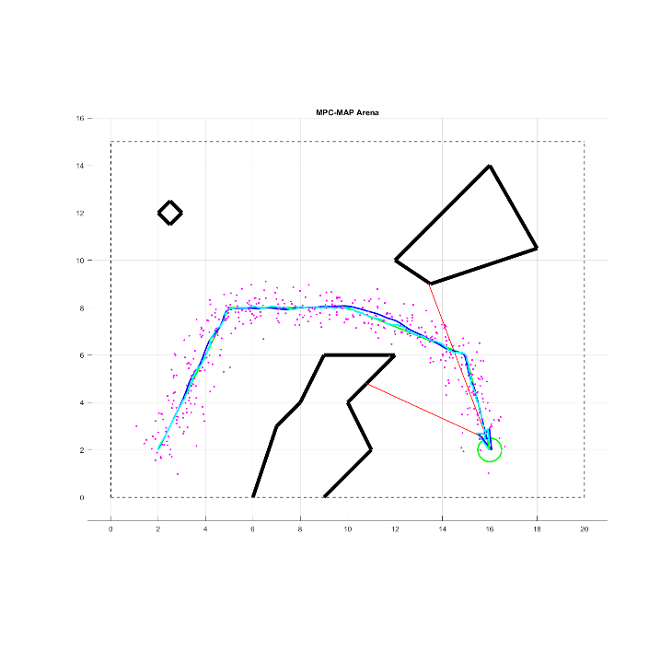In this task, the initial state has been manually set to the initial pose of the robot. The measurement noise matrix Q values have been obtained from the measurement in the first assignment. EKF performance has been tuned by adjusting the process noise matrix R. The resulting path tracking to the goal position is shown in Figure 1.

## Task 4

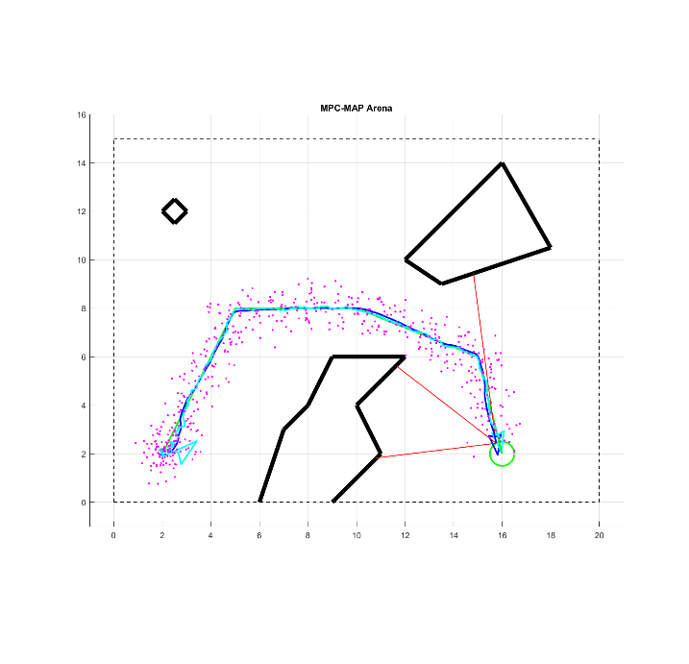The initialization procedure from Task 1 has been utilized to obtain the initial belief for the EKF. Once the robot starts moving, the orientation converges and is successfully estimated. The robot is then able to navigate to the goal location as is shown in Figure 2.

Figure 1 – known initial state

Figure 2 – initialization procedure