# MPC-MAP Assignment No. 5 - Report

## **Author:** Martin Procházka

## **Date:** 26. 3. 2025

## Task 1

In this task I have implemented an algorithm to find the shortest path between any position on the map and the goal position. Since the environment is static, it is possible to compute directions for each cell. Then when we need to plan a path, we just backtrack, utilizing these precomputed directions, which makes the planning itself very fast at the expense of computationally demanding initialization. Depending on how many times we need to replan the path, this approach could be faster than repeated use of A*.

## Task 2

To keep clearance from the obstacles, I have used convolution with a disk kernel to expand the occupied space.

## Task 3

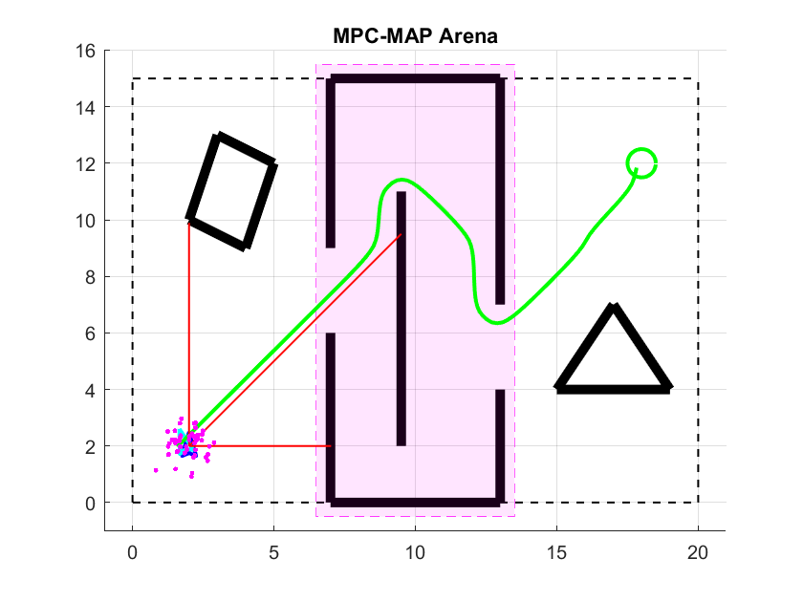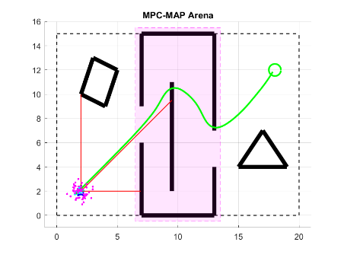I have used the iterative method for path smoothing, which uses two parameters—alpha and beta. The alpha parameter affects how closely the smoothed path should follow the original path, and the beta parameter affects the smoothness of the new path. However, smoothing requires additional clearance from the obstacles, otherwise it can lead to undesirable paths (Figure 1). Experimentally, I have determined alpha = 0.1 and beta = 0.4 to produce the best results for the given map and clearances (Figure 2).

Figure – Undesirable path

Figure 2 – Tuned smoothing