**Dear Applicant!**

We are very much interested in your application, thus we would like to invite you to the second round of the selection process.

Here is a short test to survey your experience and knowledge in software development. It is important that you code according to your own style or habits. The purpose of the test is to show us how you are coding.

You have to make your implementation in .Net environment, C# language, MVC architecture, with MSSQL database. When you finished the work, export the DB structure and data into a sql file. Compress all the files and attach the .zip with the answer e-mail. Please make also the frontend of the website where we can test your functions.

**The Test:**

You have to make a package-information system where users can get details about their orders by package number.

First of all you have to make a login interface, where users can login into their account. After the successful login they can inquire information about their orders. Orders always have status as you can see in the table below.

*All possible status of the ordered packages:*

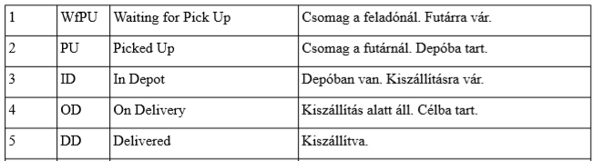

Csomag a feladónál. Futárra vár - Package is ready for pick-up, awaiting courier.

Csomag a futárnál. Depóba tart. - Package is with the courier on its way to the depot.

Depóban van. Kiszállításra vár. - Package is at the depot awaiting delivery.

Kiszállítás alatt áll. Célba tart. - Package is being delivered on its way to destination.

Kiszállítva. - Package has been delivered

The Package ID contains 4 letters and 4 numbers for example: QWER1234. Users get info by giving this string into searchbar input field.

An ordered package can contain multiple products.

You have to insert products into the DB. All products have *price, name*. To create the products you have to crawl ’Árukereső’ website (link below). There are mobile phones on the site (when this document was made, there were 95 available items). Please create the products from exisiting products available on Árukereső (not manually).

https://www.arukereso.hu/mobiltelefon-c3277/f:samsung,erintokepernyo/

The depth of design of the interfaces is up to you. As said the main goal of the test is to show your coding skills. It is an advantage if you also include a little summary of the implementation (word file, readme.txt …).

Good luck with the assignment! We hope you will be our next colleague.

**Smartkosár Team**

