




IMMERSIVE AR-BASED LEARNING
Department of Computer Science and Engineering
Adhiyamaan College of Engineering (Autonomous), Hosur

ABSTRACT
METHODOLOGIES ARCHITECTURE DIAGRAM CONCLUSION

CodeAR is an Augmented Reality (AR)-based educational platform that transforms the way Computer Science students learn by visualizing core concepts as 3D interactive models. When students scan predefined images or QR codes, CodeAR displays animated 3D representations along with synchronized voice explanations. This immersive approach enhances conceptual clarity and bridges the gap between theoretical study and practical understanding. The system supports visualization of key subjects like Data Structures, Operating Systems, Database Systems, and Networking, making complex topics easier to grasp. By integrating AR technology with interactive learning, CodeAR promotes deeper engagement, improved retention, and a future-ready digital learning experience.

OBJECTIVES

Visualize Abstract Concepts: Use AR to turn complex CSE topics into easy-to-understand 3D visual experiences.
Enhance Learning Engagement: Provide an interactive and immersive platform that encourages exploration and curiosity.
Bridge Theory and Application: Connect classroom knowledge with real-world systems through realistic 3D representations.
Support Multimodal Learning: Combine visual, auditory, and kinesthetic learning styles for better comprehension.
Foster Innovation in Education: Utilize AR as a modern teaching tool to make learning dynamic and technology-driven.
Encourage Self-Paced Learning: Allow students to revisit concepts anytime through visual and audio-based modules.
Collaborative Learning Environment: Enable group learning sessions where multiple students can interact in shared AR space.
Cross-Platform Flexibility: Ensure compatibility with Android, iOS, and web-based AR applications.

CodeAR follows a structured development process to transform computer science concepts into interactive Augmented Reality experiences.
Requirement Analysis: Identify key topics from Data Structures, Operating Systems, and Networking suitable for AR visualization. Collect inputs from students and educators to define system goals and functional needs.
System Design: Plan the app architecture, user interface, and AR interaction flow. Define data movement, image tracking logic, and visual layout to ensure smooth performance and intuitive navigation.
3D Model Development: Create optimized 3D models in Blender and import them into Unity. Models represent core CSE concepts like algorithms, CPU processes, and network topologies with simple animations for clarity.

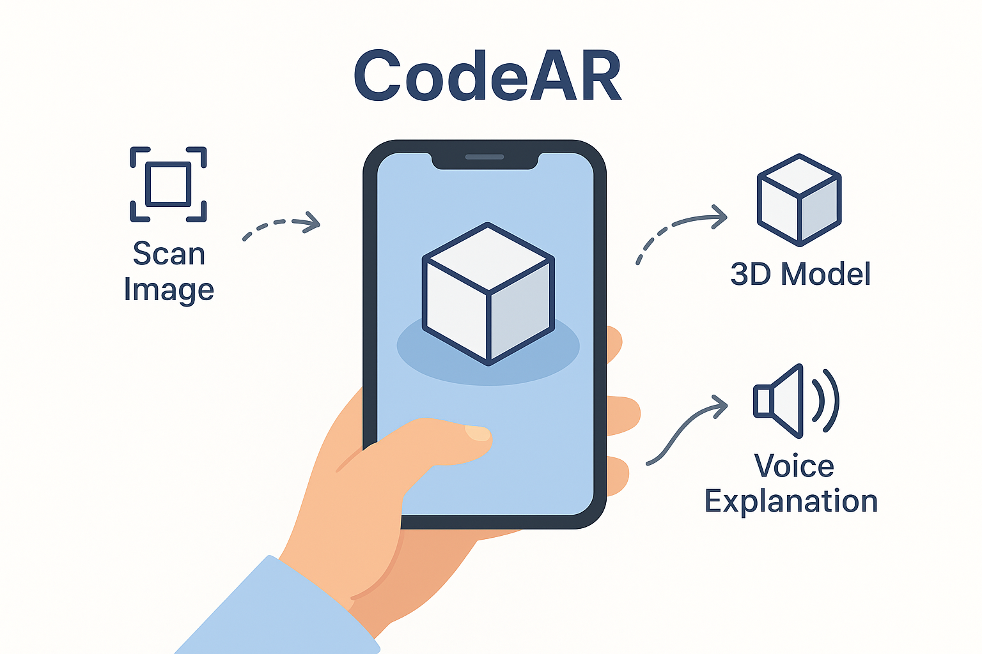

AR Integration: Integrate Vuforia or ARCore SDK within Unity 3D for marker-based tracking. Each image target triggers its respective 3D model, aligned with real-world scaling and stable tracking.
Voice-Over Synchronization: Add voice explanations using Unity’s Audio Source to narrate concepts as models appear. This blends visual and auditory learning for better understanding.
Testing and Debugging: Test the app for performance, recognition accuracy, and responsiveness on multiple Android devices. Fix issues related to model stability, sound playback, and detection lag.
Deployment: Build and deploy the project as an Android application. The lightweight AR app runs smoothly on most devices and can be extended to iOS or web platforms for wider use.

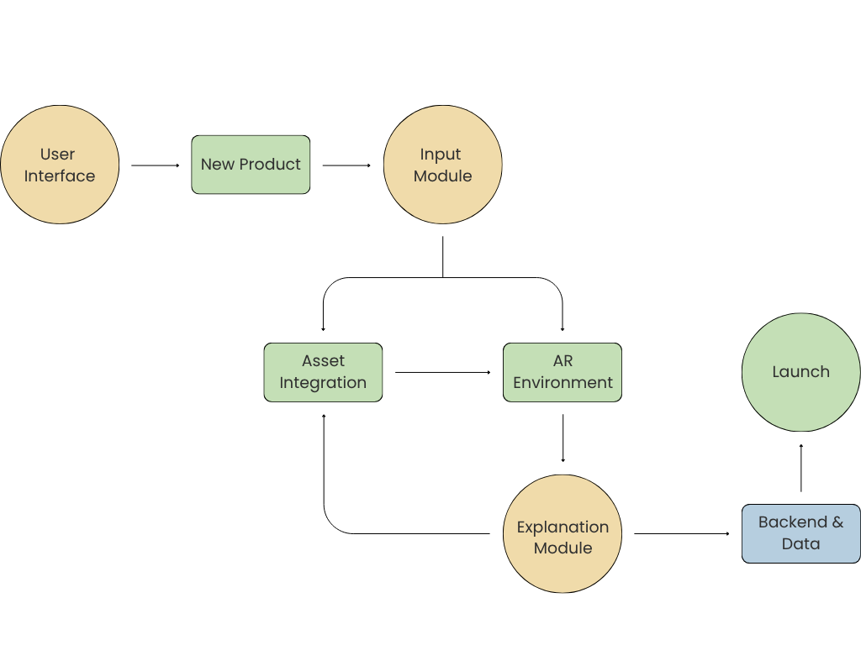

RESULT
The developed CodeAR application successfully detects image targets and projects corresponding 3D models with synchronized audio narration in real time.The system demonstrates smooth performance with minimal latency and high frame stability. It effectively enhances user understanding through realistic visualization and interactive exploration. CodeAR runs efficiently on mobile devices with stable tracking, ensuring a continuous and engaging learning experience.

OUTPUT

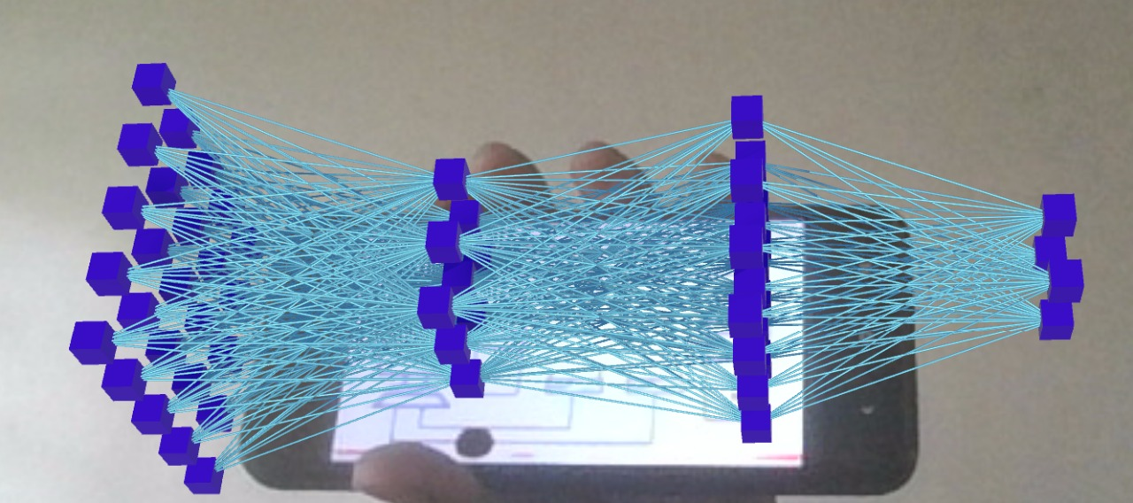
The CodeAR project successfully demonstrates how AR technology can redefine computer science education. By visualizing theoretical topics as interactive 3D models with audio guidance, the system improves comprehension, retention, and student engagement. It serves as a bridge between classroom learning and real-world applications, making it an effective modern educational tool. CodeAR highlights the potential of immersive technologies to transform digital learning environments.

REFERENCES

Azuma, R. T. (1997). A Survey of Augmented Reality. Presence: Teleoperators and Virtual Environments, 6(4), 355–385.
Billinghurst, M., Clark, A., & Lee, G. (2015). A Survey of Augmented Reality. Foundations and Trends in Human–Computer Interaction, 8(2–3), 73–272.
Zhou, F., Duh, H. B.-L., & Billinghurst, M. (2008). Trends in Augmented Reality Tracking, Interaction and Display: A Review of Ten Years of ISMAR. Proceedings of the 7th IEEE/ACM International Symposium on Mixed and Augmented Reality.
Lee, K. (2012). Augmented Reality in Education and Training. TechTrends, 56(2), 13–21.

GUIDED BY

Mrs. D. M. VIJAYALAKSHMI, M.E.,

CONTACT

  - JEEVAN KISHORE B,CSE - 6176AC21UCS066
  - KARTHIKEYAN M, CSE - 6176AC21UCS071
  - NITHISHKUMAR M, CSE – 6176AC22UCS108

