Library Infrastructure

About Library
The knowledge centre of Shree Venkateshwara Arts and Science (co-edu.) College (SVCAS), established in 2019, serves as the academic information hub of the institution. Spread across 4,000 sq. Ft.With a seating capacity of 80 students, it provides a learner-friendly environment that supports teaching, learning, research and self-study.
The centre maintains a collection of 6,644 volumes with 2,272 titles, covering science, arts, commerce, management, and allied disciplines. The collection is regularly updated to meet curriculum requirements and support academic excellence
The centre is automated using Campusilib library management software, offering barcode-based circulation and OPAC (online public access catalogue) facilities for efficient access to library resources.
To promote digital learning, the centre provides access to DELNET Resources, enabling users to access a wide range of e-books, e-journals, theses, dissertations and online databases.
Computer infrastructure

The knowledge centre is equipped with ICT-enabled facilities to support library operations and digital learning.
- Circulation section: Two computer systems are available for circulation services.
- OPAC-(online public access catalogue): one dedicated computer system is available for users to search the library catalogue.
- Digital library: Fifteen computer systems with internet connectivity provide access to DELNET, e-books, e-journals, and other online academic resources.
- Server: one server system supports library automation and digital services.
- Scanning facilities: Barcode scanner are available for library operations

Library Services: Timings

& Guidelines

Membership
The knowledge centre extends membership to all students, faculty members, and non-teaching staff of the institution, enabling them to access library resources, digital services, and information facilities for academic and professional development.

Working Hours
Monday- Friday : 9:10 Am To 4:30pm
Saturday : Library is open (College Working Day Only).
Sundays & Holidays : Closed

Category | Book Limit | Return Period (Days)
UG | 3 | 30
PG | 5 | 30
PhD | 7 | 30
Teaching Staff | 10 | 30
Non-Teaching | 3 | 30

Usage Guidelines
- Library membership is available to all students, faculty members, research scholars, and staff.
- A valid college identity card is mandatory for library entry and borrowing privileges.
- Users shall maintain silence, discipline, and a study-friendly environment within the library.
- Mobile phones must be kept in silent mode while inside the library.
- Food and beverages are not permitted in the library premises.
- Library resources shall be handled with care. Users are responsible for any loss or damage to borrowed materials.
- Books must be returned or renewed on or before the due date to ensure equitable access for all users.
- Reference Books, journals, newspapers, and other non-circulating resources are for in-library use only.
EVENT

DEPARTMENT OF LIBRARY ACTIVITY
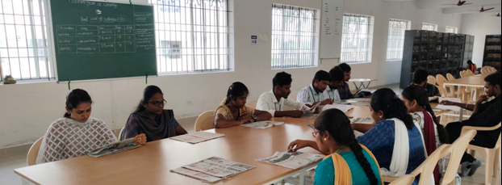

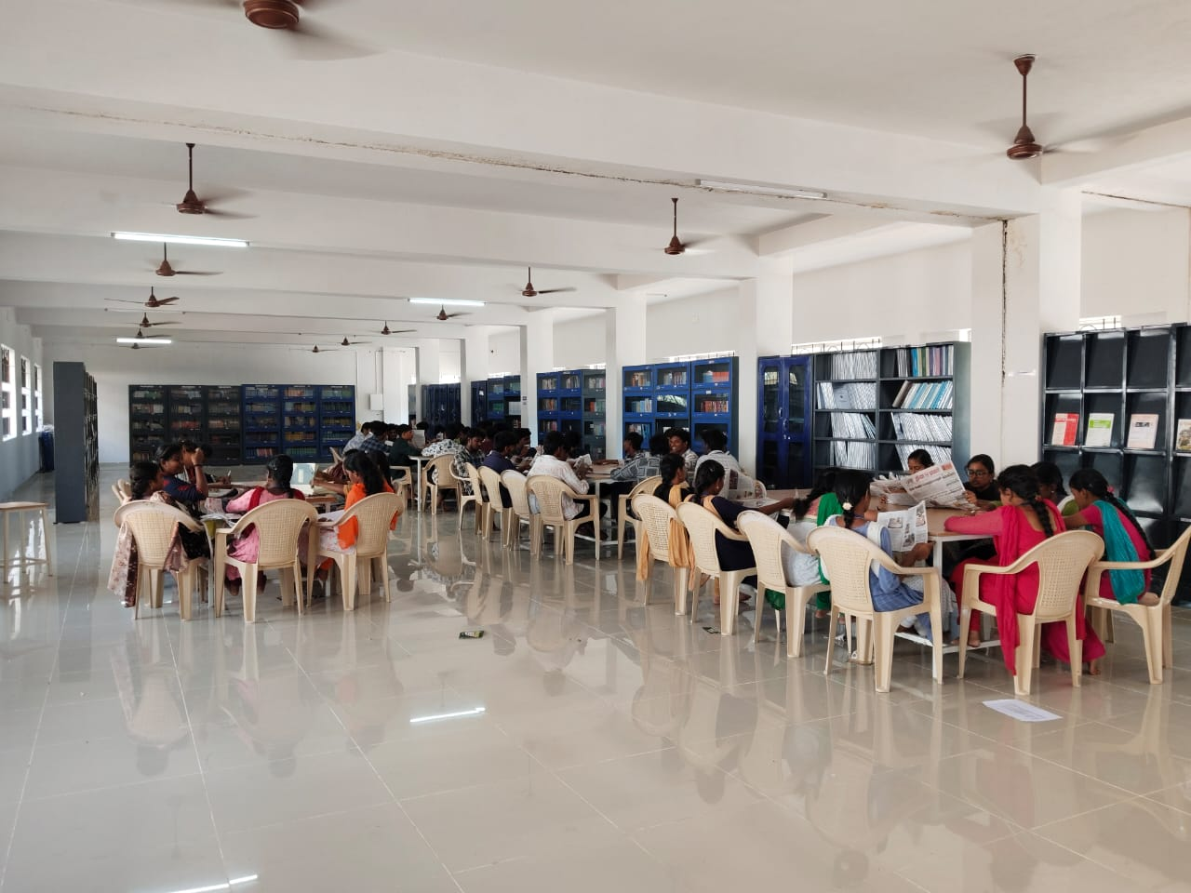

Library Orientation Program
The Department of library conducted a library orientation program from 18 June 2025 to 26 june2025. During the sessions, the librarian and library staff explained all the library services in detail. Live demonstrations were provided on DELNET, OPAC, and digital resources. The program helped students understand and effectively use both print and electronic resources for their academic studies.
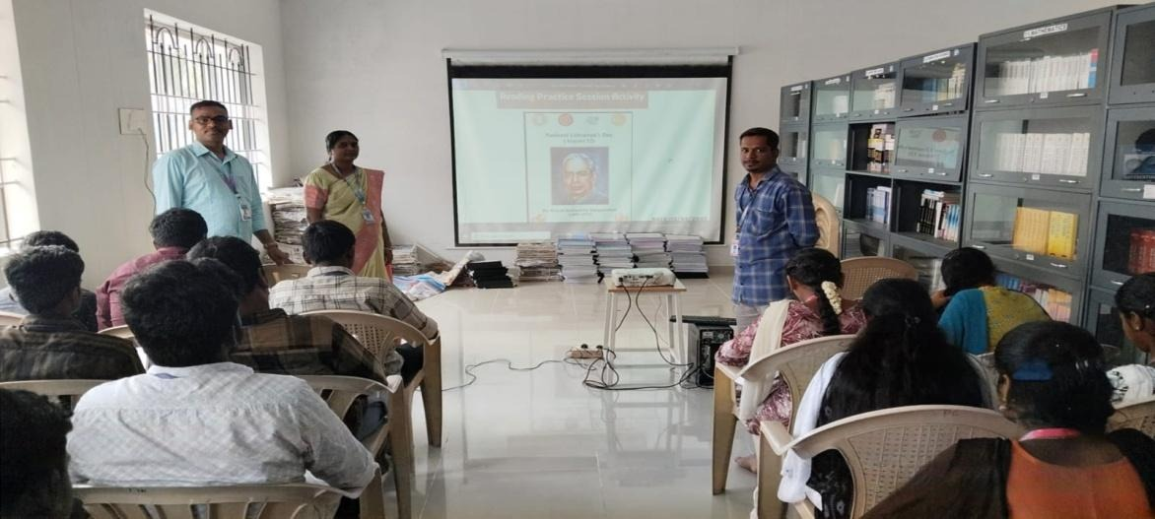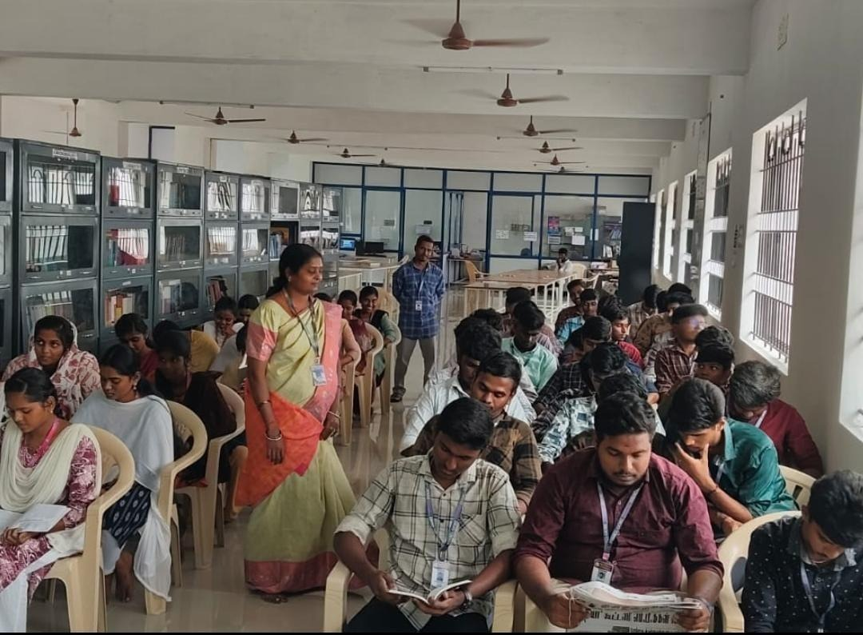

Reading Skill Training Program

The Department of library conducted a reading skill training programon 01 august 2025. Students actively participated in the program, which enhanced their knowledge about the importance of reading books and helped improve their reading skills.
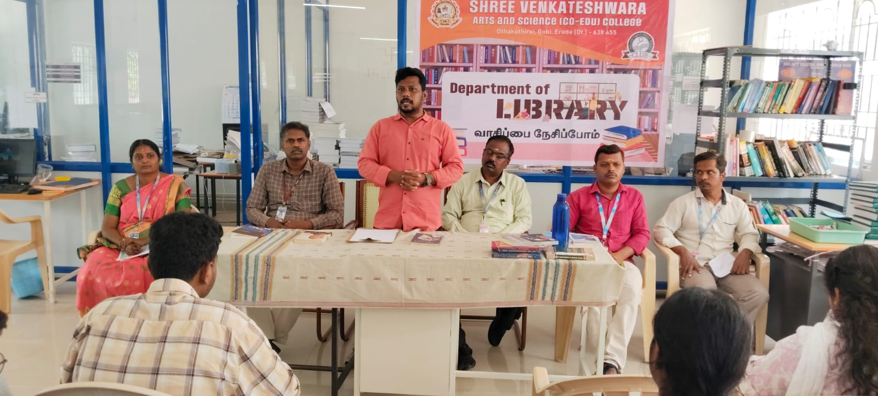

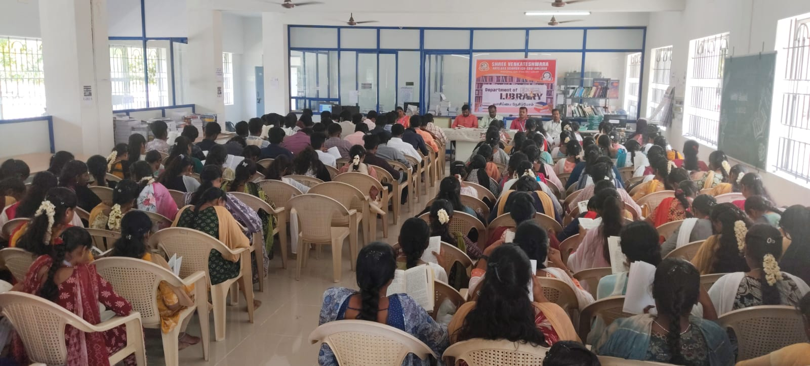

Book Fair

The Department of library organized a Book Fair trip on 11 august 2025.The main objective of this trip was to encourage reading habits among students and provide them with an opportunity to purchase various kinds of books. The event proved beneficial in helping students realize the value and importance of books.

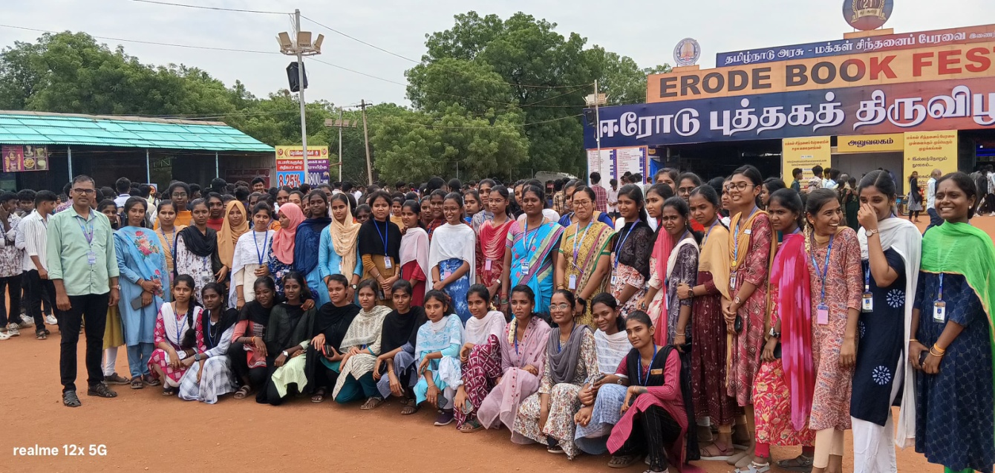

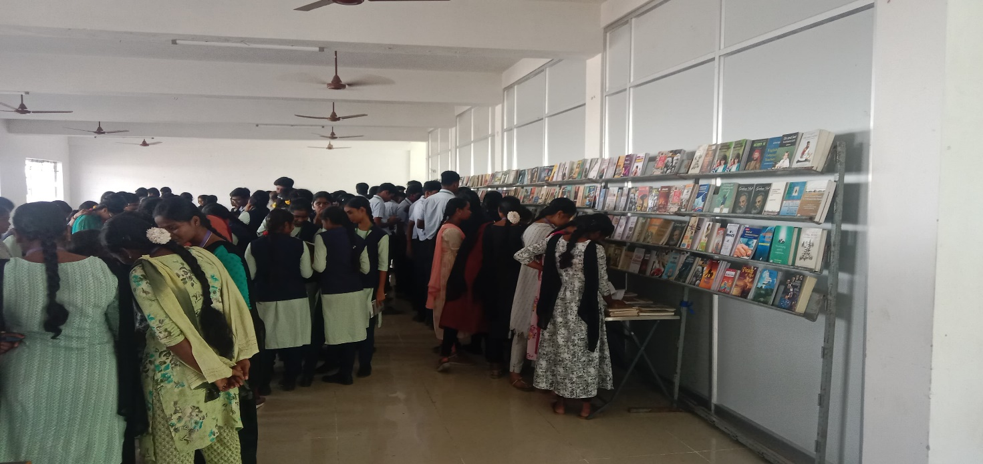

“அல்காரிதம் கடந்த தேடல்” and Book Fair

A seminar on “search beyond algorithms” and a three-day book fair (3–5 February 2026) were organized by the department of library, with chief guest Mr. S. Karthikeyan highlighting the importance of reading and libraries. More than 3,500 students participated, and the exhibition showcased notable authors, books on national leaders, and new century book house publications, encouraging reading beyond the syllabus. The three-day book fair concluded successfully, creating meaningful academic impact and promoting a vibrant reading culture among students and staff.
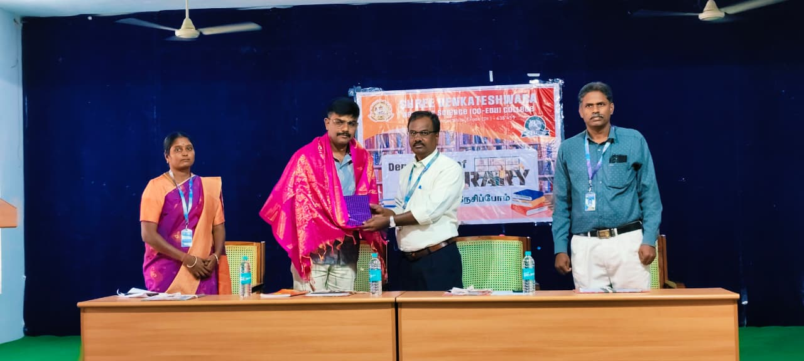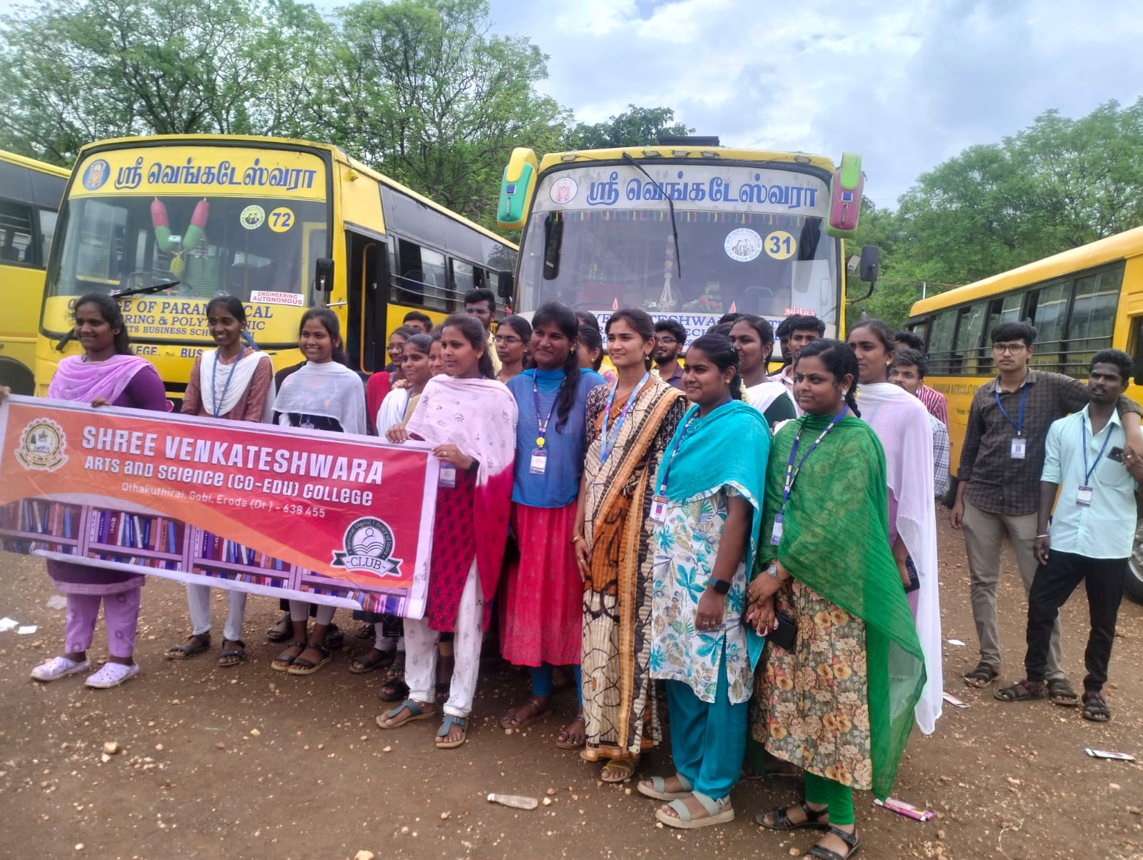

Librarian’s Day
The Department of library celebrated librarian’s dayon 12 august 2025.the program highlighted the importance of practicing daily reading habits among both staff and students. It proved beneficial in cultivating a strong reading culture and fostering a deeper interest in books.





Best User Award 2024-2025

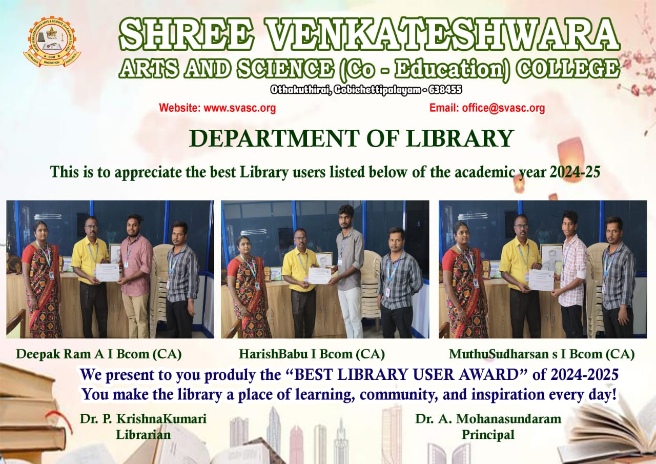

BEST LIBRARY USER AWARD
STUDENT 2025-2026
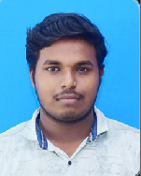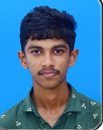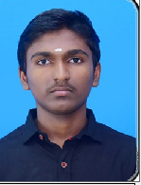
DEEPAK RAM A (II BCOM CA) GOKULA KANNAN (II BCOM CA) NAGAMOORTHI ( II BCOMCA)
The Department of library proudly presents the best library user award for the academic year 2025–2026 to Deepak ram a, Gokula Kannan, and Nagamoorthi (II B.COM CA). This recognition honors their outstanding dedication to reading and effective use of library resources.

BEST LIBRARY USER AWARD -STAFF 2025-20
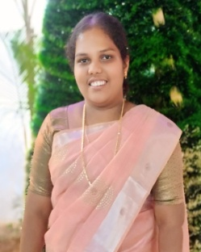
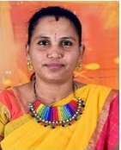
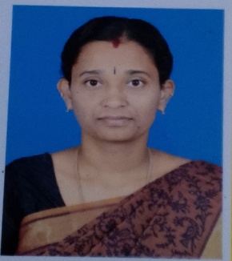

Dr.RAJESWARI.SMs. G.NANDHINIMrs.R.PUSHPA
ASSISTANT PROFESSOR ASSISTANT PROFESSOR ASSISTANT PROFESSOR
ENGLISH TAMIL TAMIL

BEST LIBRARY USER AWARD -NON-STAFF 2025-2026

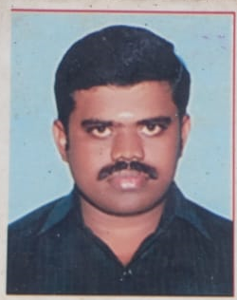
C.ANDAVAR MICROBIOLOGY LAB TECHNICAN

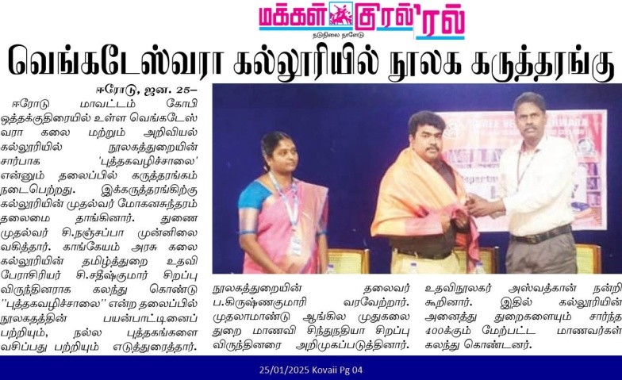
NEWSPAPER CLIPPING
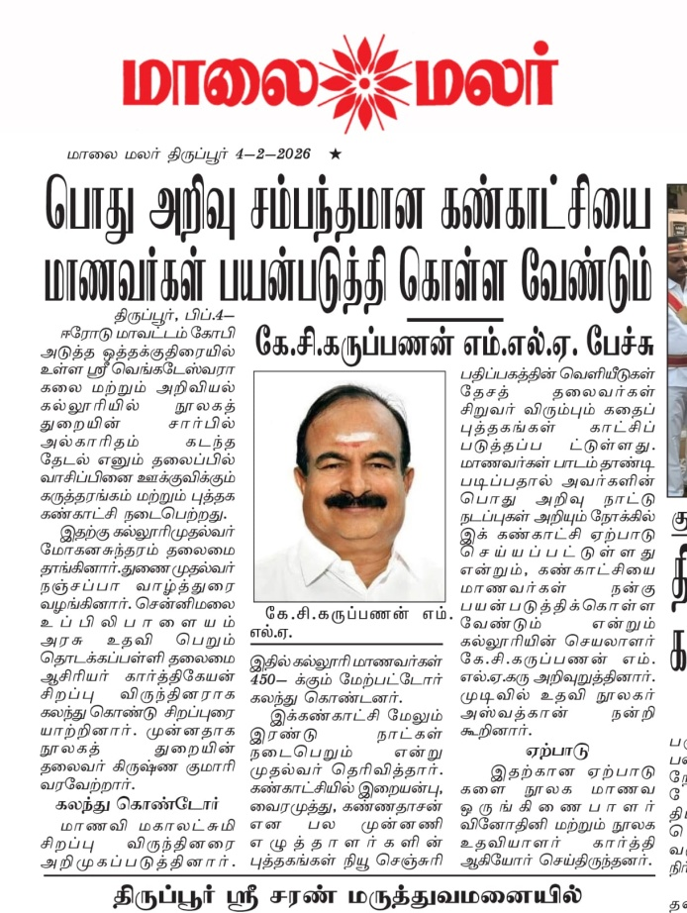
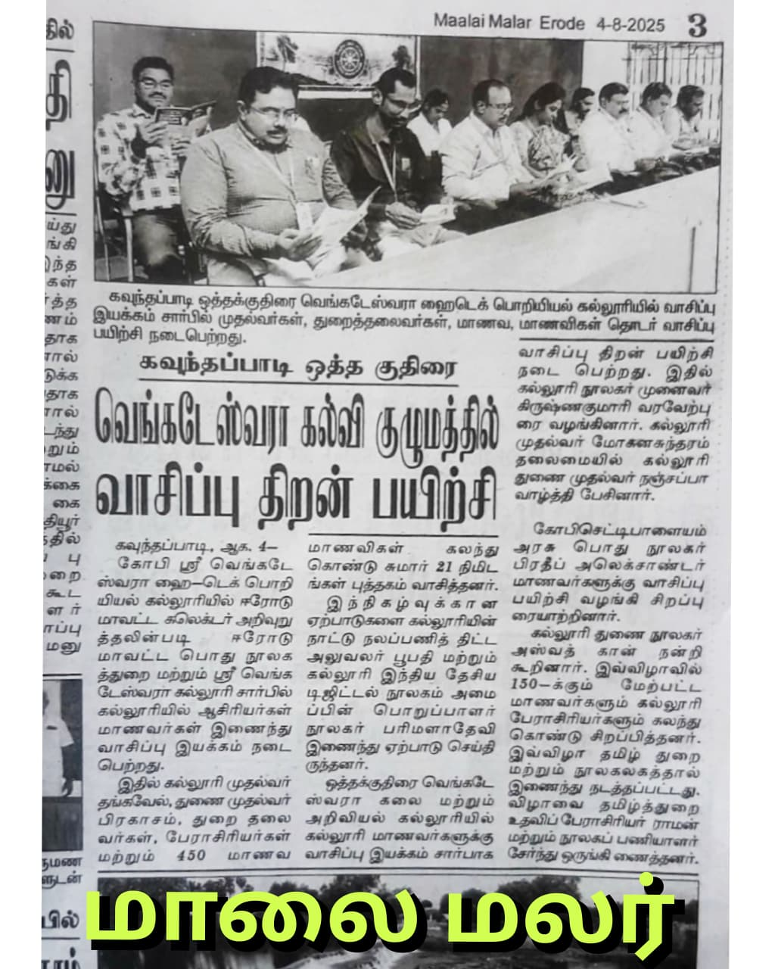
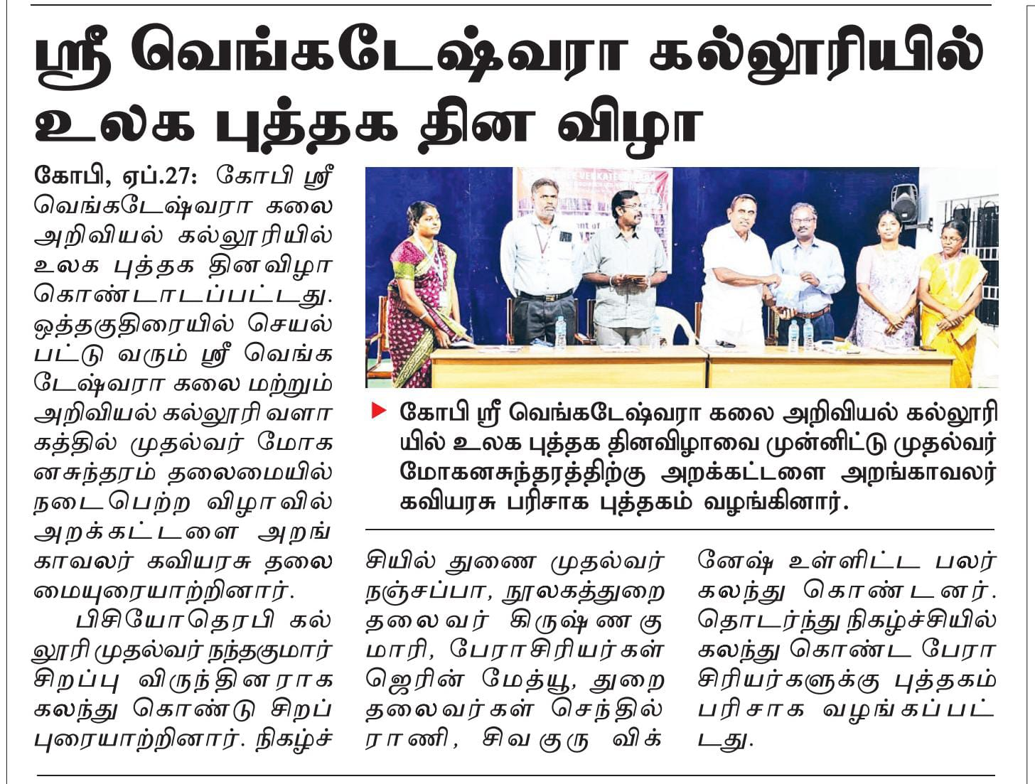

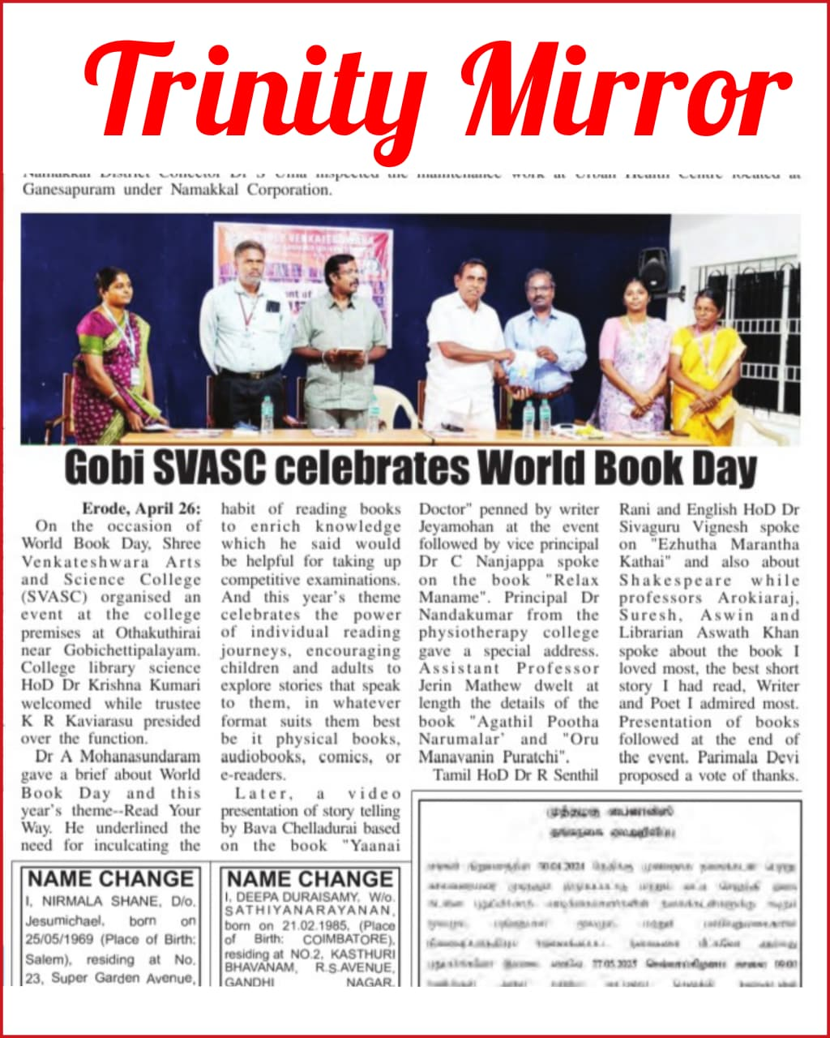
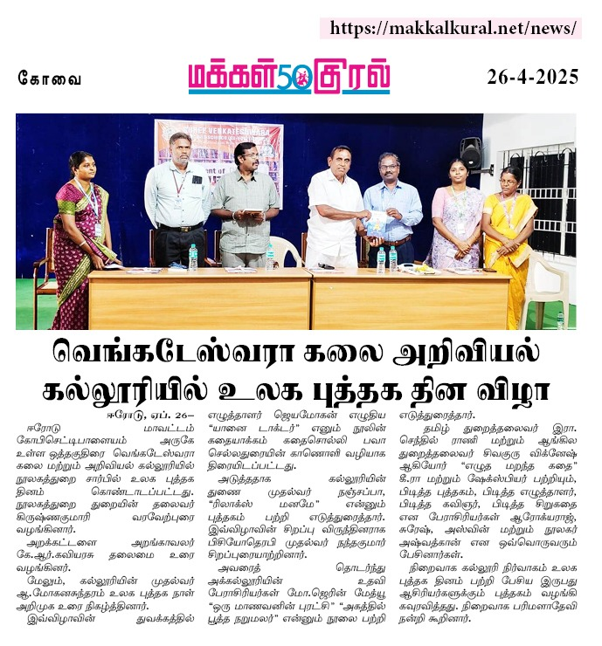

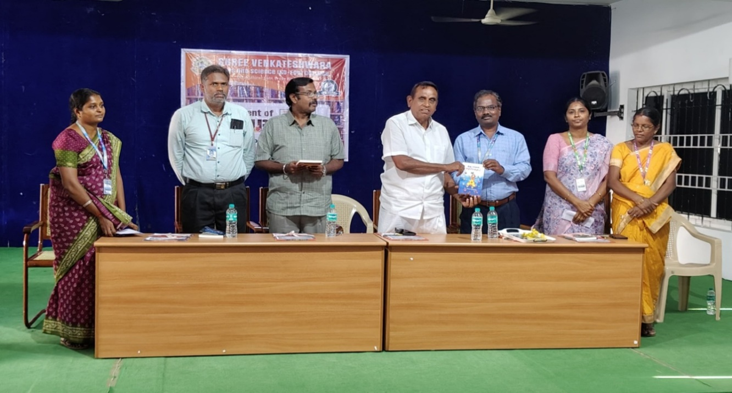
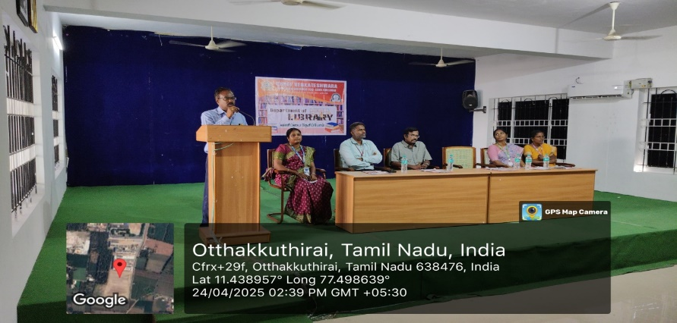
GALLERY
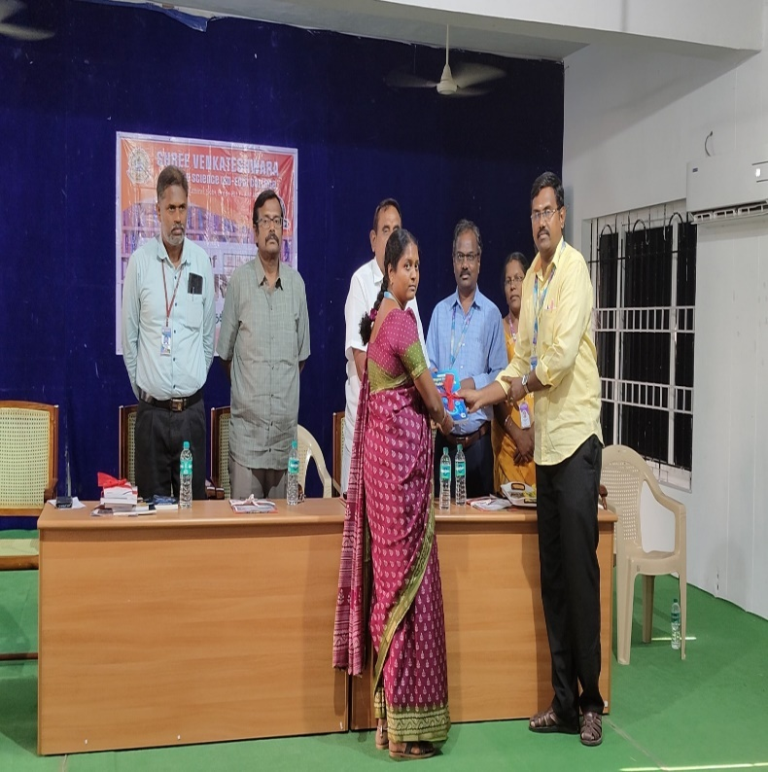
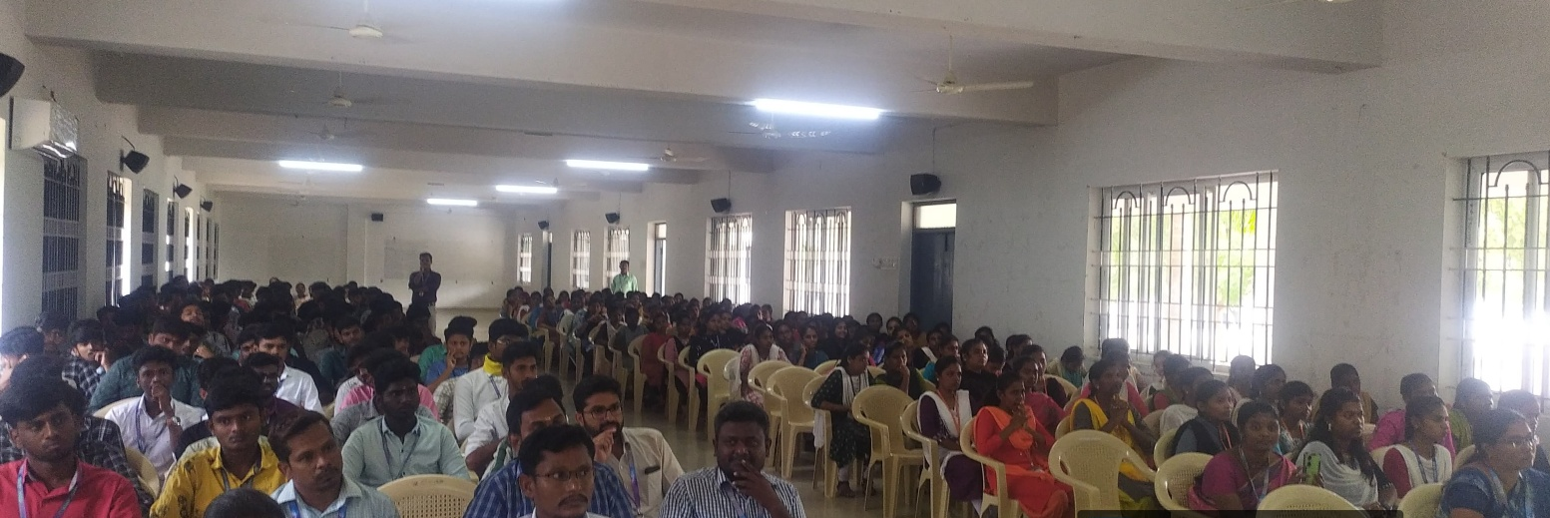
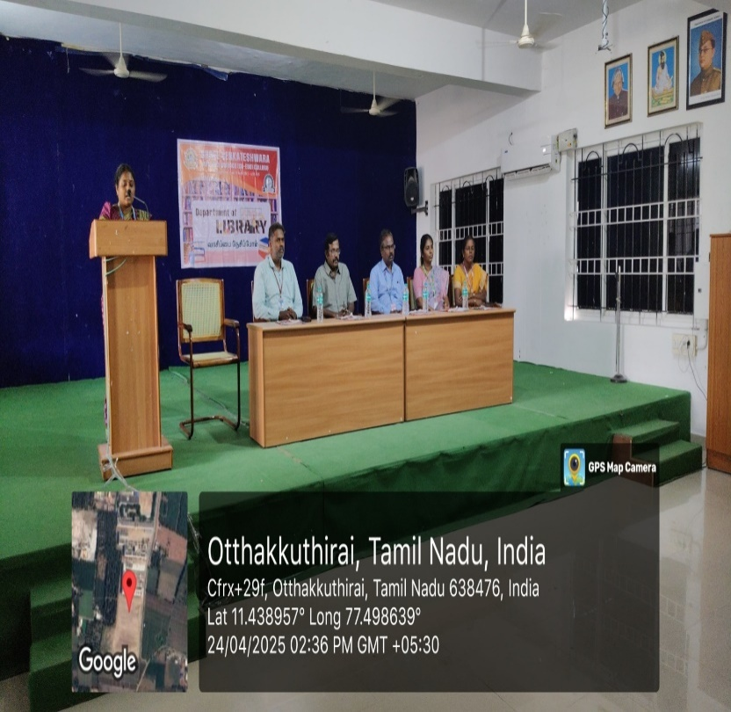
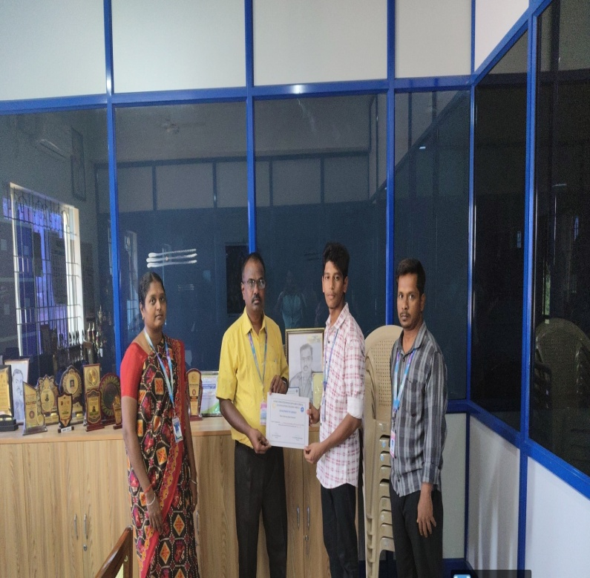
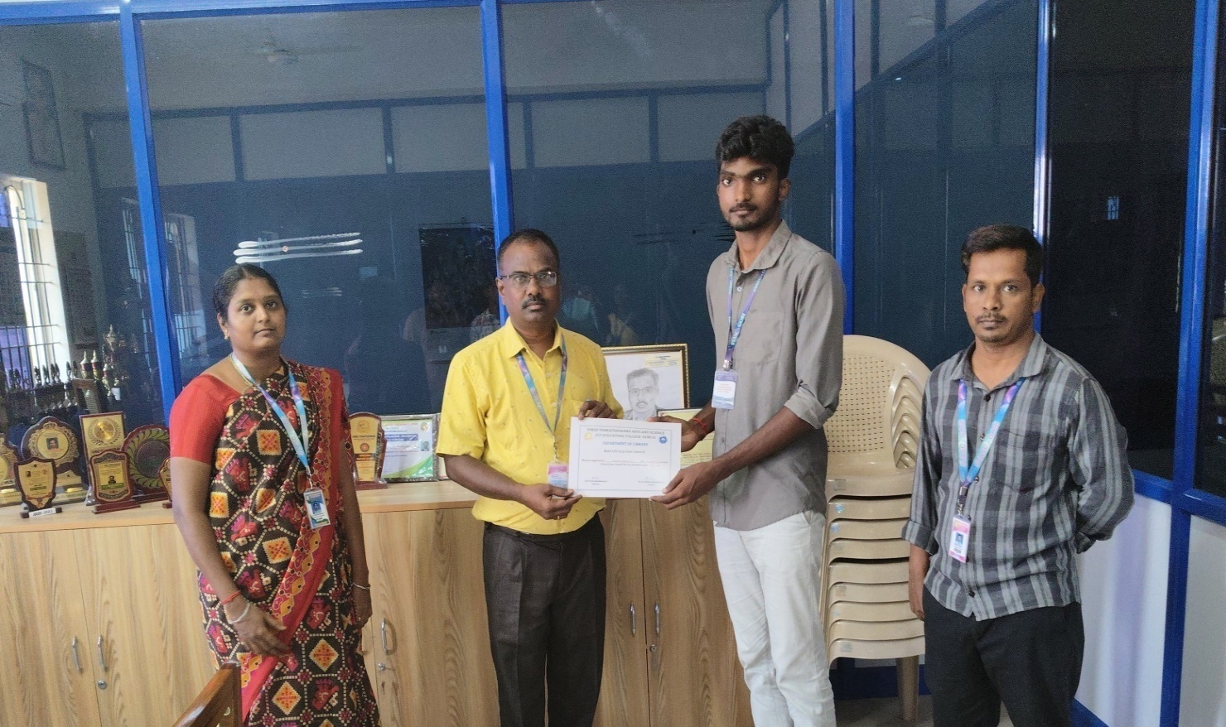

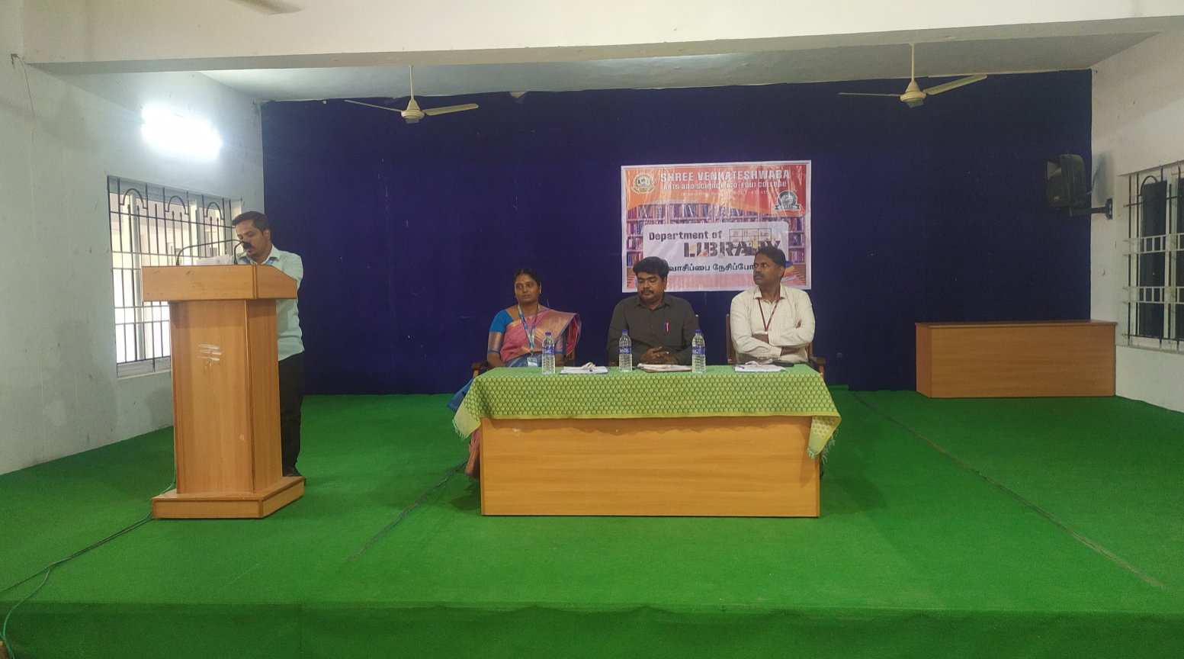
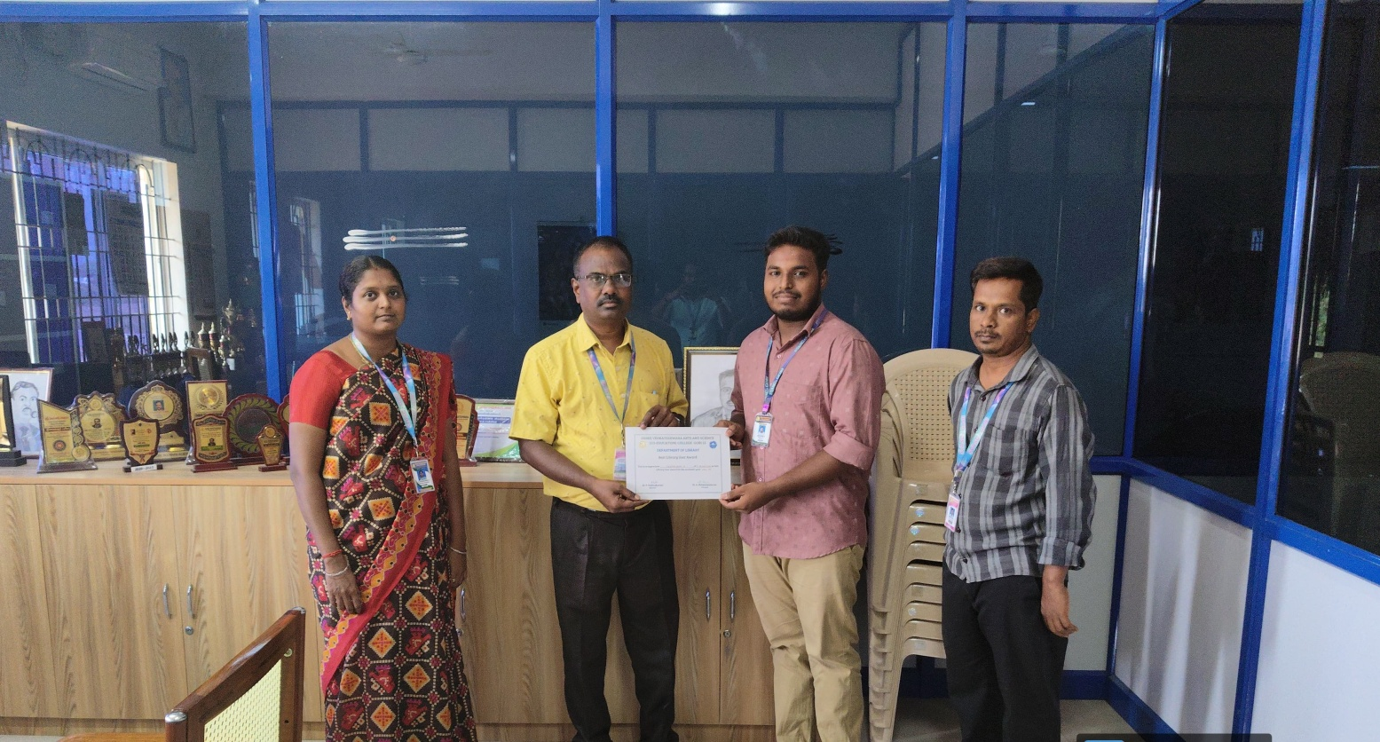

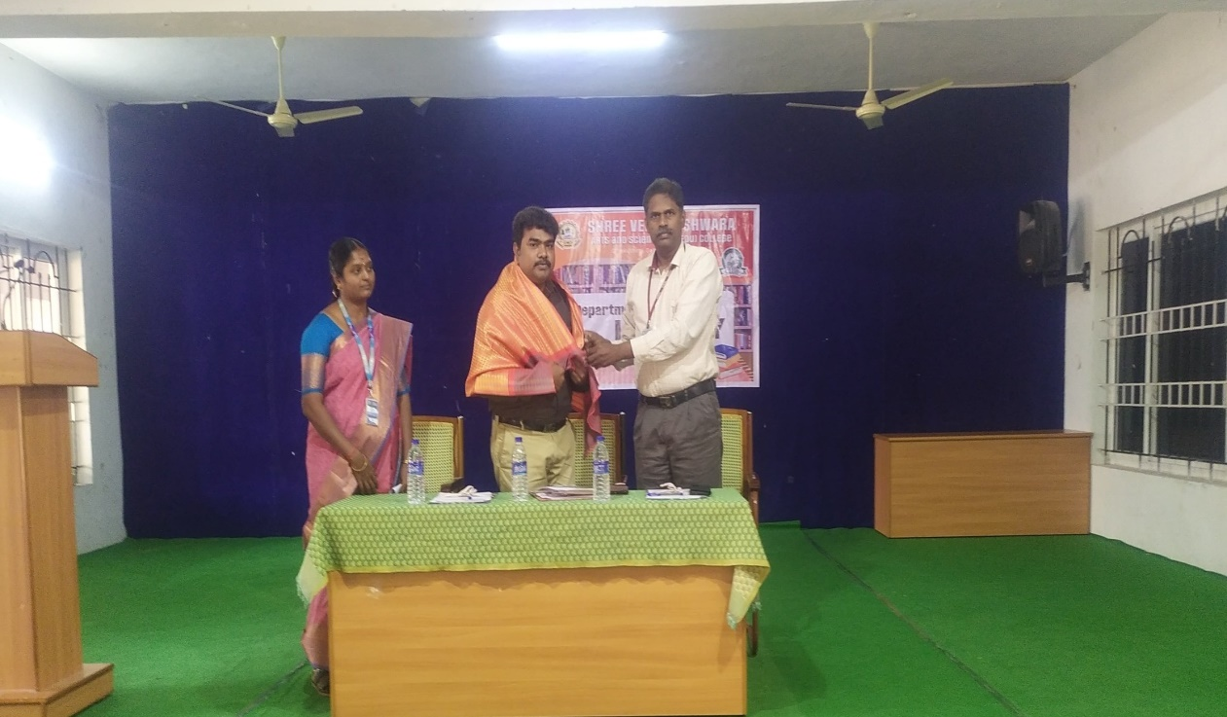
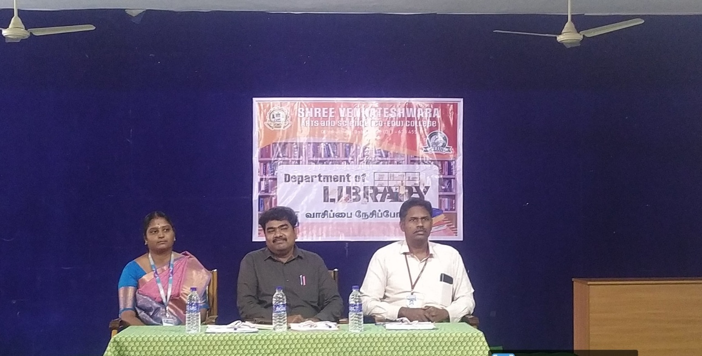
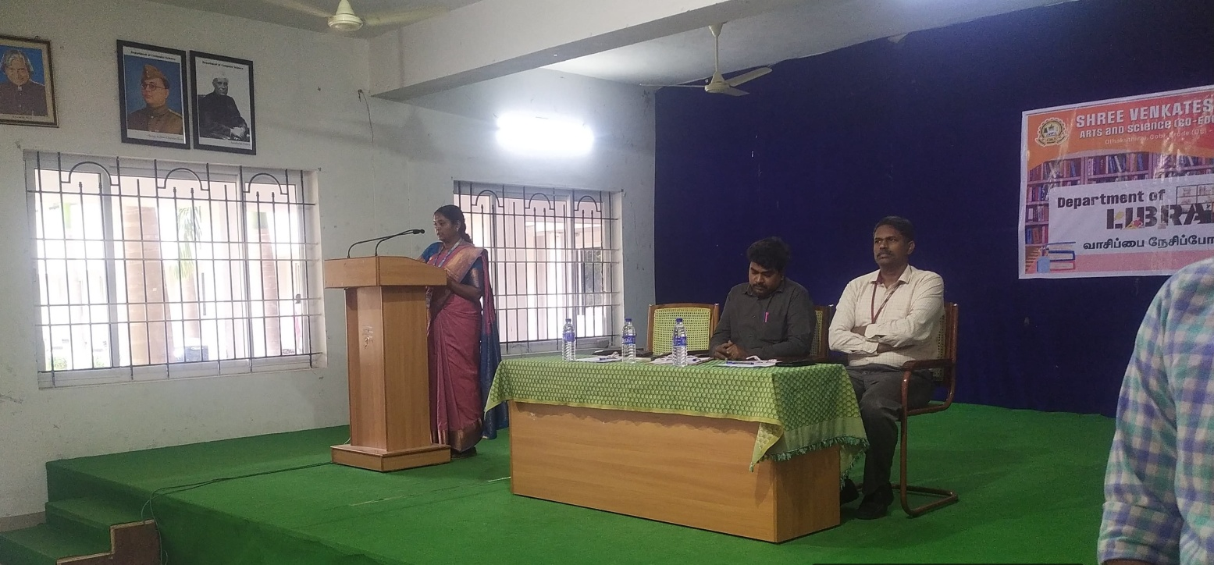

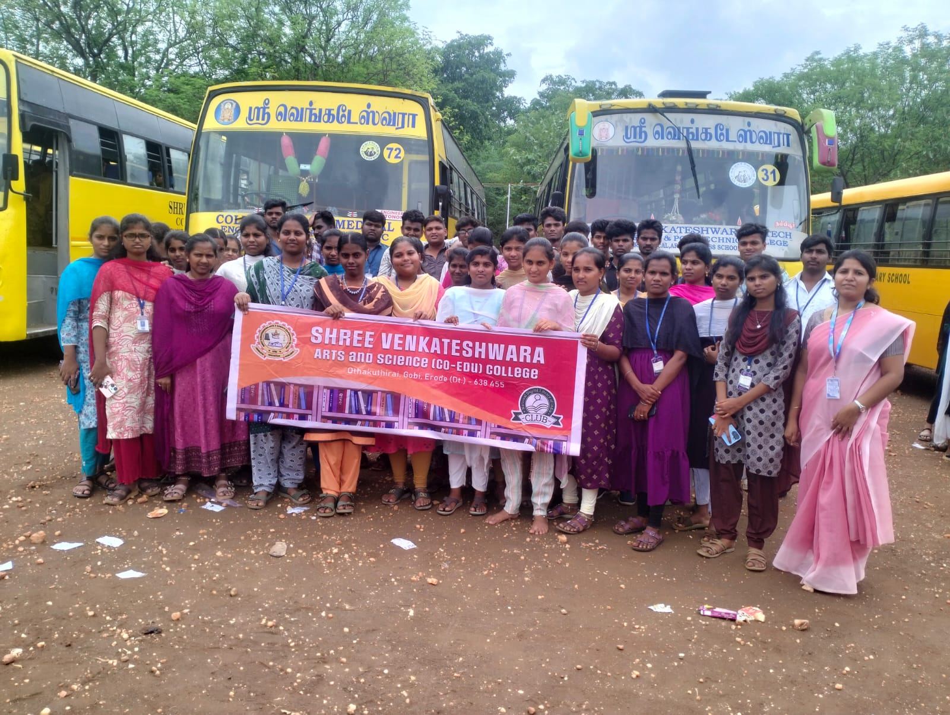

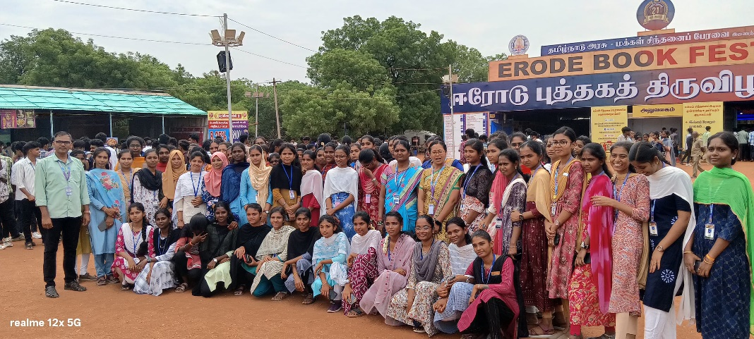




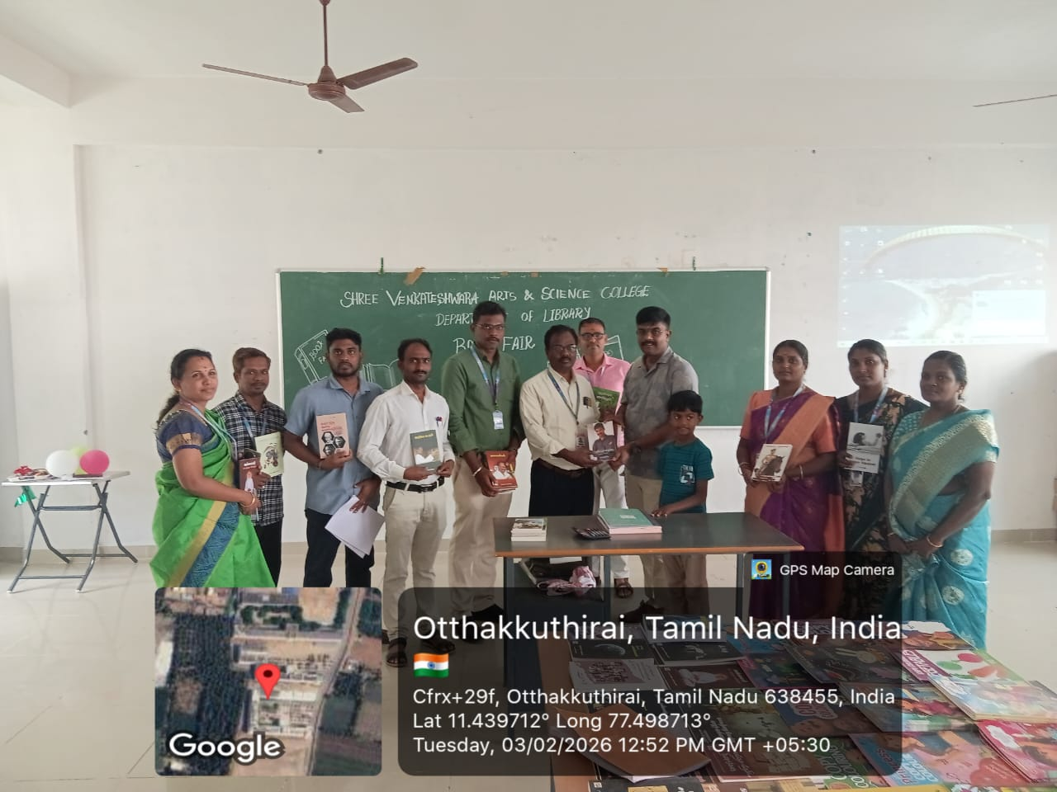
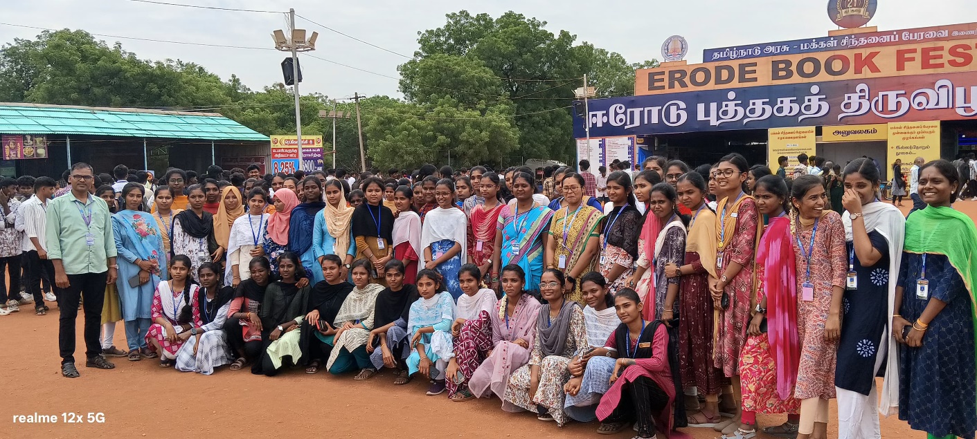
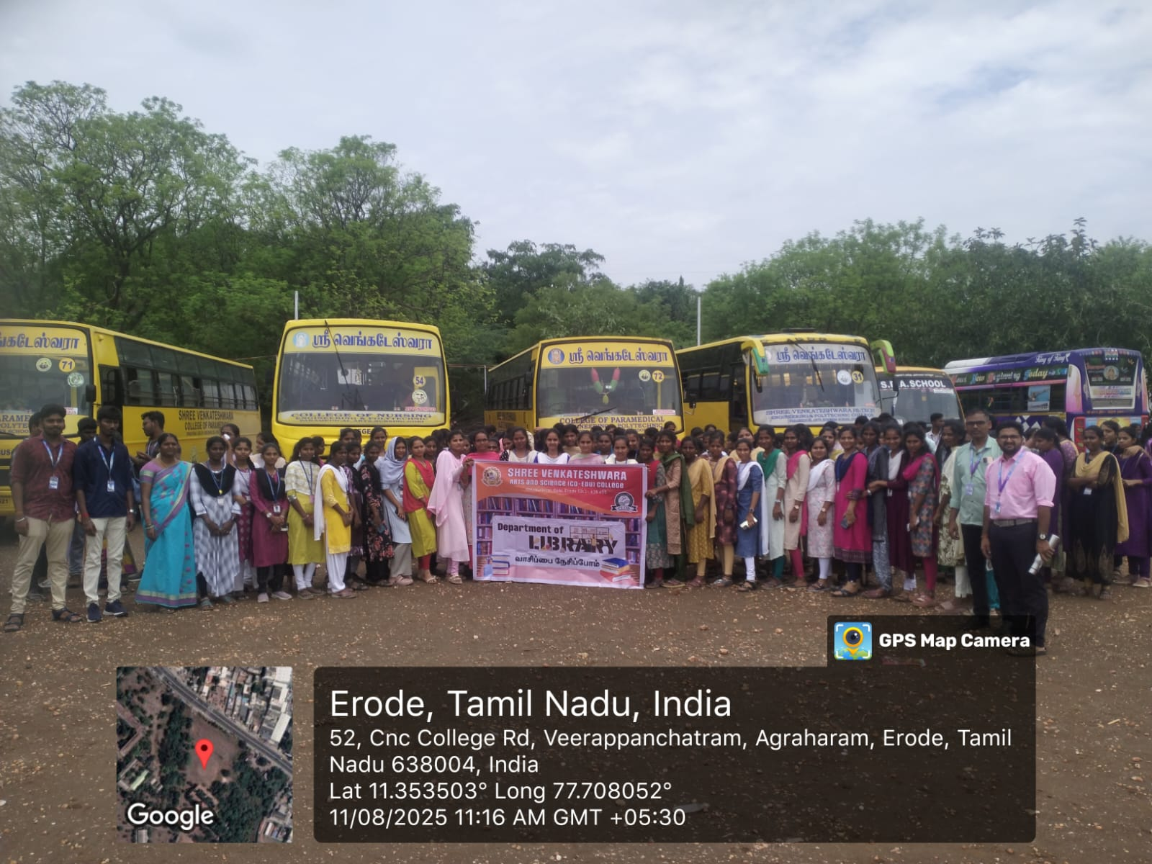

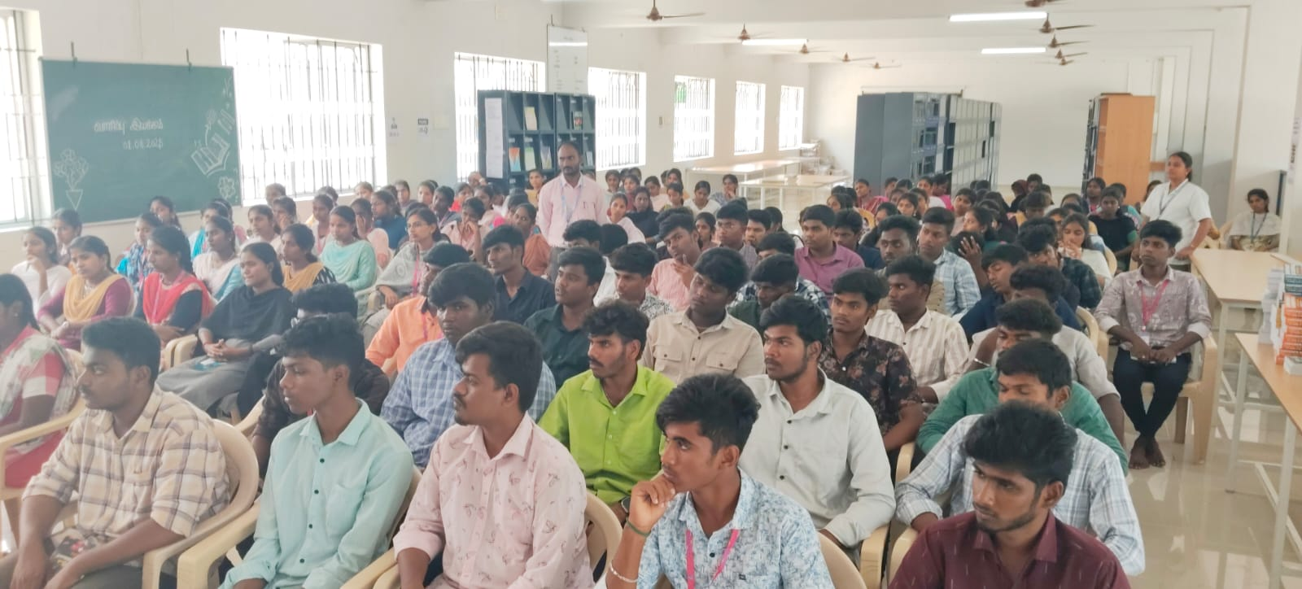

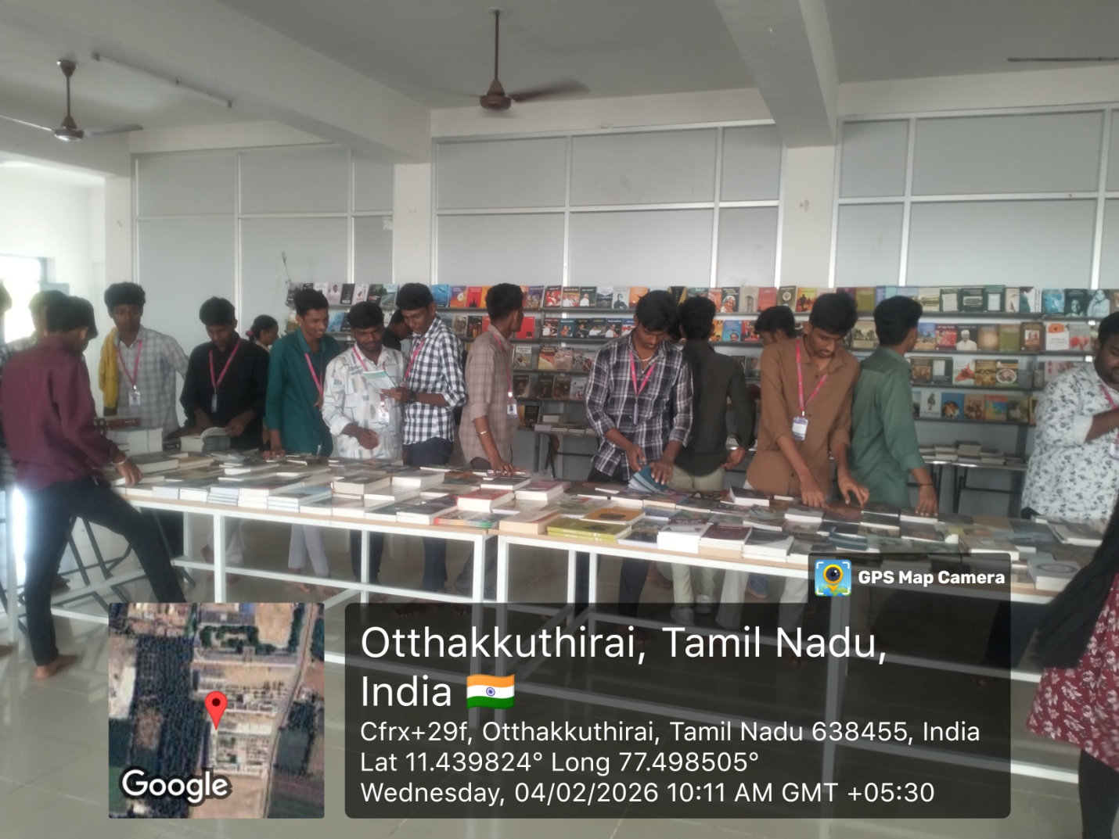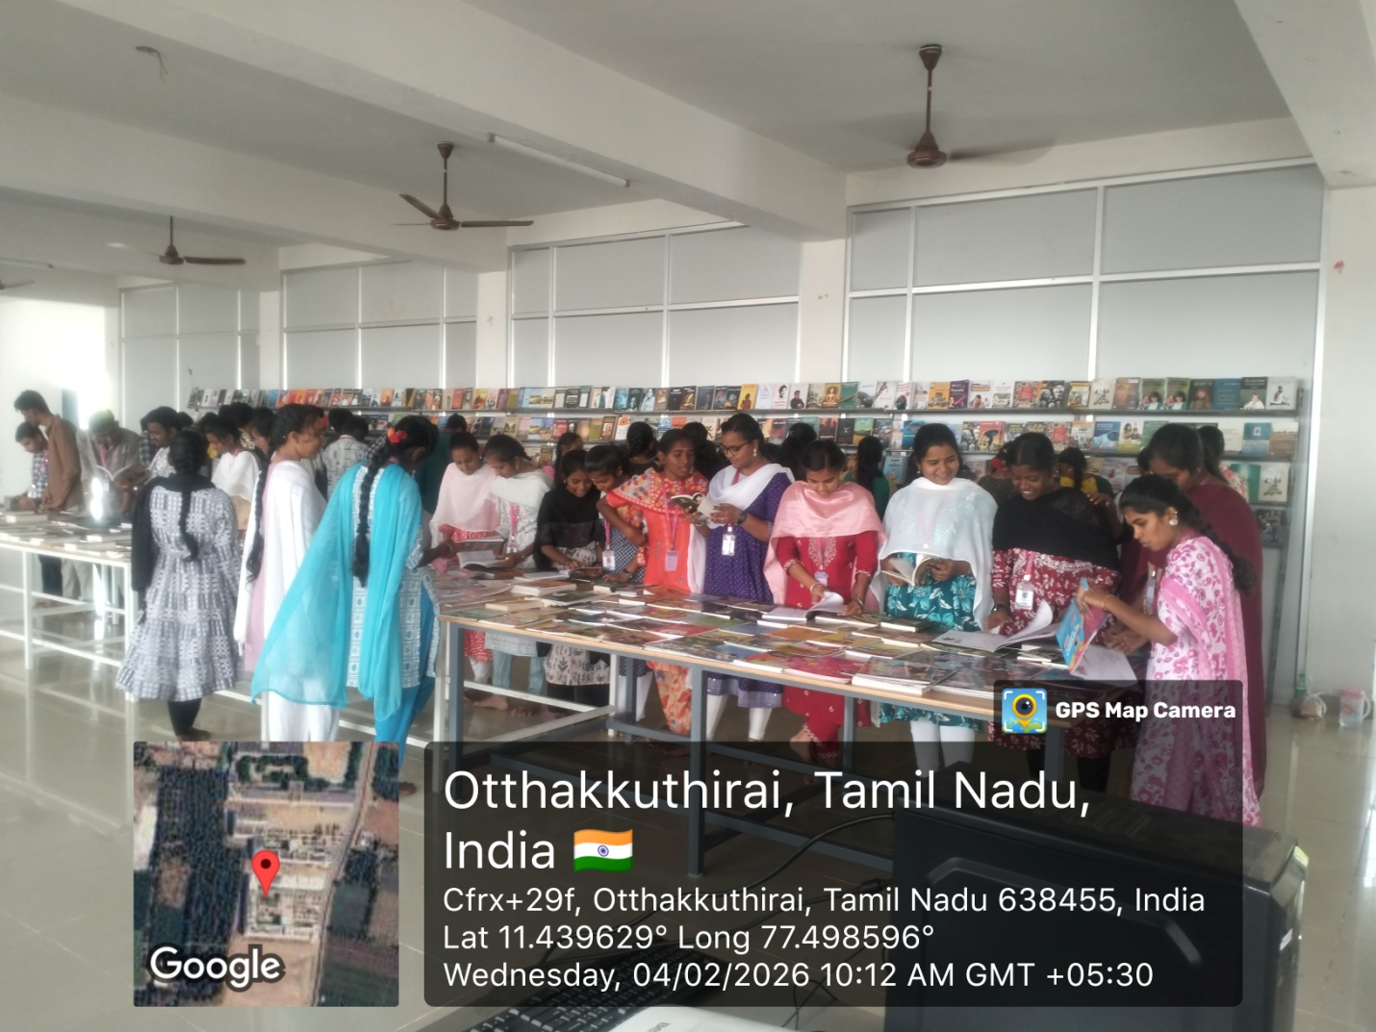
STAFF PROFILE

S.no | Staff photo | Name &designation | Year of joining | Email id
1. | 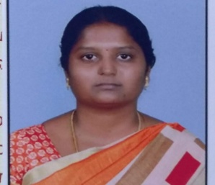 | Dr.P.Krishnakumari  MLIS.,MPhil.,PhD.,  Librarian&Head | 2024 | krishna.phdlib13@gmail.com
2. | 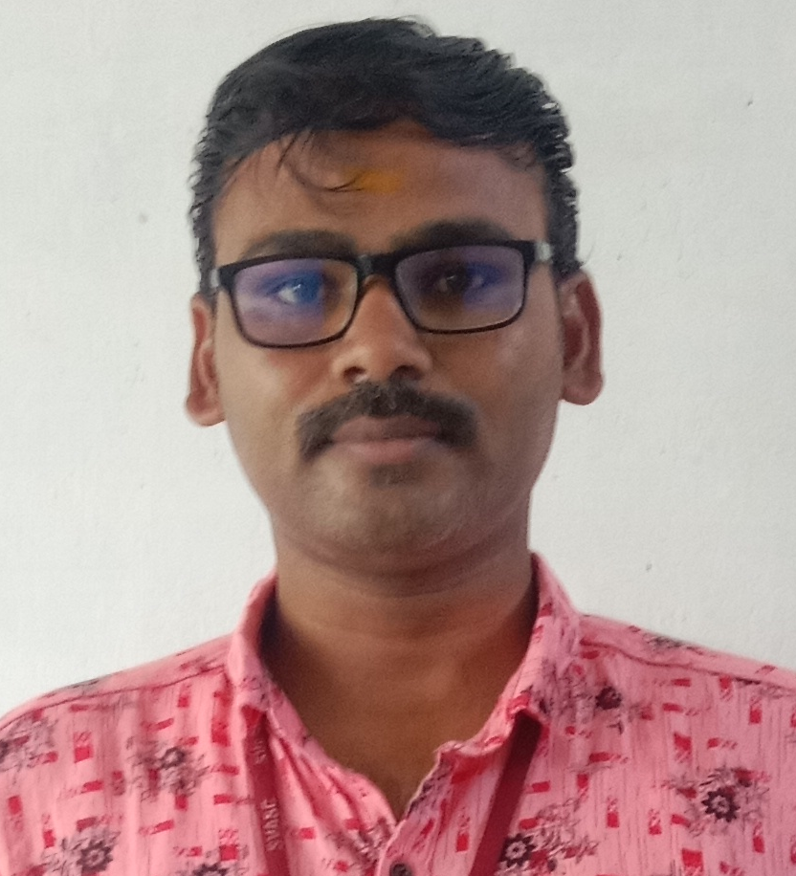 | Karthi P Bcom.,BLIS.,  Library Assistant | 2022 | karthideva2311@gmail.com

