Abdulwahab Al-Rumaihi

15112-W Prof. Saquib

Project Proposal

November 17, 2020

Project Description:

This project is based on a game called Pikmin by Nintendo. I felt inspired by the interactions in the game and thought to myself that I could make such a game in 2 dimensions, from a top down perspective. The main point of Pikmin is to explore the world and survive day by day by collecting resources. This project is kind of like a tech demo for what could be added on in the future by building on the code here.

In sum there will be a main character, pikmin which are small creatures that serve the player, enemies, fruit, and a spaceship.

In this project, I will implement the advanced interactions between the pikmin and the world around them, with the player as the commander. Pikmin are able to follow the main character, attack enemies, and bring back items to the spaceship. Enemies are also able to attack pikmin, so pikmin are able to die as well. If an enemy is brought to the ship it will spawn more pikmin to allow the player to do activities faster. If a fruit is brought to the ship it will be stored as treasure.

Competitive Analysis:

My only inspiration for this project was from the actual Pikmin series of games. My project is very close to the original game, but the original game is far more complex. For comparison in my project there is only one kind of pikmin, and in the main game there are 5 with different attributes that would allow them to be useful in different situations. Yet, I believe that I have captured the main charm of the game in the fact that in my project you can send pikmin to do a task by clicking on objects such as enemies or items, and they will wait for you to come collect them and take them to do their next task

Structural Plan:

My code includes 3 sections:

Section 1 which is at the beginning includes the import statements and some initialization for the game.

Section 2 which is the middle section includes the classes that will be used for the project. These classes include the Enemy, Character, Pikmin, Fruit, and Spaceship Class.

Section 3 which is the final section includes the game loop. This loop is where the code will account for user input and handling screen events such as updating the screen.

Algorithmic Plan:

The trickiest part of my project is getting the pikmin to do what I want them to do in the correct sequence. The direct solution to this problem is making the pikmin operate similar to a finite state machine. So I am planning to create a variable in the pikmin class that changes depending on what the pikmin is commanded to do. For example, by default the pikmins do nothing when they spawn out of the spaceship, but when the player comes to collect them, they follow the player around till the player clicks on an object which will instruct them to do the task related to that object; that is my solution.

Timeline Plan:

By TP1 I plan to have the motion of the player done, some of the pikmin class done, a basis for the spaceship and enemy classes, and a game where the player can move around and the pikmin are spawned by clicking on the screen and they will follow the player.

By TP2, I plan to have the Fruit and Spaceship classes to be fully complete, and their interactions with the pikmin complete as well. I hope I can fully finish the enemy class and it’s interactions with the pikmin in the game as well by that time, but I cannot see myself completing this before TP3.

By TP3, I plan to have the whole project complete. The pikmin can interact successfully with the enemies, fruit, spaceship, and main character making this project done. At this stage I may add extra features before the deadline if possible, but I think I can submit what I have completed on it’s own and get a good score.

Version Control Plan:

For version control I plan to use github to upload my files to my repository on github.

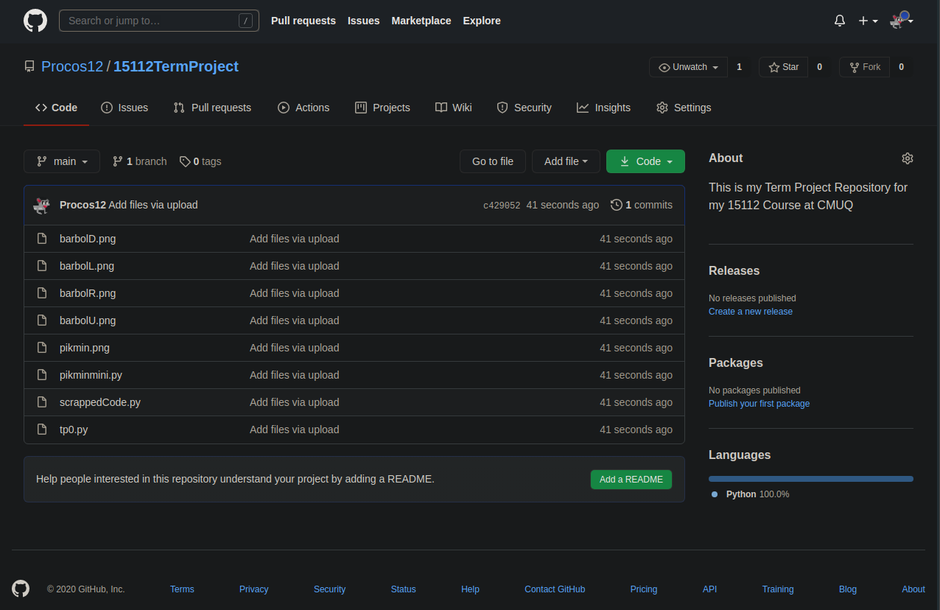

Module List:

For this project, the only external module I plan on using is pygame