PROCUCEV ENTERPRISE
QUA AI 2.0 SOURCING & PROCUREMENT PLATFORM
Complete System Architecture, Multi-Persona Workflows, Autonomous Chasing & Technical Operations Manual
Document Property | Specification / Value
System Release | Procucev Enterprise Production Release 2.0 (August 2026)
Platform Core | QUA AI Autonomous Sourcing & Multi-Channel Logistics Engine
Primary Sourcing Modes | Mode 1 (Private Roster), Mode 2 (Hybrid Network), Mode 3 (360° Qualification)
Security & Integrity | Dual OTP MFA, Azure SSO, SHA-256 Cryptographic Audit Stamping
Target Audience | Enterprise Buyers, Category Managers, Vendor Partners, Platform Administrators & Auditors
Document Classification | Enterprise Confidential — Technical & Operational Reference Manual

1. Executive Summary & Platform Overview
Procucev Enterprise (powered by QUA AI 2.0) is a next-generation autonomous procurement, sourcing intelligence, and multi-channel supplier coordination platform. Designed specifically for heavy engineering, industrial infrastructure, EPC, and manufacturing procurement, Procucev solves the critical friction points of modern enterprise buying: manual vendor chasing, delayed quotation turnarounds, inconsistent supplier qualification, and fragmented audit trails.
📌 Key Business Value Proposition
By orchestrating autonomous multi-channel AI agents (Voice Calls with live transcripts, WhatsApp Business bots, SMS Direct alerts, and 24-hour escalation emails), Procucev reduces quote acquisition cycles by over 65%, eliminates vendor non-response, and guarantees 100% cryptographic audit compliance across every transaction.

1.1 The Three Core Sourcing Operating Modes
Procucev provides three distinct, selectable sourcing modes tailored to organizational risk tolerance and market discovery needs:
Sourcing Mode | Target Use Case | Vendor Selection Mechanism | Verification Level
Mode 1: Private Approved Roster | Strict compliance, single-source procurement, or proprietary internal contracts. | Exclusive dispatch to pre-approved internal vendor master list. Zero marketplace exposure. | Internal roster compliance with pre-negotiated commercial payment terms.
Mode 2: Hybrid Sourced Pool | Standard competitive procurement balancing familiar suppliers with price discovery. | Dispatches to client roster suppliers + AI recommended suppliers matching BOQ parameters. | AI quality score benchmarking, lead time validation, and real-time bid comparison.
Mode 3: 360° Vendor Qualification | High-stakes capital equipment, specialized manufacturing, or critical vendor onboarding. | Full-scale evaluation across 6 comprehensive pillars (M1-M6) and 24 criteria with OCR verification. | Mandatory 24/24 document audit (NABL lab certs, ISO, financial statements, BCP plans).

2. Platform Architecture & Technology Stack
Procucev Enterprise is engineered on a modern, high-throughput, microservices-ready full-stack architecture designed for enterprise scalability, sub-second reactivity, and military-grade data protection.
Architecture Layer | Technology Implementation | Key Capabilities & Guarantees
Frontend Application | Next.js 14 App Router, React 18, Tailwind CSS, Lucide Icons | Sub-second page transitions, dynamic light/dark theming, responsive glassmorphic UI.
State & Data Layer | React Context Engine (`lib/store.tsx`), TypeScript Types (`lib/types.ts`) | Centralized immutable state management, real-time telemetry updates, audit log persistence.
AI Sourcing Core | Hybrid LLM Engine (Local Ollama Mistral / Llama 3 & Azure OpenAI GPT-4o) | Autonomous BOQ entity extraction, parametric bid normalization, real-time phone dialog synthesis.
Multi-Channel Engine | Twilio Voice AI, WhatsApp Business API, SMS DLT Gateway, NodeMailer SMTP | Autonomous follow-ups across 4 communication channels with 24-hour automated escalation rules.
Cryptographic Security | SHA-256 Digital Hashing Engine | Every generated Purchase Order and audit entry receives an immutable cryptographic hash stamp.

3. Authentication, Registration & RBAC Governance
Access to Procucev Enterprise is strictly governed by enterprise-grade identity management featuring Dual-Factor OTP verification and Single Sign-On (SSO) integration.
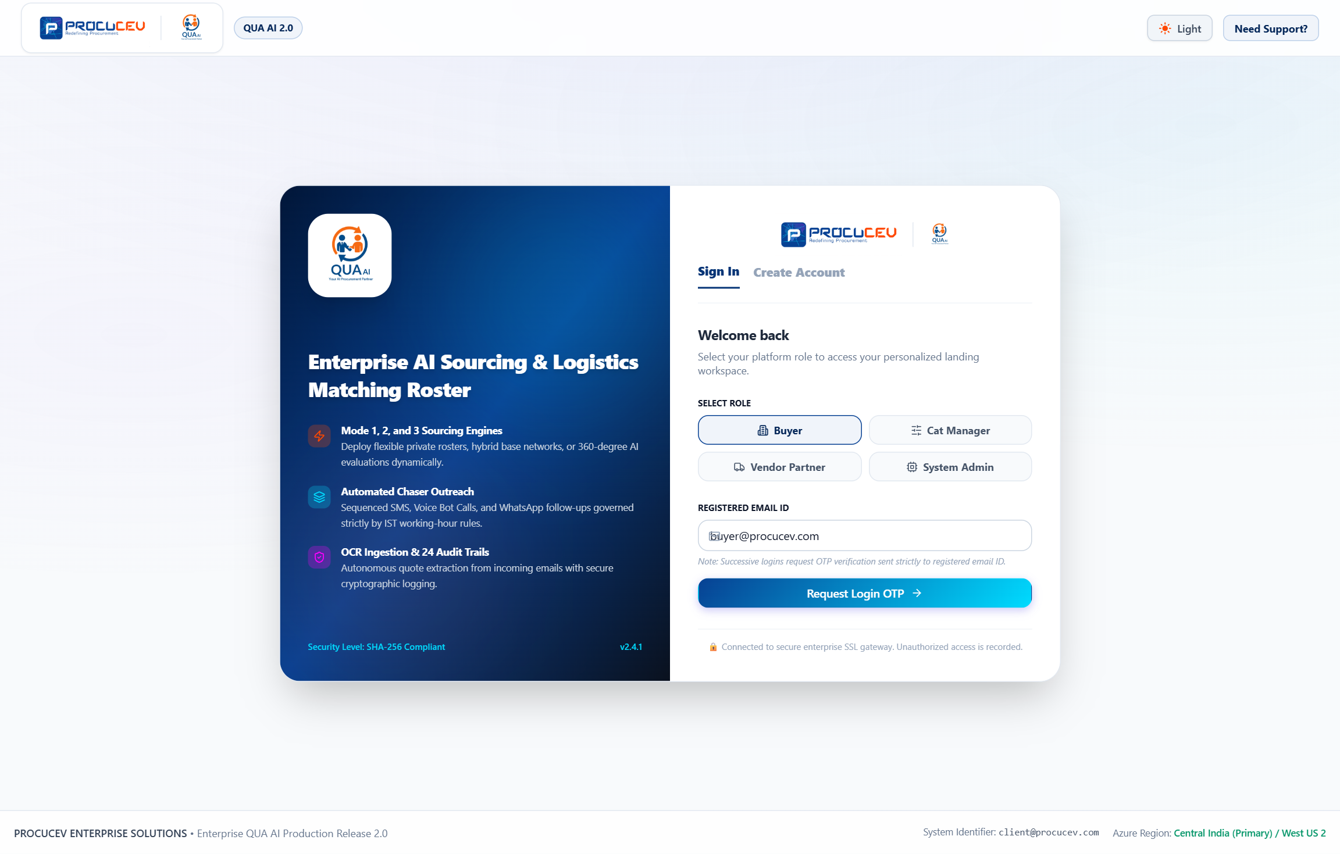
Figure: Sign In Authentication Portal with Dual OTP and Role Quick-Selectors
Screen Highlights: Features role-specific access gates for Buyer (L&T), Category Manager, Vendor (Apex Supplies), and Platform Auditor with simulated OTP verification and Azure AD SSO login.

3.1 Buyer & Vendor Self-Serve Registration
New enterprise buyers and supplier organizations register through a streamlined dual-verification onboarding gate requiring real-time email verification codes and mobile SMS OTP.
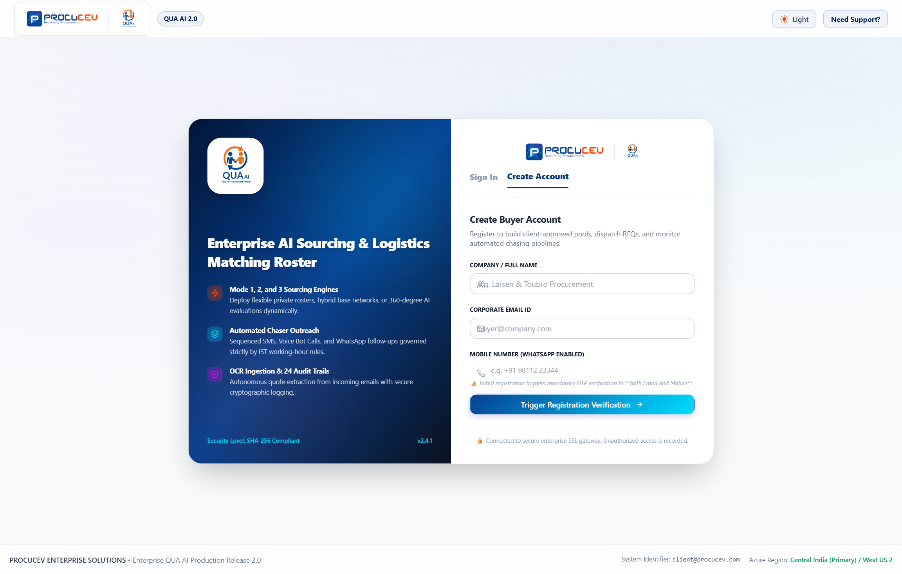
Figure: Enterprise Registration Portal with Dual Verification Engine
Screen Highlights: Validates organization domain, GSTIN/Tax ID, procurement category scope, and enforces dual-channel mobile and email verification before account provisioning.

3.2 Role-Based Access Control (RBAC) Permissions Matrix
Role Persona | Primary Responsibilities | Accessible Modules & Screens | Security Clearance
Enterprise Buyer | RFQ creation, AI BOQ parsing, quote comparison matrix, PO authorization. | Screens 1.1 through 1.6 + Matrix, Deep Dive & PO Dispatch Modals. | Level 3 — Enterprise Procurement Scope.
Category Manager | Category pipeline governance, multi-channel overrides, vendor survey audit. | Screens 2.1 through 2.6 + Global Chaser Controls & Audit Dashboards. | Level 4 — Strategic Sourcing & Governance.
Vendor Partner | Opportunity bidding, quotation submission, Mode 3 qualification survey. | Screens 3.1 through 3.6 + Item Catalogue & Subscription Plans. | Level 2 — Supplier Partner Extranet.
Admin & Auditor | AI model infrastructure control, OCR threshold tuning, immutable audit logs. | Screens 4.1 through 4.2 + Global Config & Cryptographic Verification. | Level 5 — Super Administrator & Compliance.

4. Enterprise Buyer Ecosystem (Module 1)
The Buyer Ecosystem empowers procurement professionals to manage the entire sourcing lifecycle: from automated document parsing to multi-channel chasing, quote matrix evaluation, and 1-click PO issuance.

4.1 Screen 1.1: Buyer Command Center
The central dashboard provides real-time visibility into active procurement pipelines, pending vendor quotes, AI sourcing quotas, and live autonomous follow-up telemetry streams.
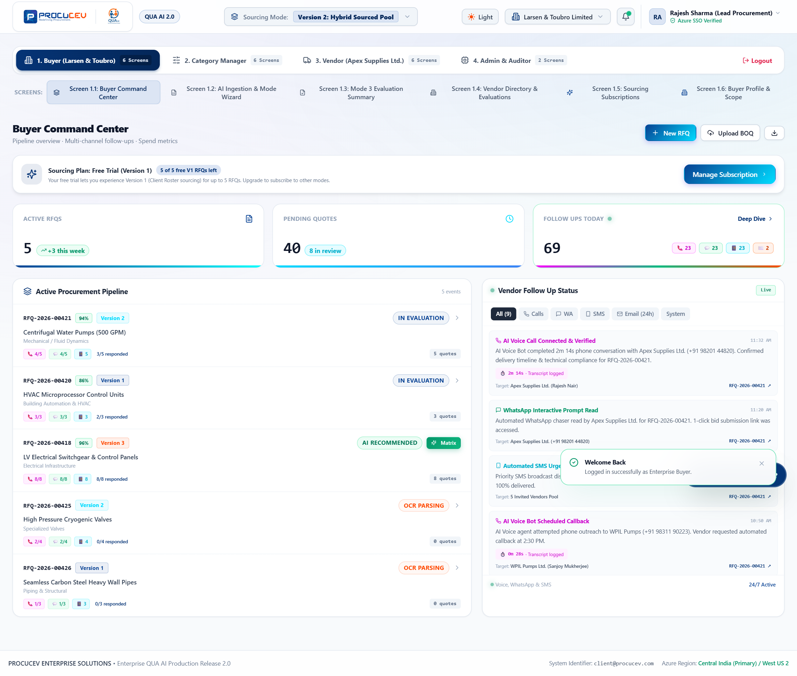
Figure: Screen 1.1: Buyer Command Center Dashboard
Screen Highlights: Highlights include active RFQs categorized by sourcing mode, real-time counter metrics (Calls, WhatsApp, SMS, 24h Emails), and live AI follow-up event stream.

4.2 Multi-Channel Autonomous Auto-Chaser Engine
When suppliers delay their quotations, Procucev dispatches autonomous multi-channel AI agents across phone calls, WhatsApp messages, and SMS alerts.
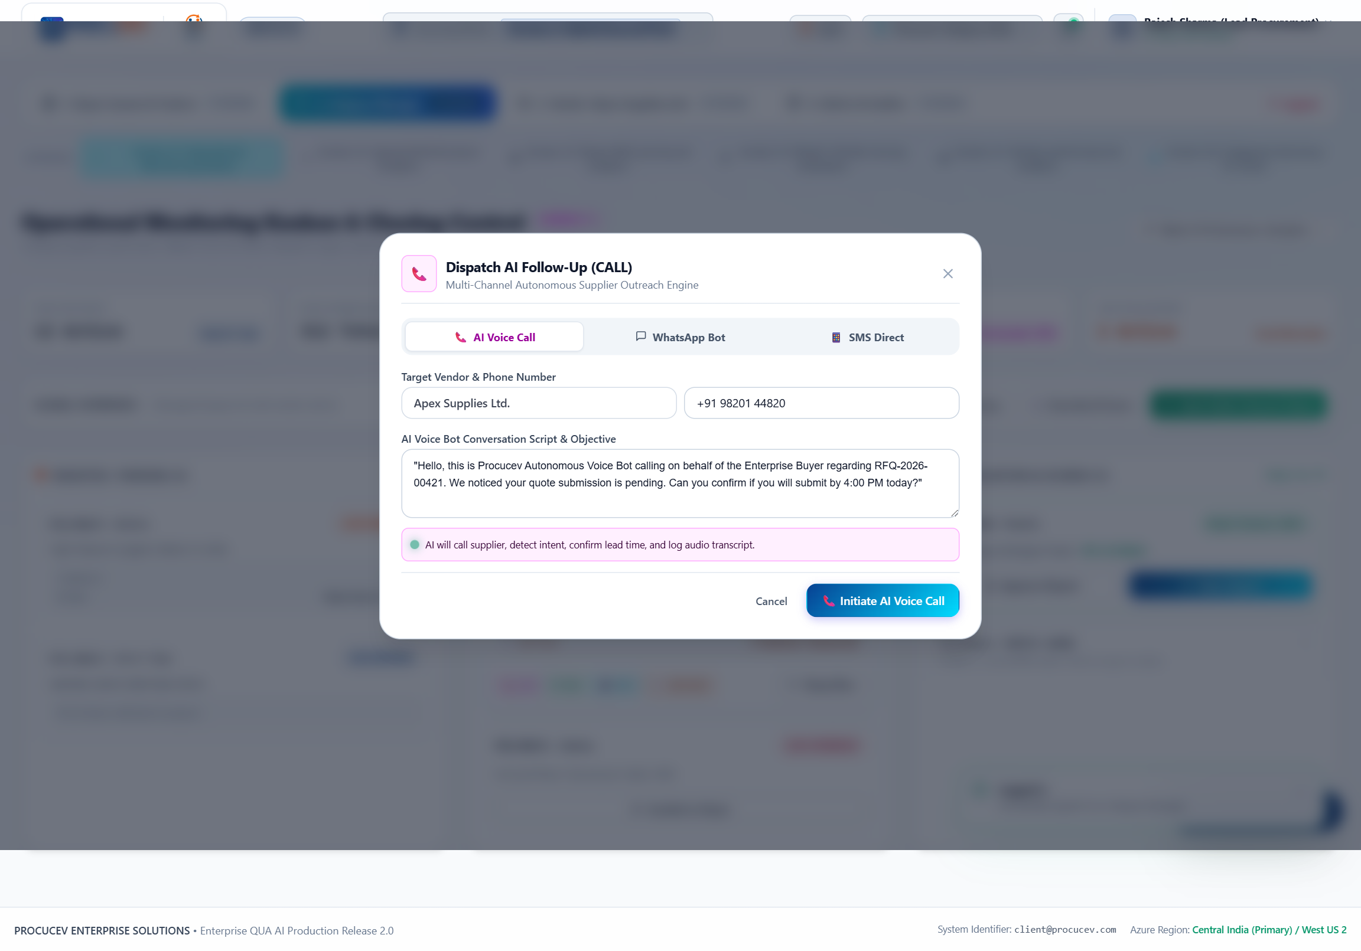
Figure: Autonomous Multi-Channel Chaser Dispatch Modal
Screen Highlights: Enables direct AI Voice Call dispatch with conversational script generation, WhatsApp interactive prompts with 1-click bid links, and carrier-priority SMS alerts.

4.3 RFQ Follow-Up Telemetry & 4-Channel Deep-Dive Matrix
Clicking any active RFQ opens a comprehensive follow-up telemetry matrix revealing exact engagement timestamps, call durations, audio transcripts, and 24-hour escalation countdowns.
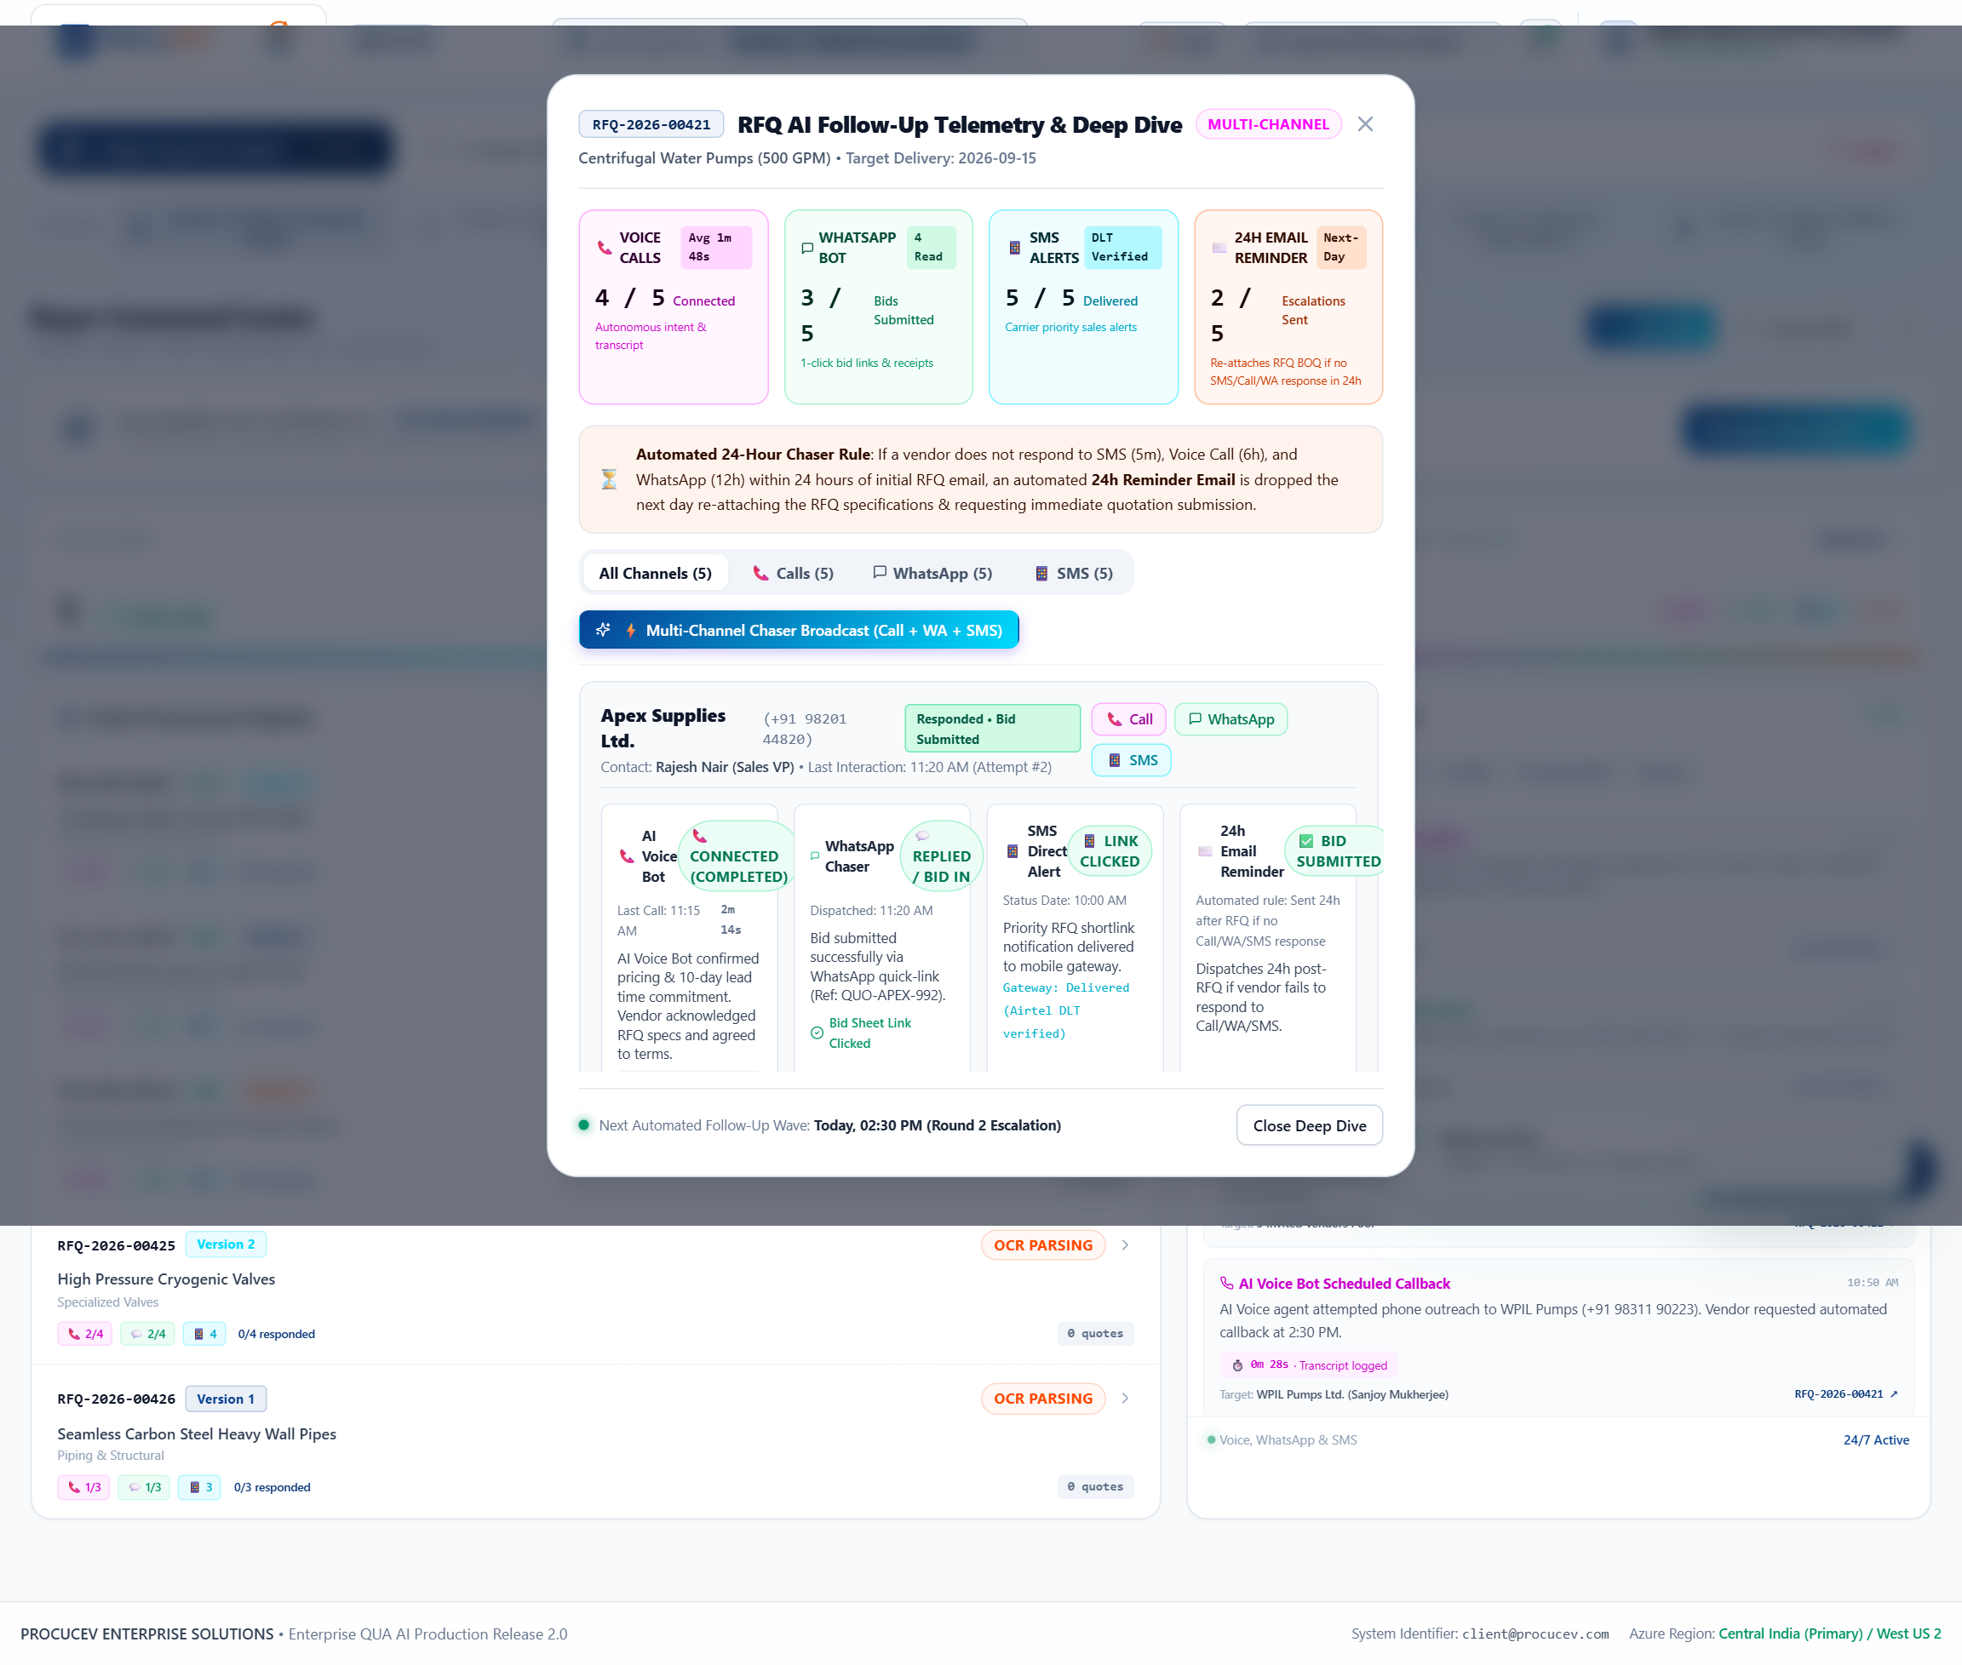
Figure: RFQ Follow-Up Telemetry & 4-Channel Deep-Dive Modal
Screen Highlights: Displays individual supplier engagement status across AI Voice Bot, WhatsApp Chaser, SMS Direct, and the automated 24-hour next-day email escalation trigger.

4.4 Screen 1.2: AI Ingestion & Sourcing Mode Wizard
Buyers can upload unstructured PDF, Excel, or CAD Bill of Quantities (BOQ). The integrated OCR engine automatically extracts line items, quantities, and technical specifications, routing them through Mode 1, Mode 2, or Mode 3.
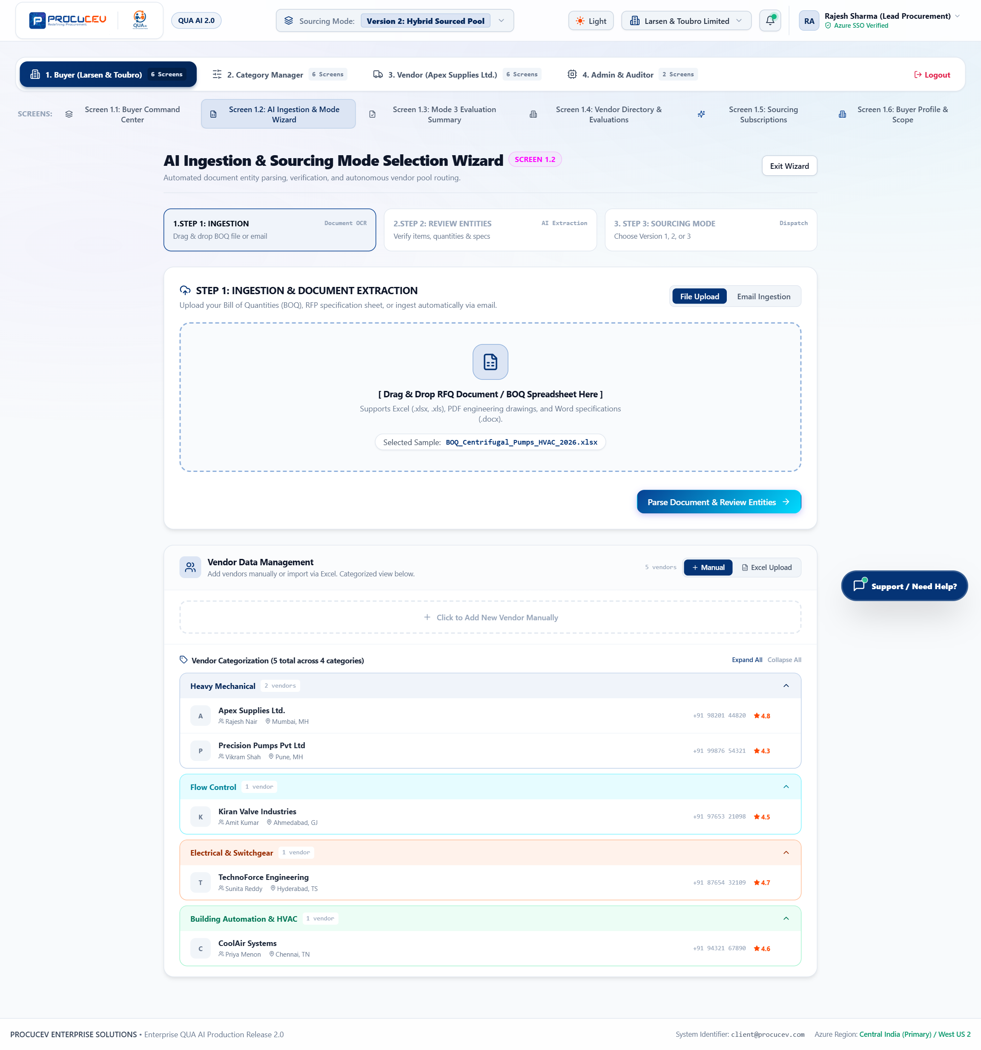
Figure: Screen 1.2: AI Ingestion & Sourcing Mode Dispatch Wizard
Screen Highlights: Demonstrates drag-and-drop BOQ ingestion, OCR entity confidence scores (98.4%), category classification, and one-click Sourcing Mode 1/2/3 selection.

4.5 Comparative Quote Evaluation Matrix
Once vendor bids are submitted, QUA AI normalizes commercial terms, prices, lead times, warranties, and compliance ratings into a side-by-side parametric matrix.
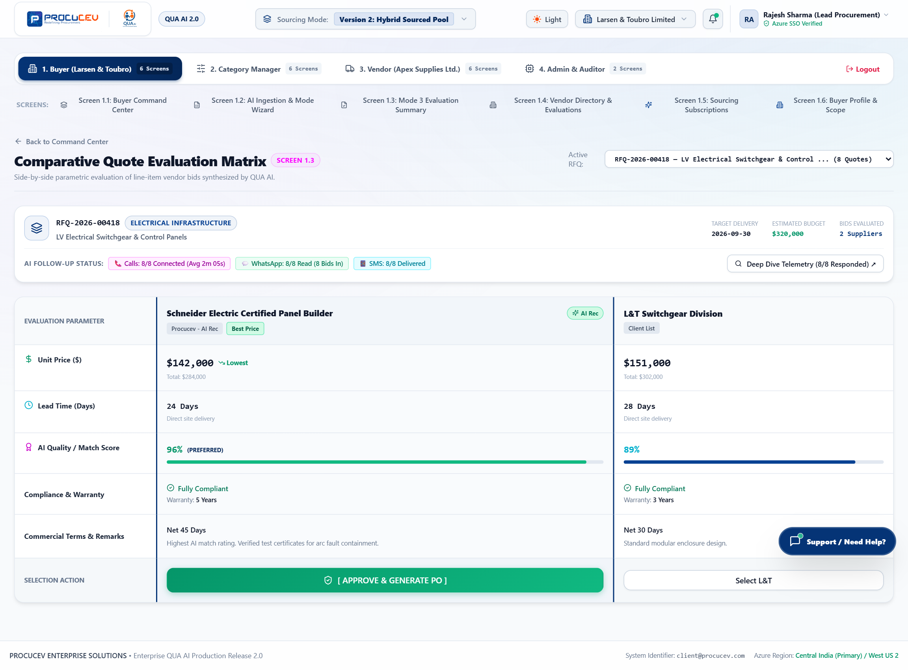
Figure: Comparative Quote Evaluation Matrix (Screen 1.3)
Screen Highlights: Side-by-side parametric comparison displaying unit prices, lead times, AI Quality/Match scores (96% preferred), warranty compliance, and the 1-click PO dispatch trigger.

4.6 Enterprise Purchase Order Generation & Cryptographic Seal
Approving a supplier bid generates a formal enterprise Purchase Order contract stamped with a SHA-256 cryptographic audit seal for ERP synchronization (SAP / Oracle).
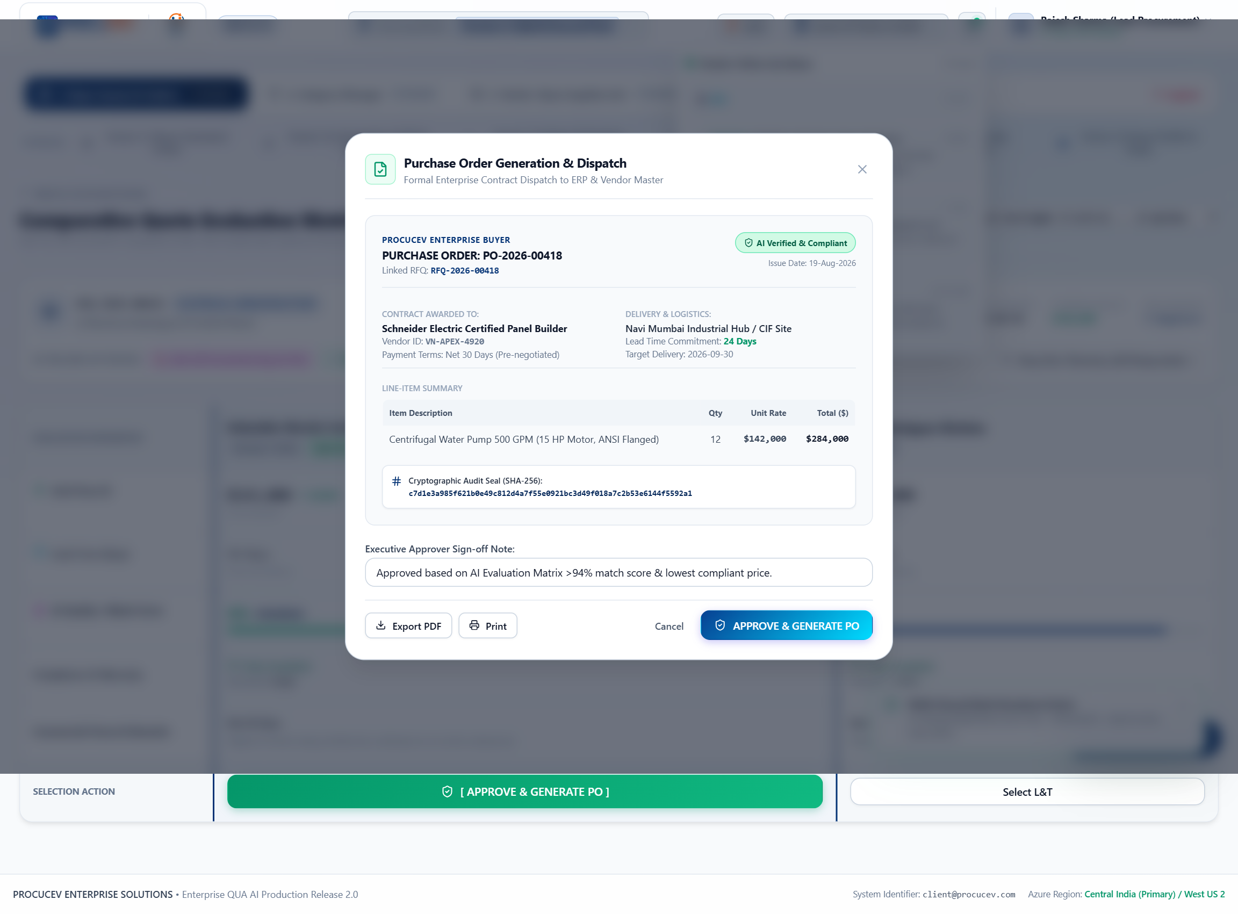
Figure: Enterprise Purchase Order Generation & Dispatch Modal
Screen Highlights: Shows official PO structure, line item financial summaries, executive approval notes, and the cryptographic SHA-256 digital audit stamp.

4.7 Screen 1.3: Mode 3 360-Degree Vendor Evaluation Summary
For complex sourcing, Mode 3 audits suppliers across 6 evaluation pillars (M1 Commercial, M2 Technical, M3 Quality & Warranty, M4 Operational Delivery, M5 Financial Stability, M6 Governance & ESG) and 24 mandatory document attachments.
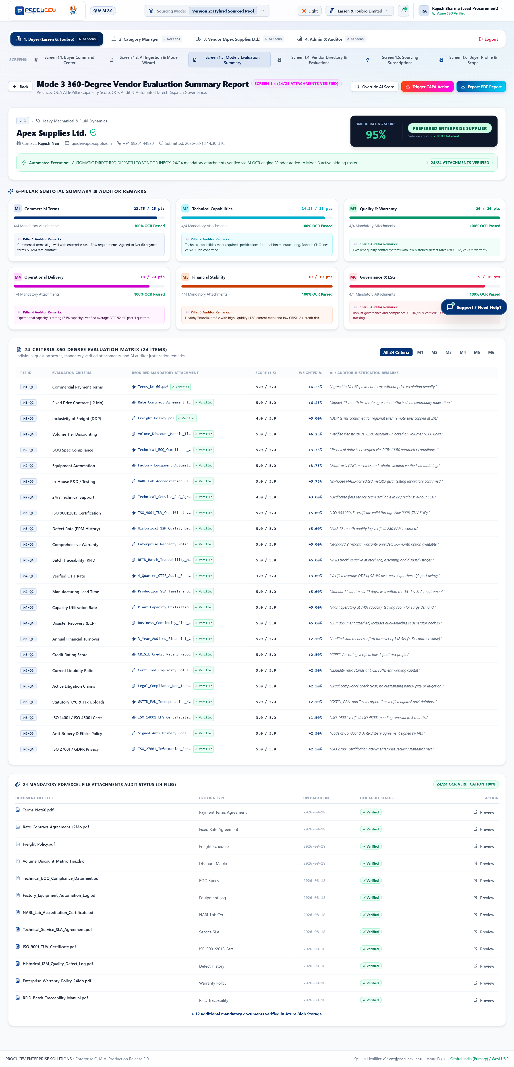
Figure: Screen 1.3: Mode 3 360-Degree Vendor Evaluation Summary Report
Screen Highlights: Detailed audit view showing 95% AI Rating Score, Preferred Enterprise Supplier certification, 24/24 attachment verification, and weighted criterion scores.

4.8 Screen 1.4: Vendor Directory & Master Records
A searchable master repository of pre-qualified and active vendor partners with performance ratings, spend histories, and quick RFQ dispatch controls.
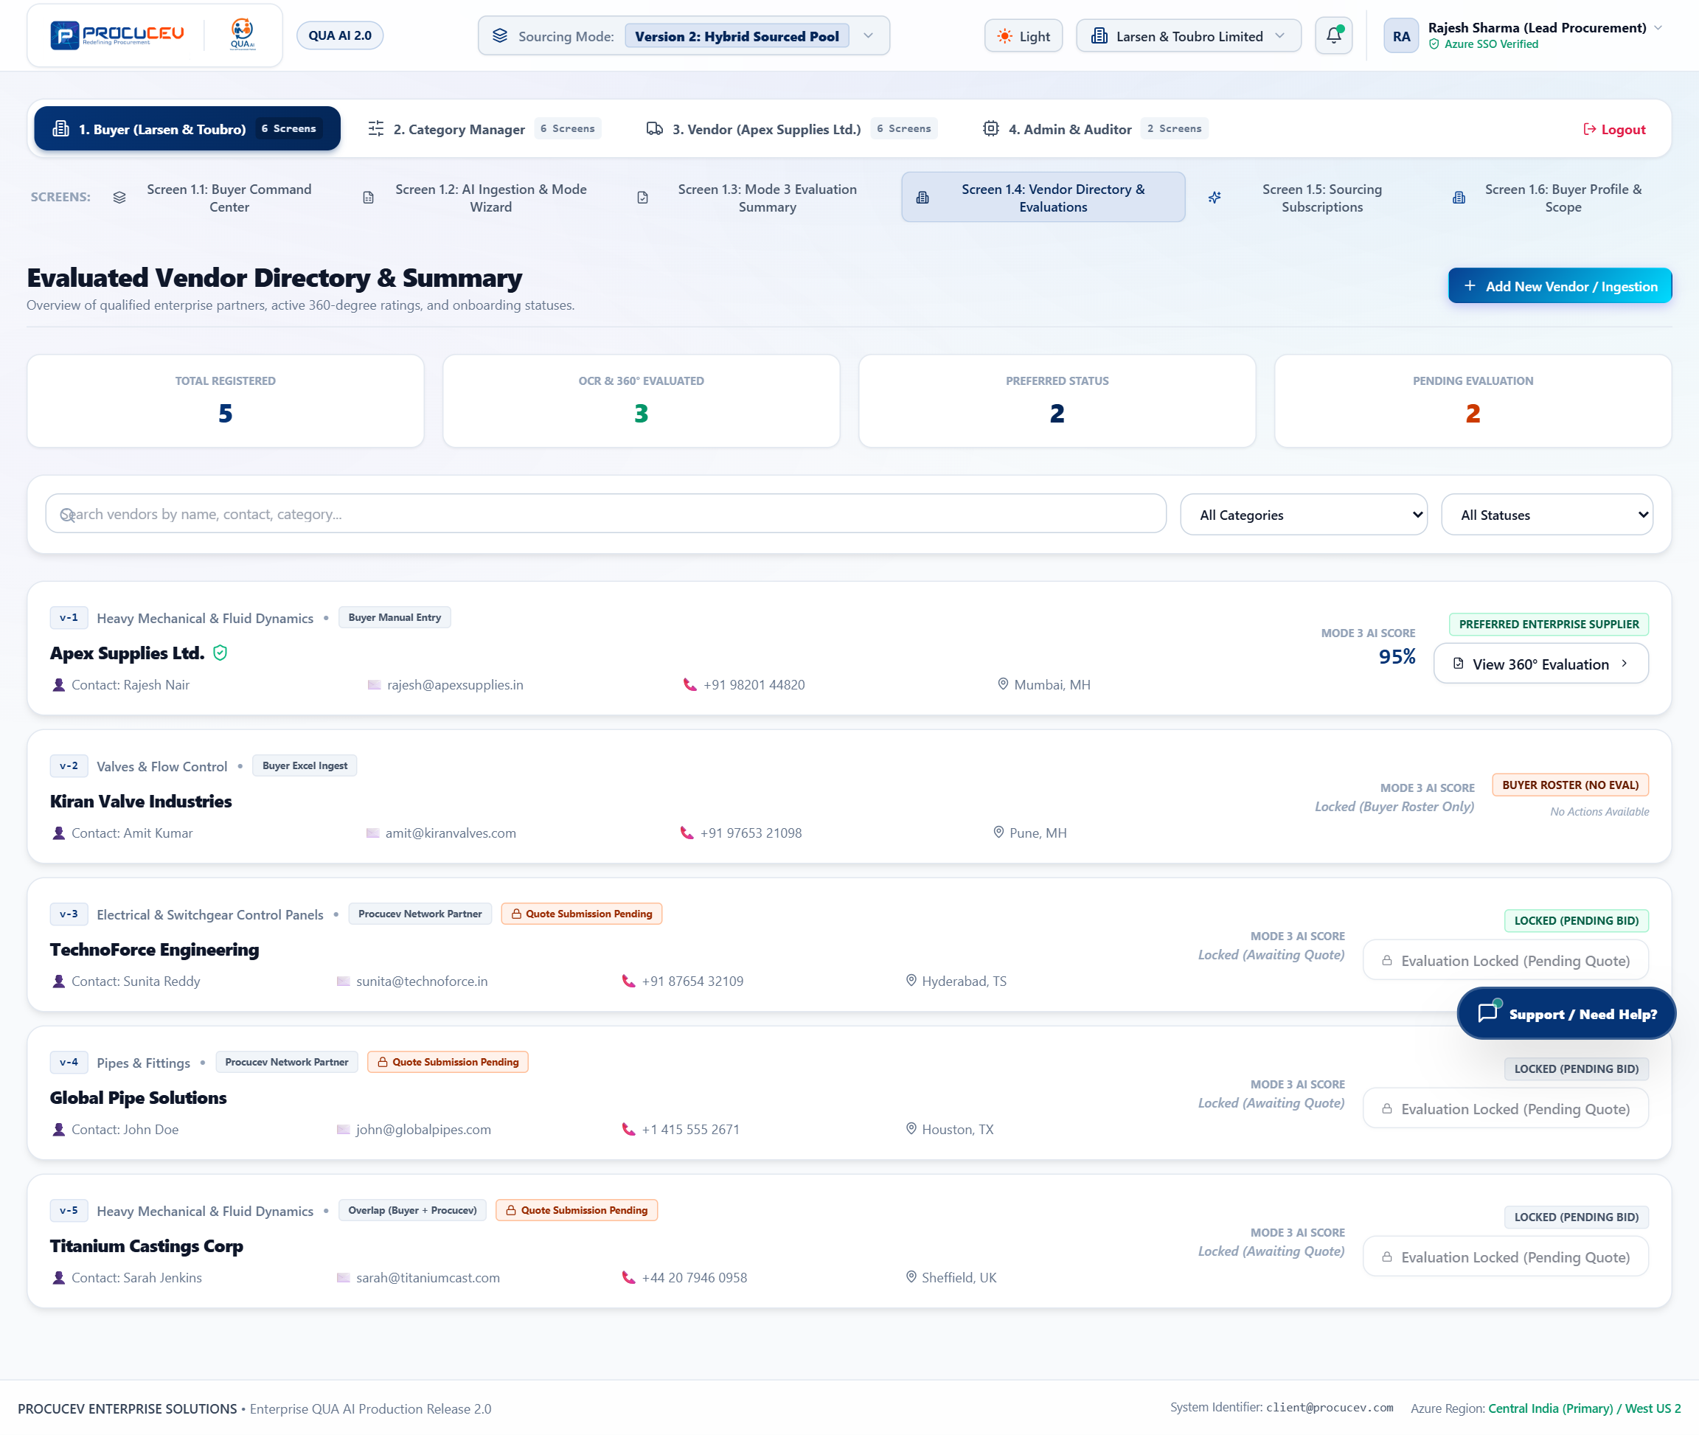
Figure: Screen 1.4: Vendor Directory & Master Records
Screen Highlights: Comprehensive supplier cards featuring category tags, performance metrics, compliance badges, and direct contact options.

4.9 Screen 1.5: Buyer Sourcing Subscriptions & Quota Plans
Manages enterprise RFQ usage allowances across Sourcing Mode 1 (Free Trial), Mode 2 (Enterprise Hybrid), and Mode 3 (360° Unlimited) with self-serve upgrades.
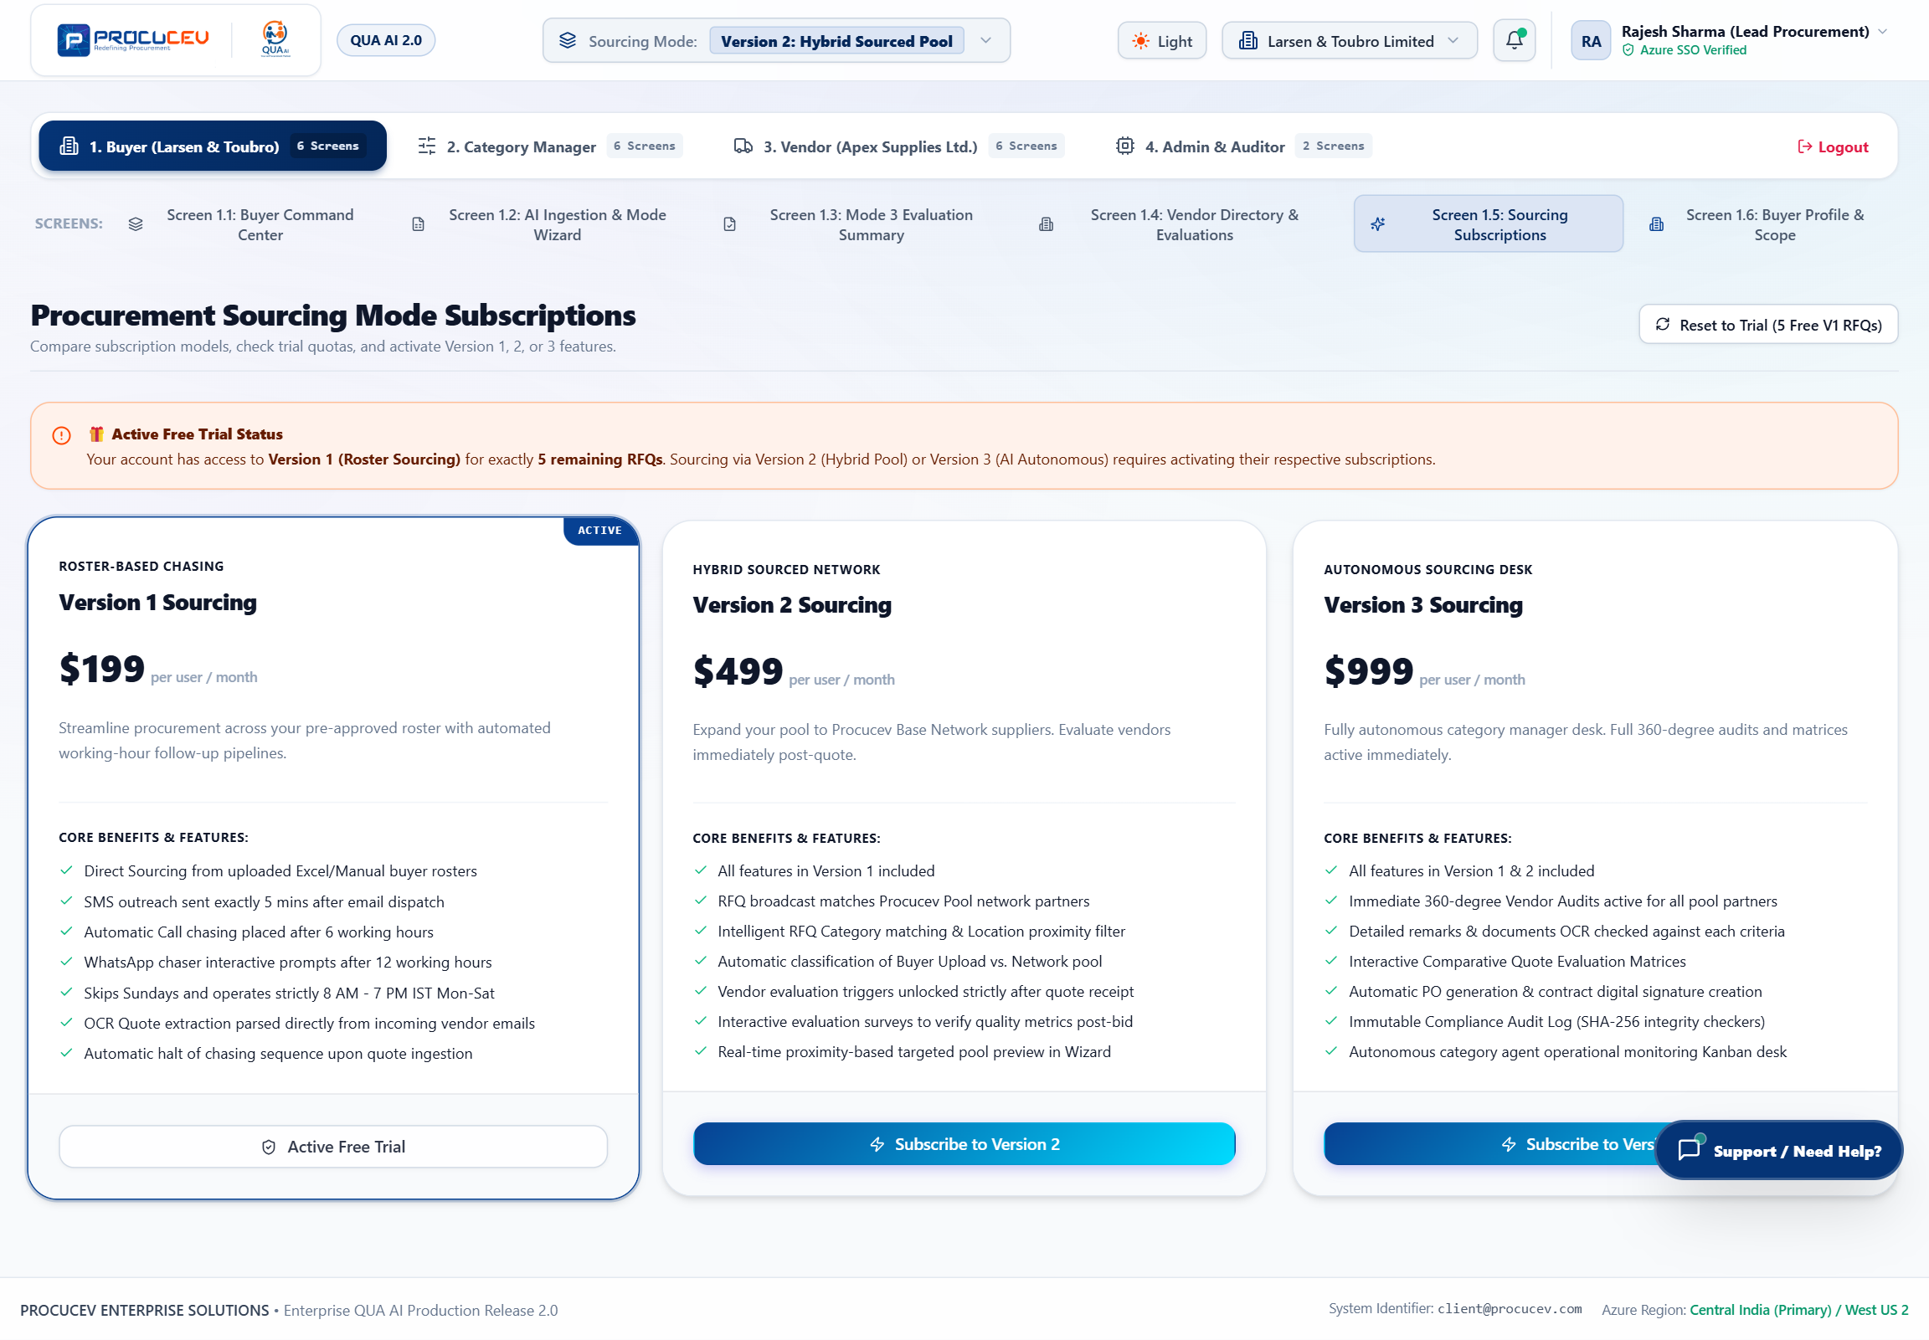
Figure: Screen 1.5: Buyer Sourcing Subscriptions & Quotas
Screen Highlights: Subscription overview illustrating plan features, quota consumption meters, and seamless upgrade triggers.

4.10 Screen 1.6: Buyer Profile & Procurement Scope
Enterprise profile settings configuring buyer organization credentials, ERP connection parameters, delivery hub addresses, and default commercial terms.
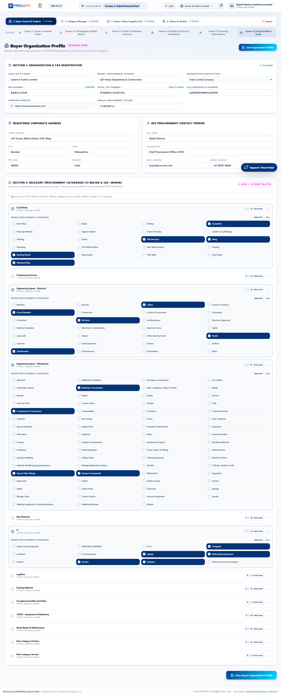
Figure: Screen 1.6: Buyer Profile & Procurement Scope Settings
Screen Highlights: Company governance profile, tax IDs, shipping locations, and enterprise ERP integration configurations.

5. Category Manager Governance Ecosystem (Module 2)
Category Managers oversee cross-organizational spend, monitor live chasing pipelines, conduct Mode 3 vendor survey audits, and track supplier performance benchmarks.

5.1 Screen 2.1: Operational Monitoring Kanban & Chasing Control
A 3-column operational Kanban board categorizing RFQs across Ingested/Parsing, Quotes Pending/AI Follow-Up, and AI Evaluation & Scored with managerial override actions.
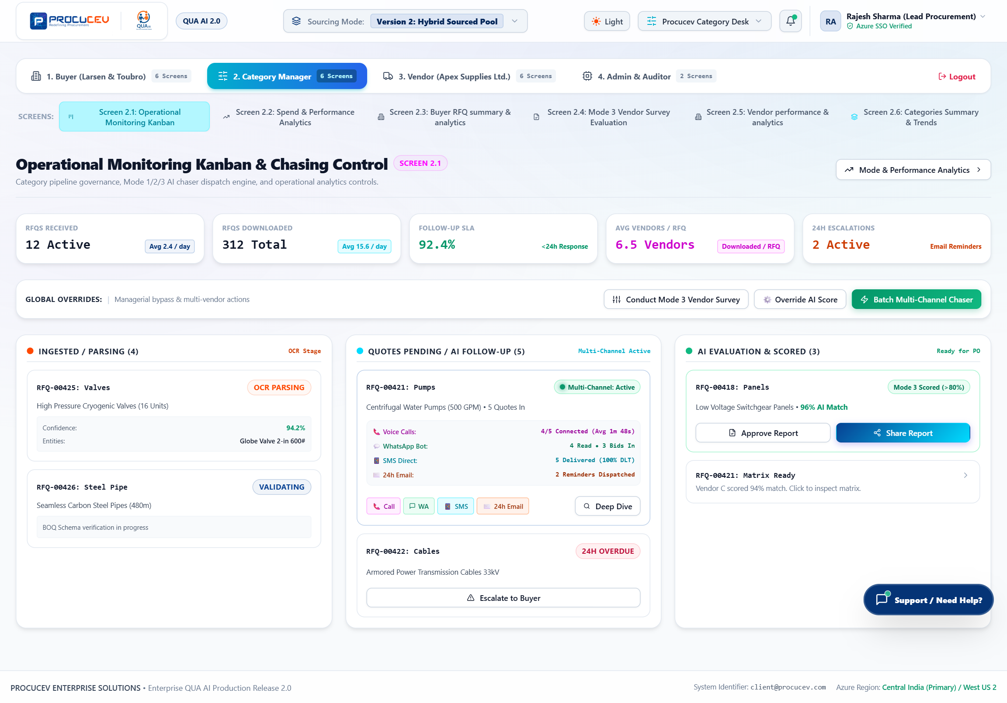
Figure: Screen 2.1: Operational Monitoring Kanban Dashboard
Screen Highlights: Displays live RFQ cards, channel dispatch buttons (Call, WA, SMS, 24h Email), overdue escalation badges, and global batch chaser controls.

5.2 Screen 2.2: Spend & Performance Analytics Dashboard
Deep visual analytics tracking total spend ($1.24M+), mode distribution, cost savings benchmarks (14.8% average savings), and on-time response rates.
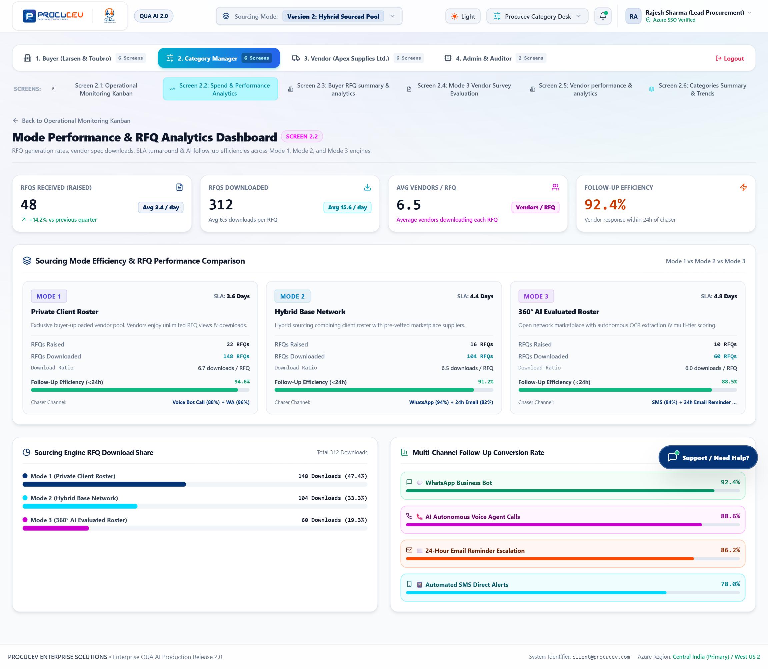
Figure: Screen 2.2: Spend & Performance Analytics Dashboard
Screen Highlights: Features monthly spend trajectory charts, savings by category breakdowns, and AI vs. manual procurement cycle time comparisons.

5.3 Screen 2.3: Buyer Console & RFQ Summary
Provides category managers with a holistic summary of all internal buyer procurement activities, active requisitions, and departmental throughput.
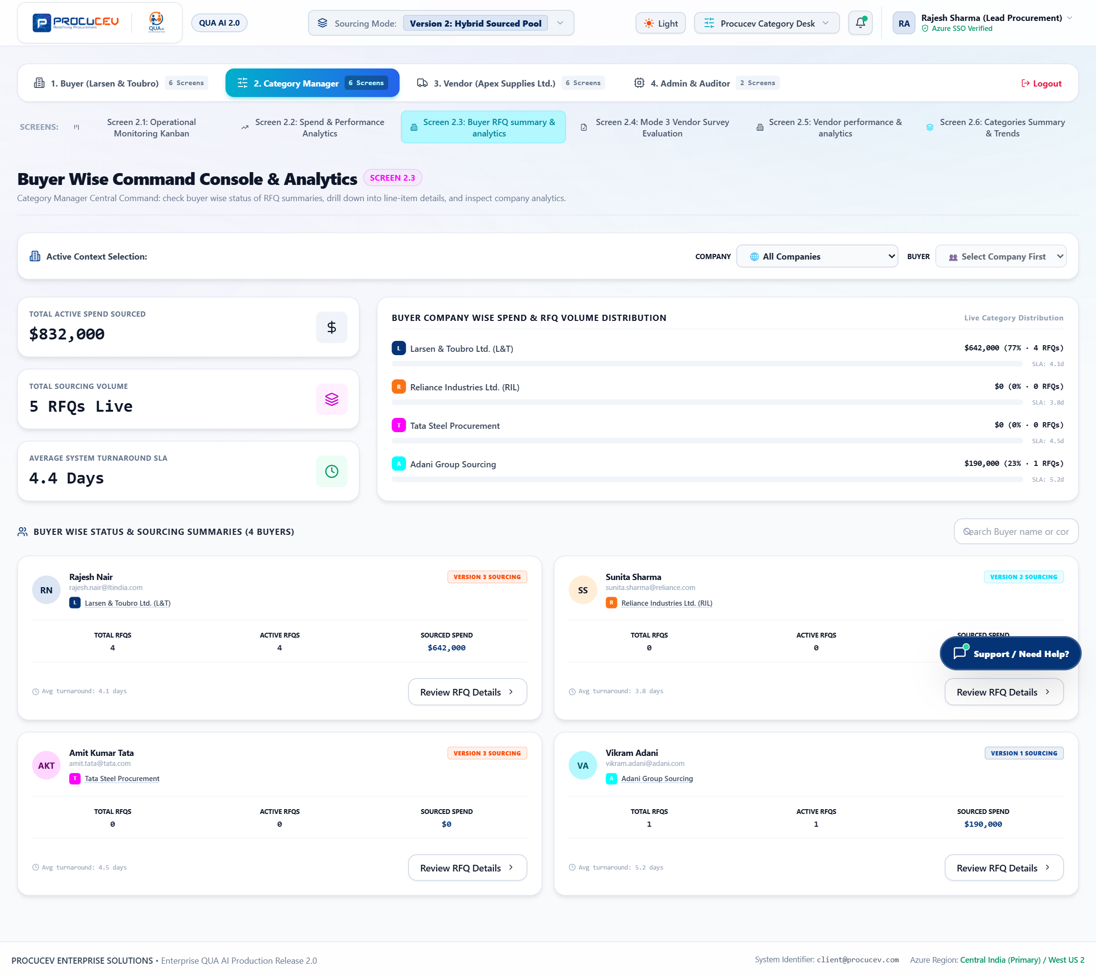
Figure: Screen 2.3: Buyer Console & RFQ Summary
Screen Highlights: Centralized buyer activity table with status filtering, department tagging, and requisition auditing.

5.4 Screen 2.4: Mode 3 Vendor Survey Evaluation Audit
An auditing interface enabling Category Managers to inspect vendor qualification surveys, verify OCR extracted attachments, and approve score overrides.
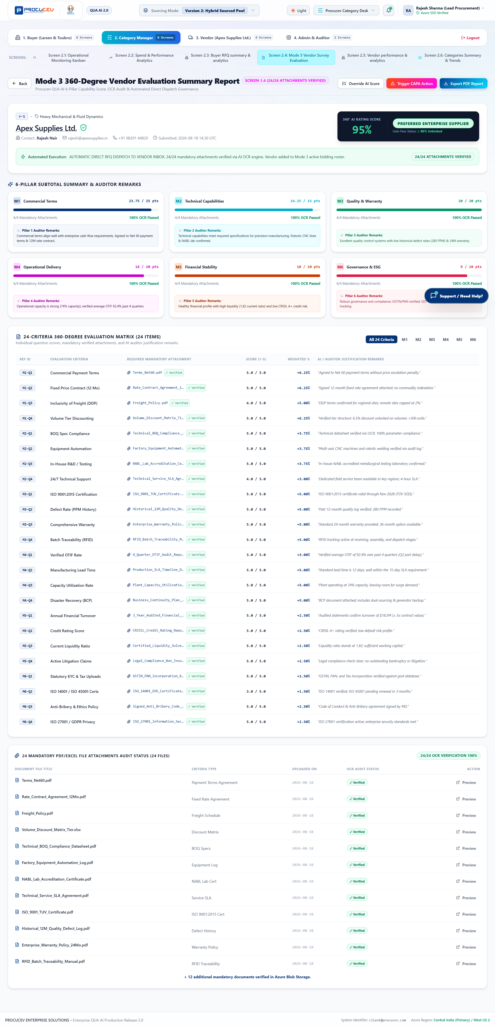
Figure: Screen 2.4: Mode 3 Vendor Survey Evaluation & Document Audit
Screen Highlights: Line-by-line audit view of 24 qualification criteria with attachment previews, OCR confidence scores, and compliance sign-offs.

5.5 Screen 2.5: Vendor Performance & Scorecard Analytics Console
Comprehensive supplier scorecards tracking historical On-Time Delivery (OTIF), Defect Parts Per Million (PPM), bid competitiveness, and ESG ratings.
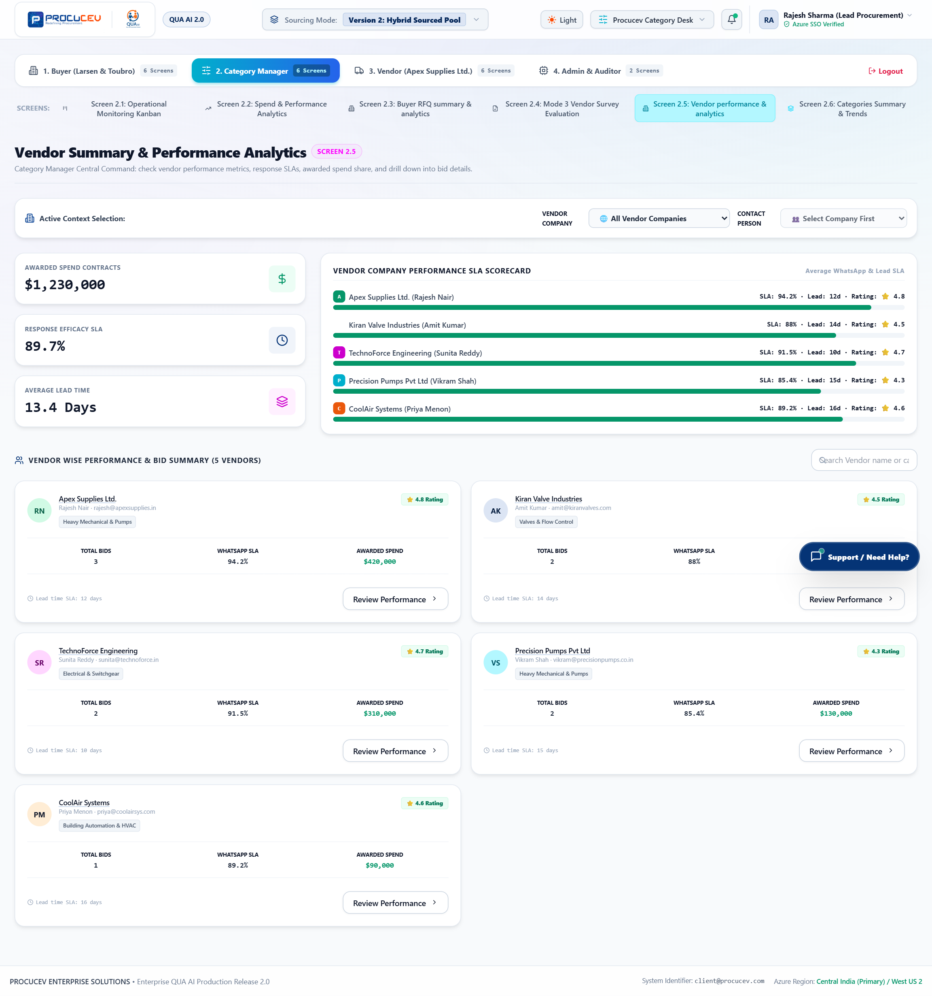
Figure: Screen 2.5: Vendor Performance & Scorecard Console
Screen Highlights: Multi-metric vendor evaluation cards with historical quality radar graphs and supplier tiering badges.

5.6 Screen 2.6: Category Taxonomy & Spend Trends
Hierarchical category management interface for mapping procurement taxonomies, managing spend caps, and defining preferred vendor rosters per category.
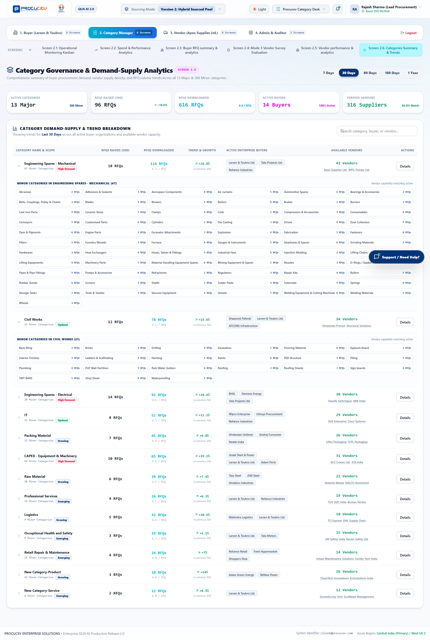
Figure: Screen 2.6: Category Taxonomy & Spend Trends
Screen Highlights: Category hierarchy trees with spend allocations, budget variance trackers, and automated category rule builders.

6. Vendor Partner Ecosystem (Module 3)
Suppliers access Procucev through a dedicated vendor portal to discover RFQ opportunities, submit itemized quotations, complete Mode 3 audits, and manage catalogues.

6.1 Screen 3.1: Vendor Workspace & Opportunity Feed
A real-time opportunity dashboard segregating Direct Invited RFQs (from client rosters) and Marketplace Sourcing Leads with urgent submission timers.
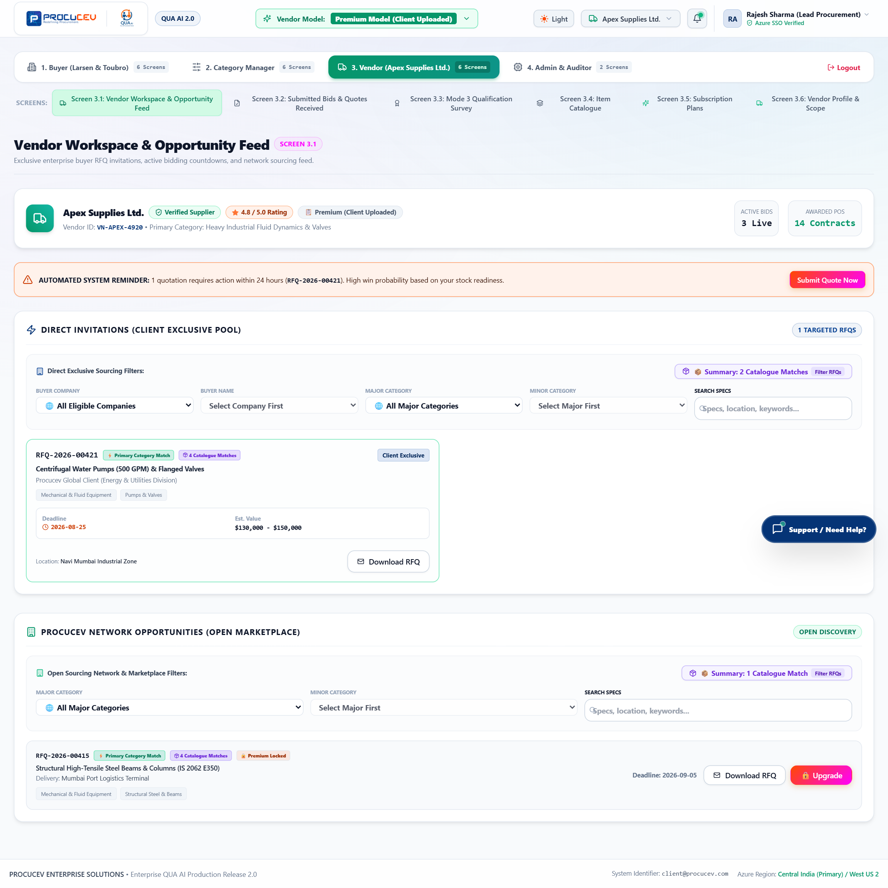
Figure: Screen 3.1: Vendor Opportunity Feed Dashboard
Screen Highlights: Displays active RFQ leads with estimated budgets, delivery deadlines, buyer profiles, and one-click quote submission triggers.

6.2 Screen 3.2: Quotation Submission & Bid Entry Form
An intuitive bid form where suppliers enter unit rates, lead times, tax breakdowns, delivery terms, and upload technical data sheets.
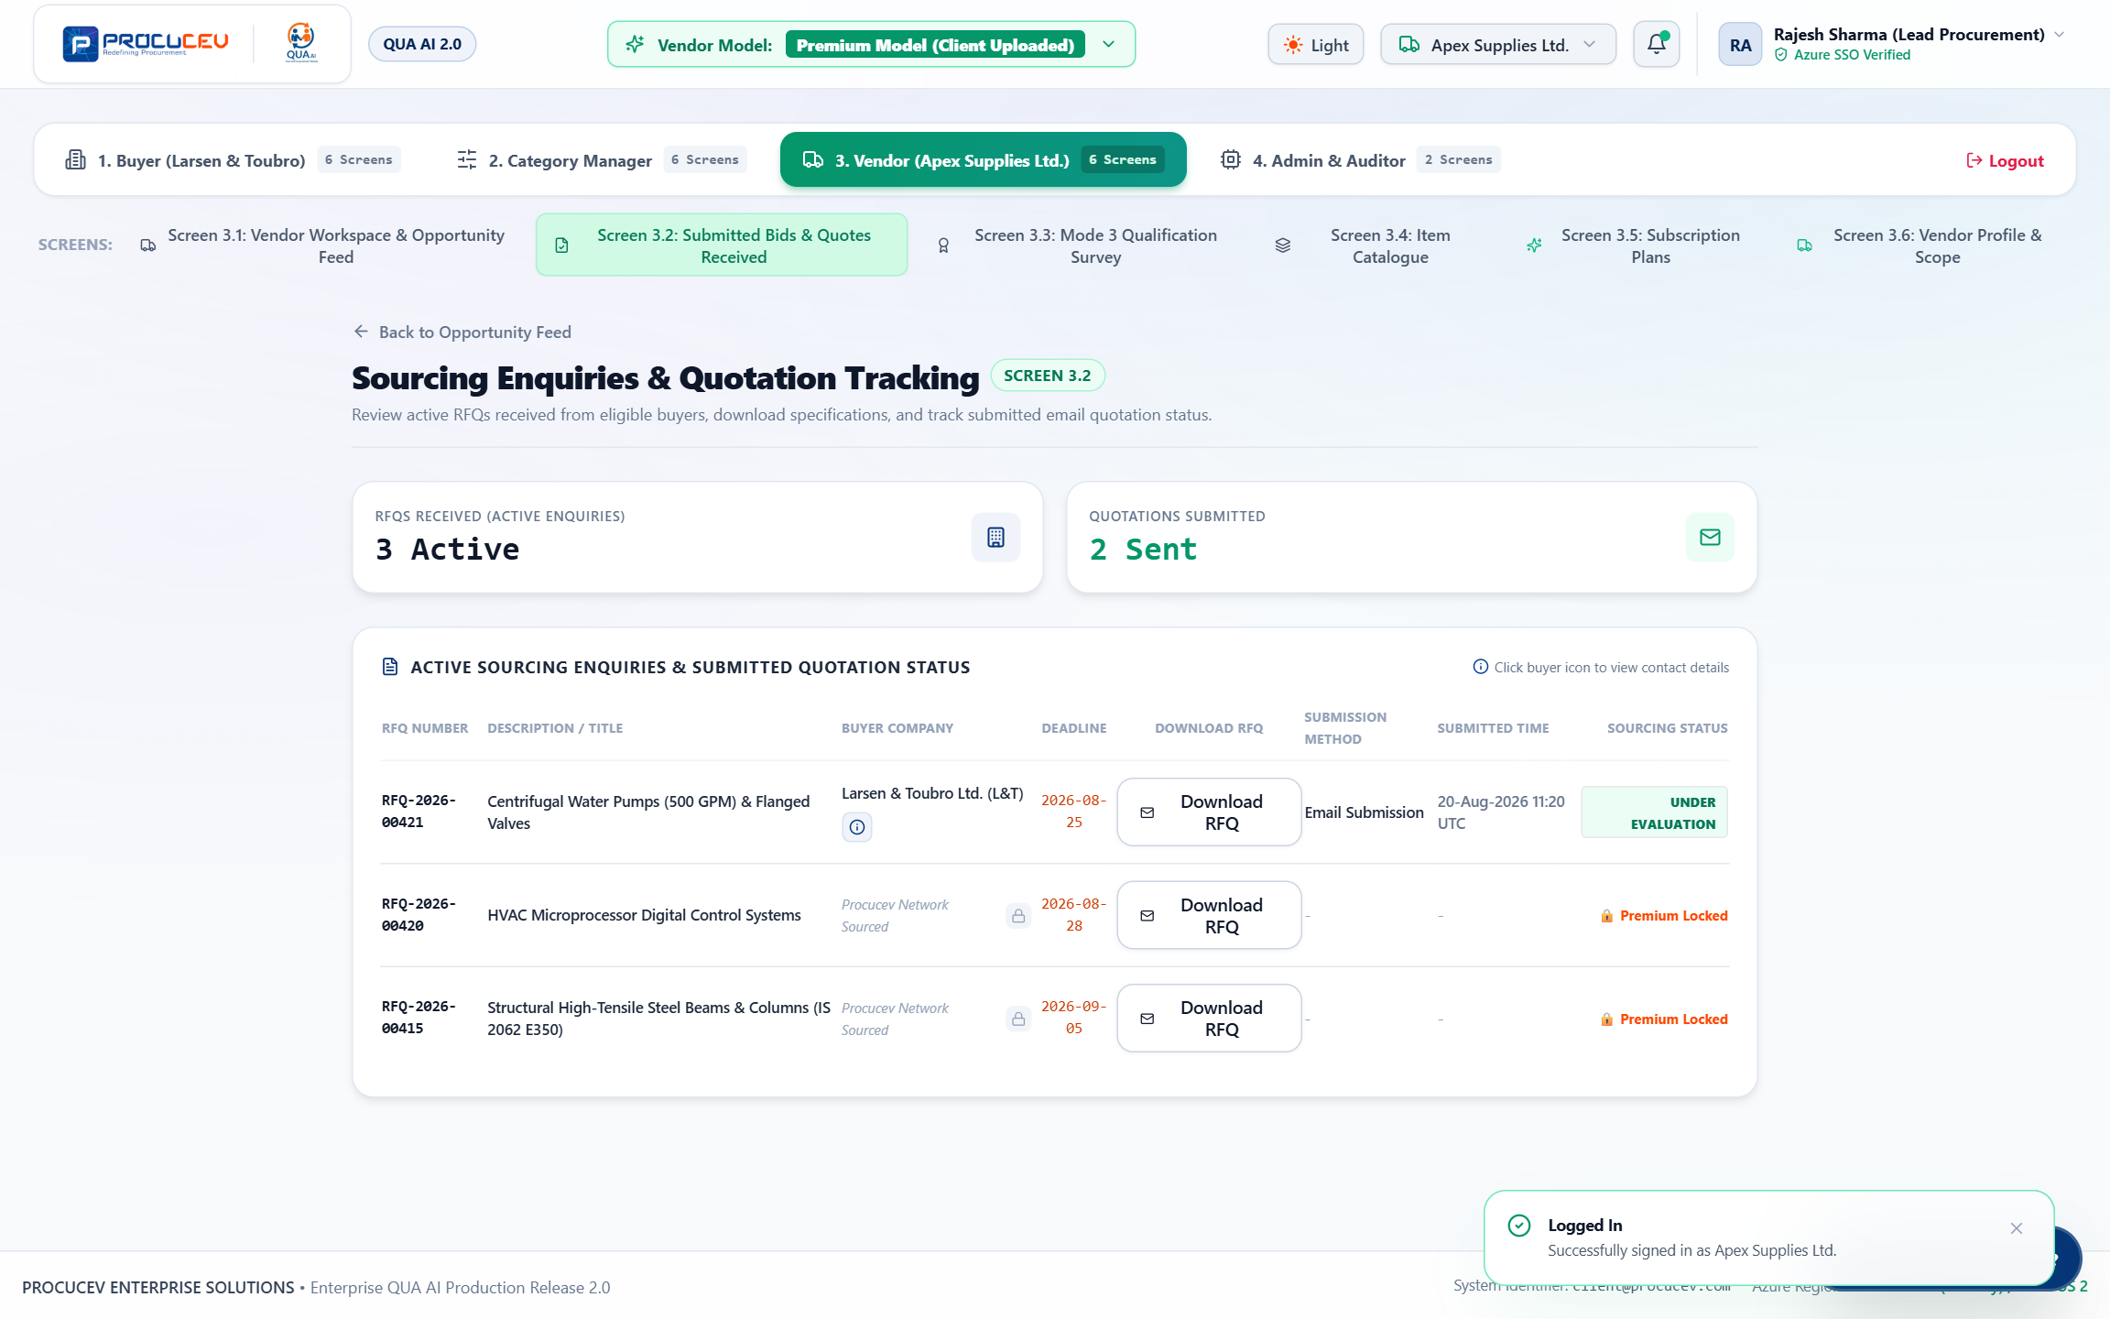
Figure: Screen 3.2: Quotation Submission & Bid Entry Form
Screen Highlights: Line-item pricing inputs with real-time tax calculation, total bid computation, and technical compliance confirmation.

6.3 Screen 3.3: Mode 3 24-Criteria Vendor Qualification Survey
Suppliers complete self-service Mode 3 qualification across 6 pillars, attaching mandatory certificates (ISO, NABL, audited financials, ESG policies) verified via AI OCR.
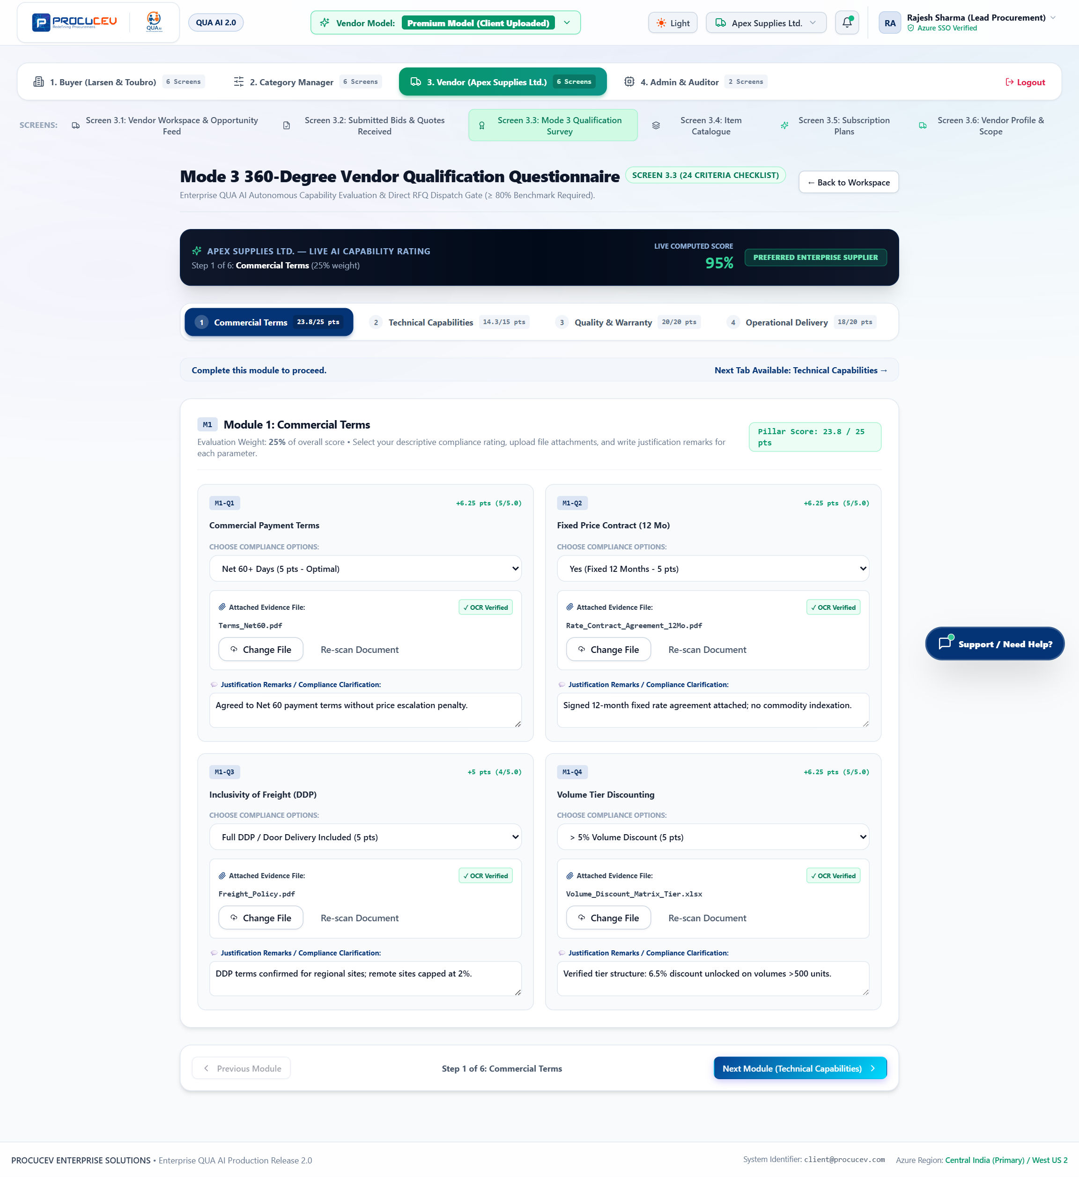
Figure: Screen 3.3: Mode 3 24-Criteria Vendor Qualification Survey
Screen Highlights: Pillar-based survey navigation with drag-and-drop document uploaders and instant OCR validation indicators.

6.4 Screen 3.4: Item Catalogue Repository
A digital catalogue repository allowing suppliers to publish product specifications, standard pricing, and inventory availability for automated buyer discovery.
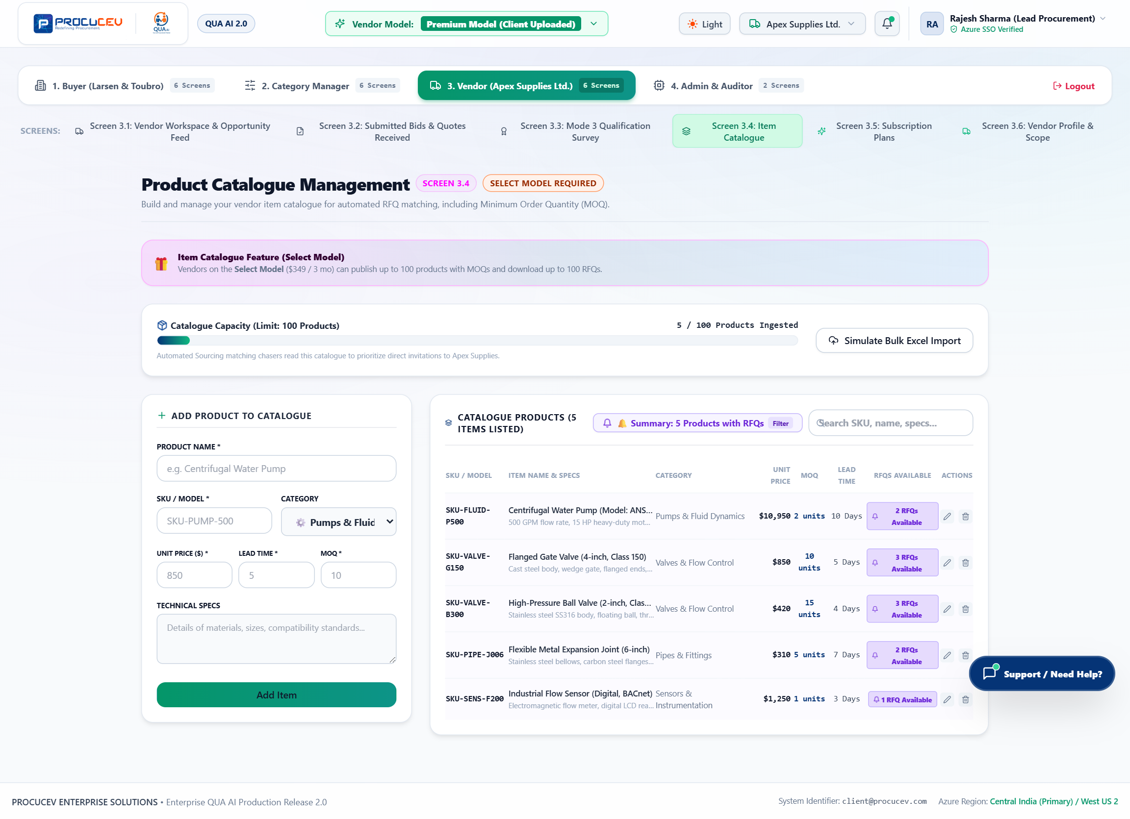
Figure: Screen 3.4: Vendor Item Catalogue Repository
Screen Highlights: Product grid showcasing item codes, technical specs, standard unit rates, and bulk tiered pricing tiers.

6.5 Screen 3.5: Vendor Tiered Subscriptions
Suppliers choose from tiered membership plans (Select, Connect, Premium) to expand marketplace bidding access, receive priority AI matching, and obtain verified vendor badges.
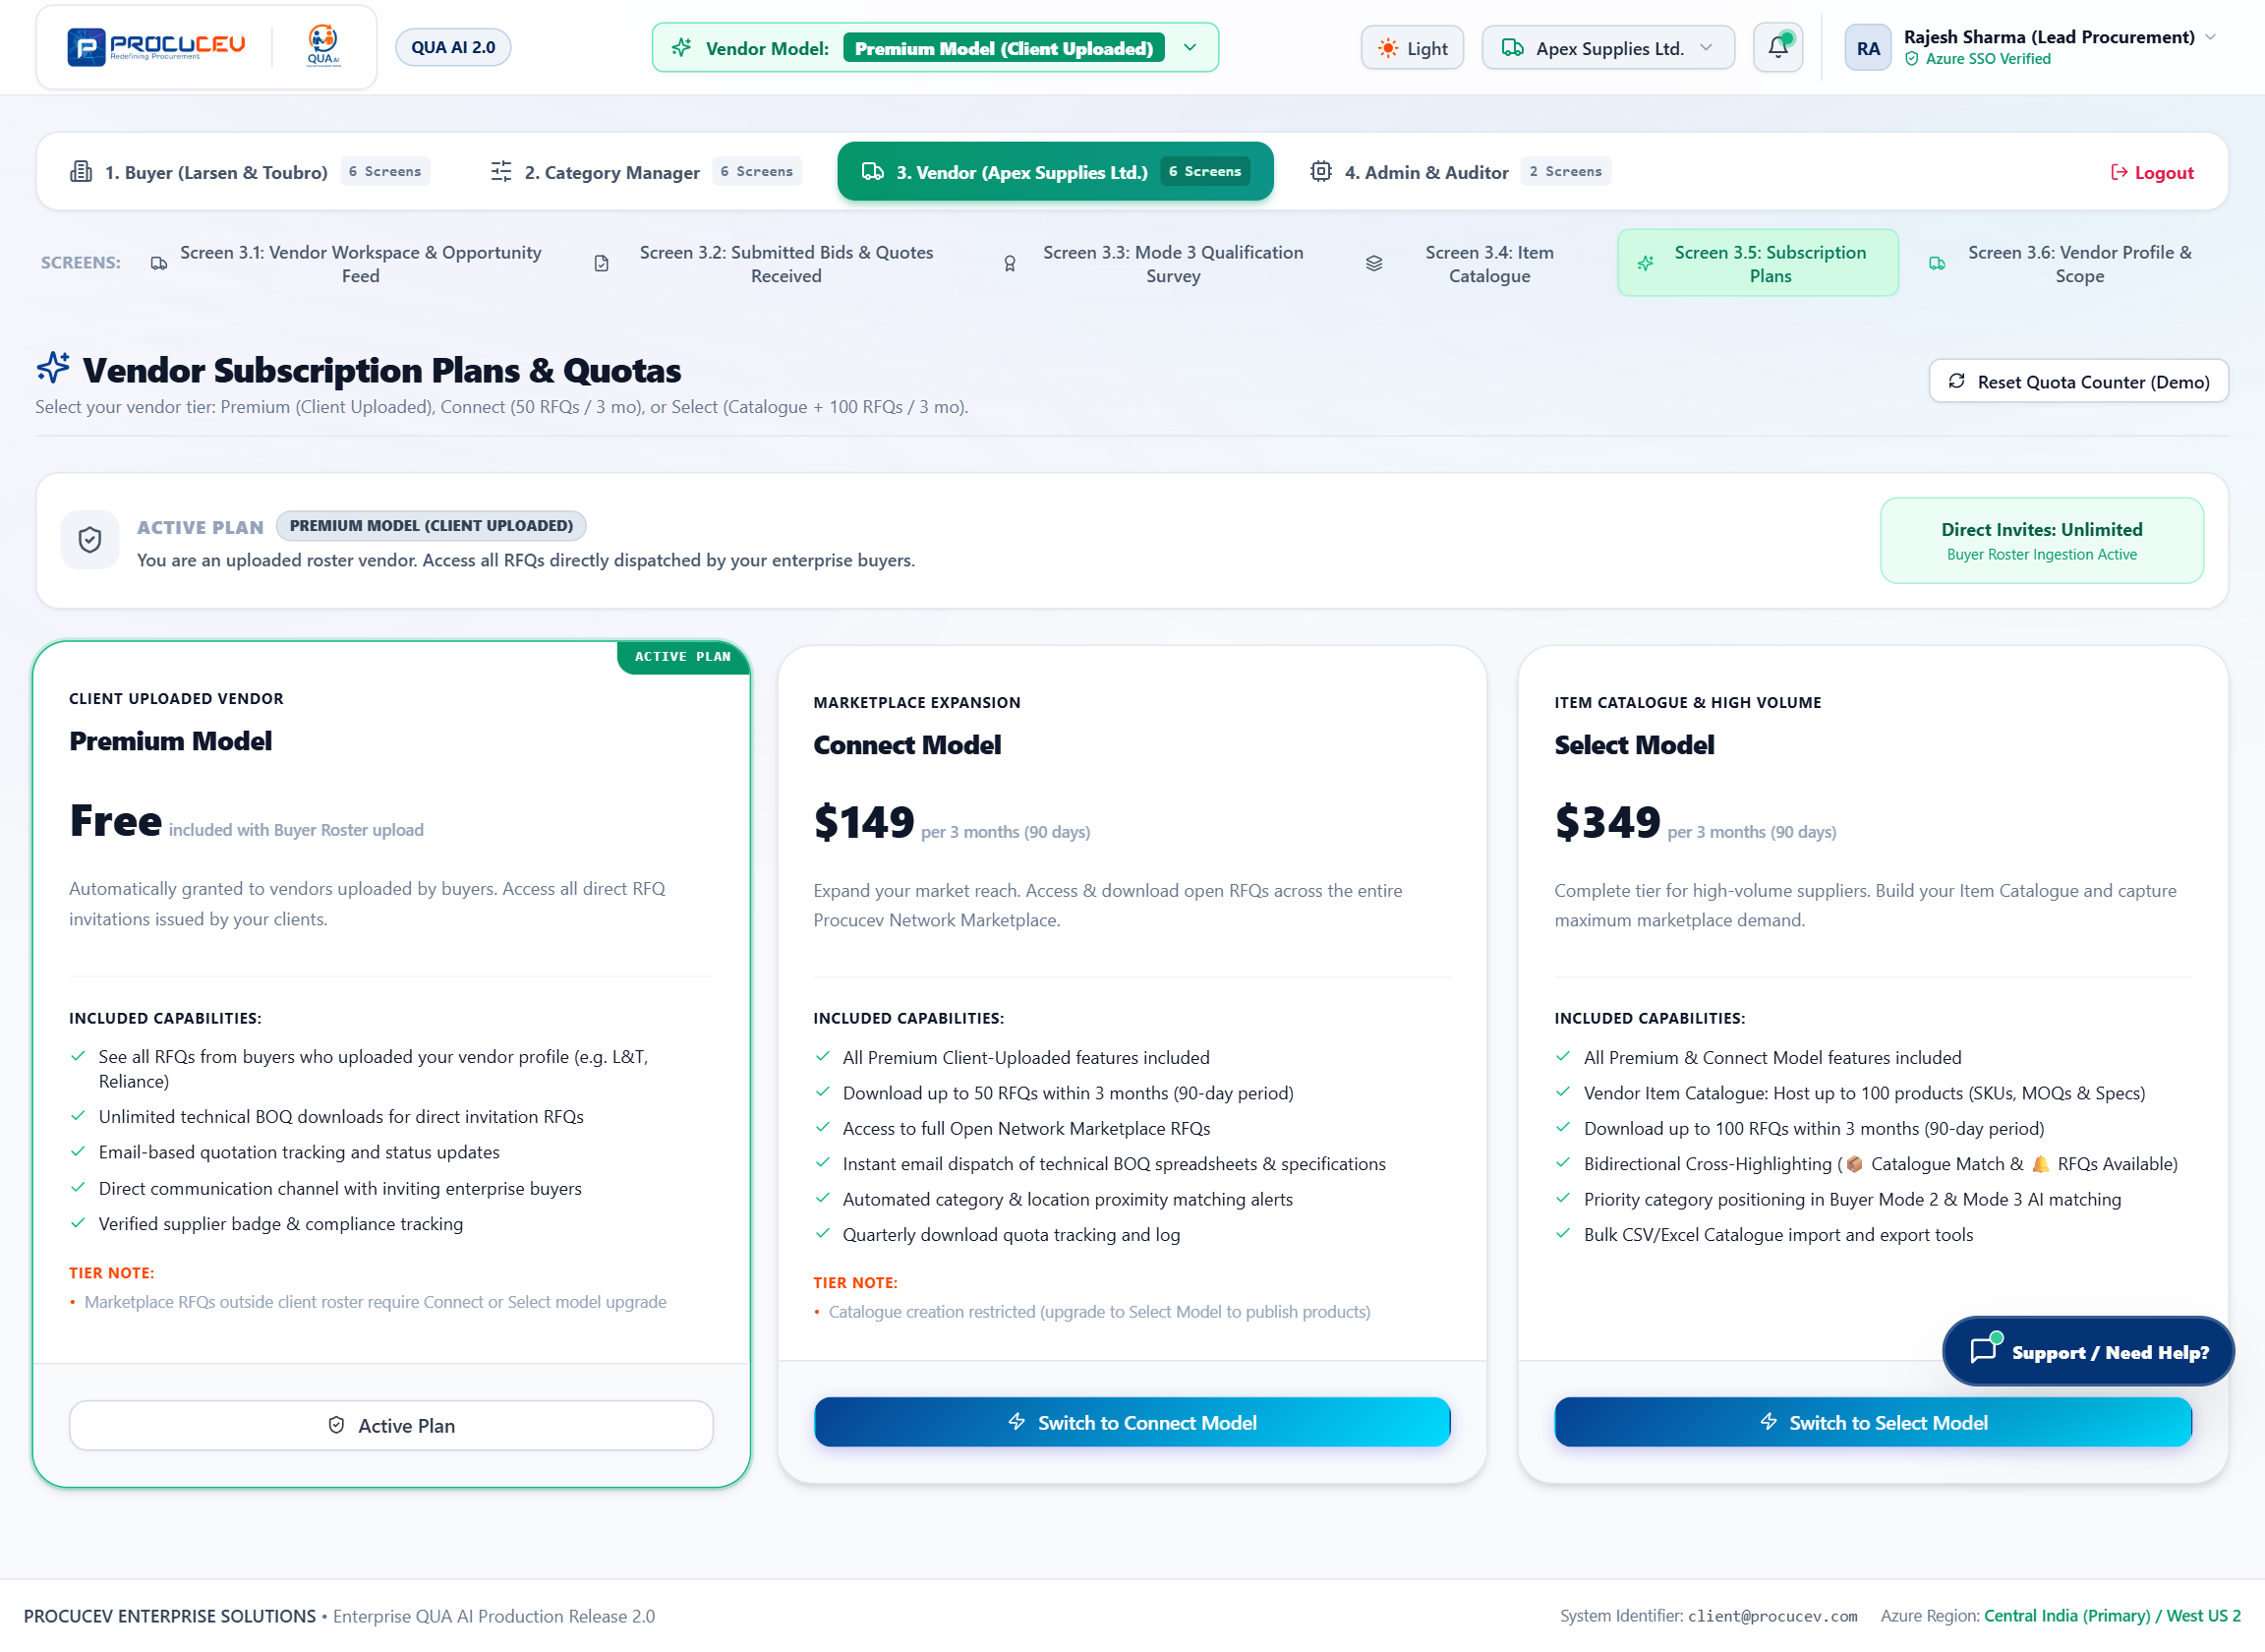
Figure: Screen 3.5: Vendor Subscription Plans
Screen Highlights: Tiered pricing packages detailing feature matrix, RFQ response allowances, and verified supplier certifications.

6.6 Screen 3.6: Vendor Profile & Manufacturing Scope
Maintains supplier factory locations, manufacturing machinery capabilities, quality accreditations, and primary commercial contact information.
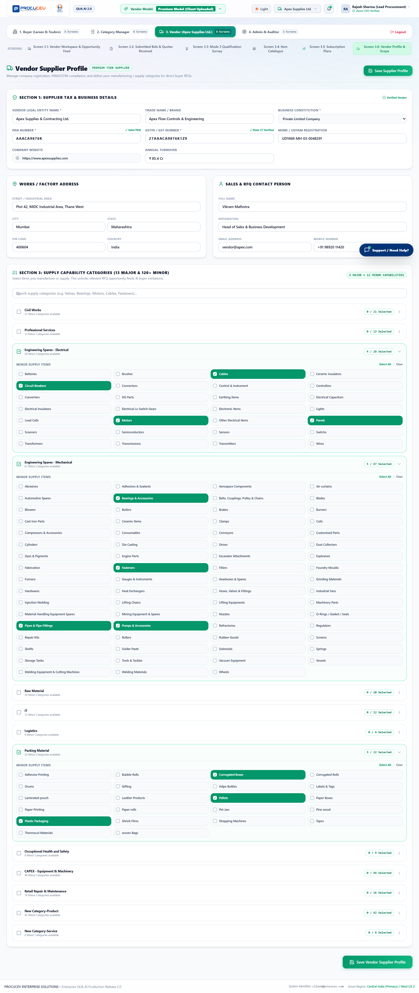
Figure: Screen 3.6: Vendor Profile & Manufacturing Scope
Screen Highlights: Factory capacity details, machinery inventory, geographic delivery reach, and verified contact profiles.

7. Platform Administration & Compliance Governance (Module 4)
System administrators and compliance officers configure AI models, tune OCR extraction thresholds, and audit immutable transaction logs.

7.1 Screen 4.1: Azure Infrastructure & AI Model Orchestration
Configures AI inference backends (switching between local Ollama Mistral/Llama 3 and Azure OpenAI GPT-4o), OCR confidence thresholds, and multi-channel API credentials.
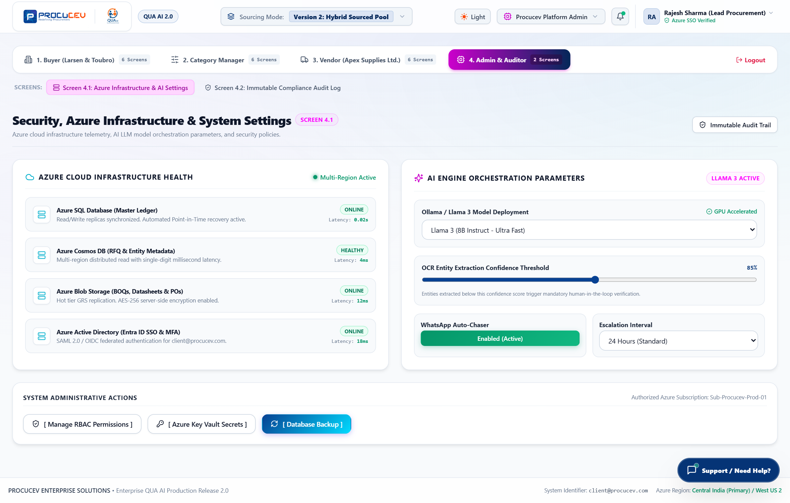
Figure: Screen 4.1: Azure Infrastructure & AI Settings Console
Screen Highlights: AI model selector, temperature controls, OCR confidence sliders, and multi-channel gateway health monitors.

7.2 Screen 4.2: Immutable Compliance Audit Log & Cryptographic Verification
A tamper-proof compliance ledger recording all system events, approvals, overrides, and RFQ dispatches with SHA-256 cryptographic verification.
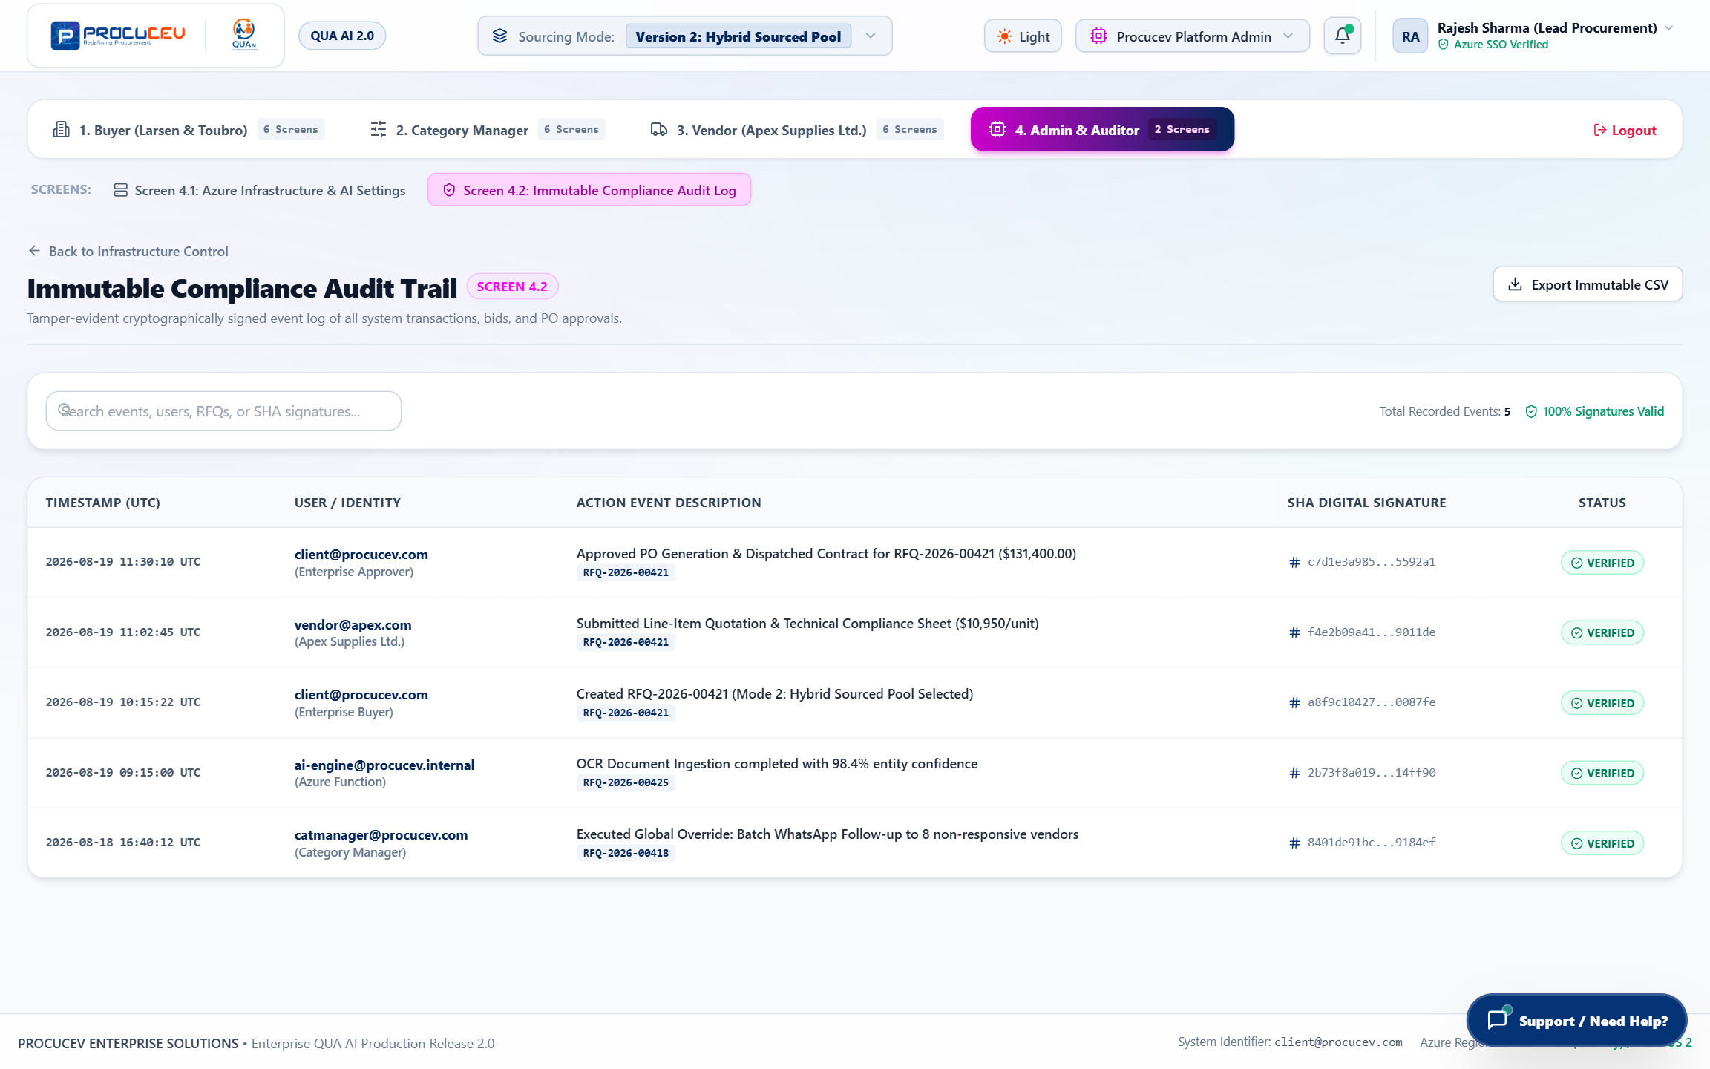
Figure: Screen 4.2: Immutable Compliance Audit Log Console
Screen Highlights: Cryptographically verified event stream with event hashes, user timestamps, severity filters, and CSV/PDF export options.

8. Global Intelligence & Autonomous Features
Procucev embeds continuous background intelligence accessible across all roles through real-time bot feeds and conversational AI assistants.

8.1 Autonomous AI Bot Activity Feed Drawer
A persistent slide-out feed streaming real-time autonomous agent actions: phone calls completed, WhatsApp read receipts, OCR extraction completions, and PO dispatches.
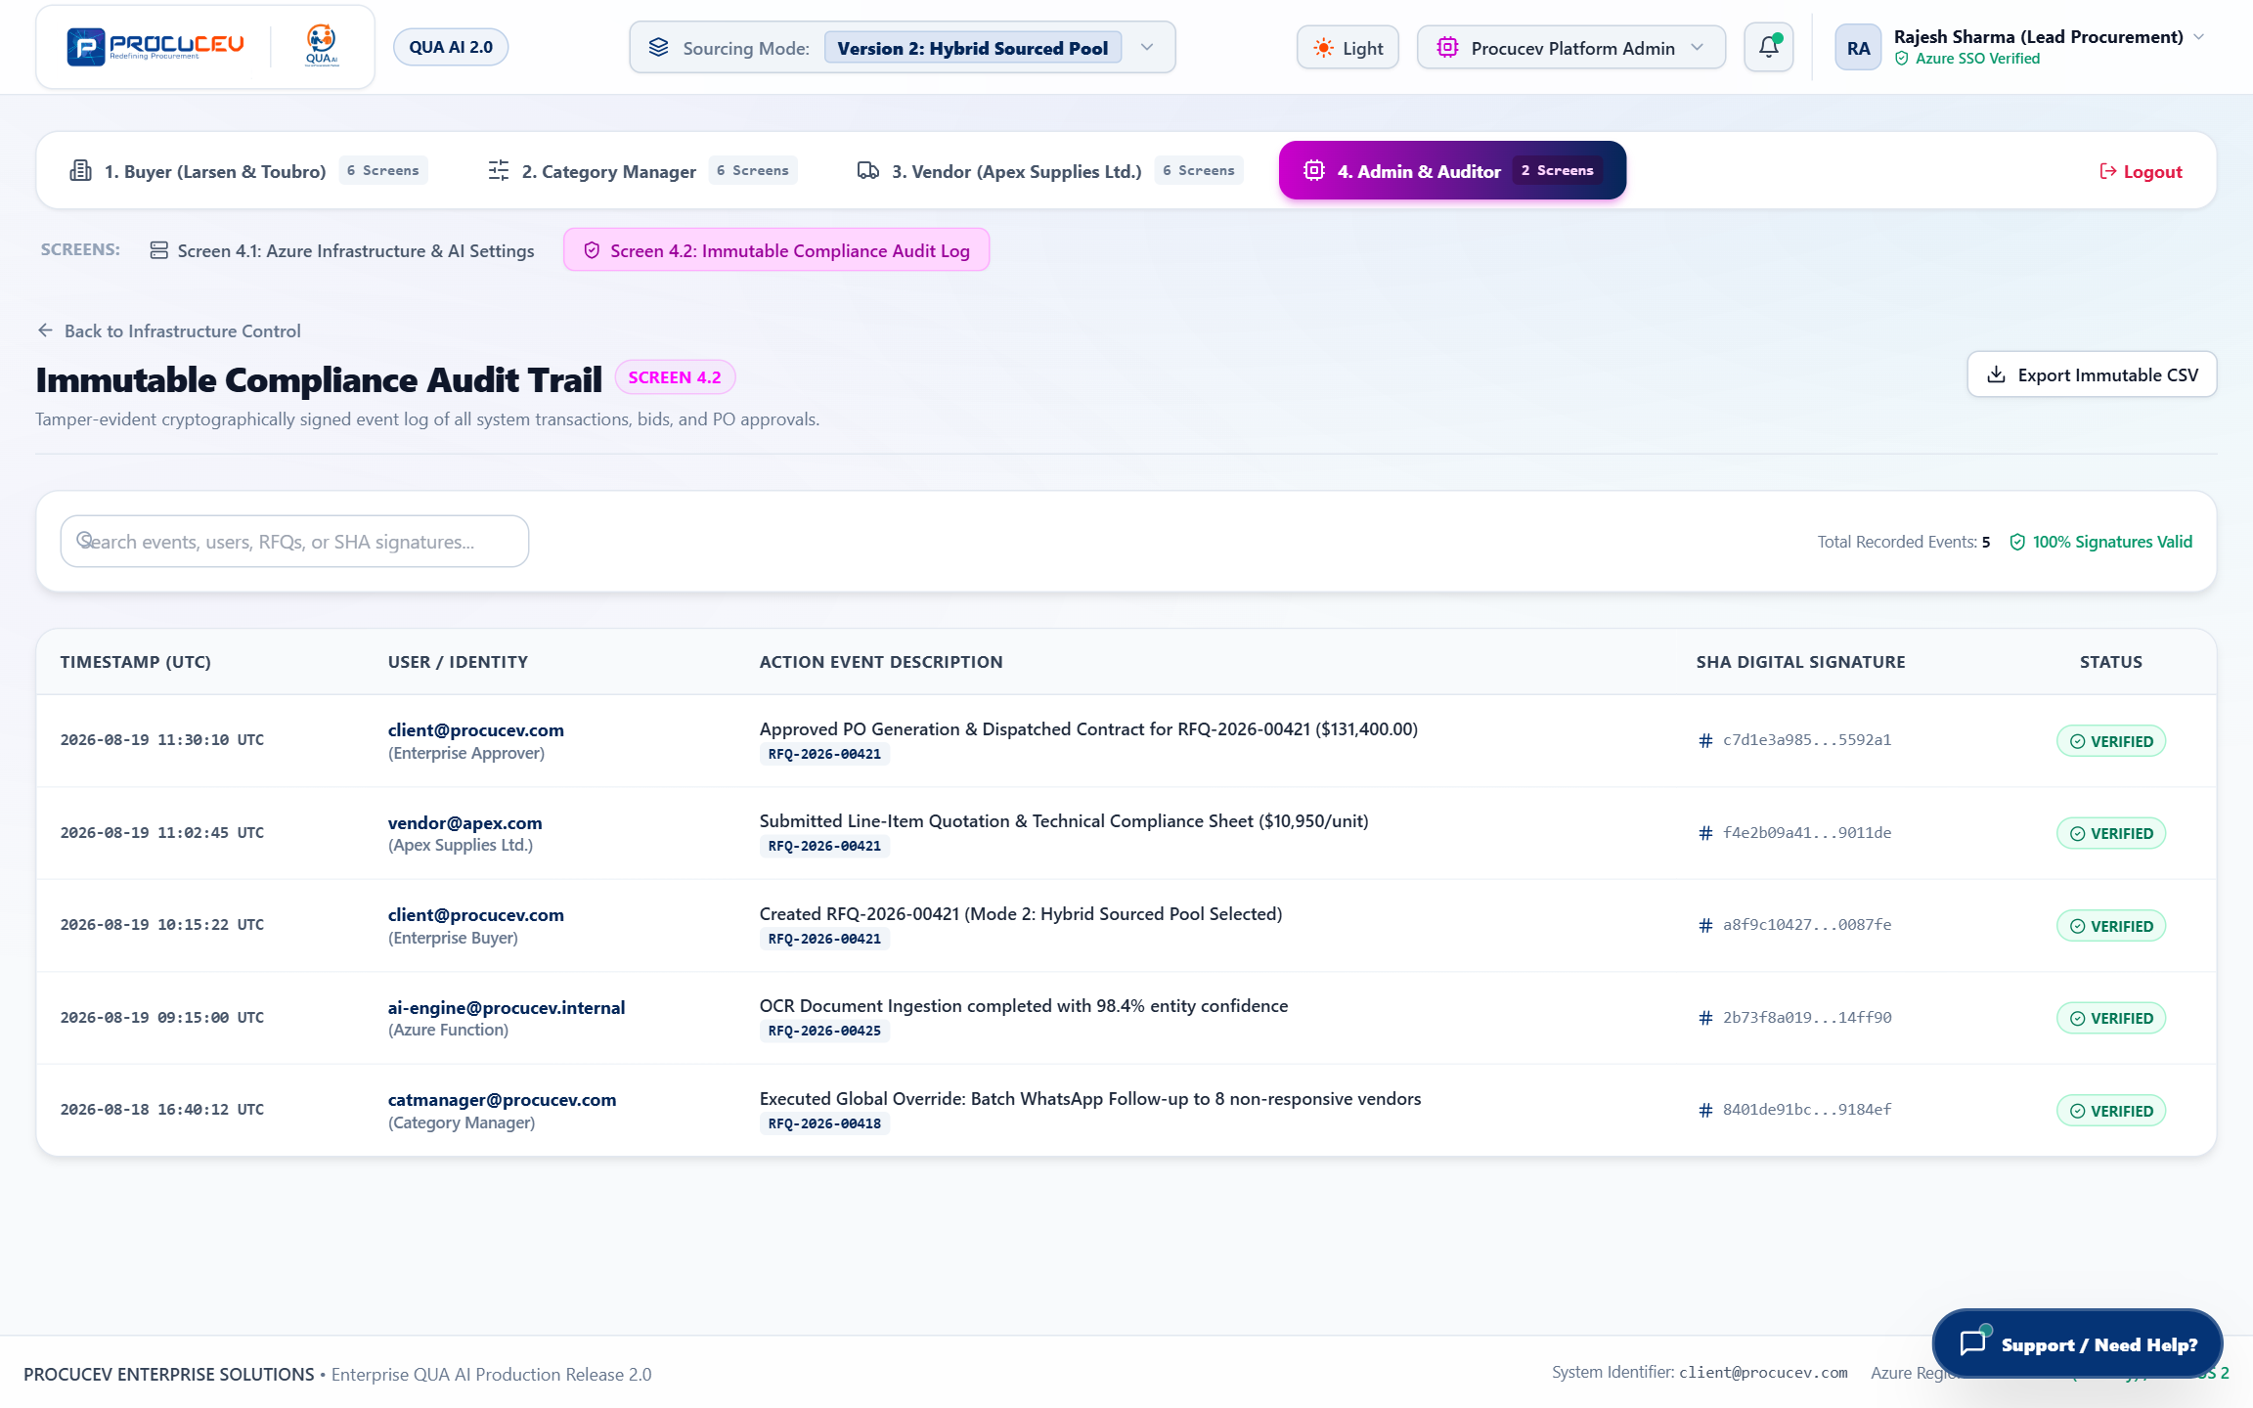
Figure: Autonomous AI Bot Activity Feed Drawer
Screen Highlights: Real-time streaming drawer displaying live autonomous multi-channel agent execution logs and timestamps.

8.2 Interactive AI Support Chat Assistant
An embedded conversational assistant capable of answering procurement queries, navigating sourcing modes, explaining score calculations, and assisting RFQ creation.
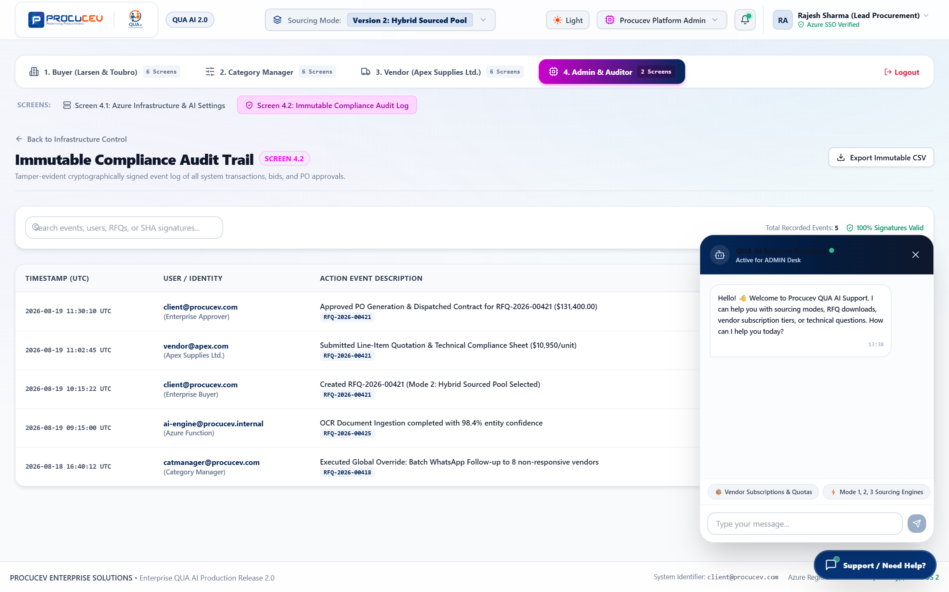
Figure: Interactive AI Support Chat Widget
Screen Highlights: Context-aware conversational assistant providing instant guidance, workflow shortcuts, and technical procurement help.

9. Enterprise Integration & Compliance Standards
Procucev Enterprise connects seamlessly with existing ERP, SCM, and financial management suites through RESTful APIs and webhook notifications.
Integration Interface | Protocol / Format | Target Enterprise System | Data Exchange Scope
ERP Ingestion API | RESTful JSON / OData | SAP S/4HANA, SAP Ariba, Oracle ERP Cloud | Purchase Requisitions (PR) import, PO export, and vendor sync.
Vendor Master Sync | OAuth 2.0 Webhook | Internal Master Data Management (MDM) | Mode 3 vendor qualification status and NABL document records.
Multi-Channel Gateways | Encrypted TLS 1.3 REST | Twilio Voice, WhatsApp Business Cloud, Airtel DLT | Voice audio transcripts, WhatsApp interactive payloads, SMS alerts.
Compliance Export | Cryptographic JSON / PDF | Enterprise SIEM & SOC Auditing Systems | Tamper-evident audit logs stamped with SHA-256 hash chains.
📌 Enterprise Compliance & Security Certifications
Procucev Enterprise meets ISO/IEC 27001:2022 standards for Information Security Management, SOC 2 Type II operational compliance, GDPR Article 32 data pseudonymization requirements, and TRAI DLT commercial communication mandates.

