|  |  |
| --- | --- |
| TS-7-01 | Login to Oracle Fusion Refer to TS-1 / TS-2 |

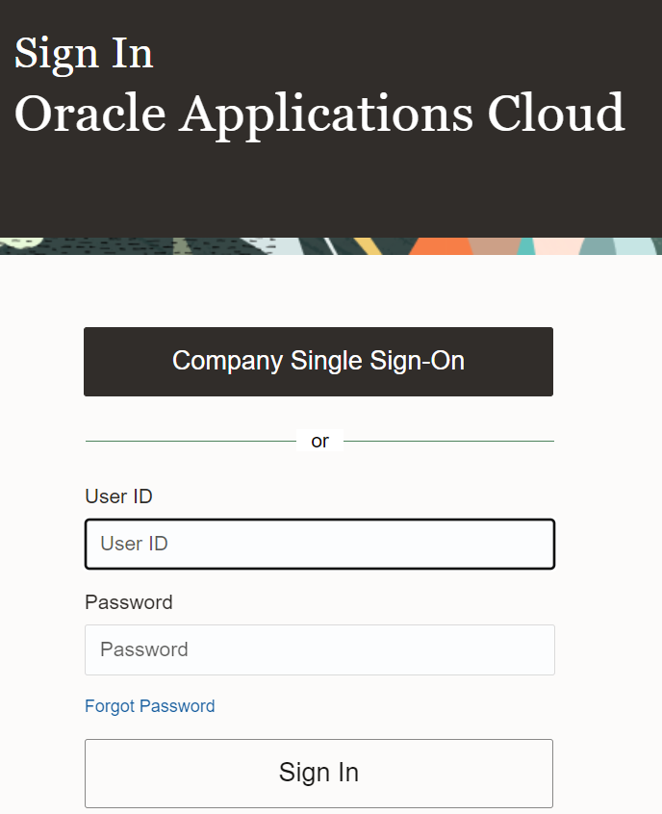

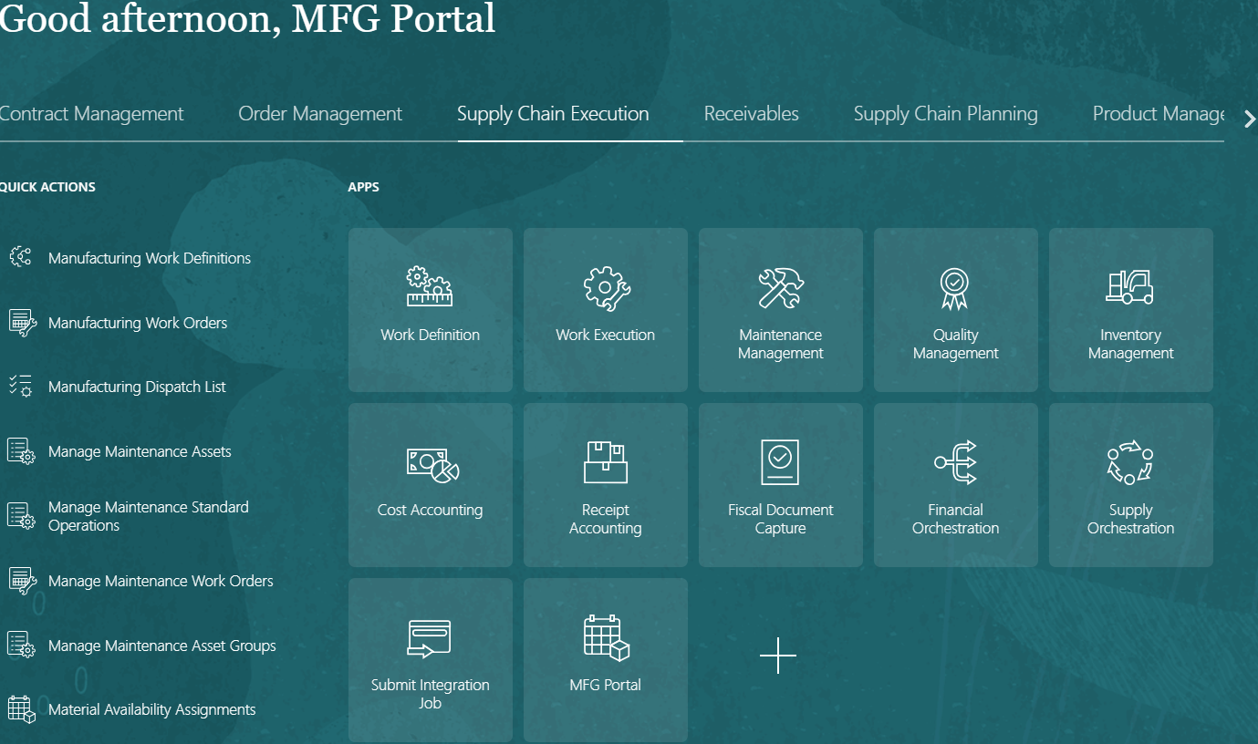

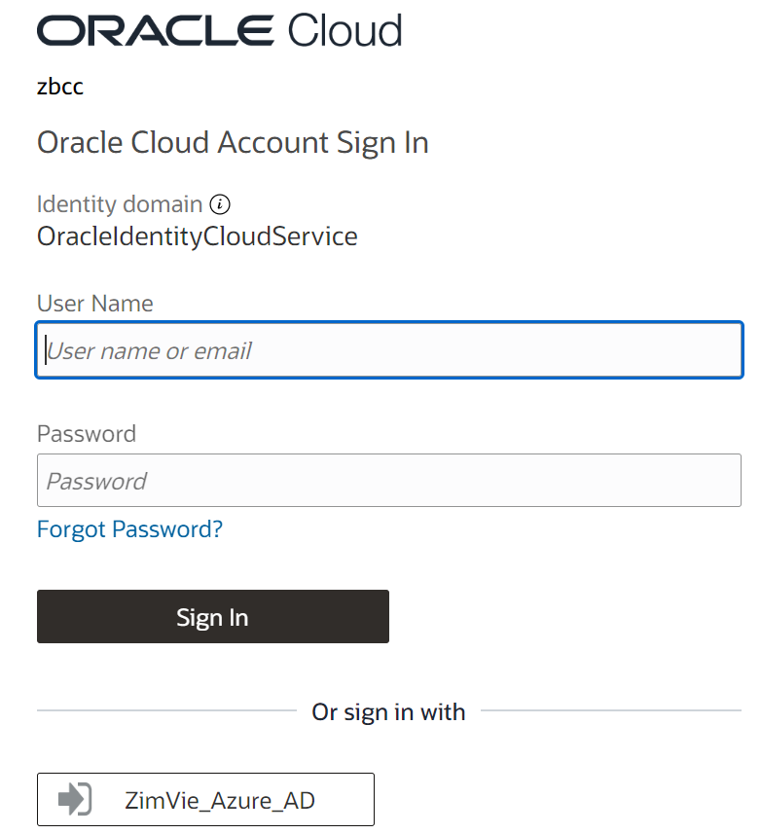

|  |  |
| --- | --- |
| TS-7-02 | Click on Search bar |

|  |  |
| --- | --- |
| TS-7-03 | Enter the Work Order Number |

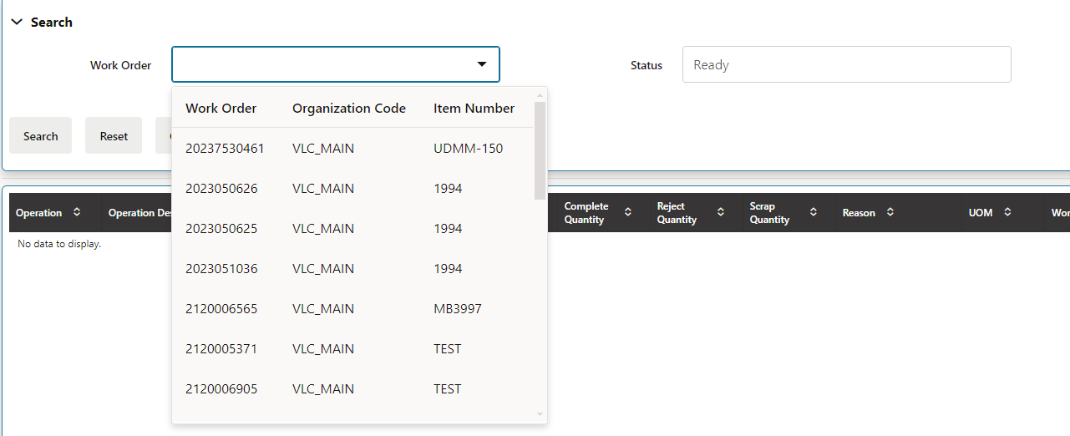

|  |  |
| --- | --- |
| TS-7-04 | Enter the Work Order Number |

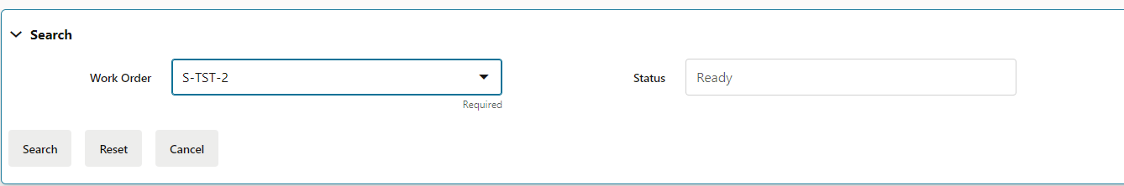

|  |  |
| --- | --- |
| TS-7-05 | Click on Search Button |

