MFG Portal Navigation Document

**LITE Solution for MFG Transactions to Zimvie**

**Document Information**

|  |  |
| --- | --- |
| Document Name | Zimvie Manufacturing Portal Navigation Document |
| Project Name | MFG Poral App |
| Client | ZimVie |
| Document Author | Partho / Virender / Ram |
| Document Version | 1.0 |
| Document Status | Draft |
| Date Released | 9/9/2024 |

**Document Edit History**

|  |  |  |  |
| --- | --- | --- | --- |
| Version | Date | Modifications | Revised By: |
| Draft | September 9, 2024 | Created initial draft | Ram Chaturvedi |
|  |  |  |  |
|  |  |  |  |
|  |  |  |  |
|  |  |  |  |
|  |  |  |  |

**Document Review / Approval History**

|  |  |  |  |
| --- | --- | --- | --- |
| Date | Name | Organization / Title | Comments |
|  |  |  |  |
|  |  |  |  |
|  |  |  |  |

**Contents**

1. Executive Summary 5

2. Introduction 6

3. Prerequisites and Key Features 7

Key Features of MFG Portal 8

4. MFG Application Navigations 9

5. High-Level Design 18

6. Application Detail Descriptions. 19

7. Other Considerations 20

8. Out-of-scope 21

9. Open/Close Issue 21

*IMPORTANT!*

**Note 1:** While a lot of effort has been put into this document to make it as generic as possible, you will inevitably find yourself adding additional sections or removing irrelevant ones, and that is perfectly fine.

**Note 2:** Make sure to read the article on documenting a solution design before attempting to use this document. Reading and understanding the article contents will allow you to achieve the intended purpose from documenting a good solution design.

**Note 3:** Make sure to use your company’s template if you have one.

# Executive Summary

ZimVie is a global life sciences leader in the dental market that develops, manufactures, and delivers a comprehensive portfolio of products and solutions designed to support dental tooth replacement and restoration procedures.

ZimVie’ s mission is to advance technology and clinical practices that are essential for restoring daily life. ZimVie has 1800+ employees world wide and ZimVie develops, manufactures, and delivers a comprehensive portfolio of products and solutions for dental tooth replacement and restoration procedures.

Currently they are using Oracle Cloud Fusion system to perform their transactions and Oracle fusion cloud enables Zimvie to track and execute manufacturing transactions. In this **MFG App** we will perform MFG transactions through custom screen.

# Introduction

* This document stats about MFG Application run book and how to execute this efficiently.
* In this document we have capture step by step procedures to run this MFG Application.
* The MFG Portal is a streamlined single-page application designed to simplify and optimize the completion of work orders in manufacturing environments. Built using Oracle Visual Builder Cloud Service (VBCS), the portal enables users to efficiently manage and execute work order operations with ease and precision.
* With a focus on user experience and operational simplicity, the MFG Portal allows users to perform essential tasks such as Complete, Scrap, and Reject operations on work orders without the concern of incurring additional licensing costs. This cost-effective approach provides manufacturers with the flexibility to manage production tasks without the complexities of traditional licensing models, making it a valuable tool for companies looking to enhance productivity while controlling overhead expenses.
* The portal supports Single Sign-On (SSO) for seamless user authentication, enabling quick and secure access to the system.

# Prerequisites and Key Features

Before utilizing the MFG Portal, the following prerequisites must be met to ensure smooth operation and access:

**SSO (Single Sign-On) Setup:** Ensure that Single Sign-On (SSO) is properly configured to allow multiple users to access the portal under a unified authentication system. This is prerequisite to have seamless connectivity between Azure AD, Oracle Fusion and OCI. We have been agreed on below 2 options.

* 1. New Tab cascading: On clicking on the MFG Portal Icon this will be opened in a new tab. At first time, it will redirect to login screen and user can click in AZURE AD or use credentials to login. MFG Portal will be in full screen page and will align better within browser window. also, link can be saved in browser to open directly and use IDCS/AZURE AD login to work.
  2. Desktop Icon Enablement: MFG portal Icon can be exposed as desktop icon and can be published to user's system then can click on icon and use login option to login and then work directly as standalone application. Easy access and login to MFG Portal directly.

**Oracle VBCS Access:** Users must have access to the Oracle Visual Builder Cloud Service (VBCS) platform, as the MFG Portal is built using this technology. VBCS is Oracle PaaS based service to orchestrate custom screens and easily pluggable into Oracle Fusion.

**User Role in Oracle Cloud:** “Zimvie MFG Portal” a custom role has been created to control the access to this MFG Portal form. This role must be assigned to users to ensure they can perform operations such as Complete, Scrap, or Reject on work orders using MFG portal application.

**Network Access:** Ensure that users have access to the organization’s network or cloud infrastructure where the MFG Portal is deployed. Please note that MFG Portal VBCS application should have deployed in OIC and pointed to current environment.

**Basic System Requirements:** Users must have an up-to-date web browser to access the single-page application without performance issues. Google Chrome and Microsoft Edge are the recommended.

**Key Features of MFG Portal**

The MFG Portal provides a range of essential features designed to simplify and enhance the work order management process in manufacturing environments. Key features include:

**Single Sign-On (SSO) Integration:**

The MFG Portal is integrated with SSO, allowing multiple users to perform work order operations under a single license, significantly reducing licensing costs. This system ensures secure access and eliminates the need for multiple individual licenses, offering a scalable and cost-effective solution for manufacturers.

**Effortless Work Order Operations:**

The MFG Portal enables users to perform Complete, Scrap, or Reject operations on work orders with ease. The intuitive design and user-friendly interface ensure that these critical actions can be completed efficiently and accurately, minimizing errors and maximizing productivity.

**Cost-Effective Licensing Model:**

By leveraging SSO, the MFG Portal enables organizations to manage work order operations without the expense of multiple software licenses, ensuring that teams can operate efficiently within budget constraints.

**User-Friendly Interface:**

Designed with simplicity in mind, the portal’s single-page application provides a seamless experience, allowing users to quickly navigate and complete tasks without extensive training or technical expertise.

**Real-Time Operational Efficiency:**

The MFG Portal facilitates real-time execution of work order actions, helping manufacturing teams keep track of progress and ensuring timely completion of tasks. This ensures that production processes run smoothly with minimal delays.

By meeting these prerequisites and leveraging the portal’s key features, manufacturers can significantly streamline work order operations, reduce costs, and enhance operational efficiency.

# MFG Application Navigations

* **Sign-In to Oracle Instance:** The first step is to sign into the Oracle instance to access the VBCS application.

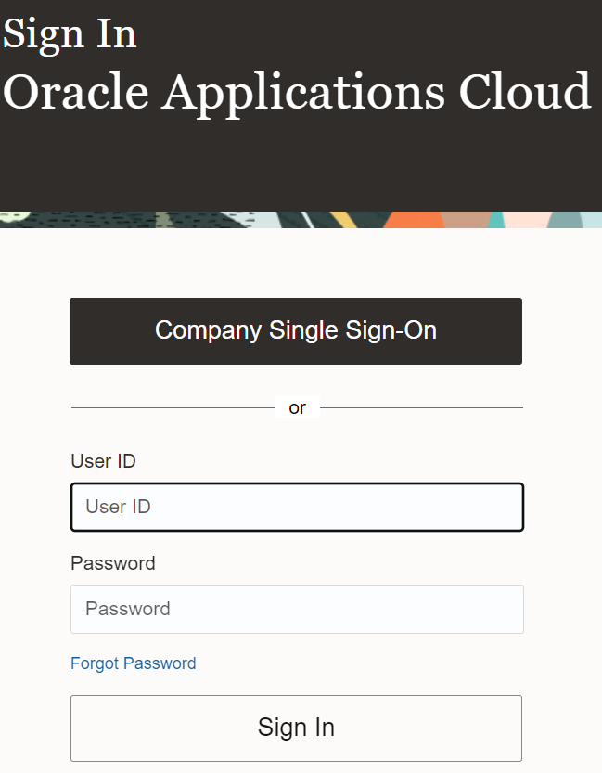

* **Navigate into:** Once logged in, navigate to the **Supply Chain Executive** tab within the Oracle instance and select the **MFG Portal** application to begin managing manufacturing operations.  
   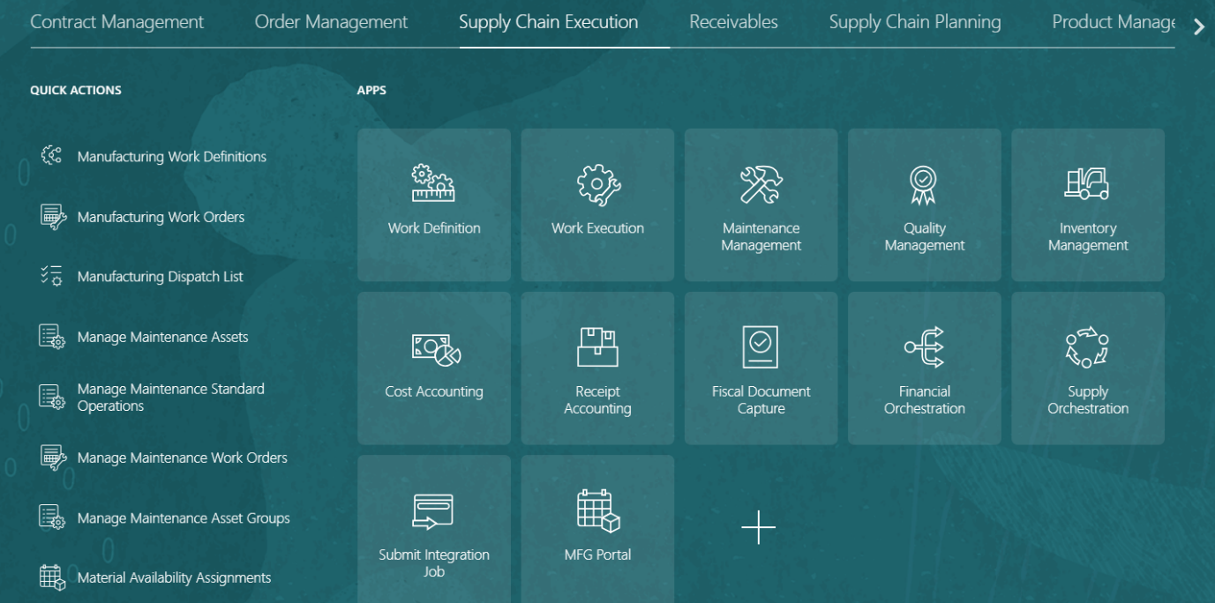
* **Sign-In to MFG Portal:** To access the system, users are required to enter their OIC credentials on the sign-in page. These credentials ensure secure authentication and grant access to the relevant features and data.

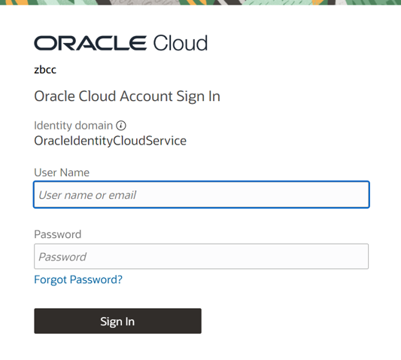

Fields and their descriptions/purpose are described below.

|  |  |  |
| --- | --- | --- |
| # | Field | Description |
| 1 | Work Order | This is mandatory search parameter. User can enter/scan the WO number from dispatch list. |
| 2 | Status | Fixed value. WO where operations are in Ready status can be searched. Other WO status are restricted. |
| 3 | Search | The "Search" button allows you to find a specific Work Order to perform operations on. |
| 4 | Reset | The "Reset" button clears the current search fields, enabling you to search for new Work Orders. |
| 5 | Cancel | The "Cancel" button use to clear the search result. |

* **Home Page:** Users are restricted to searching for Work Orders that are in the **Ready** state. This ensures that only active and actionable Work Orders are available for processing, streamlining the workflow and reducing errors.

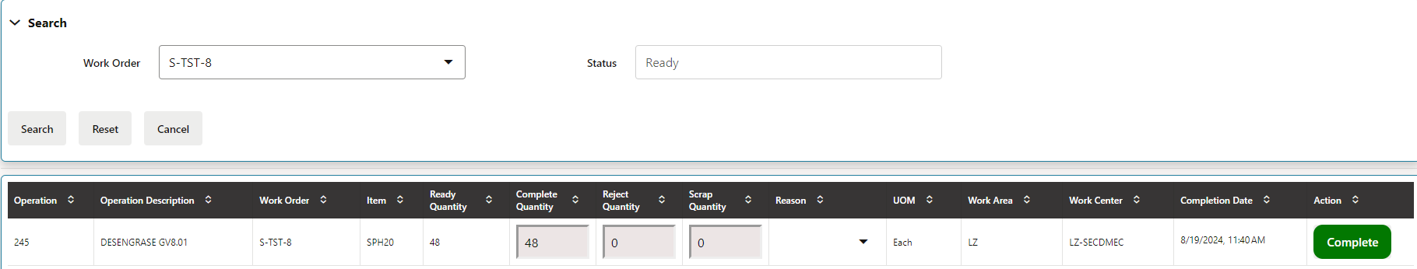

If a user searches for a Work Order and the operation is associated with the "GEN ALM" Work Center, a popup will appear with the message: **"Ready: The operation is in the 'GEN ALM' Work Center."** This notification informs the user that the operation cannot proceed due to the specific Work Center.

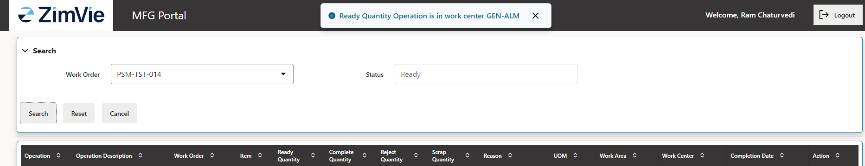

* **Complete:**

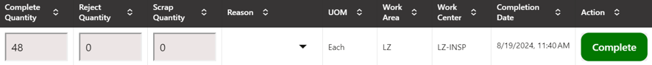Once a specific Work Order is searched, a "**Complete**" button will appear on the right side of the screen. If a Lot is assigned to the Work Order, clicking the "**Complete**" button will take the user to the **Work Order component details page**, where they can review the Lot number before finalizing the completion. If no Lot is assigned, the Work Order will be completed immediately upon clicking the button, streamlining the process.

* **Work Order Component Details:**

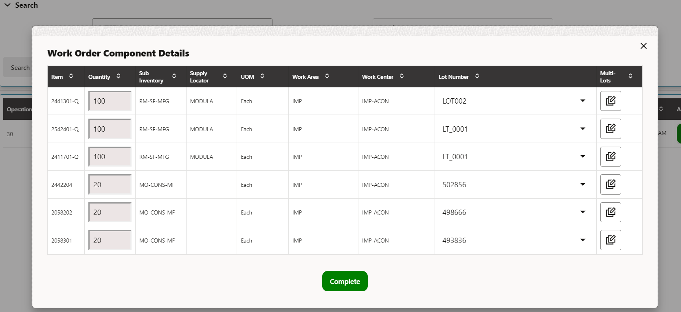This page is displayed only when Lots are available for the selected Work Order. On this page, users can review the assigned Lot numbers and proceed with finalizing the Work Order completion. The **Subinventory** and **Locator** fields are automatically derived from the Work Order definition and are fixed, ensuring consistency. Users are not permitted to modify these values, maintaining alignment with predefined Work Order configurations.

* **Multi-lot selection:** Users can assign quantities to multiple lots by clicking the "Multi-Lot Selection" button. This feature allows for the efficient allocation of quantities across various lots, streamlining the process.

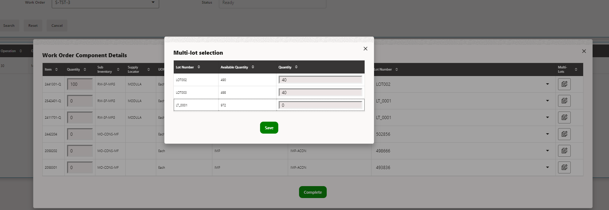

**Transaction Executions**

* Enter the Work Order Number 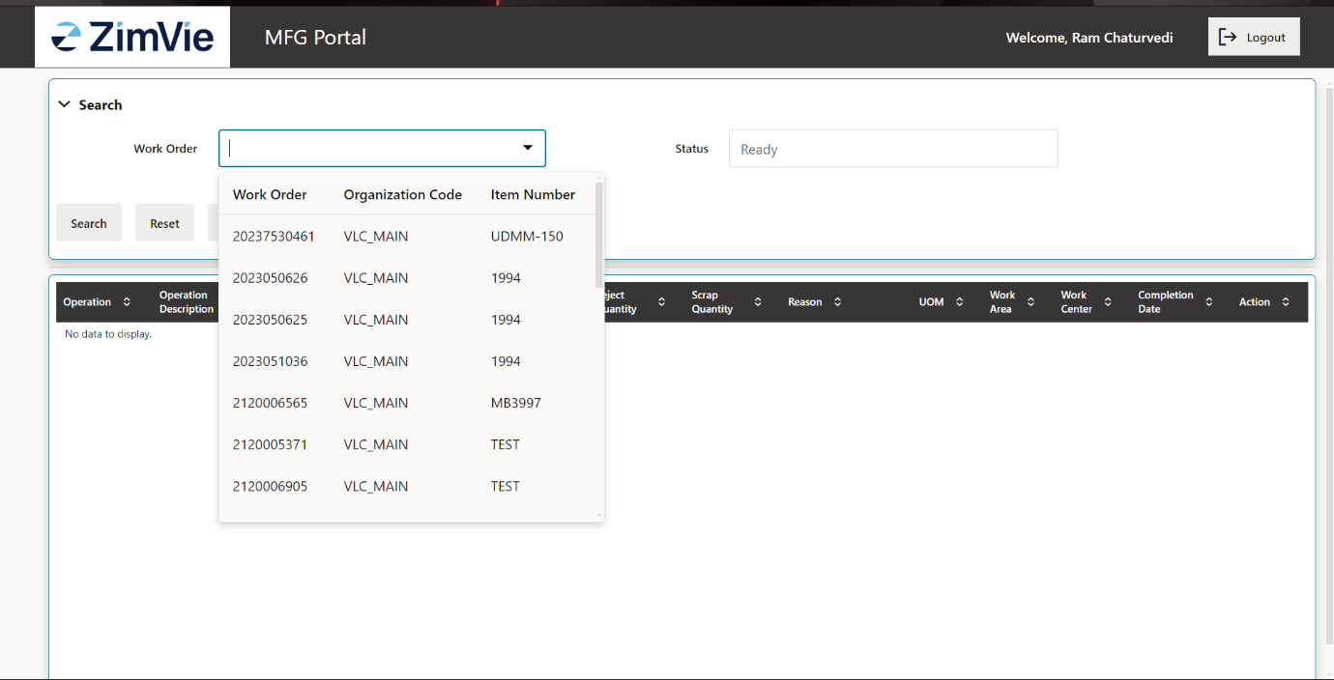
* Select the Work Order From the list below search bar

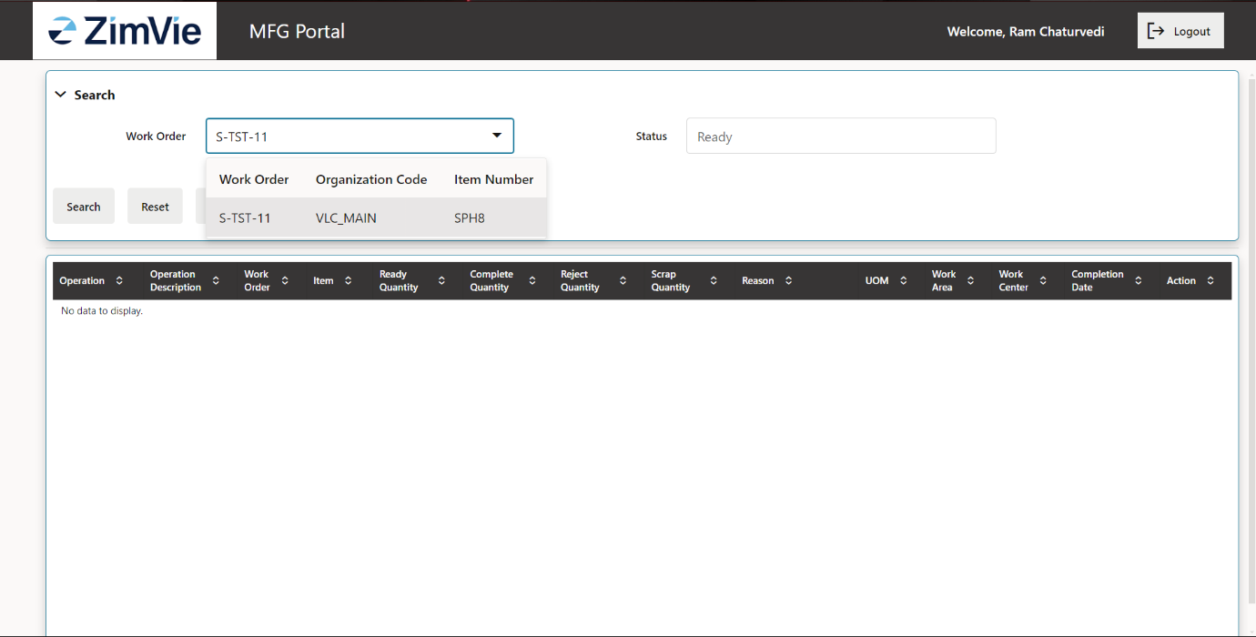

* Click on search button and operation in ready state appears as below 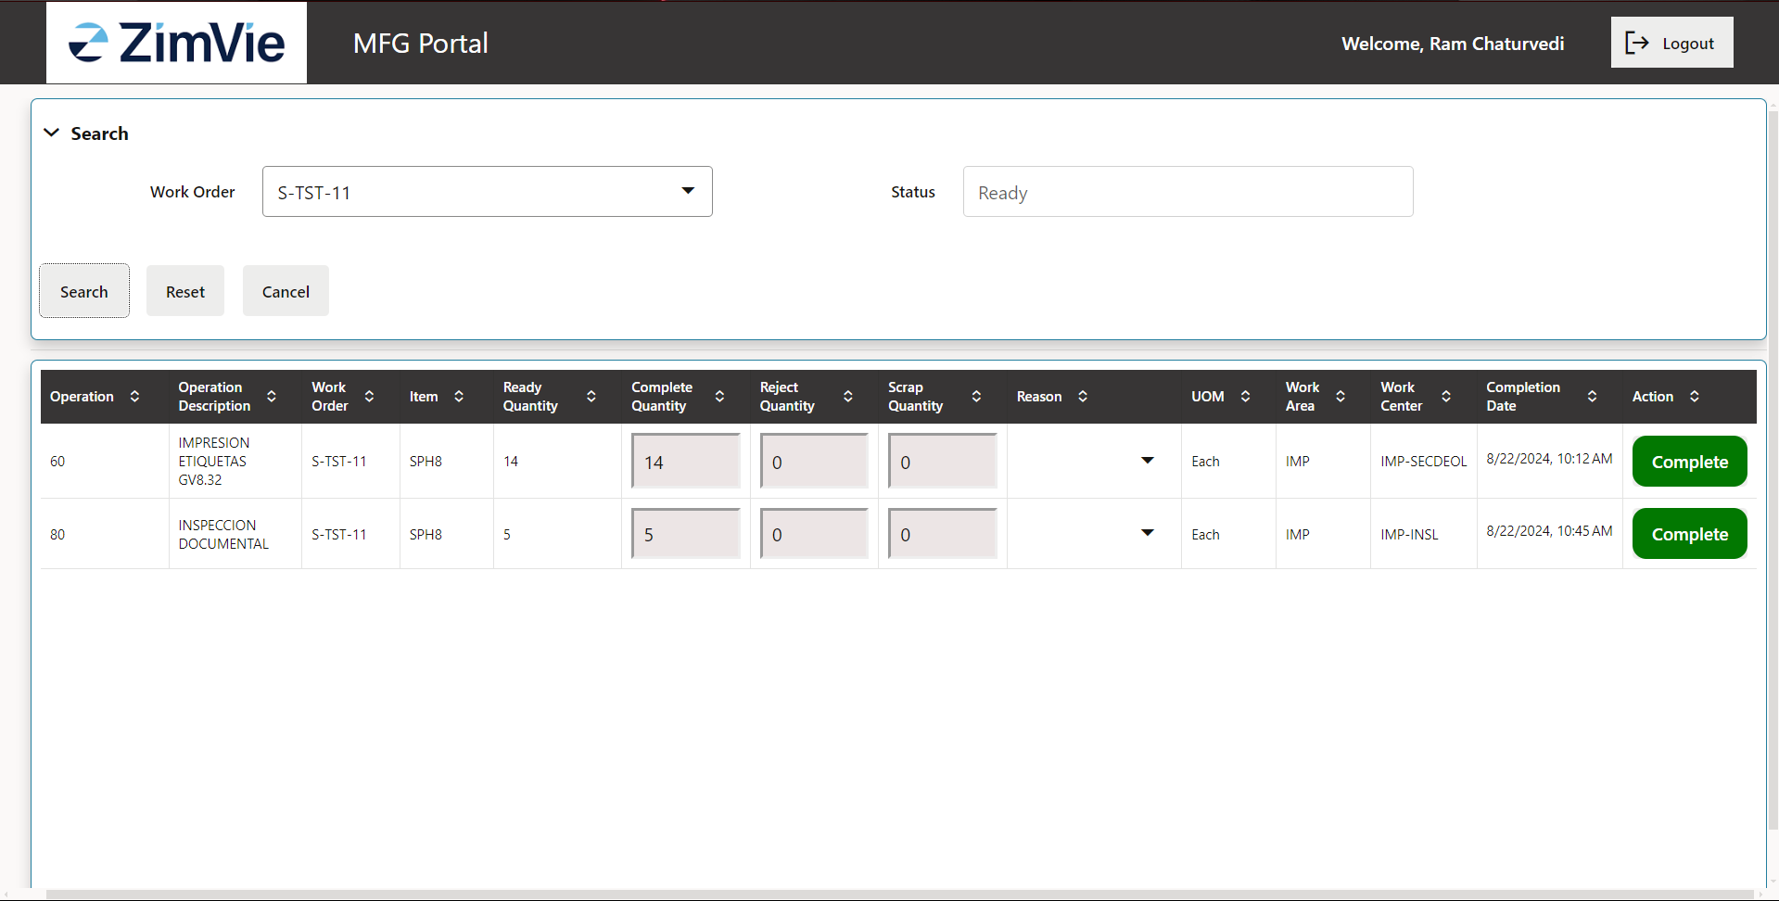
* Enter the Quantity whether to complete or scrap or reject
* Click on complete button, if the operation has lot then the component details tile will appear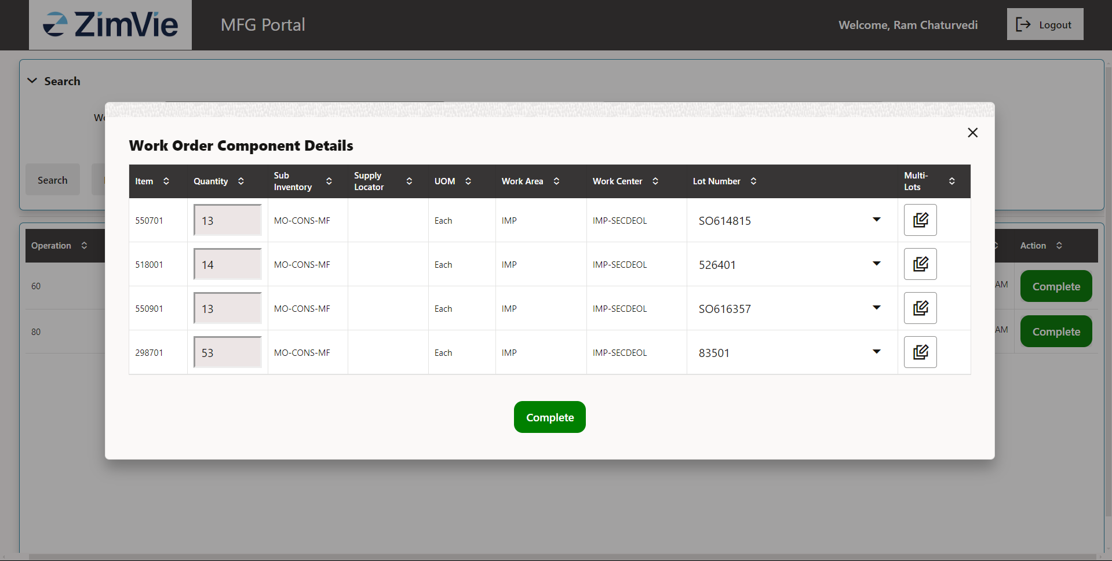
* To record scrap, users must enter the **scrap quantity** and provide a **reason for the scrap**. This ensures accurate tracking of material loss and allows for detailed reporting and analysis of the reasons behind the scrap

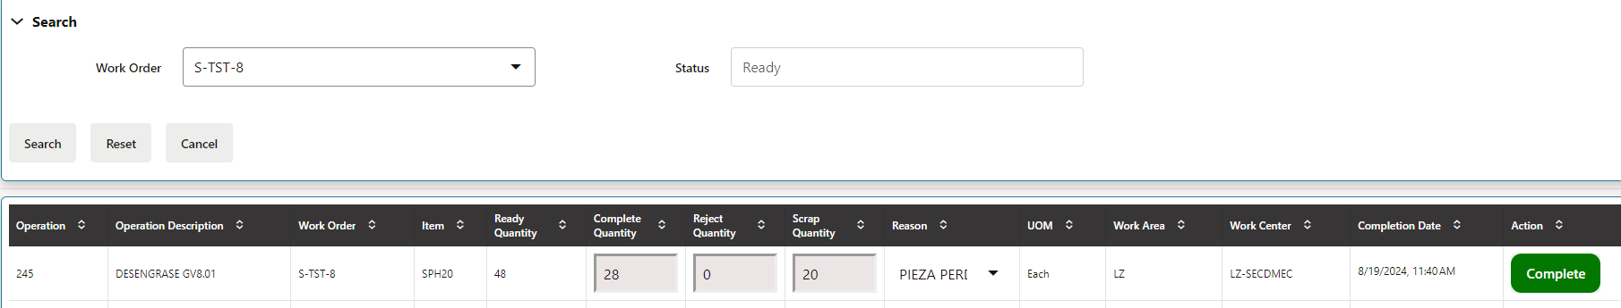

* Select the lot number 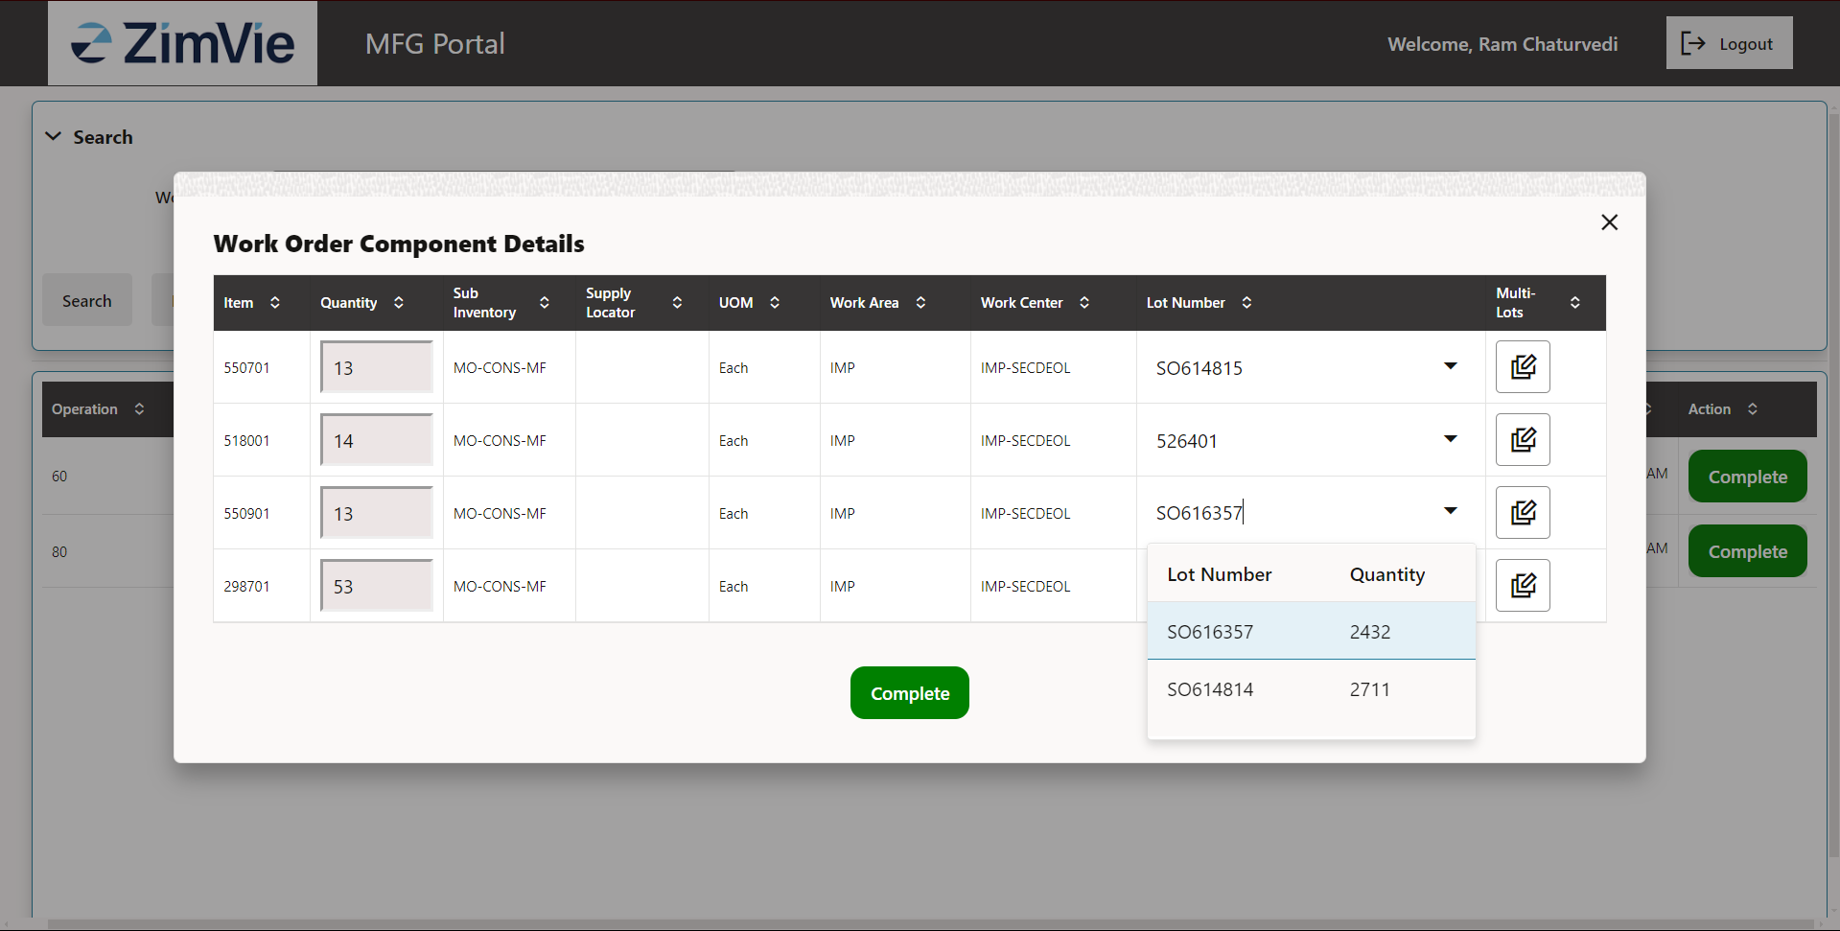
* Click on complete button 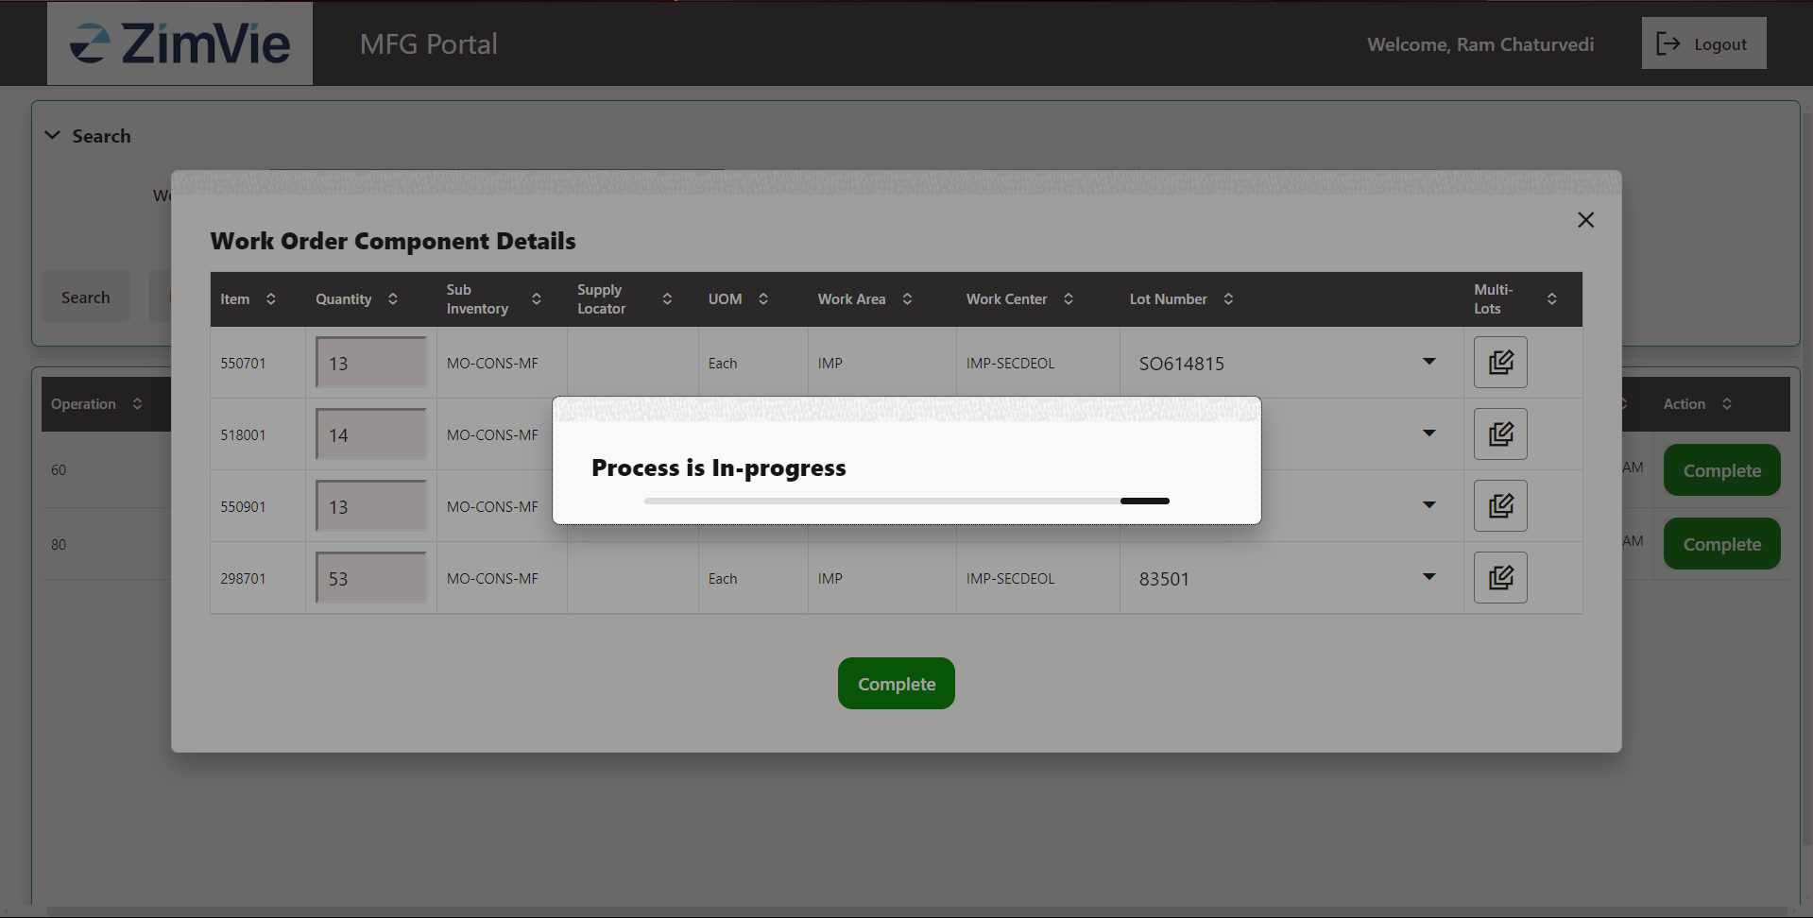
* And then operation will be completed 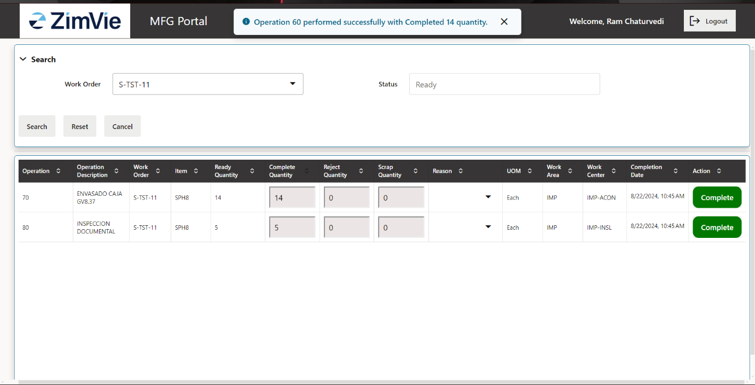
* Once the operation is completed, one can go for next operation and if the operation does not have lot details, then after clicking on complete button operation will be completed 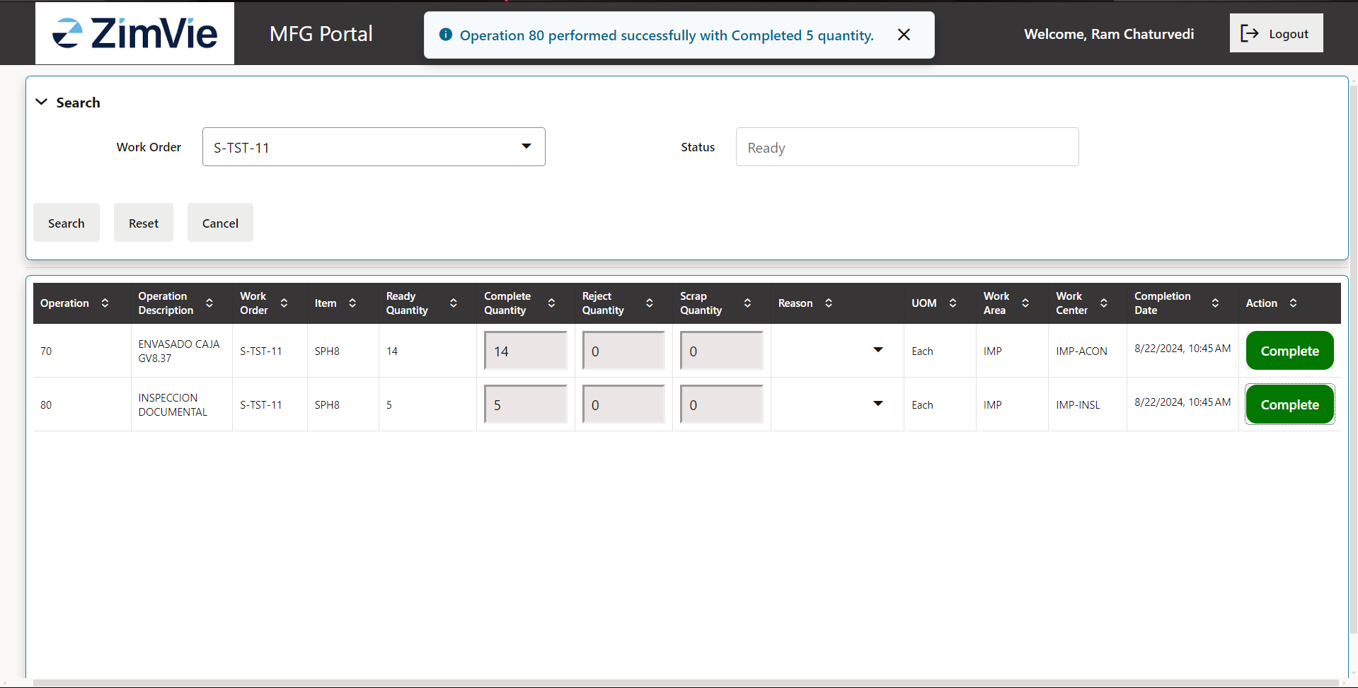
* If the quantity entered is more than available quantity it will show error

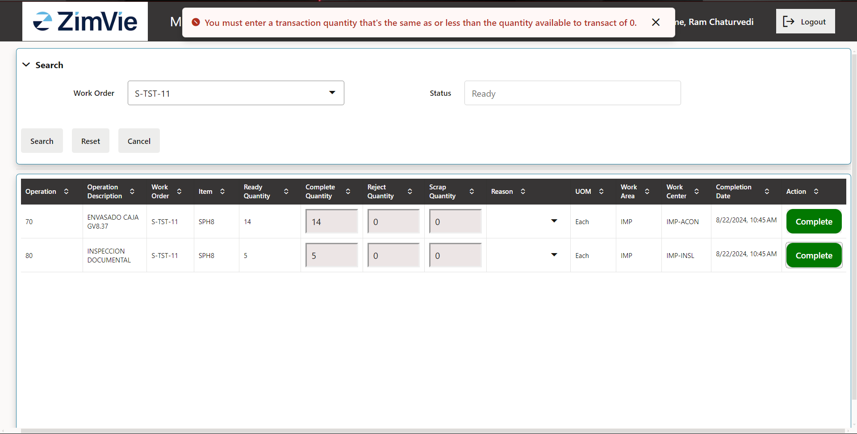

* Username and Transaction history: To verify the **Username** and review the **Transaction History**, users can navigate to the specific Work Order within the Oracle instance.

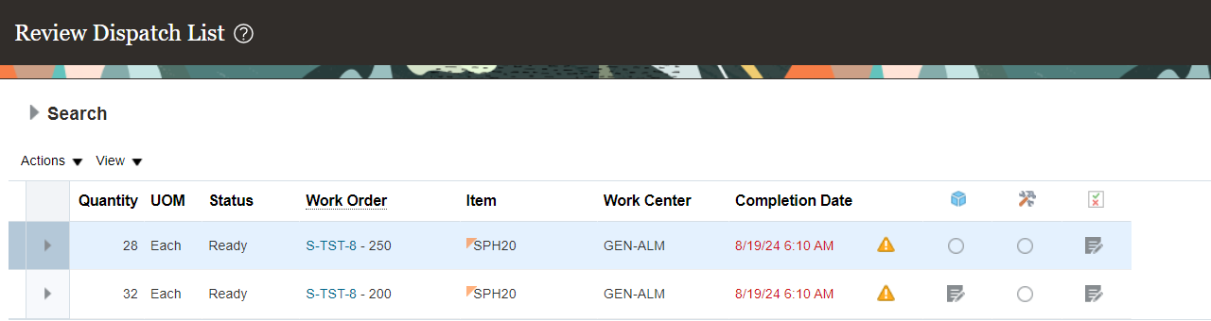

Within the **Work Order**, the **Transaction History** section provides a detailed record of all transactions related to the Work Order. Users can review key activities, including material movements, completions, and any adjustments, offering full visibility into the lifecycle of the Work Order.

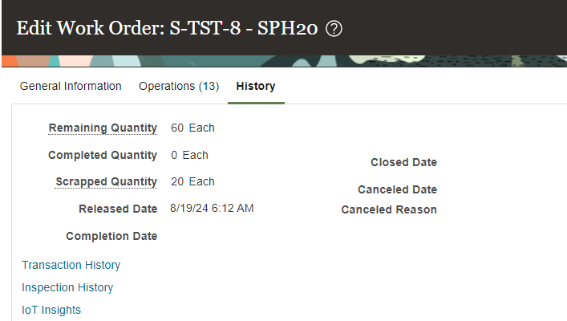

On the far right side of the **Transaction History** section, users can access **Additional Details** to check the associated **Username** for each transaction. This feature allows users to identify who performed specific actions, providing greater transparency and accountability.

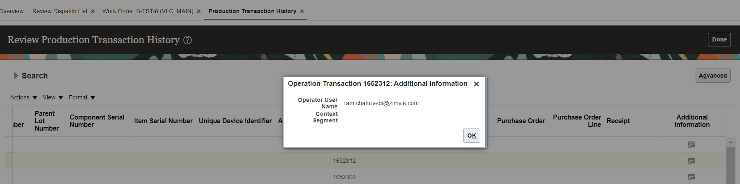

* Debug and tracing details: Navigate to **Oracle Integration Cloud (OIC)** and enter your credentials to access the platform. This login step ensures secure authentication.

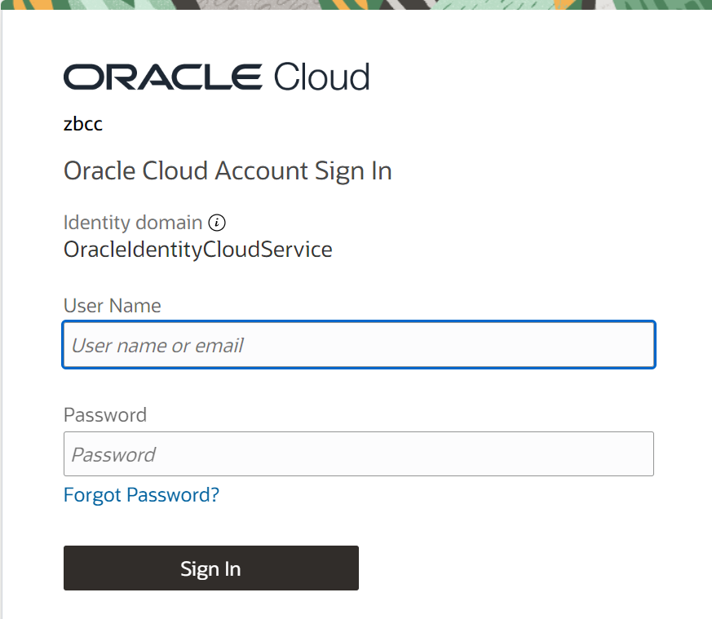

Click on the **hamburger icon** (three horizontal lines) and select **Integration** from the menu. This will direct you to the Integration section, where you can manage and configure your integration tasks and settings.

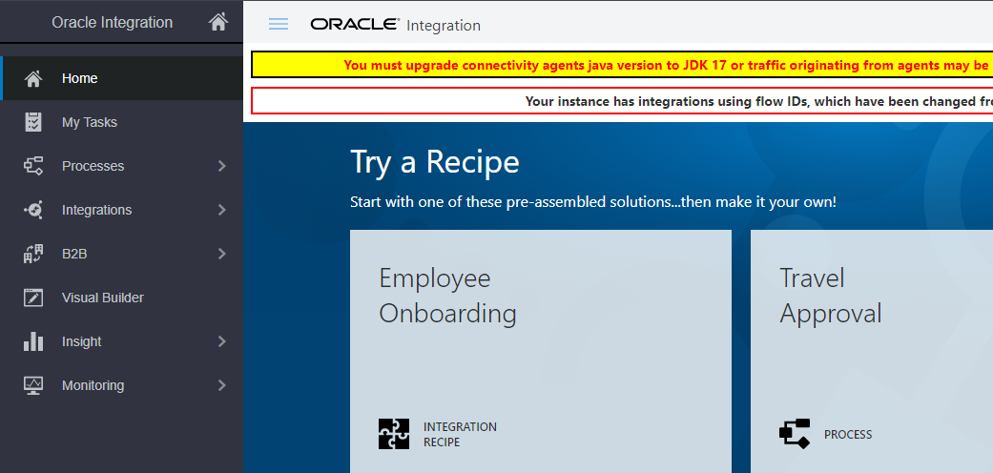

From the menu, select **Monitoring**.

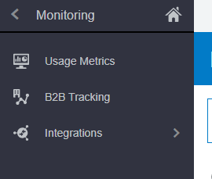

Navigate to the **Integrations** section and select the **Integrations** option within it.

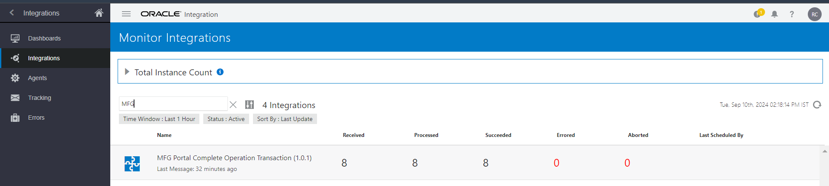Search for **MFG** in the available integrations. Once you locate it, click on the corresponding **number** to access the Succeeded integration details.

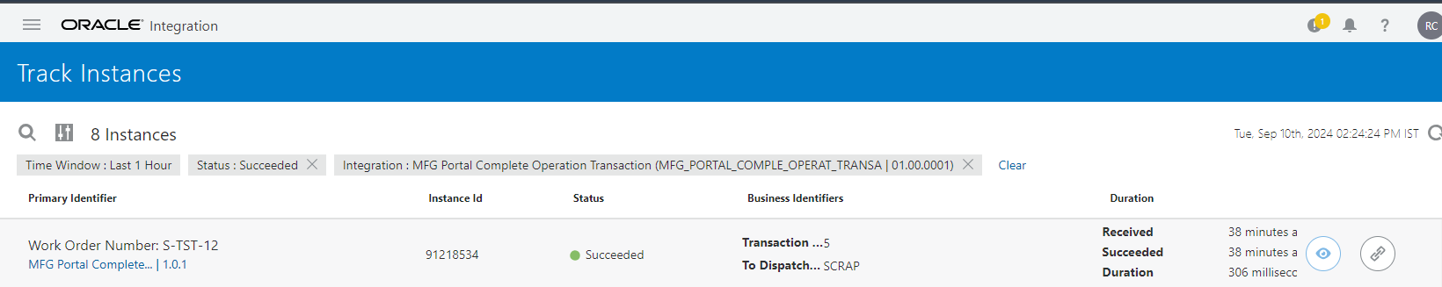Once you click on the **succeeded** integration, select any Work Order from the list. To track the Work Order, click on the **eye icon** that appears on the far right side. This will allow you to view detailed information and monitor the status of the Work Order.

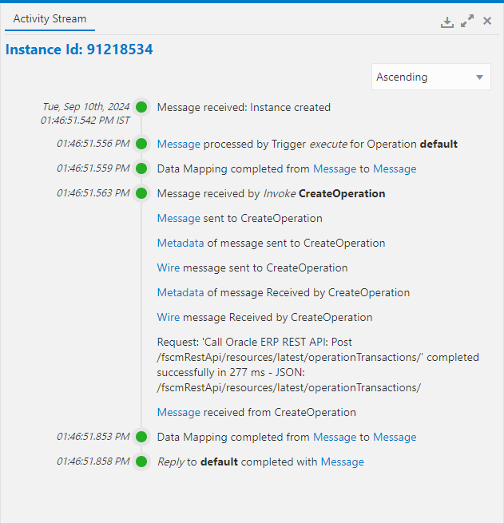

From this view, you can track all operations performed on the selected Work Order. This provides a comprehensive overview of each action and its status, allowing for detailed monitoring and management of the Work Order’s lifecycle.

# Application Detail Descriptions.

* This can be achieved via flowcharts, pseudo-code, and flowchart diagrams.
* The aim is to pinpoint expected source code files, data model tables, and functions to be modified.
* It will also give testers an idea of the scope of change and help drive the overall testing effort.
* This section equally covers exception handling and negative scenarios.

# Other Considerations

* Discusses the impact on existing versions of the product already in production. It also discusses any possible degradation or interruption of service after the upgrade.
* It can take the form of a bidirectional traceability matrix. The latter is extremely useful in linking business requirements to pieces of code and specific test cases and user documentation.
* We need to have a separate BI/OTBI report to capture the transaction creation and performed by details.

# Out-of-scope

* Essential for a mutual understanding of what will not be covered in the current project.
* It helps avoid misunderstandings and potential "free work".

While the MFG Portal offers streamlined functionality for executing work order operations, certain aspects of work order management remain out of scope. These include:

* **Creation of Work Orders:**

The portal does not facilitate the creation of new work orders. Users are required to generate work orders through external systems, and the MFG Portal is designed to handle only the execution of pre-existing work orders.

* **Updating Work Orders:**

The MFG Portal does not allow for updating or modifying existing work order details. Operations are limited to completing, scrapping, or rejecting work orders as they are, without altering any attributes within the work order.

By understanding these limitations, users can better leverage the MFG Portal’s capabilities for work order execution, while utilizing other systems or processes for activities outside the portal’s scope.

# Open/Close Issue

|  |  |  |  |
| --- | --- | --- | --- |
| **SQ** | **Issue** | **Status** | **Date** |
|  |  |  |  |
|  |  |  |  |
|  |  |  |  |