|  |  |
| --- | --- |
| TS-3-01 | Login to Oracle Fusion Refer to TS-1 / TS-2 |

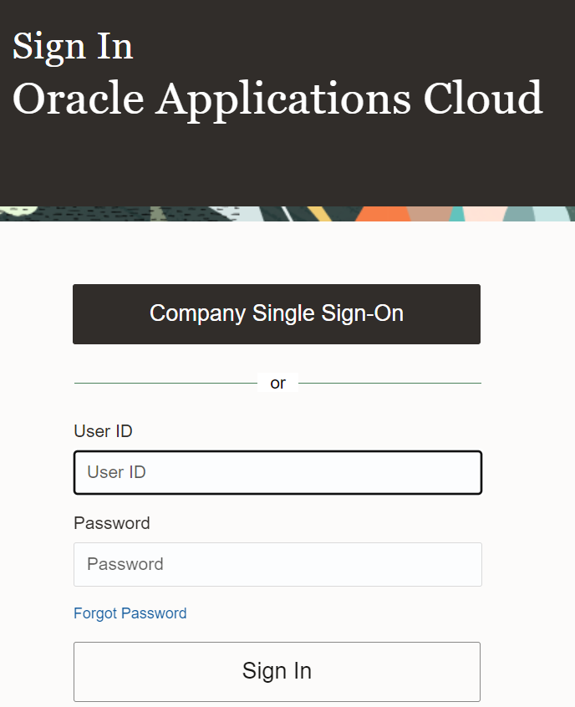

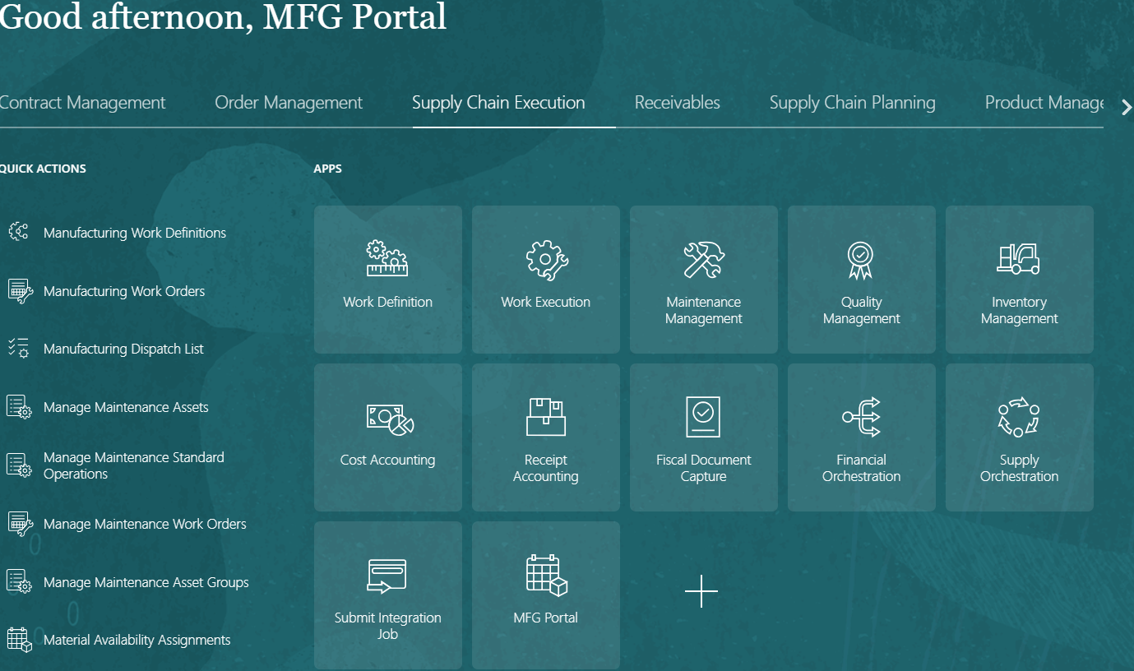

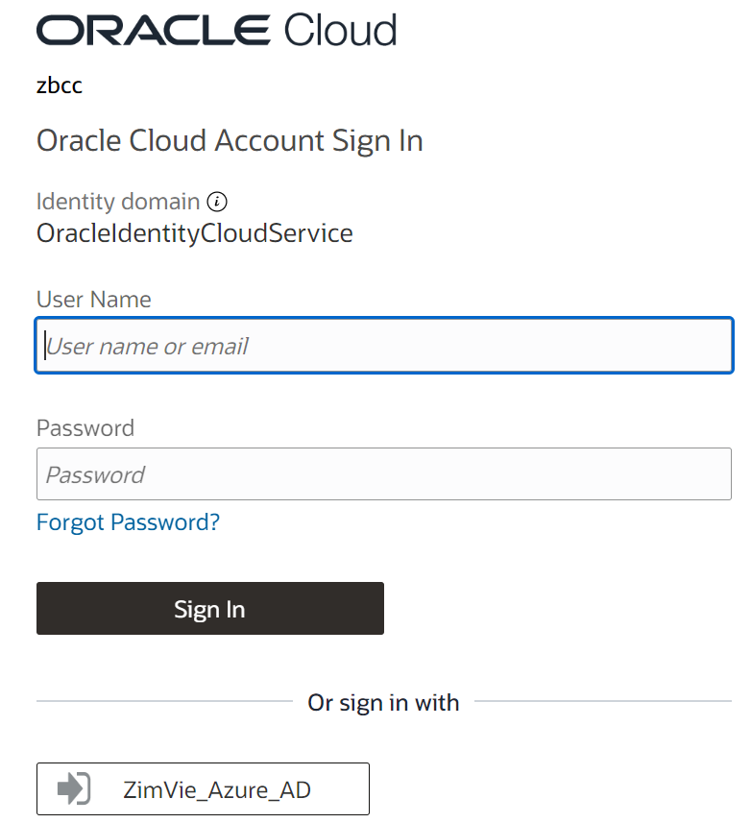

|  |  |
| --- | --- |
| TS-3-02 | Click on Search bar |

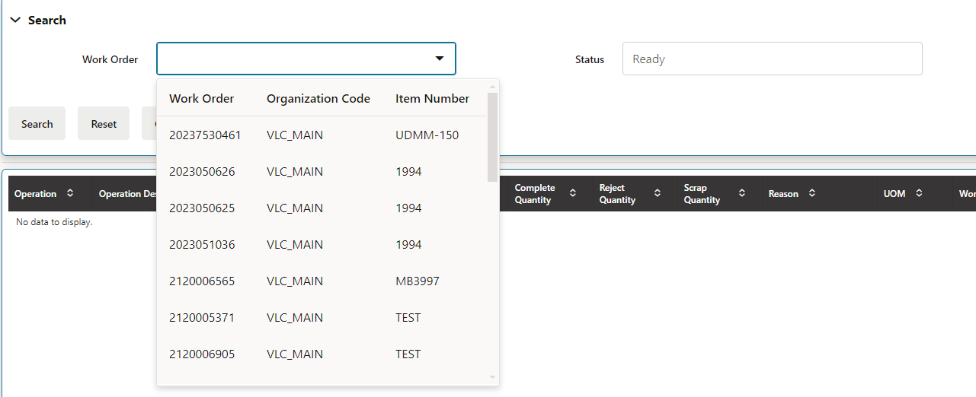

|  |  |
| --- | --- |
| TS-3-03 | Enter the Work Order Number in MFG Portal which is in Unreleased status in Cloud |

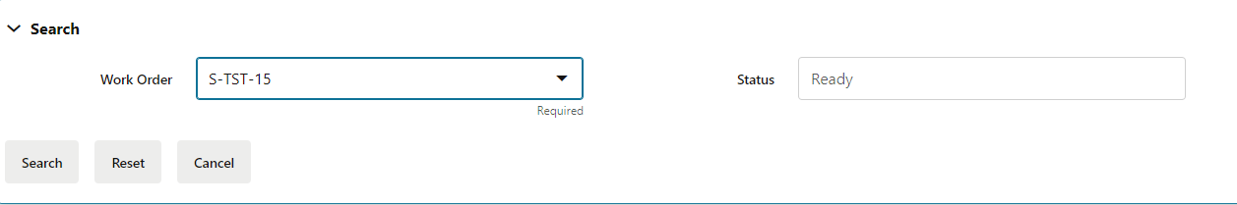

|  |  |
| --- | --- |
| TS-3-04 | Enter the Work Order Number in MFG Portal which is in Released status in Cloud |

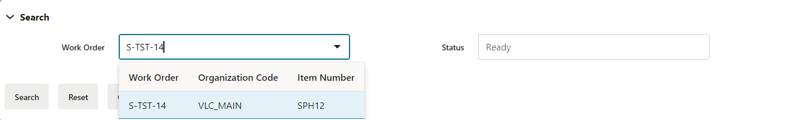

|  |  |
| --- | --- |
| TS-3-05 | Enter the Work Order Number in MFG Portal which is in On Hold status in Cloud |

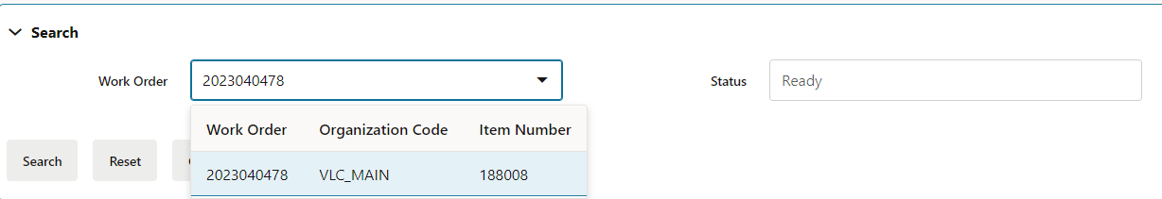

|  |  |
| --- | --- |
| TS-3-06 | Enter the Work Order Number in MFG Portal which is in Completed status in Cloud |

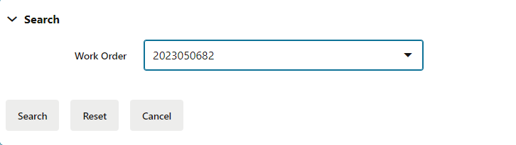

|  |  |
| --- | --- |
| TS-3-07 | Enter the Work Order Number in MFG Portal which is in Closed status in Cloud |

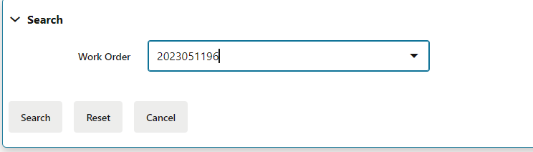

|  |  |
| --- | --- |
| TS-3-08 | Enter the Work Order Number in MFG Portal which is in Cancelled status in Cloud |

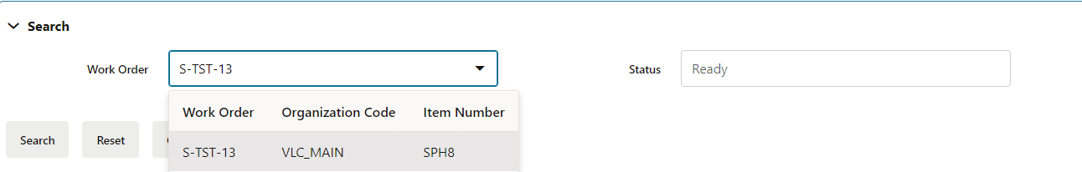

|  |  |
| --- | --- |
| TS-3-09 | Select WO and Default Status as 'Ready' and Click on Search Button |

