|  |  |
| --- | --- |
| TS-5-01 | Login to Oracle Fusion Refer to TS-1 / TS-2 |

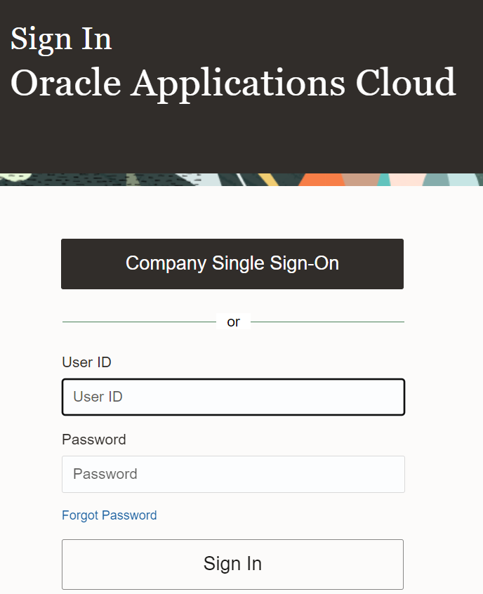

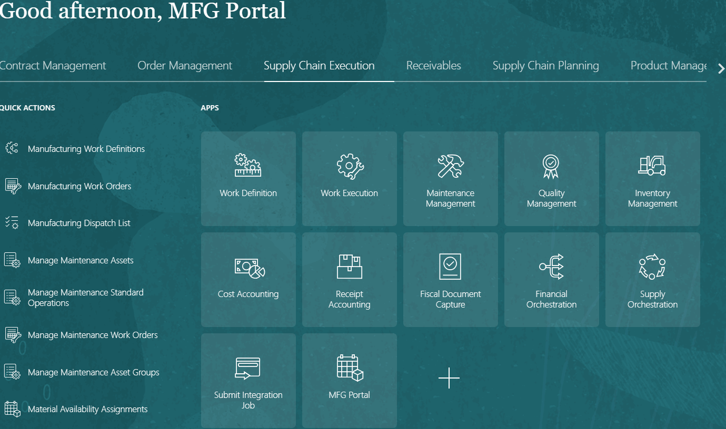

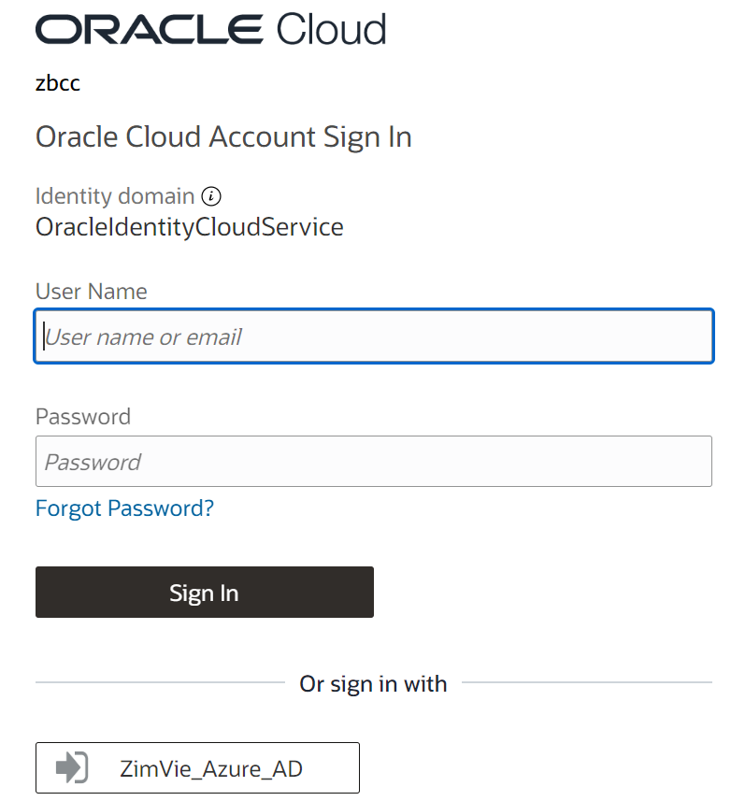

|  |  |
| --- | --- |
| TS-5-02 | Click on Search bar |
| TS-5-03 | Enter the Work Order Number |

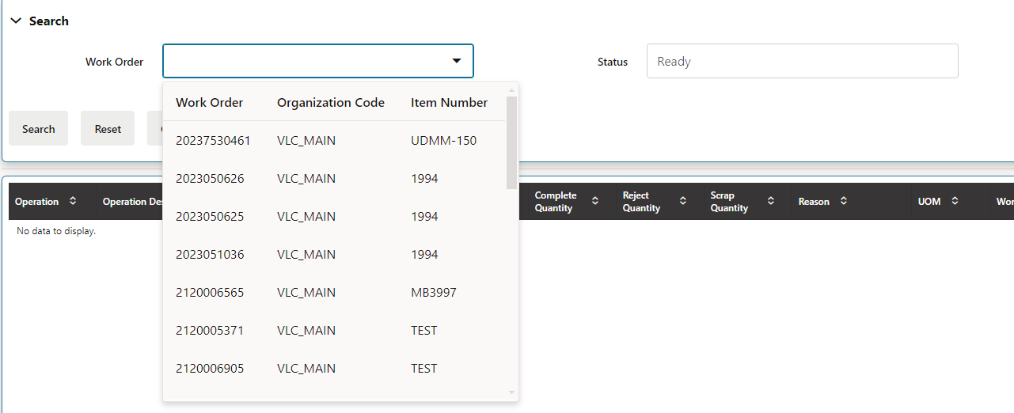

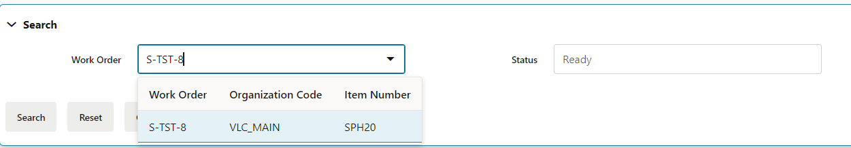

|  |  |
| --- | --- |
| TS-5-04 | Select the Work Order from the List |

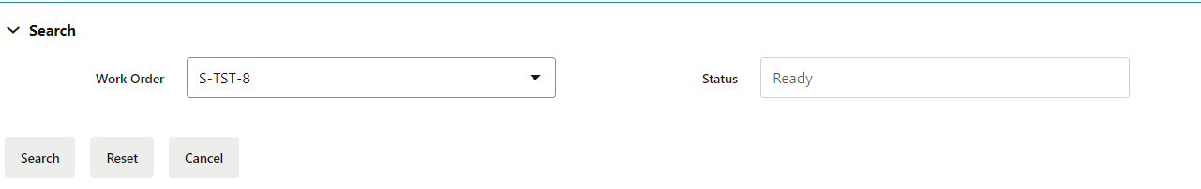

|  |  |  |
| --- | --- | --- |
| |  |  | | --- | --- | | TS-5-05 | Select the operation and click on complete button | |

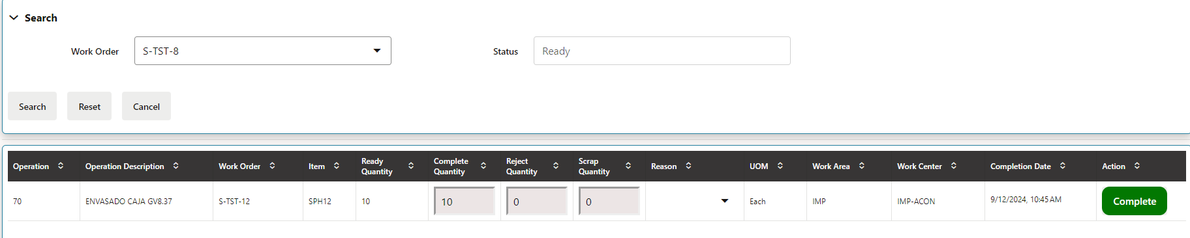

|  |
| --- |
|  |

|  |  |
| --- | --- |
| TS-5-06 | Click on Multi-lots icon |

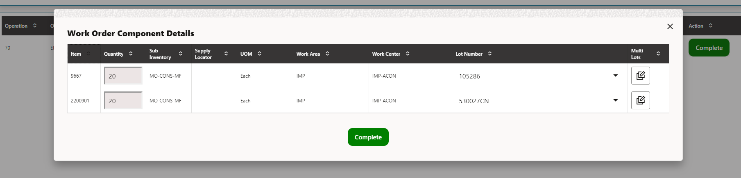

|  |  |
| --- | --- |
| TS-5-07 | Enter the quantity for lot number and click Done button |

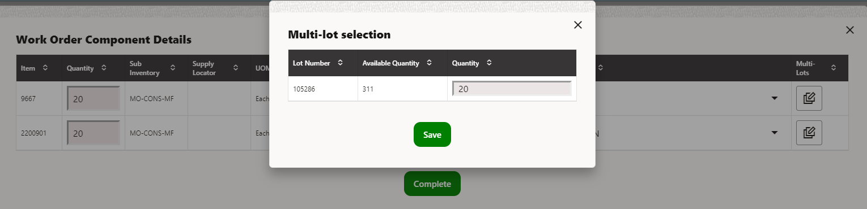

|  |  |
| --- | --- |
| TS-5-08 | Click on Complete button |

