Images
An inline image on its own line:
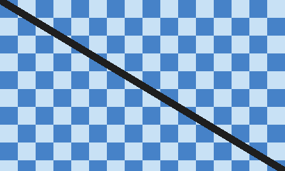
An image floating to the right, with text wrapping around it:
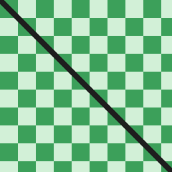
The harbour office opens at seven, and the first ferry leaves as soon as the pilot has signed the manifest. Every shipment carries a paper copy of its route, because the radio link fails more often than anyone admits. In winter the northern channel freezes, so the schedule moves two hours later and the crews rotate every week. A good report states what was measured, how it was measured, and what the numbers do not show. The warehouse keeps a running count of pallets, which the night shift reconciles against the dock log. When the forecast changes, the dispatcher calls each captain in turn and notes the time of every call. Most delays come from paperwork rather than weather, which is why the new form has only eleven fields. The committee agreed to review the tariff each spring and to publish the result in both languages.
In winter the northern channel freezes, so the schedule moves two hours later and the crews rotate every week. A good report states what was measured, how it was measured, and what the numbers do not show. The warehouse keeps a running count of pallets, which the night shift reconciles against the dock log. When the forecast changes, the dispatcher calls each captain in turn and notes the time of every call. Most delays come from paperwork rather than weather, which is why the new form has only eleven fields.
An image inside a table cell:
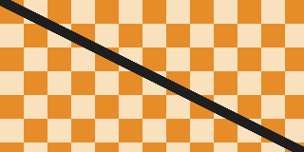 | The warehouse keeps a running count of pallets, which the night shift reconciles against the dock log. When the forecast changes, the dispatcher calls each captain in turn and notes the time of every call.

