Mermaid Smoke Test
Open this file in Ritemark after Developer: Reload Window.

Expected Checks
• The first mermaid block should render as a diagram by default.
• The Code button should switch to raw source and back to the diagram.
• The Copy button should copy the mermaid source, not SVG.
• The invalid mermaid block should show an error state and still allow source editing.
• Saving and reopening should preserve the fenced mermaid blocks unchanged.

Valid Diagram
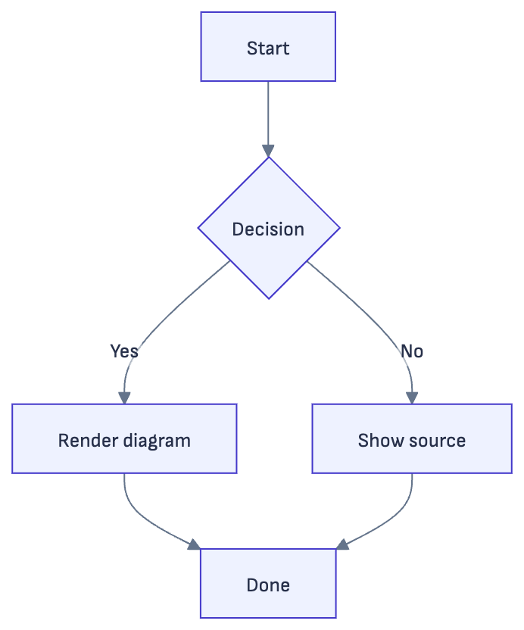

Sequence Diagram
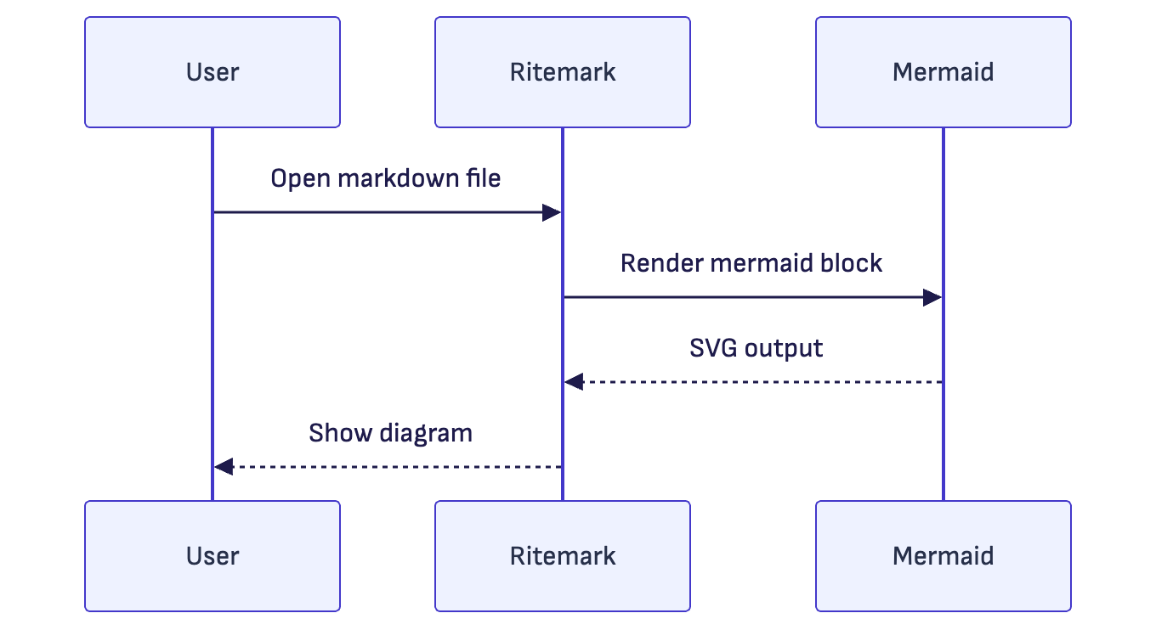

Class Diagram
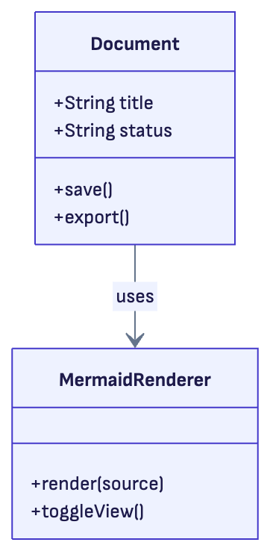

State Diagram
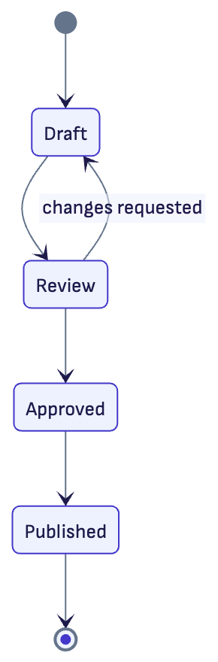

Entity Relationship Diagram
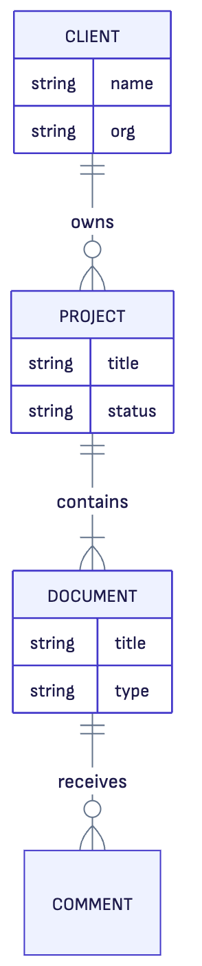

Gantt Chart
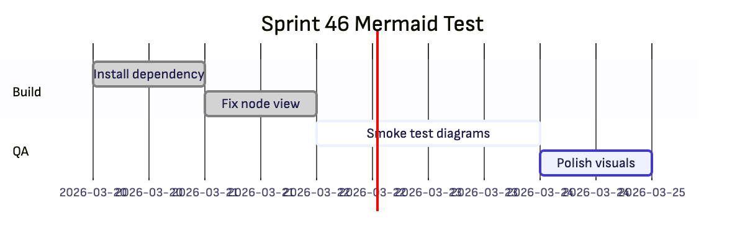

Pie Chart
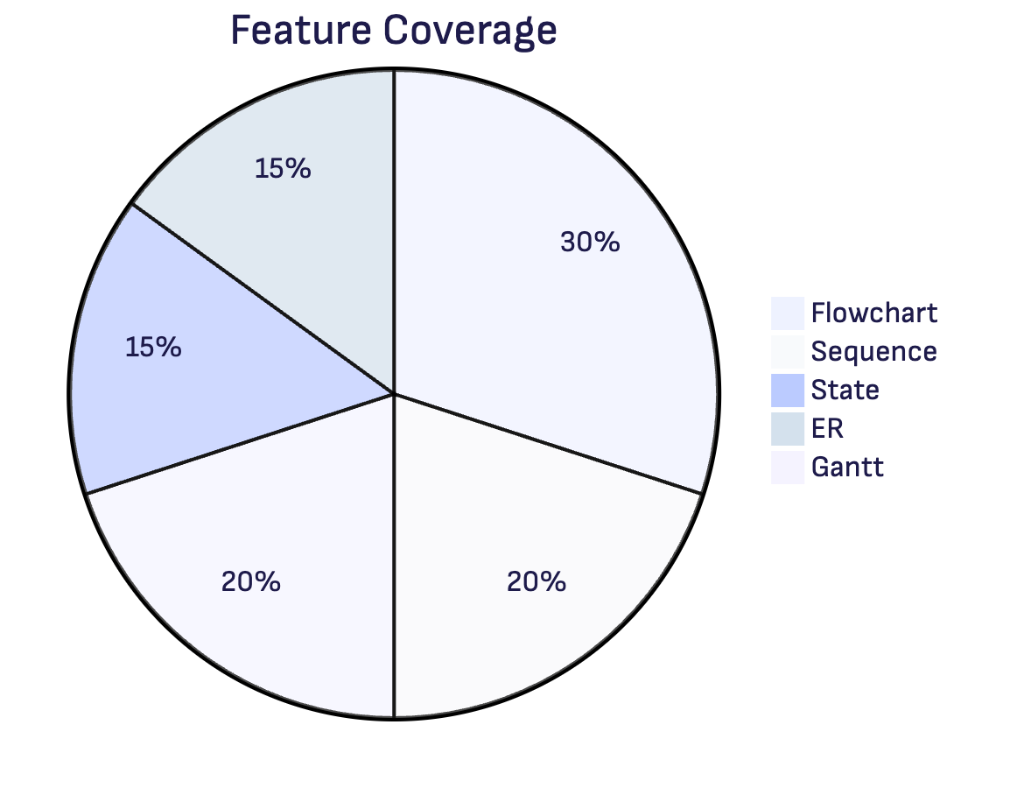

Invalid Diagram
flowchart TD
A[Broken
B --> C

