Ritemark v1.3.0

Released: 2026-02-06
Type: Major (new viewers: PDF & DOCX)
Download: GitHub Release

Highlights

Ritemark v1.3.0 expands from a markdown editor to a unified document workspace. Open PDFs and Word documents alongside your markdown files. Edit CSV data with sorting and row operations. All in one app, without leaving Ritemark.

What's New

PDF Preview

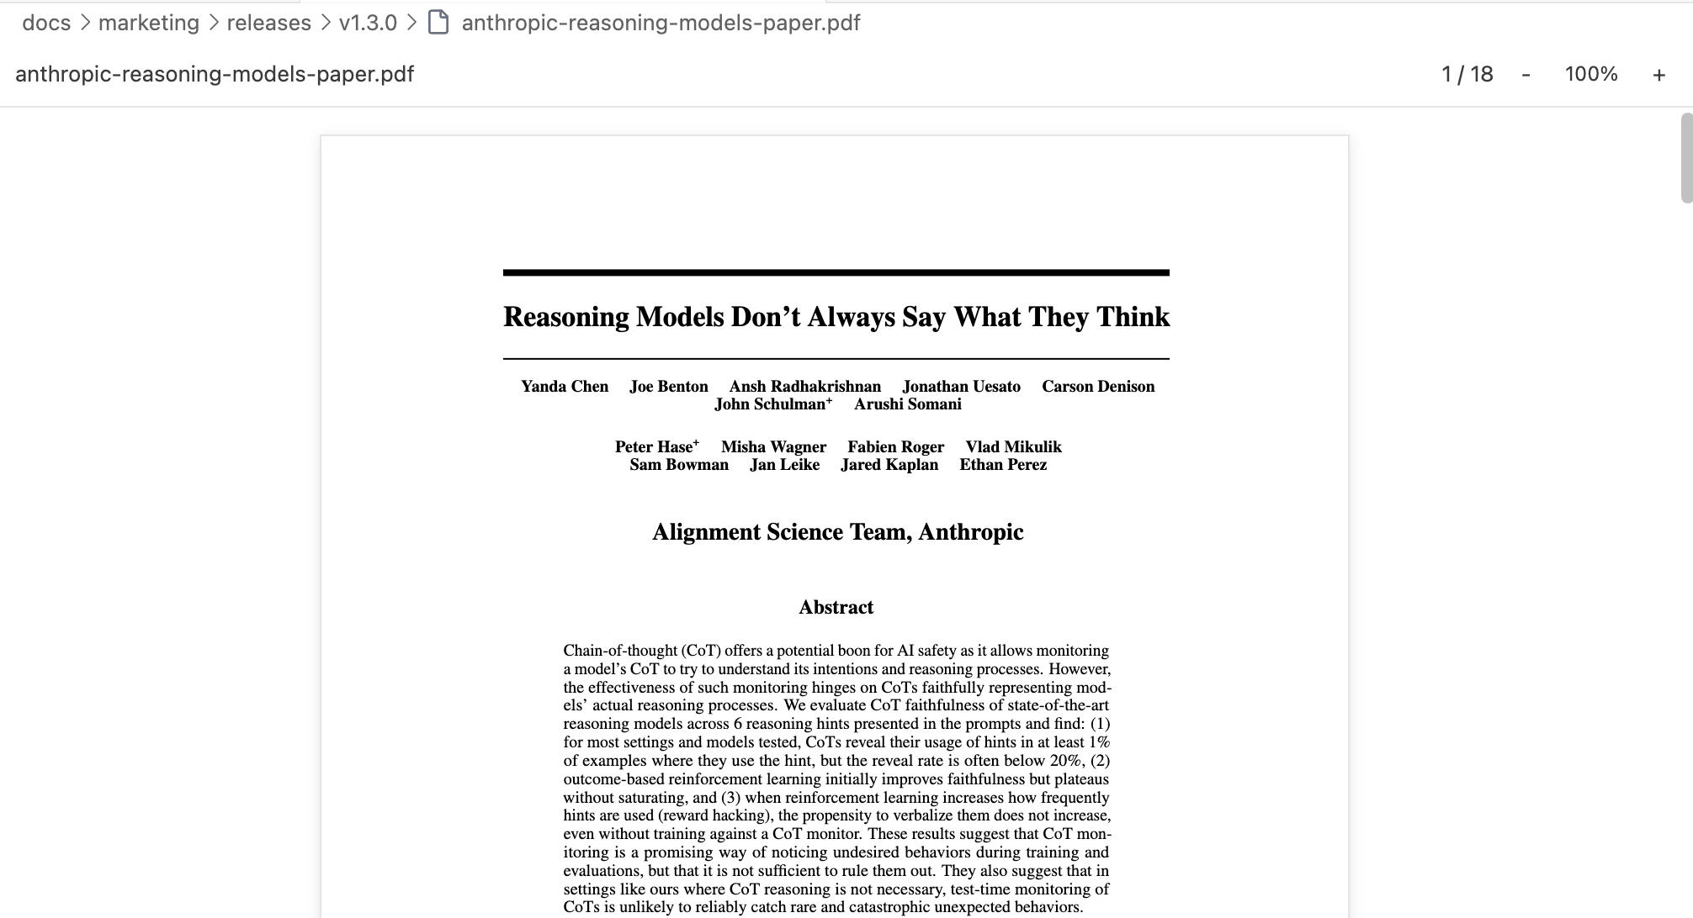

Open any PDF file in Ritemark with a clean, document-focused viewer:

• **Continuous scroll:** All pages in one scrolling view (like reading a document)

• **Text selection:** Select and copy text from PDFs (not just an image)

• **Zoom controls:** 50%, 75%, 100%, 125%, 150%, 200%, Fit Width, Fit Page

• **Page navigation:** Jump to any page with keyboard shortcuts

• **Lazy loading:** Large PDFs render pages as you scroll (performance-optimized)

Technical: Uses PDF.js with react-pdf for faithful rendering. Text layer overlay enables selection/copy. Worker loaded separately for performance.

DOCX Preview

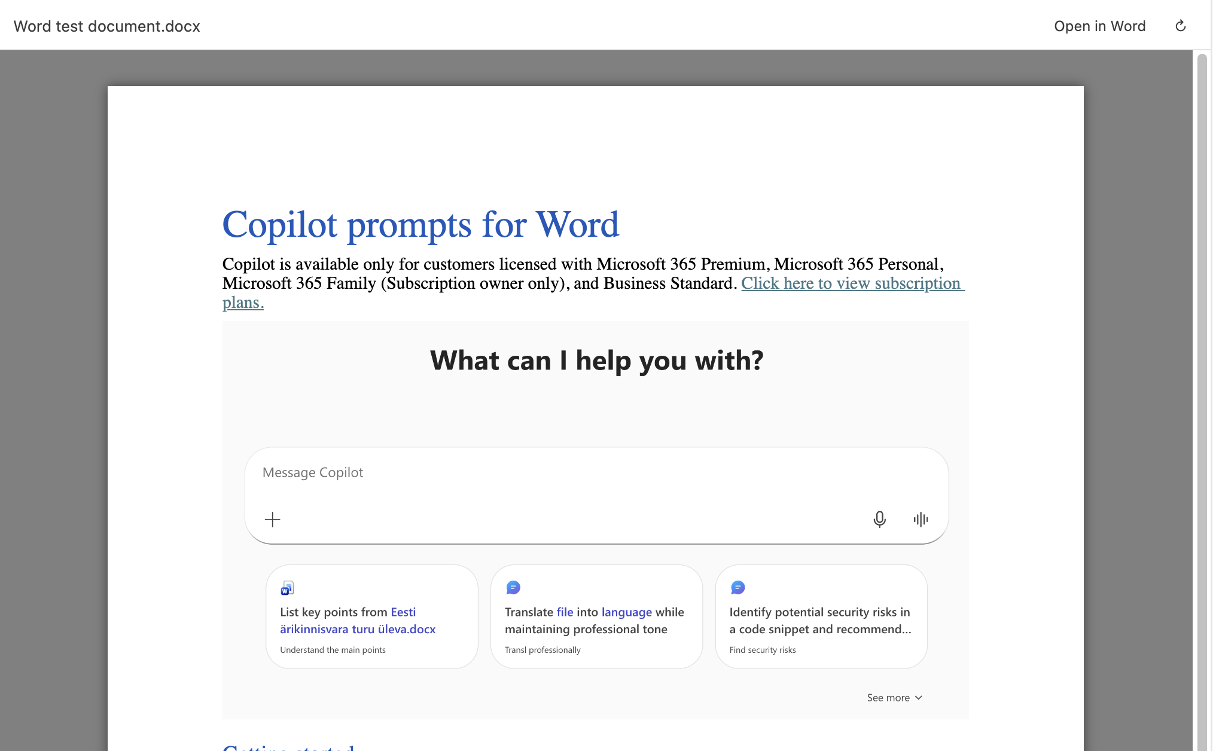

Open Microsoft Word documents (.docx) with basic visual rendering:

• **Colors intact:** Text colors, highlights, and backgrounds match the original

• **Layout respected:** Alignment (center, right), columns, and page structure preserved

• **Images included:** Base64-encoded inline images render correctly

• **Tables formatted:** Cell widths, borders, and padding maintained

Known limitations:

• Background images are not yet rendered

• Some fonts are missing

Technical: Uses docx-preview library (same engine as popular VS Code extensions). The useBase64URL: true option handles webview security restrictions.

CSV Editing Enhancements

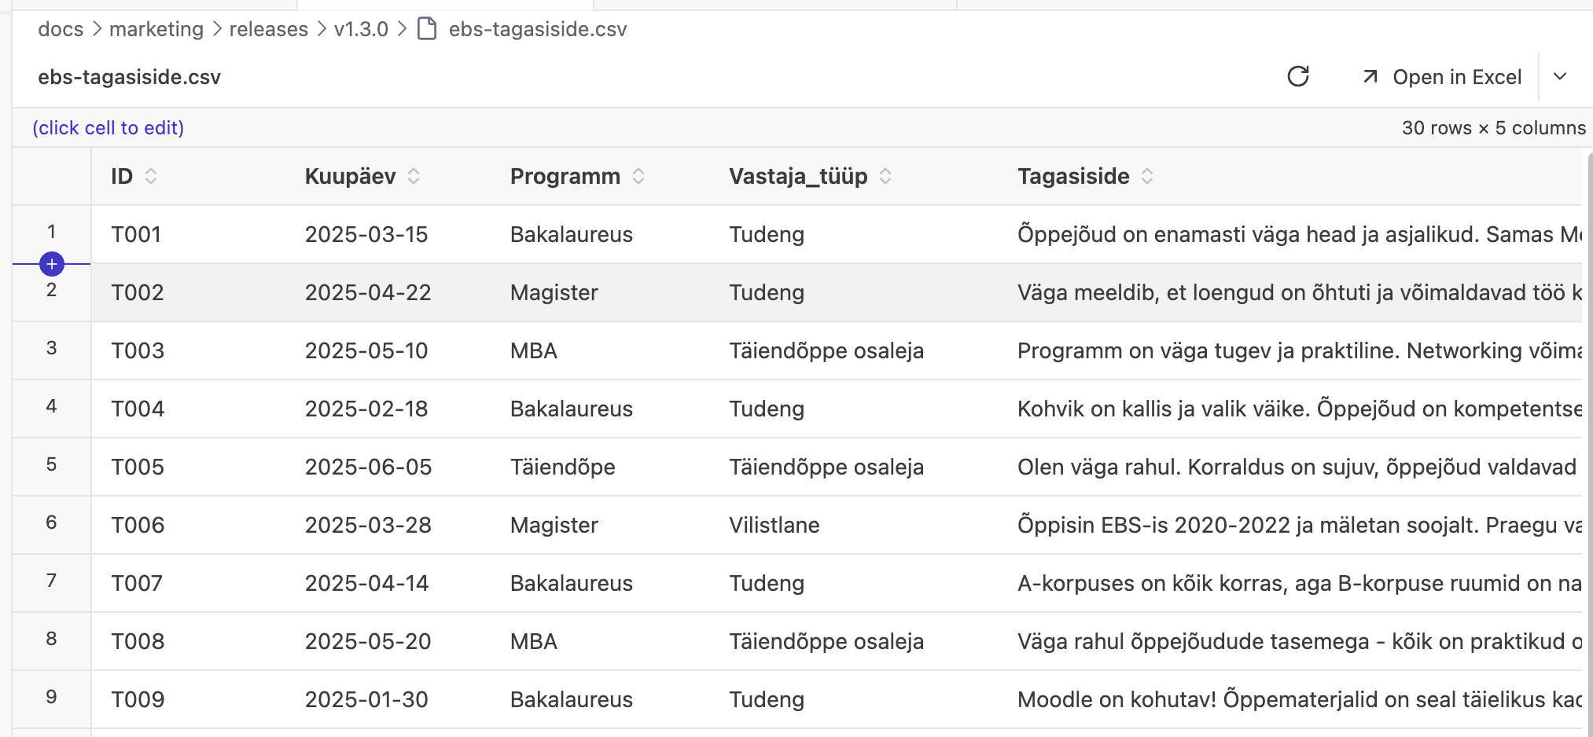

Building on v1.0.1's CSV preview, v1.3.0 adds interactive data operations:

Column Sorting:

• Click any column header to sort ascending

• Click again for descending

• Click third time to return to original order

• Sort indicators show current state (up/down/unsorted arrows)

• Cell editing works correctly while sorted (original row indices preserved)

Add Rows:

• New `[+ Row]` button in spreadsheet toolbar

• Appends empty row with all columns

• Auto-saves to CSV file

• Works with sorted data (new row appears at bottom)

Why it matters: Quick data exploration without opening Excel. Sort to find patterns, add rows for new entries, all in the same app where you write documentation about that data.

Claude Code Node (Flows)

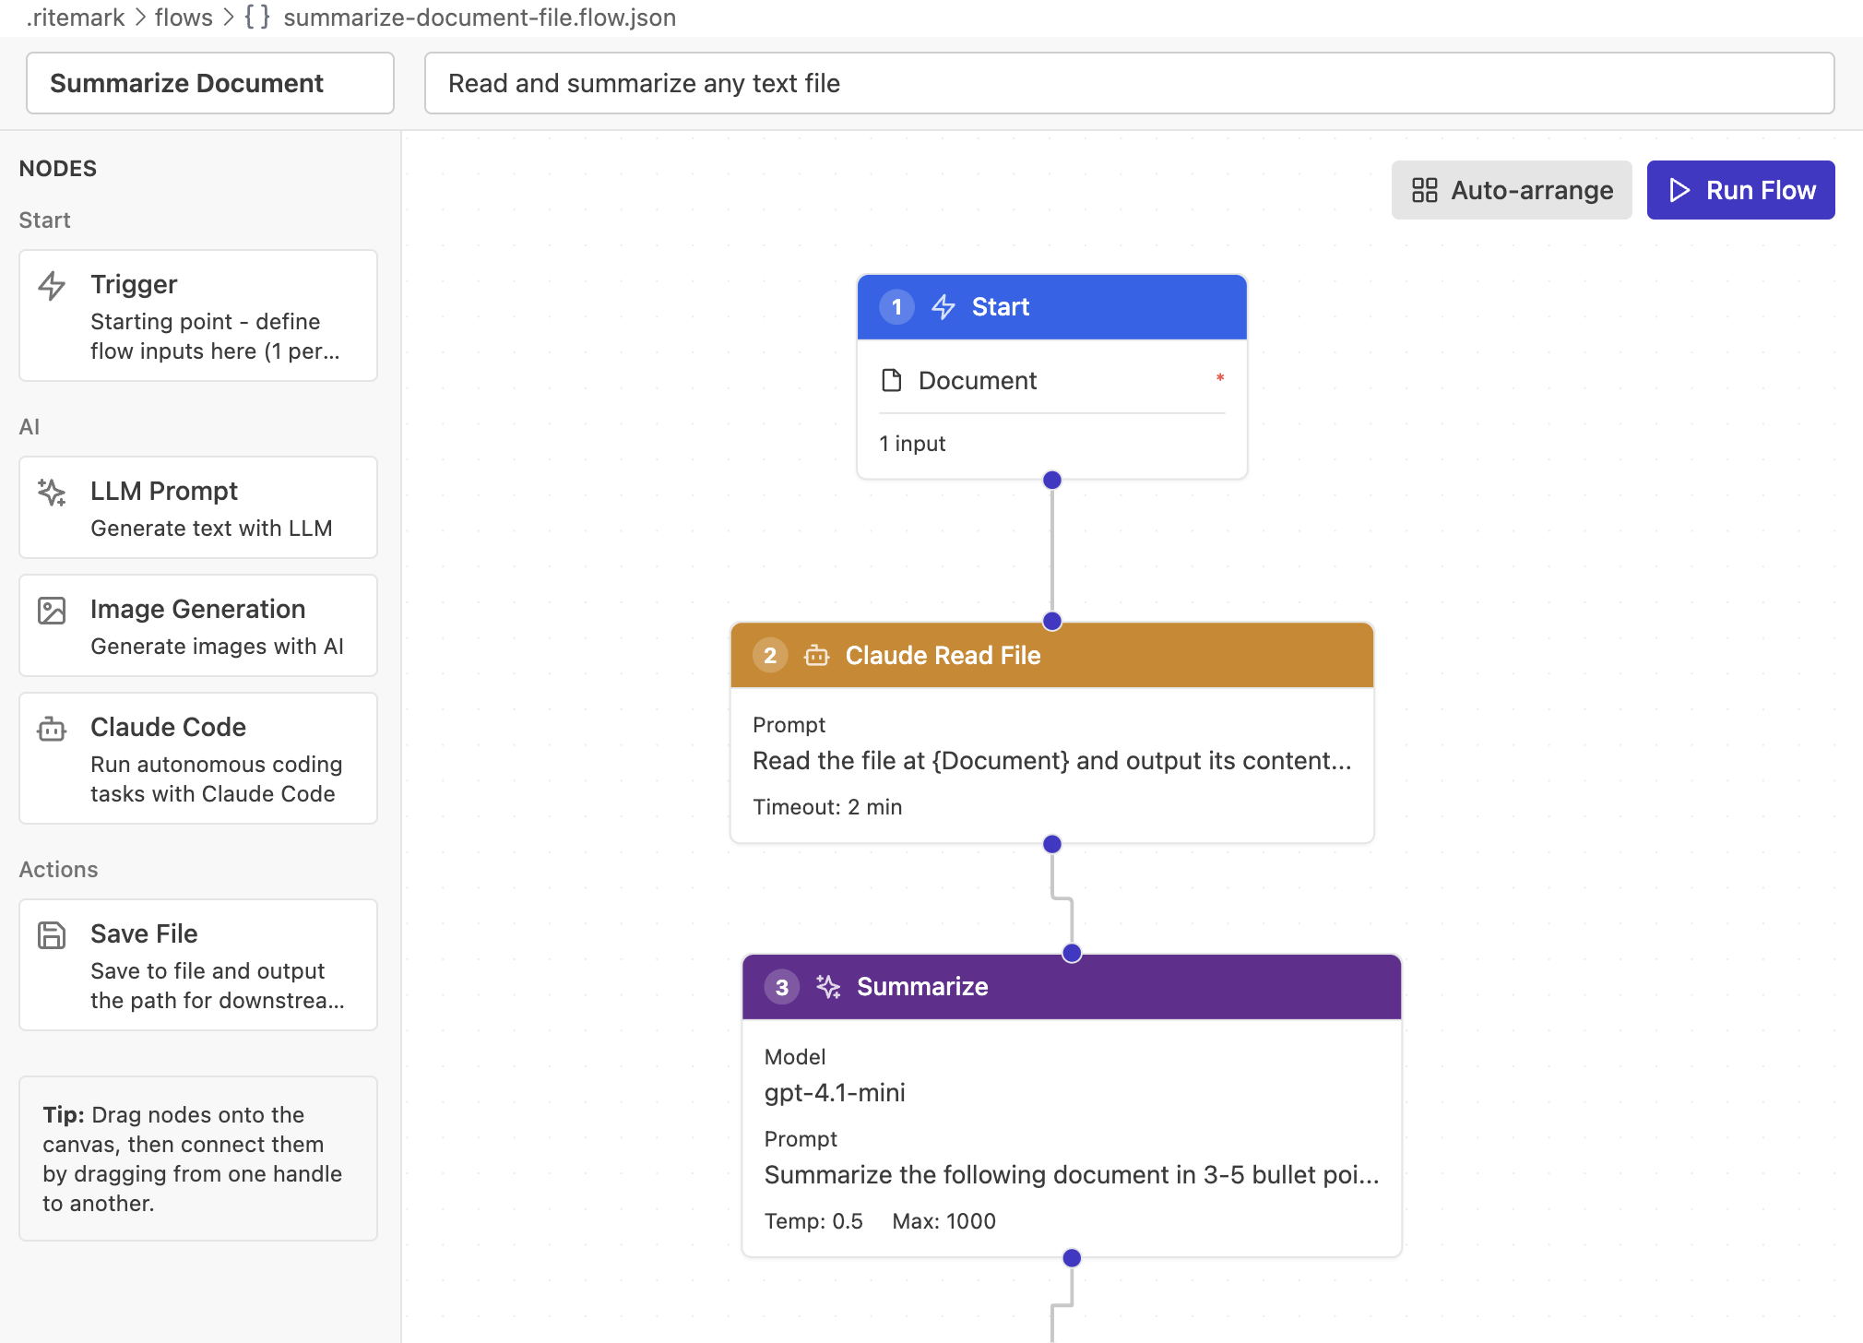

Ritemark Flows now includes a Claude Code node type for advanced automation:

• Execute tasks using Claude Code (Anthropic's Agent SDK)

• Pass dynamic inputs from other flow nodes

• Capture outputs (text, file paths) for downstream nodes

• Integration testing included (requires ANTHROPIC_API_KEY)

Example workflow:

Trigger (filename) → Claude Code (analyze file) → LLM (summarize) → Save File (report.md)

This enables agentic workflows where Claude Code performs complex research/analysis tasks, then LLMs refine the output, all automated.

Platform Expansion

Intel Mac Support (darwin-x64):

• Ritemark now builds for older Intel-based Macs (2020 and earlier)

• GitHub Actions automated builds for macOS x64

• Separate DMG for Intel architecture

Windows CI:

• Automated Windows builds via GitHub Actions

• Triggered on git tags (e.g., `v1.3.0`)

• Setup installer (.exe) built and uploaded to releases

What this means: More users can run Ritemark, and releases are faster (automated builds reduce manual work).

Enhanced Export System (V2)

The PDF and Word export engine now uses HTML-based rendering instead of markdown-to-native conversion:

Benefits:

• **Better tables:** Column widths, borders, and cell alignment preserved

• **Complex formatting:** Nested lists, blockquotes, and mixed content render correctly

• **Consistent output:** What you see in the editor matches the exported document

Technical: Uses the editor's HTML output directly, styled with CSS for print media. Renders to PDF via headless browser approach (pdfkit) and Word via docx library with HTML parsing.

Breaking Changes

None. All existing features work as before.

Known Limitations

PDF Viewer

• **Large PDFs:** Files over 50MB may cause performance issues (warning shown at 10MB)

• **Password-protected PDFs:** Not supported (shows error message)

• **Old PDF format:** Very old PDFs (pre-1.4) may not render correctly

• **Forms:** PDF forms are read-only (cannot fill or submit)

DOCX Viewer

• **Old Word format:** `.doc` files (Word 97-2003) not supported (shows error message)

• **Macros:** VBA macros are ignored (security restriction)

• **Complex layout:** Some advanced layout features (text boxes, SmartArt) may render imperfectly

• **Track changes:** Revision markup not displayed

CSV Enhancements

• **Multi-line cells:** Not yet supported (deferred to future sprint)

• **Delete row:** Not yet implemented (deferred)

• **Column operations:** Add/delete/rename columns deferred to future sprint

• **Context menus:** Right-click menus deferred (may conflict with VS Code context menus)

Technical Notes

Bundle Size

• **Webview.js:** ~3.95MB (includes react-pdf + docx-preview)

• **PDF.js worker:** ~1MB (separate file, not bundled)

• **Total:** ~5MB (at target limit)

• **Previous version:** ~900KB (v1.2.0 before PDF/DOCX)

Content Security Policy (CSP)

PDF and DOCX viewers required CSP updates:

• `worker-src ${webview.cspSource} blob:` (PDF.js worker)

• `img-src data: blob:` (Base64 images in DOCX)

• `font-src data:` (Embedded fonts in DOCX)

• `style-src 'unsafe-inline'` (docx-preview inline styles)

Dependencies Added

• `react-pdf@10.3.0` - React wrapper for PDF.js

• `docx-preview@0.3.4` - DOCX rendering with visual fidelity

• `@anthropic-ai/claude-agent-sdk@0.2.29` - Claude Code integration

Build Platform Support

• macOS Apple Silicon (darwin-arm64) - primary platform

• macOS Intel (darwin-x64) - added in v1.3.0

• Windows 32-bit (win32-x64) - via GitHub Actions

Upgrade Notes

macOS:

- Download `Ritemark.dmg` from GitHub Releases

- Open the DMG

- Drag Ritemark to Applications (replace existing)

- Launch Ritemark

Windows:

- Download `Ritemark-setup.exe` from GitHub Releases

- Run the installer

- Follow setup wizard

- Launch Ritemark

Intel Macs:

- Download `Ritemark-x64.dmg` from GitHub Releases (separate download for Intel)

- Open the DMG

- Drag to Applications

- Launch Ritemark

Your existing documents, settings, Flows, and RAG index are preserved across updates.

Testing Checklist

For users who want to verify the release:

PDF Viewer:

☐ Open a PDF file (should open in Ritemark, not external viewer)
☐ Scroll through multiple pages
☐ Select and copy text from a page
☐ Try zoom controls (50%, 100%, 200%, Fit Width, Fit Page)
☐ Jump to a specific page number

DOCX Viewer:

☐ Open a .docx file
☐ Verify fonts and colors match Microsoft Word
☐ Check that images appear correctly
☐ Verify tables have proper alignment and borders

CSV Enhancements:

☐ Open a CSV file
☐ Click a column header to sort
☐ Click again to reverse sort
☐ Click a third time to unsort
☐ Edit a cell while sorted (verify correct row is updated)
☐ Click `[+ Row]` button to add a new row
☐ Verify new row saves to file

Regression Testing:

☐ Markdown editing still works
☐ Excel preview still works
☐ Flows still work
☐ AI chat still works
☐ Export to PDF/Word still works

What's Next

Future enhancements being considered:

• CSV multi-line cell editing (Shift+Enter to add line breaks)

• CSV column operations (add/delete/rename columns)

• CSV row deletion with context menu

• PDF annotation support (comments, highlights)

• DOCX editing (not just preview)

• Improved text search across PDF/DOCX content

These are not commitments - just ideas based on user feedback and technical feasibility.

Support

Issues: GitHub Issues
Documentation: docs/

• * *

Sprint Credits:

• Sprint 32: PDF/DOCX Preview & CSV Editing

• Sprint 30: Claude Code Node

• Sprint 31: Export V2

• Sprint 25: CI/CD Pipeline

