Ritemark v1.4.0
Released: 2026-02-14
Type: Major (agentic AI + visual refresh)
Download: GitHub Release

Highlights
Ritemark v1.4.0 brings autonomous AI assistance to your writing workflow. Claude Code can now read, edit, and organize your files directly from the sidebar — no terminal required. The release also includes a visual refresh with cleaner typography and a more writer-friendly aesthetic.

What's New

Claude Code Agent in AI Sidebar

The AI sidebar now supports a second agent mode: Claude Code. While the original Ritemark Agent helps with writing and research, Claude Code can perform autonomous file operations.
Why a custom UI for Claude Code?
We built a dedicated chat interface instead of using the terminal because:
• Easier setup: A guided wizard helps you install Claude Code CLI with visual feedback
• Non-technical friendly: Writers and researchers don't feel comfortable in the terminal
• Better context: The agent automatically sees your active document — no need to explain what file you're working on
• Visual feedback: Real-time activity feed shows what the agent is doing
• Approachable: Chat interface feels familiar and less intimidating than command-line tools
Features:
• Multi-turn sessions: Persistent conversations with fast follow-ups (~2-3s latency)
• Activity feed: Real-time visibility into what Claude is doing (reading files, writing, running commands)
• Image paste: Cmd+V screenshots directly into chat for visual context
• Clickable paths: File paths in responses are clickable — jump to any file mentioned
• Active file context: Agent automatically knows what file you're looking at
• Model selection: Choose Sonnet (fast), Opus (powerful), or Haiku (lightweight)
• Excluded folders: Set boundaries on what the agent can access
How to enable:
1. Open Settings (gear icon in sidebar)
2. Navigate to Ritemark Features
3. Enable "Agentic AI Assistant"
4. Select "Claude Code" in the agent dropdown
Requirements: Claude Code CLI must be installed. The setup wizard will guide you through installation when you first select Claude Code.

Refreshed Visual Design
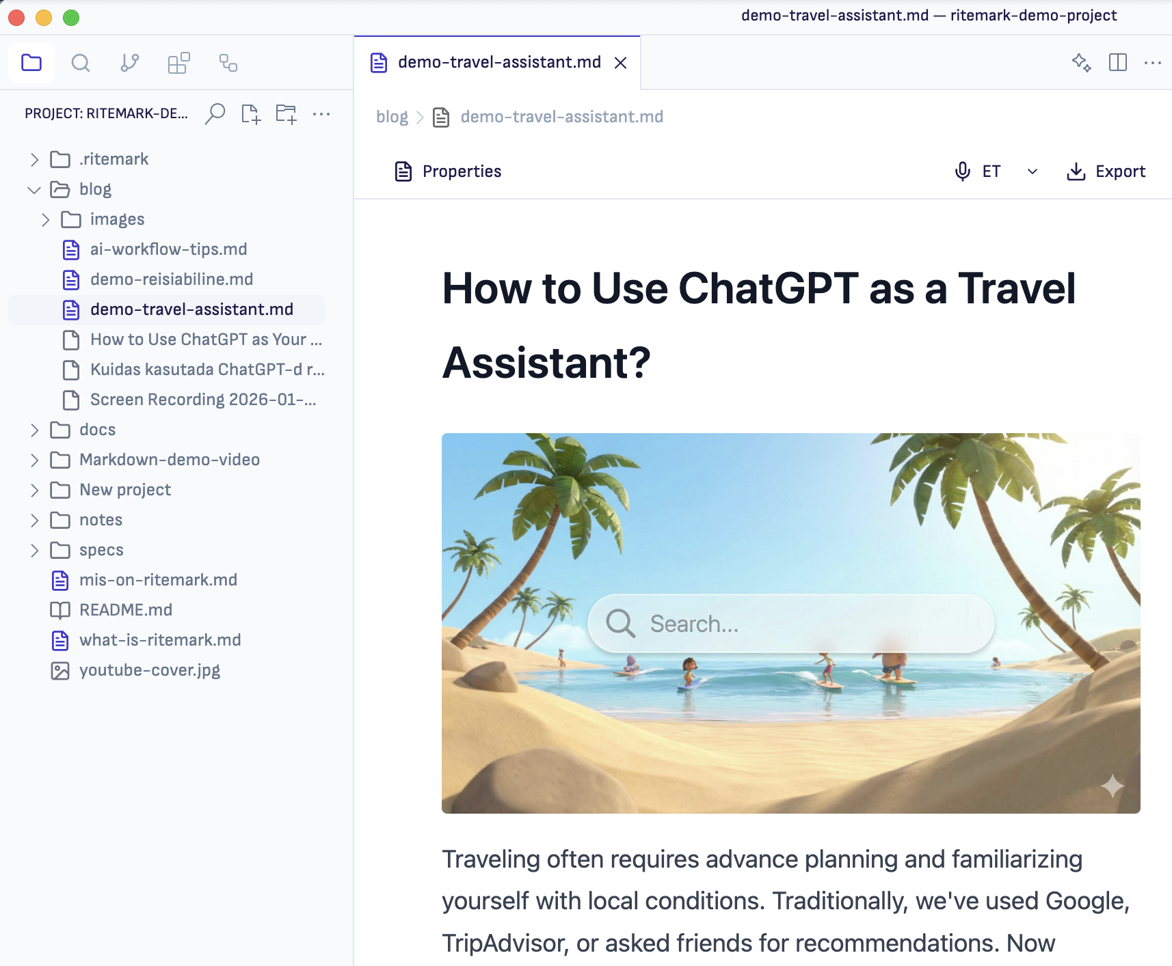
Ritemark now looks cleaner and more professional:
• Sofia Sans typography: A friendly, readable UI font replaces the default system font
• Refined colors: Softer grays, consistent indigo accents, better contrast
• Horizontal sidebar tabs: The activity bar is now a horizontal tab bar at the top of the sidebar to make you more room for writing.
• Smaller breadcrumbs: More vertical space for your documents
• Harmonized icons: Consistent icon styling throughout
These changes make Ritemark feel less like a code editor and more like a writing app.

Improved CSV Editing
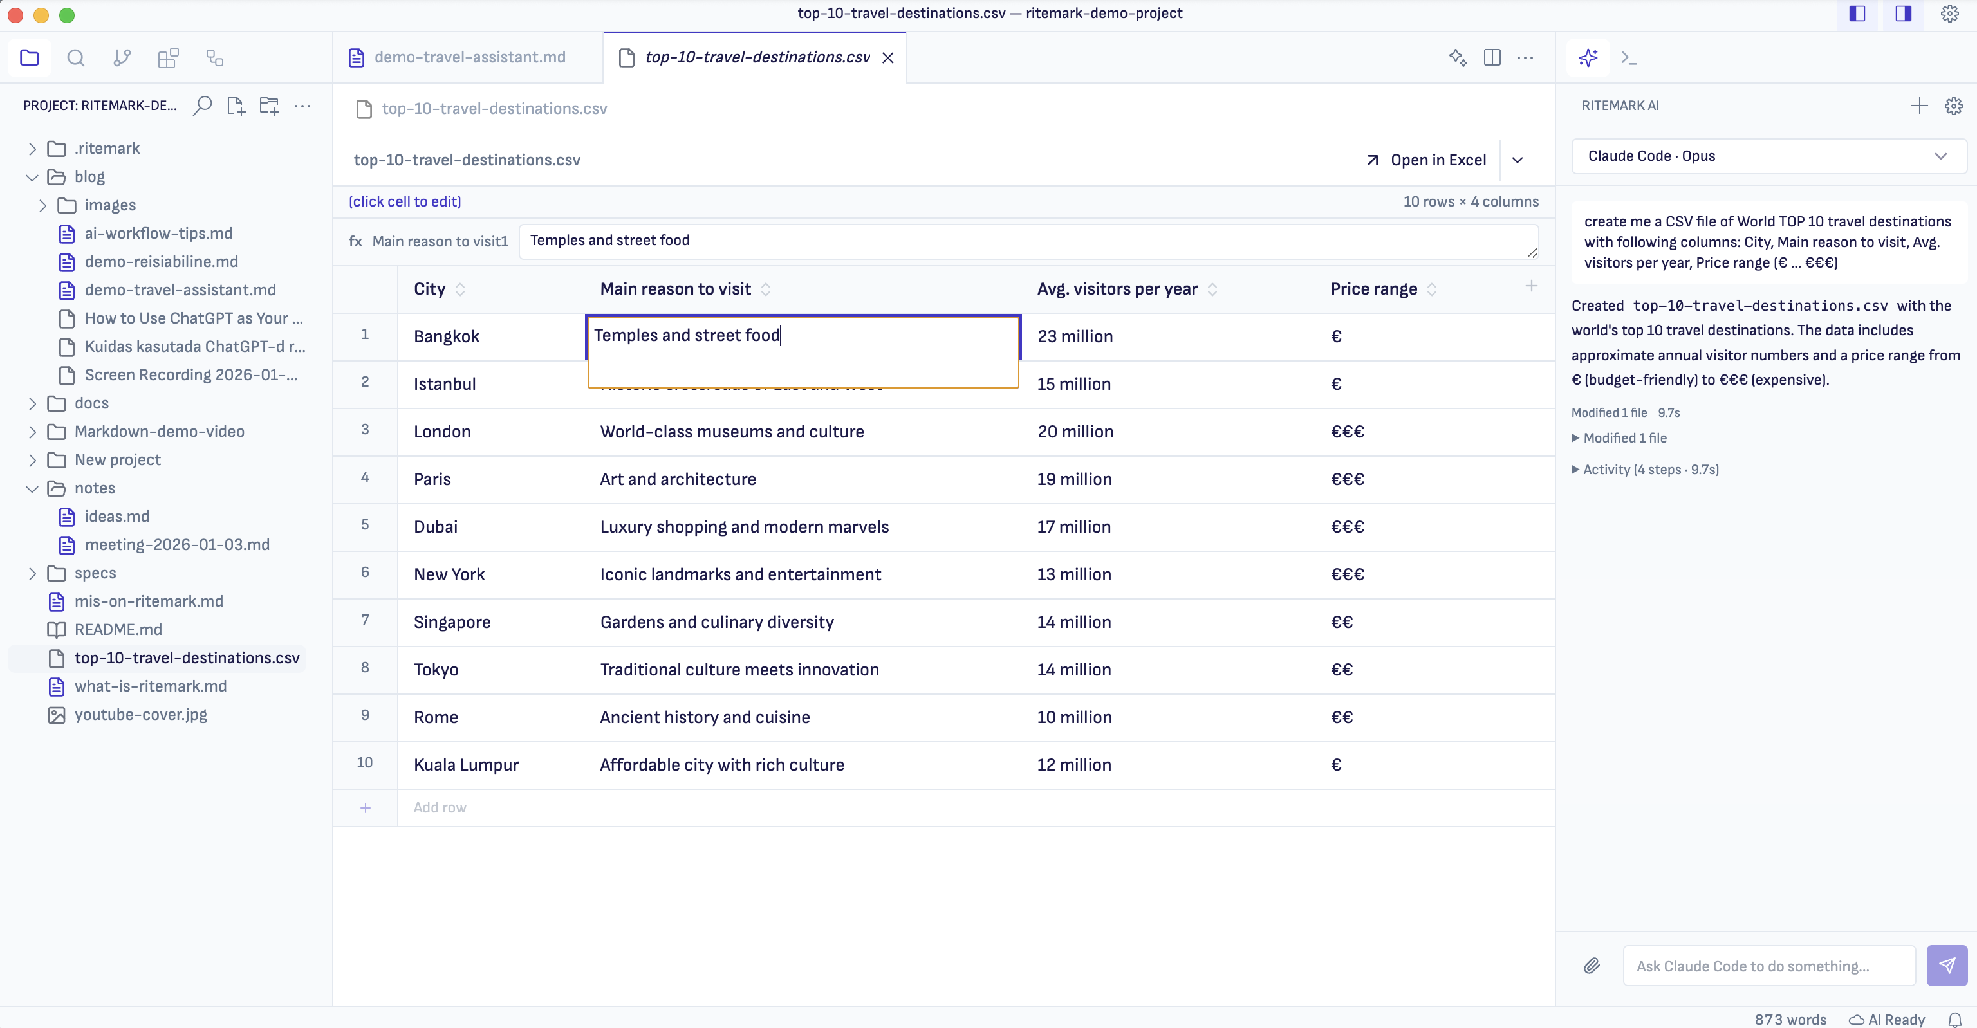
The spreadsheet experience is now closer to Excel:
• Full-text editing: See the entire cell contents while editing (no more truncation)
• Clear active cell: Excel-like blue border on the selected cell
• Column operations: Add, rename, and delete columns via header interactions
• Copy-paste: Cmd+C copies cell content, Cmd+V pastes
• Better keyboard navigation: Enter commits edits, Esc cancels, Tab moves to next cell

Export Improvements

PDF and Word export quality improvements:
• PDF images work: Images now render correctly (was broken in v1.3.x)
• Word images: Proper aspect ratio calculation for embedded images
• PDF heading spacing: Consistent spacing with orphan protection (headings stay with content)
• PDF blockquotes: Left border styling for visual distinction
• Simpler export menu: Removed confusing template options

Bug Fixes
• Cmd+B works for Bold: No longer conflicts with sidebar toggle
• Terminal only opens when needed: Stops auto-opening on every window
• Toolbar refresh: Spreadsheet toolbar updates correctly after operations

Breaking Changes
None. All existing features work as before.

Known Limitations

Claude Code Agent
• Experimental feature: Must be explicitly enabled in Settings
• Requires CLI: Claude Code CLI must be installed (claude --version to check)
• Folder permissions: Agent respects excluded folders setting but cannot yet show a visual picker

Visual Changes
• Font rendering: Sofia Sans may render differently across macOS versions (tested on macOS 11-15)
• Theme override: Custom themes may conflict with new color tokens

Technical Notes

New VS Code Patches
Seven new patches customize the VS Code workbench:
Patch | Purpose
015 | Font and typography (Sofia Sans)
016 | Sidebar top tabs layout
017 | Titlebar controls
018 | Explorer UI refinements
019 | Right sidebar styling
020 | Icon harmonization
021 | Breadcrumbs ribbon

AgentRunner Architecture
The Claude Code integration uses a streaming input pattern for fast multi-turn conversations:
• Persistent process across conversation turns
• AsyncGenerator yields messages on demand
• Turn tracking prevents stale results after interrupt
• Workspace-scoped permissions via excluded folders config

Feature Flags
Flag | Status | Description
agentic-assistant | Experimental | Claude Code agent in sidebar
ritemark-flows | Stable | Visual workflow automation
voice-dictation | Experimental | Voice input (macOS only)

Upgrade Notes
macOS:
1. Download Ritemark-arm64.dmg (Apple Silicon) or Ritemark-x64.dmg (Intel)
2. Open the DMG and drag to Applications (replace existing)
3. Launch Ritemark
Windows:
1. Download Ritemark-1.4.0-win32-x64-setup.exe
2. Run the installer (will upgrade existing installation)
3. Launch Ritemark
Your documents, settings, Flows, and RAG index are preserved.

What's Next
• Setup wizard: Guided Claude Code CLI installation
• Research tool: RAG-powered search for Claude Code agent
• Folder permissions UI: Visual picker for agent access boundaries
• Checkpoint system: Undo/redo for agent file modifications

Support
Issues: GitHub Issues
Documentation: docs/

Sprint Credits:
• Sprint 33: Agentic GUI Phase 1
• Sprint 34: Export V2 &amp; CSV Editing
• Sprint 35: GUI Customization

