Root-finding Test Functions
Sérgio Galdino. A family of regula falsi root-finding methods. Proceedings of 2011 World Congress on Engineering and Technology. Shanghai, China. IEEE Press. ISBN 978-1-61284-365-0. p. 514-517
http://sergiogaldino.pbworks.com/w/file/fetch/66011429/0130-1943543


,

My functions
Steven A. Stage. Comments on An Improvement to the Brent’s Method. International Journal of Experimental Algorithms (IJEA), Volume (4) : Issue (1) : 2013
A. Swift, G. R. Lindfield, Comparison of a continuation method with Brent's method for the numerical solution of a single nonlinear equation, The Computer Journal, Volume 21, Issue 4, 1978, p. 359–362
https://doi.org/10.1093/comjnl/21.4.359
Alojz Suhadolnik, Combined bracketing methods for solving nonlinear equations, Applied Mathematics Letters, Volume 25, Issue 11, 2012, Pages 1755-1760, ISSN 0893-9659
https://doi.org/10.1016/j.aml.2012.02.006
Oliveira I. F. D., Takahashi R. H. C. An Enhancement of the Bisection Method Average Performance Preserving Minmax Optimality
Lambert -  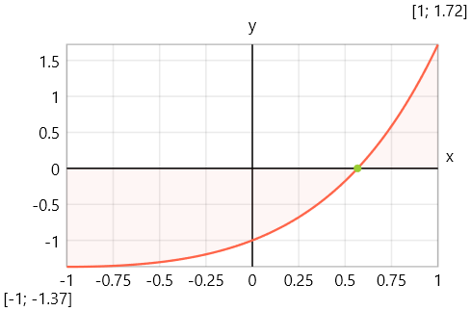 | Trigonometric 1 -  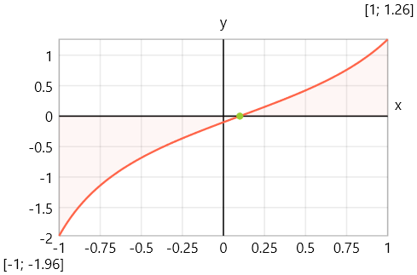
Trigonometric 2 -  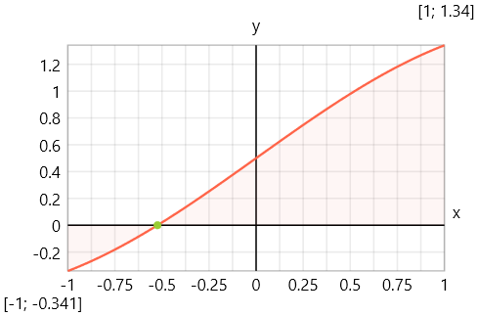 | Polynomial 1 - 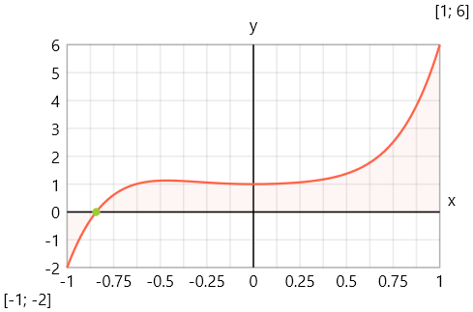
Polynomial 2 -  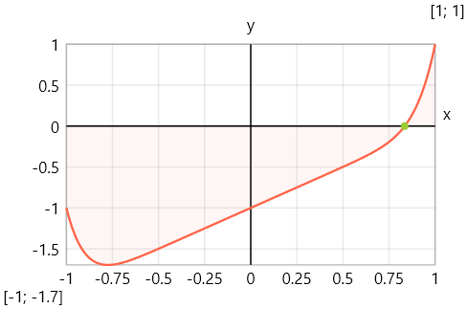 | Exponential -  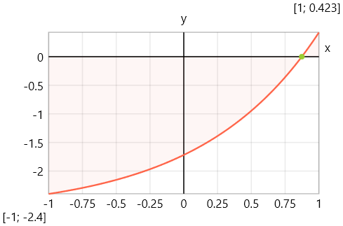
Logarithmic -  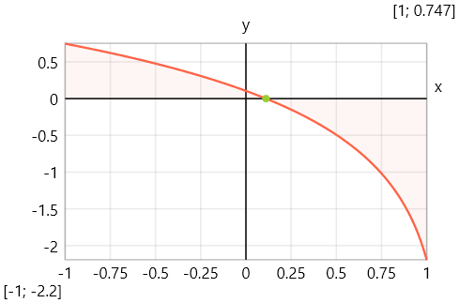 | Polynomial -  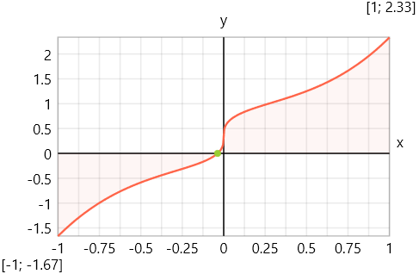
Poly. Frac. -  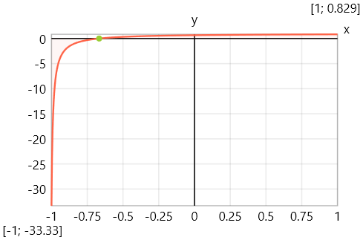 | Polynomial 3 -  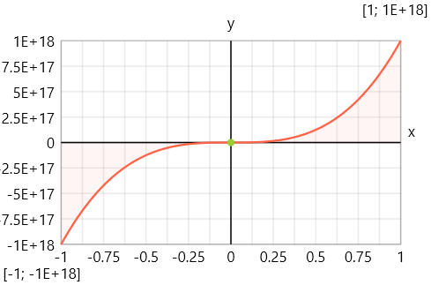
Exp. Poly. -  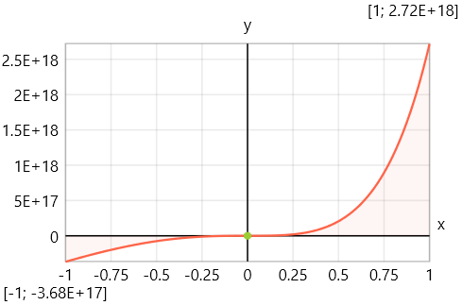 | Tan. Poly. -  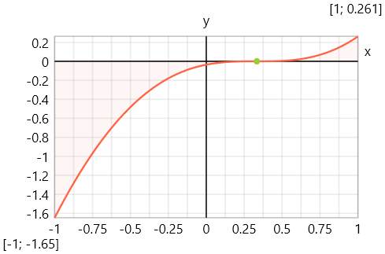
Circles  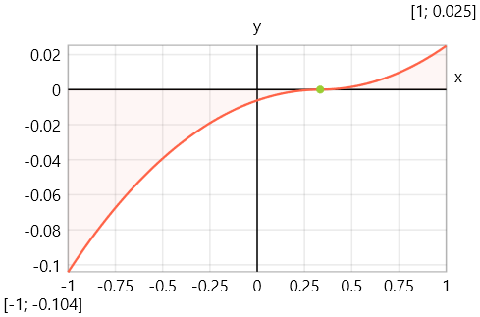 | Step Function  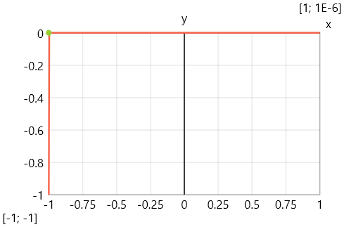
Geometric -  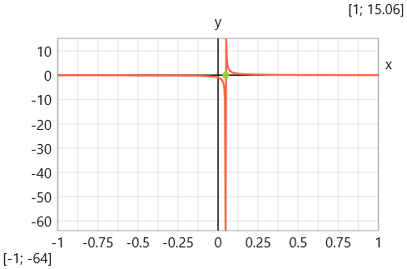 | Trunc. Poly.  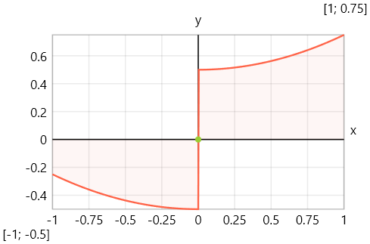
Staircase  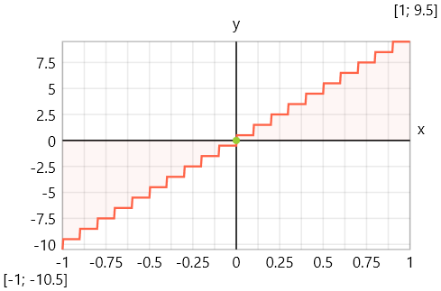 | Noisy Line  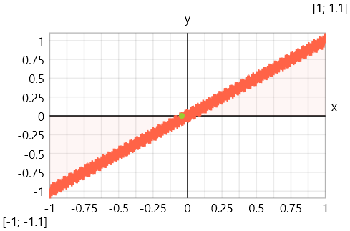
Warsaw  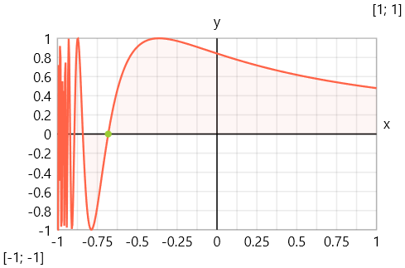 | Sawtooth  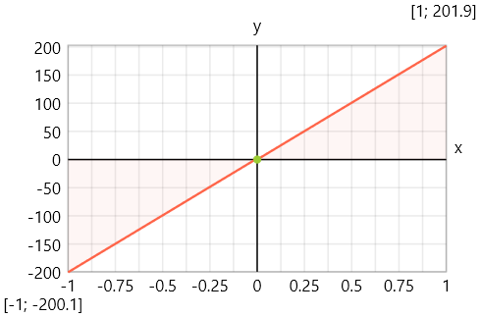

SciML Benchmarks test suite
Sawtooth Cube  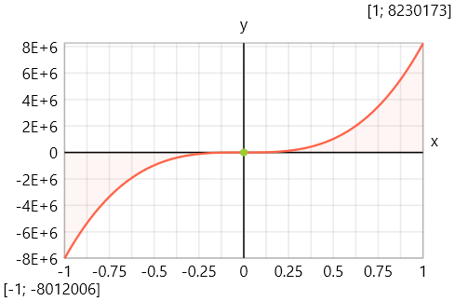 | Polynomial with multiple roots  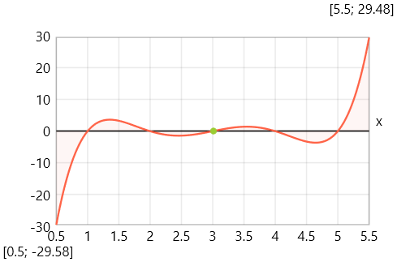
Trigonometric with multiple roots  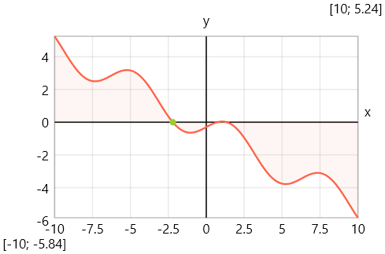 | Exponential function (sensitive near zero)  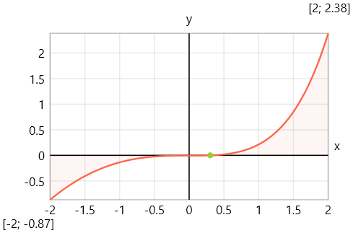
Rational function with pole 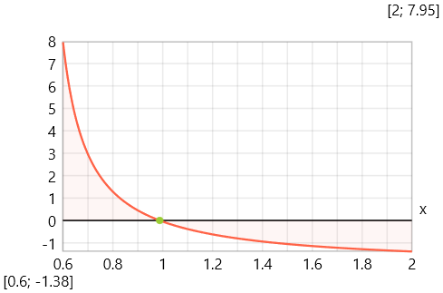 | Logarithmic function  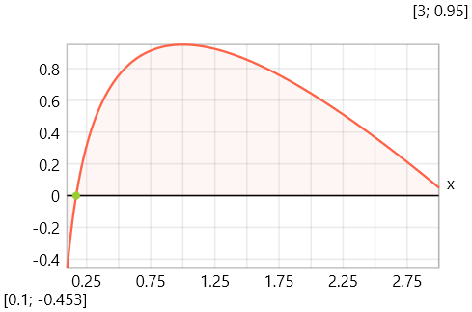
High oscillation function  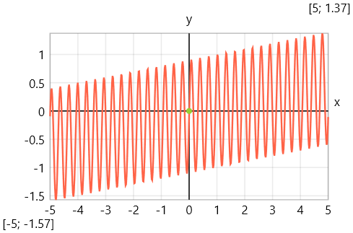  x89 = $Root{f89(x) @ x ∈ [-5.0; 5.0]} - No solution | Function with very flat region  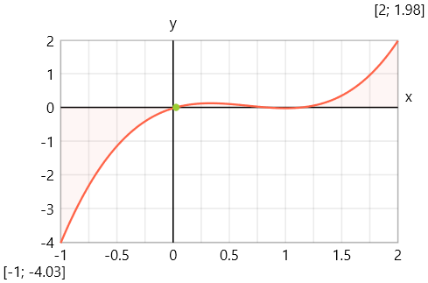
Bessel-like function -
