NiyogSentinel: Fine-Tuned Object Detection for Coconut Pest Identification

Bernard A. Bullicer a1, Alvin Sarraga Alon abc2, Leonard L. Alejandro a3, Charlene I. Vergara a4, Jesus Paguigan ad5

*a College of Computing and Information Technology, Adamson University*

*b Education Center for Artificial Intelligence Research, Department of Education*

*c Education Center for Artificial Intelligence Research, SEAMEO Innotech*

*d College of Computing Studies, Eulogio “Amang” Rodriguez Institute of Science and Technology*

*NCR, Philippines*

**Email**: 1bernard.bullicer@adamson.edu.ph, 2alon.alvin.d.eng@gmail.com, 3leonard.alejandro@adamson.edu.ph, 4charlene.vergara@adamson.edu.ph, 5jesus.paguigan@adamson.edu.ph

*Abstract*—Coconut farming in the Philippines faces persistent threats from destructive pests such as the Coconut Rhinoceros Beetle (CRB), Coconut Scale Insect (CSI), Coconut Leaf Beetle (CLB), and Red Palm Weevil (RPW), which significantly reduce yield and affect farmer livelihoods. This study presents a deep learning-based object detection approach for automated coconut pest identification using a fine-tuned YOLOv11 model. A dataset of 918 annotated images across four pest categories was compiled and processed for training, validation, and testing. Model performance was evaluated using standard metrics including precision, recall, F1 score, and mean Average Precision (mAP@0.5). The model achieved an F1 score of 0.90 and an overall mAP@0.5 of 0.912, indicating high accuracy in classifying and localizing pests. Validation results and confusion matrix analysis further confirmed the model’s robustness across varying image conditions. The findings underscore the potential of deep learning models in enhancing pest monitoring systems and contribute toward the development of intelligent, automated solutions for sustainable coconut agriculture.

Keywords— Object Detection, YOLOv11, Coconut Pest Identification, Transfer Learning, Pest Detection

# Introduction

Coconut (Cocos nucifera) is one of the Philippines’ most important agricultural crops, deeply embedded in rural livelihoods and national production [1]. In 2003, the country yielded approximately 14.89 million metric tons of coconut kernels, making it the world’s second-largest coconut producer [2]. This sector contributes around 8–9% to the national gross domestic product (GDP) [3]. Despite its significance, coconut productivity has declined due to aging tree populations, limited access to modern agricultural technologies, and increasingly severe weather events caused by climate change [4].

Pests and diseases further compound the challenges faced by coconut farmers. The coconut scale insect (Aspidiotus rigidus), locally known as "cocolisap," caused extensive damage in the Southern Tagalog region between 2010 and 2014 [5]. Although biological interventions, such as the introduction of Comperiella calauanica, helped suppress outbreaks, the threat remains. Another major pest is the coconut rhinoceros beetle (Oryctes rhinoceros), which has led to nearly 100% infestation rates in some post-typhoon areas [6]. Other notable threats include the coconut hispid beetle and fungal diseases such as bud rot and leaf spot, which further endanger palm health.

Effective pest detection and monitoring are critical for managing these threats. However, traditional methods—primarily manual inspection and field surveys—are time-consuming, subjective, and often delayed [7]. These limitations have driven a growing interest in the application of computer vision and machine learning for agricultural monitoring. Several studies have demonstrated the feasibility of using deep learning models to address similar challenges. For instance, [8] used drone imagery and YOLO to detect coconut trees in Quezon Province, achieving high localization accuracy. Similarly, [9] applied deep learning to detect banana diseases, highlighting the potential for object detection frameworks in plant health monitoring.

In the context of pest identification, [10] demonstrated the utility of convolutional neural networks for detecting multiple insect classes in agricultural environments, [11] integrated object detection models for classifying pest damage on rice leaves. These studies emphasize the value of automated detection tools in enhancing precision agriculture and reducing reliance on manual interventions.

Building on these advancements, the NiyogSentinel project proposes a deep learning-based object detection model specifically tailored for identifying common coconut pests. This study employs a fine-tuned YOLOv11 architecture trained on image datasets representing key pests such as the coconut rhinoceros beetle and scale insect. Unlike previous efforts focused primarily on tree detection or general crop monitoring, this work centers on pest-level identification to support more proactive and data-driven pest management. By improving detection accuracy and reducing inspection delays, the system offers potential benefits for coconut farmers in enhancing crop protection and resilience.

# Methodology

The system workflow is illustrated in Fig. 1, which presents Monitoring Workflow Diagram. As shown in the figure, the dataset was collected, consolidated, and subsequently prepared for annotation and labeling. During the training process, three distinct datasets were generated: (1) Test Dataset, (2) Training Dataset, and (3) Validation Dataset. These datasets were then used for model training and validation to develop an object detection algorithm suitable for edge-optimized monitoring, enabling efficient inference and potential deployment on resource-constrained devices.

## Preparation and Collection of Dataset

Datasets were sourced from publicly available repositories, including Kaggle and various search engines such as Google Images. These image datasets served as the foundation for training the object detection model used in this study. Specifically, a total of 1,612 images were collected, comprising 191 images of Coconut Leaf Beetle (CLB), 686 images of Coconut Rhinoceros Beetle (CRB), 201 images of Coconut Scale Insect (CSI), and 534 images of Red Palm Weevil (RPW). To enhance model robustness and detection accuracy, the collected images were subjected to rotation-based augmentation, ensuring sufficient variability and representation of each pest class during training.

1. Workflow Diagram.

As illustrated in Fig. 2, the dataset utilized in this study was manually consolidated, focusing on four (4) primary coconut pest categories: Coconut Rhinoceros Beetle (CRB), Red Palm Weevil (RPW), Coconut Scale Insect (CSI), and Coconut Leaf Beetle (CLB). A total of 918 images were compiled across these categories. Of these, 641 images were allocated to the training set, 183 images to the validation set, and 92 images to the testing set, ensuring appropriate distribution for model training, validation, and evaluation.

1. Sample datasets for the coconut pests (CRB, CSI, CLB and RPW) for detection.

## Dataset Annotation

The datasets were annotated and labeled to prepare them for model training and validation. As shown in Fig. 3, the annotation process was carried out manually to ensure accurate bounding box placement and class assignment for each image. The labeled dataset was then downloaded and utilized in Google Colab, where the custom training was implemented using the YOLOv11 framework.

1. Dataset Annotation and Labelling with Bounding Box.

## Object Detection Algorithm using YOLOv11

The architecture employed in this study adheres to a standard object detection framework, comprising three primary components: the Backbone, Neck, and Head [12]. The Backbone is utilized to extract rich spatial features from input images with a resolution of 640×640 pixels, using a series of convolutional layers and C3 modules. These extracted feature maps are then forwarded to the Neck, which integrates a Feature Pyramid Network (FPN)-like structure to enable multi-scale feature fusion. Through the use of upsampling and concatenation operations, both low- and high-level features are effectively merged, facilitating robust detection of objects across varying sizes. The Head component applies additional convolutional layers to produce bounding box predictions and corresponding class scores, yielding the final detection outputs for pest localization. The entire architecture was fine-tuned specifically for the task of coconut pest detection, enabling the model to accurately distinguish between different pest categories with enhanced precision.

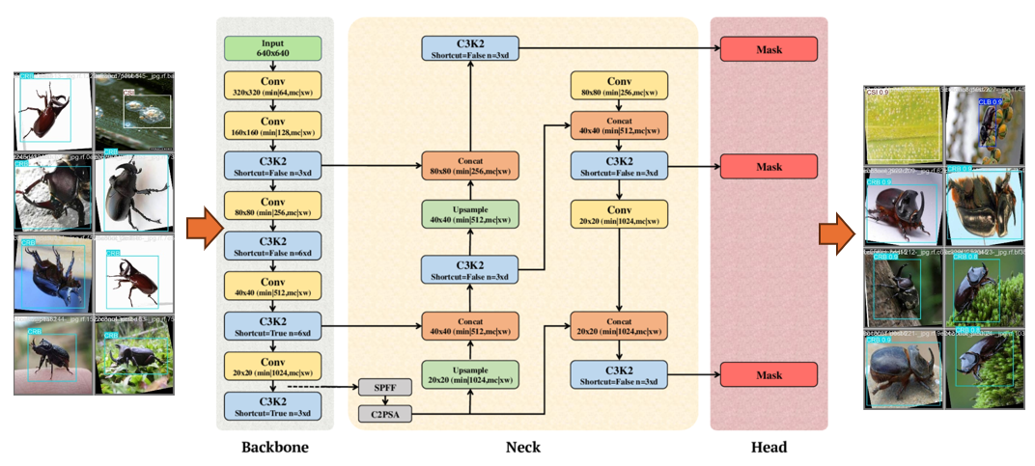

1. Finetuned YOLOv11.

## Metrics and Evaluation

To assess the performance of the fine-tuned object detection model, standard evaluation metrics were employed, including accuracy, precision, recall, F1 score, and mean Average Precision (mAP).

Accuracy measures the overall correctness of the model by accounting for both true positives (TP) and true negatives (TN) over all predictions, though it can be misleading in class-imbalanced datasets.

(1)

Precision reflects how many of the model’s positive predictions were actually correct, indicating its reliability in identifying true coconut pests while minimizing false positives (FP).

(2)

Recall quantifies the model’s ability to detect all actual positive instances, measuring how well it identifies all pests without missing any (minimizing false negatives or FN).

(3)

F1 Score provides a balanced harmonic mean between precision and recall, especially useful when a trade-off between the two is needed in real-world pest detection scenarios.

(4)

Lastly, mean Average Precision (mAP) is used as a comprehensive metric for object detection performance, averaging the precision scores across different intersection-over-union (IoU) thresholds and classes. It is particularly crucial in evaluating localization and classification accuracy in multi-class detection tasks such as identifying various coconut pests.

(4)

Together, these metrics offer a holistic view of the model’s detection capabilities, helping determine its practical effectiveness and reliability.

# Results and Discussions

The training, validation, and testing findings are discussed in this section.

## F1-Curve

Important insights into the model’s reliability and class-specific performance are conveyed through the evaluation graphs. Such assessments are essential for applications requiring real-time identification of coconut pests.

1. F1-Curve.

As shown in Fig. 5, the model achieved an F1 score of 0.90 at a confidence threshold of 0.682, indicating a strong balance between precision and recall. This result demonstrates the model’s capability to perform accurate detections while minimizing false positives and false negatives, thereby supporting its suitability for practical deployment in pest monitoring scenarios.

## Precision-Confidence Curve

Fig. 6 provides key insights into the relationship between model confidence and precision. In general, higher confidence scores are associated with increased precision, which is a desirable characteristic in object detection models. The graph illustrates that precision tends to rise as confidence increases, reflecting the model’s ability to make more accurate predictions when it is more certain. As shown by the bold blue line, precision reached a maximum value of 1.00 at a confidence level of 0.894. This indicates that predictions made with a confidence score of 89.4% or higher were entirely accurate within the evaluation set, demonstrating the model’s reliability at high confidence thresholds.

1. Precision-Confidence Curve Result.

## Precision-Recall Curve

In Fig. 7 presents a comprehensive assessment of the model’s classification performance. The graph illustrates the overall mean Average Precision at an Intersection over Union (IoU) threshold of 0.5 (mAP@0.5), along with the corresponding precision and recall trade-offs for each pest class.

1. Precision-Recall Curve Result.

The model demonstrated particularly strong performance in detecting the Red Palm Weevil (RPW), achieving an average precision of 0.995. This slightly exceeded the performance for the Coconut Rhinoceros Beetle (CRB), which attained an average precision of 0.986. These results indicate that the model is highly effective in accurately detecting specific pest classes while minimizing both false positives and false negatives, thereby supporting its robustness and reliability across multiple detection scenarios.

The bold blue curve in Fig. 7 represents the average precision-recall performance across all pest classes, yielding an overall mean Average Precision at IoU 0.5 (mAP@0.5) of 0.912. This high average score demonstrates the model’s strong generalization capability across multiple coconut pest categories. The consistent performance across classes suggests that the model is well-suited for detecting diverse pest types under varying image conditions, thereby supporting its applicability in real-world agricultural monitoring tasks.

## Recall-Confidence Curve

Fig. 8, shows the recall curve, which indicates how the model’s memory changes for each class with varying levels of confidence. In coconut pests’ detection professions were lowering false negatives is a top priority, this graph is crucial. The graph indicates that the model recovers true positives when it is lease selective, reaching its maximum recall of 0.95 across all classes at a confidence level of 0.000.

1. Recall-Curve.

## Confusion Matrix

Fig. 9 presents the normalized confusion matrix, which provides a detailed overview of the model’s classification performance across the four coconut pest classes—Coconut Leaf Beetle (CLB), Coconut Scale Insect (CSI), Coconut Rhinoceros Beetle (CRB), and Red Palm Weevil (RPW)—as well as the background class.

The diagonal elements indicate correct classifications, while off-diagonal values represent misclassifications. High values on the diagonal for CLB (0.94), CRB (0.96), CSI (0.74), and RPW (1.00) suggest that the model performs strongly in correctly identifying most pest classes. Notably, RPW achieved perfect classification in this instance, reflecting the model’s high confidence and accuracy in detecting this class.

However, some misclassifications are evident. CSI exhibits moderate confusion, with portions of its instances misclassified as background (0.247), indicating potential challenges in distinguishing CSI features from non-pest regions. Additionally, background elements were sometimes misclassified as CSI (0.429), suggesting a degree of false positive behavior likely due to visual similarity or annotation inconsistencies.

1. Normalized Confusion Matrix.

## Testing

The detection performance of the model was assessed using three distinct validation batches, as illustrated in Fig. 10 and 12. Each batch highlights the model’s capability to accurately identify and classify various coconut pests, including Coconut Leaf Beetle (CLB), Coconut Scale Insect (CSI), and Coconut Rhinoceros Beetle (CRB).

In Batch 0, the model exhibited high confidence scores and precise bounding box placements across the majority of instances. Pest classes were correctly identified even in visually complex and cluttered backgrounds, suggesting that the model was able to generalize effectively to varied image conditions. This performance underscores the model’s robustness in handling real-world agricultural scenarios where environmental noise and diverse visual contexts are common.

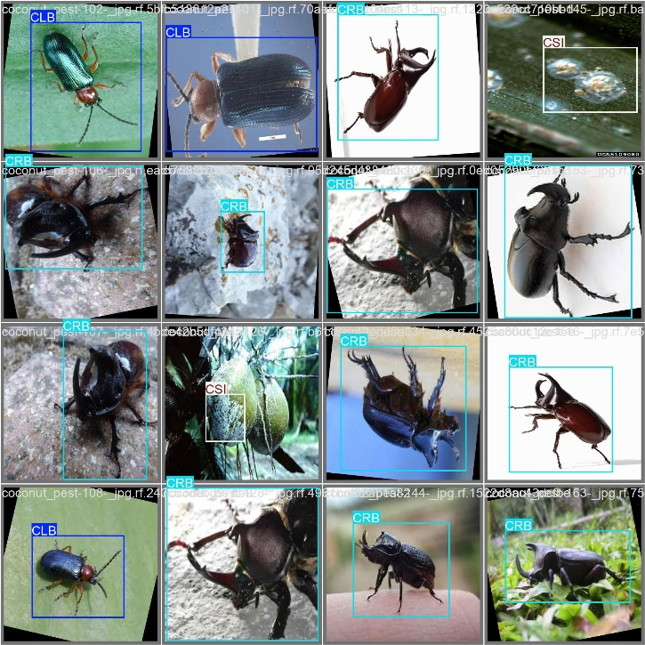

1. Test Result Batch 0.

Batch 1 further reinforces the model’s robustness. The pest instances are detected across a wider range of lighting conditions and orientations. Even in images with complex textures and overlapping elements, the model successfully distinguishes individual pests with high precision.

1. Test Result Batch 1.

In Batch 2, the model maintains consistent detection performance but encounters a few challenges. Some bounding boxes have slightly lower confidence scores (around 0.7–0.8), particularly for pest types with less distinctive features or in low-contrast images. Despite these minor inconsistencies, classification accuracy remains high, and false positives are minimal.

1. Test Result Batch 2.

The visual results across batches confirm that the fine-tuned object detection model performs reliably across diverse conditions and pest varieties. These validation outputs highlight the model’s practical potential for aiding pest management in real agricultural settings.

# Conclusion

This study successfully demonstrated the effectiveness of a fine-tuned YOLOv11 object detection model for identifying major coconut pests, including the Coconut Rhinoceros Beetle (CRB), Coconut Scale Insect (CSI), Coconut Leaf Beetle (CLB), and Red Palm Weevil (RPW). Through systematic data collection, annotation, training, and evaluation, the model achieved high detection performance, as evidenced by strong precision, recall, F1 scores, and an overall mAP@0.5 of 0.912. The model’s ability to generalize across various pest classes was further validated through detailed confusion matrix analysis and multiple validation batches, showing accurate detections even under diverse image conditions.

The findings highlight the potential of deep learning-based object detection as a practical tool for improving pest monitoring in coconut agriculture. By automating pest identification, the approach can significantly reduce the reliance on labor-intensive field inspections and enable earlier, data-driven interventions. Future work may explore the integration of this model into mobile or edge-based applications, as well as further improvements in dataset diversity and real-time deployment.

##### Acknowledgment

The researchers would like to express their sincere gratitude to all individuals and institutions who supported the completion of this study. Special thanks are extended to the faculty and staff of the College of Computing and Information Technology at Adamson University for their guidance and feedback throughout the research process. Appreciation is also given to the academic and technical communities whose open-access resources and datasets contributed significantly to the development and validation of the model.

##### References

1. I.-F. Ignacio and T.-S. Miguel, “Research opportunities on the coconut (Cocos nucifera L.) using new technologies,” *South African Journal of Botany*, vol. 141, pp. 414–420, Sep. 2021, doi: [10.1016/j.sajb.2021.05.030](https://doi.org/10.1016/j.sajb.2021.05.030).
2. Z. Rahimi, A. Anand, and S. Gautam, “An overview on thermochemical conversion and potential evaluation of biofuels derived from agricultural wastes,” *Energy Nexus*, vol. 7, p. 100125, Sep. 2022, doi: [10.1016/j.nexus.2022.100125](https://doi.org/10.1016/j.nexus.2022.100125).
3. M. Llop, “Contribution of major economies to global GDP and product reallocation around the world,” *Heliyon*, vol. 10, no. 1, p. e23909, Jan. 2024, doi: [10.1016/j.heliyon.2023.e23909](https://doi.org/10.1016/j.heliyon.2023.e23909).
4. A. Gamage *et al.*, “Advancing sustainability: The impact of emerging technologies in agriculture,” *Current Plant Biology*, vol. 40, p. 100420, Dec. 2024, doi: [10.1016/j.cpb.2024.100420](https://doi.org/10.1016/j.cpb.2024.100420).
5. S. T. N and J. G. Ray, “Ecology of arbuscular mycorrhizal association in coconut (Cocos nucifera L.) palms: Analysis of factors influencing AMF in fields,” *Rhizosphere*, vol. 32, p. 100961, Dec. 2024, doi: [10.1016/j.rhisph.2024.100961](https://doi.org/10.1016/j.rhisph.2024.100961).
6. S. D. G. Marshall, A. Moore, M. Vaqalo, A. Noble, and T. A. Jackson, “A new haplotype of the coconut rhinoceros beetle, Oryctes rhinoceros, has escaped biological control by Oryctes rhinoceros nudivirus and is invading Pacific Islands,” *Journal of Invertebrate Pathology*, vol. 149, pp. 127–134, Oct. 2017, doi: [10.1016/j.jip.2017.07.006](https://doi.org/10.1016/j.jip.2017.07.006).
7. L. Farahzadi, I. Odeh, M. Kioumarsi, and B. Shafei, “Automated image-based condition assessment of the built environment: A state-of-the-art investigation of damage characteristics and detection requirements,” *Results in Engineering*, vol. 26, p. 104978, Jun. 2025, doi: [10.1016/j.rineng.2025.104978](https://doi.org/10.1016/j.rineng.2025.104978).
8. R. Marasigan Jr., M. A. Malbog, E. Festijo, and D. E. Juanico, “CocoSense: Coconut Tree Detection and Localization using YOLOv7,” *E3S Web of Conf.*, vol. 488, p. 03015, 2024, doi: [10.1051/e3sconf/202448803015](https://doi.org/10.1051/e3sconf/202448803015).
9. J. D. Thiagarajan *et al.*, “Analysis of banana plant health using machine learning techniques,” *Sci Rep*, vol. 14, no. 1, p. 15041, Jul. 2024, doi: [10.1038/s41598-024-63930-y](https://doi.org/10.1038/s41598-024-63930-y).
10. C. B. Balingbing *et al.*, “Application of a multi-layer convolutional neural network model to classify major insect pests in stored rice detected by an acoustic device,” *Computers and Electronics in Agriculture*, vol. 225, p. 109297, Oct. 2024, doi: [10.1016/j.compag.2024.109297](https://doi.org/10.1016/j.compag.2024.109297).
11. S. Coulibaly, B. Kamsu-Foguem, D. Kamissoko, and D. Traore, “Explainable deep convolutional neural networks for insect pest recognition,” *Journal of Cleaner Production*, vol. 371, p. 133638, Oct. 2022, doi: [10.1016/j.jclepro.2022.133638](https://doi.org/10.1016/j.jclepro.2022.133638).
12. R. Khanam and M. Hussain, “YOLOv11: An Overview of the Key Architectural Enhancements,” 2024, *arXiv*. doi: [10.48550/ARXIV.2410.17725](https://doi.org/10.48550/ARXIV.2410.17725).