**Data Encryption Standard Algorithm (DES) documentation**

**User Manual for DES Application Encryptor and Decryptor program :**

**Our app is a command line tool. It enable users to change font color and background color to four different colors . User can select Red, Blue, Green, and White by entering the suitable input. Colors are selected using 1, 2, 3, or 4 numbers. The following figure[1] illustrates the color selection step for foreground or background :**

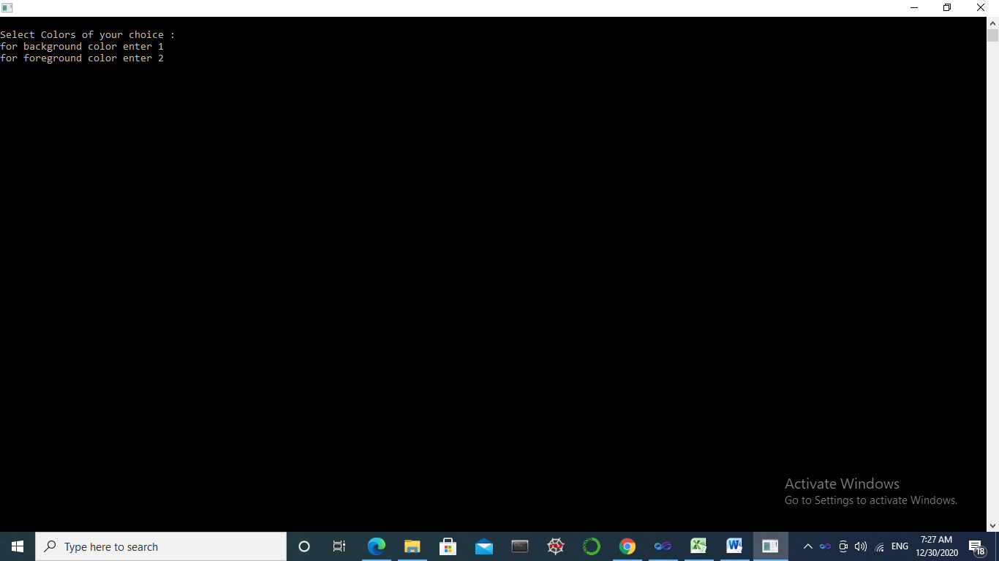

**figure[1] illustrates the color selection step for foreground or background**

**User can select which step to do by entering 1 or 2 of the available selections. If 1 is entered he would be asked again whether he would like to change the background color. But, if 2 is entered he would be asked to change the foreground color. Figure [2] illustrates the required step to change the background color after entering 1.**

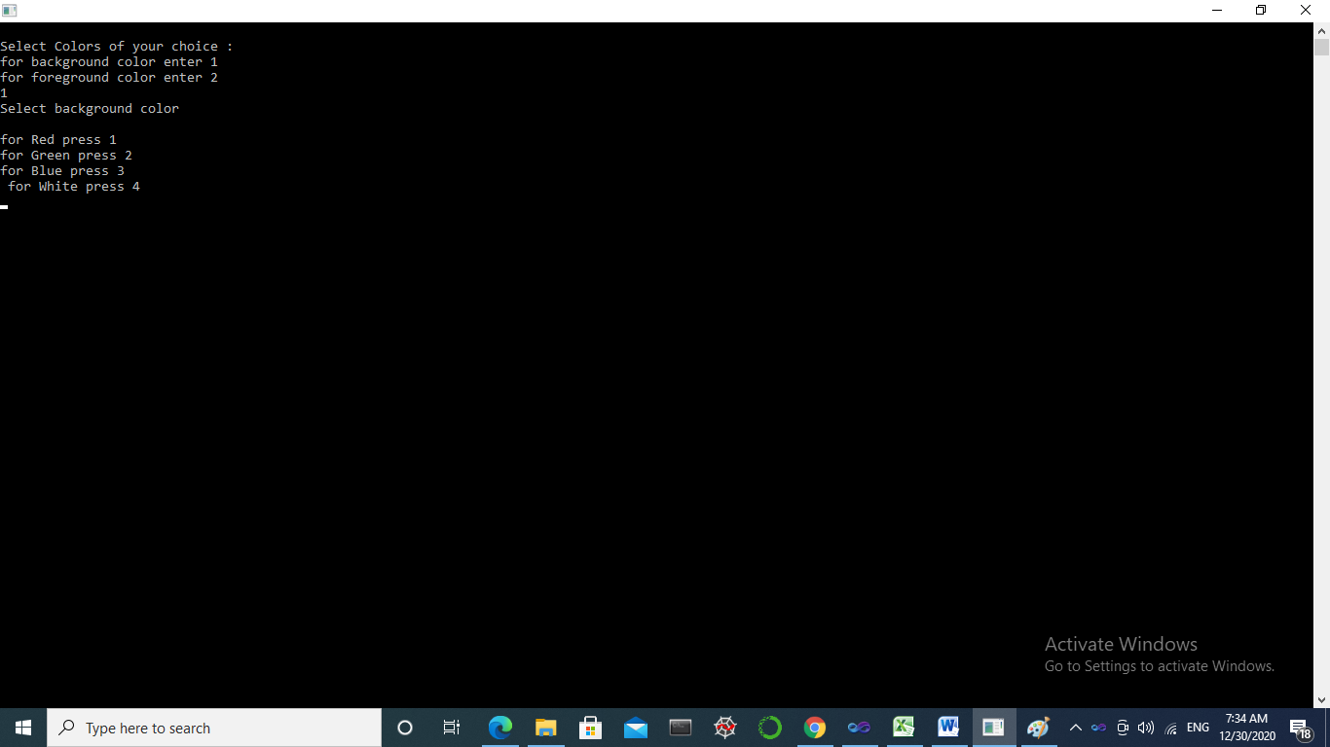

**Figure [2] illustrates the required step to change the background color.**

**Figure [2] has viewed that user can enter 1 for Red color, 2 for Green color, 3 for Blue color, and 4 for White color.**

**In figure [3], user had entered 4 in the previous step, so the figure [3] is appearing with a White background color.**

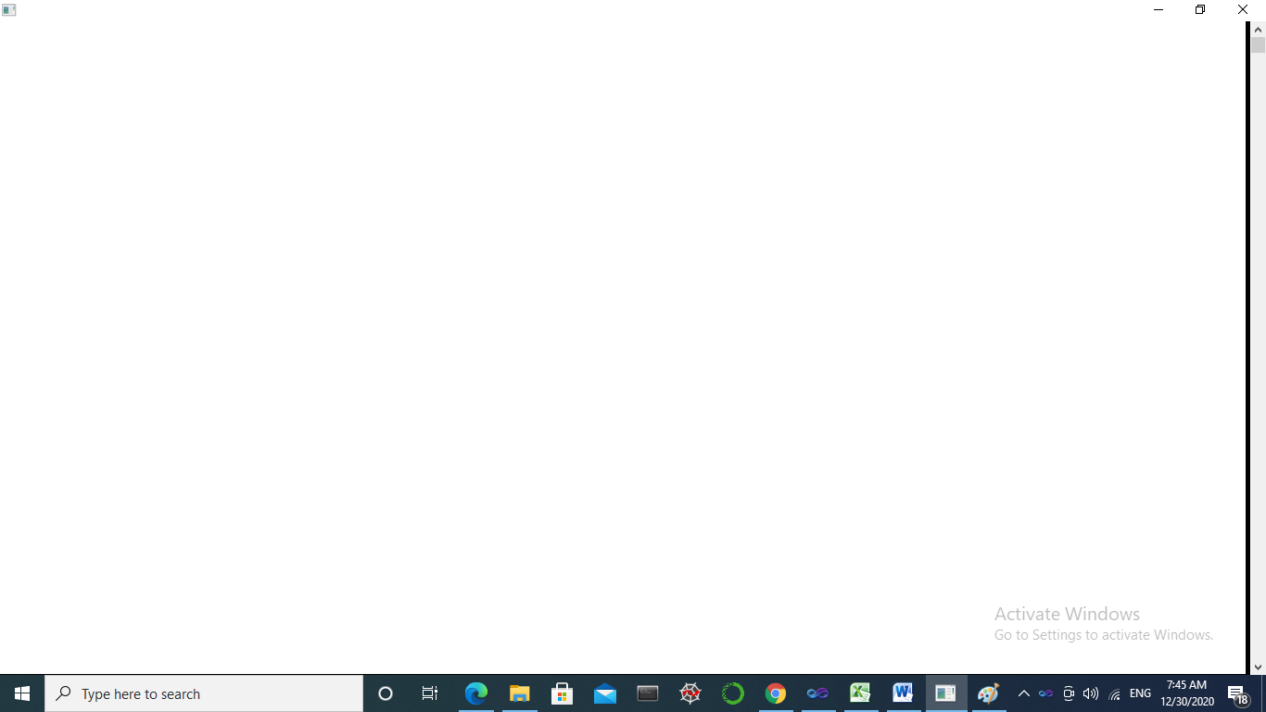

**Figure[3] is displaying a White background color**

**Press Enter so that font is appearing in the default color of the system(Console Application) on .NET environment like in Figure [4].**

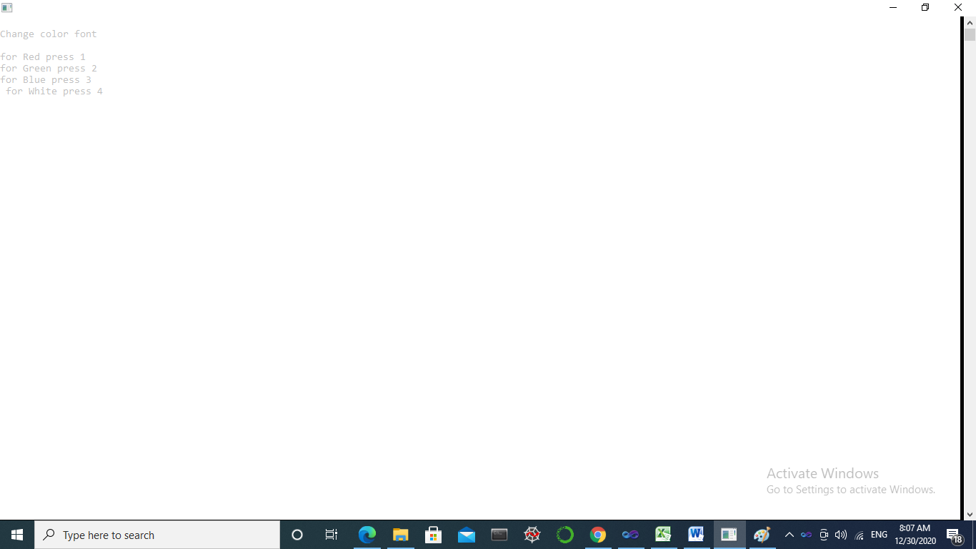

**Figure[4] display the default color of the font and asks to change font color.**

**In Figure[4], our system is asking the user to change font color by entering 1 for Red, 2 for Green, 3 for Blue, and 4 for White.**

**In Figure [5], the user has entered 1 for Red color before the screen display a Red color for the font.**

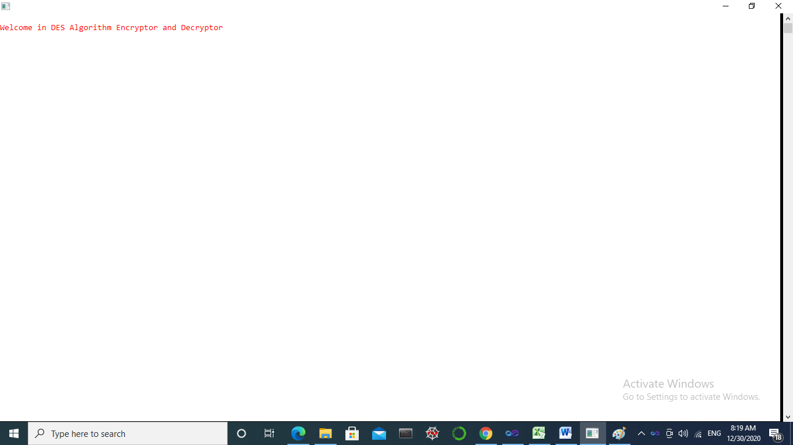

**Figure[5], display a red color of the font after entering 1 as a value for Red color.**

**In Figure [6], the program ask the user which process is preferred to start, encryption or decryption, and prompt him to enter either 1 or 2 as follows in figure[6].**

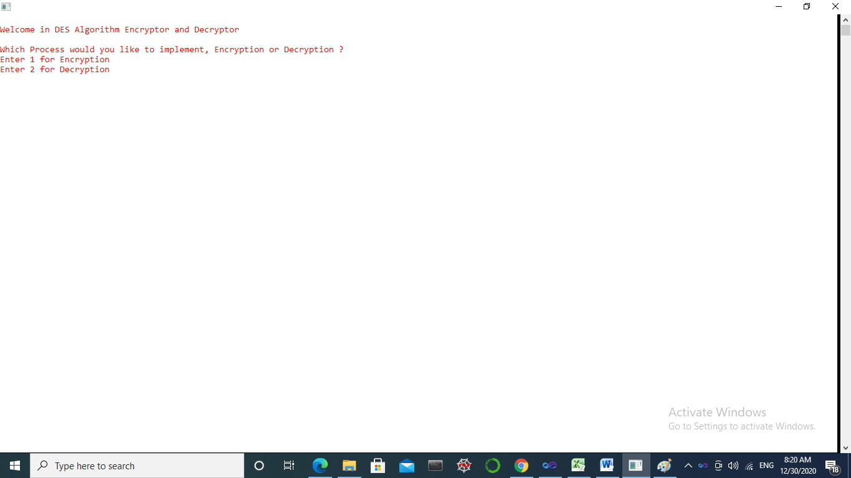

**Figure[6] display a question for the user to select encryption or decryption**

**In Figure [7], the user has entered 1 for Encryption process selection. The figure displays that the user had selected Encryption and the system is asking the user to enter his Plain Text Message. Then, the user had entered the Plain Text message : “Hi How are you dears ?”. After that, the system had displayed a message approving the user input and that it’s going to encrypt his Plain Text.**

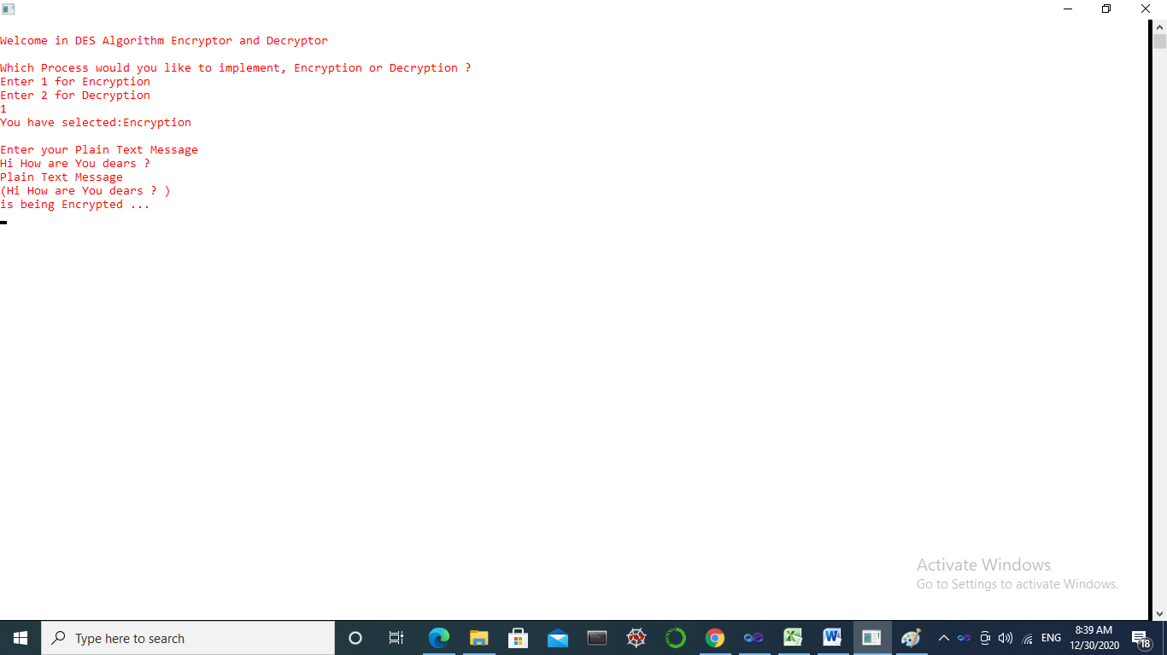

**Figure[7] illustrates how the user selected Encryption and entered his Plain Text message with approval message of user input.**

**In Figure [8], our program has displayed a message referring to the generated Cipher Text with the length of the input message.**

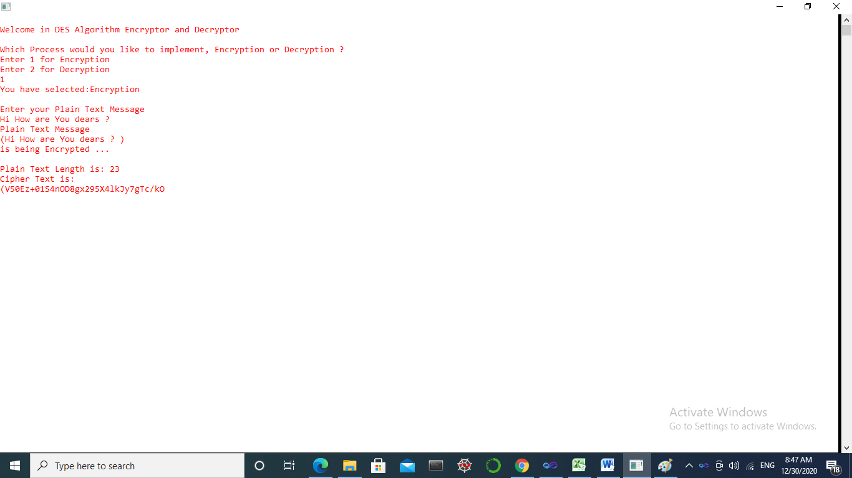

**Figure [8], illustrates the Cipher Text**

**In Figure [9], The program is asking the user whether he is willing to make a decryption of the generated Cipher Text. The user had entered 1 then the system has returned a message with the entered Plain Text to the user again.**

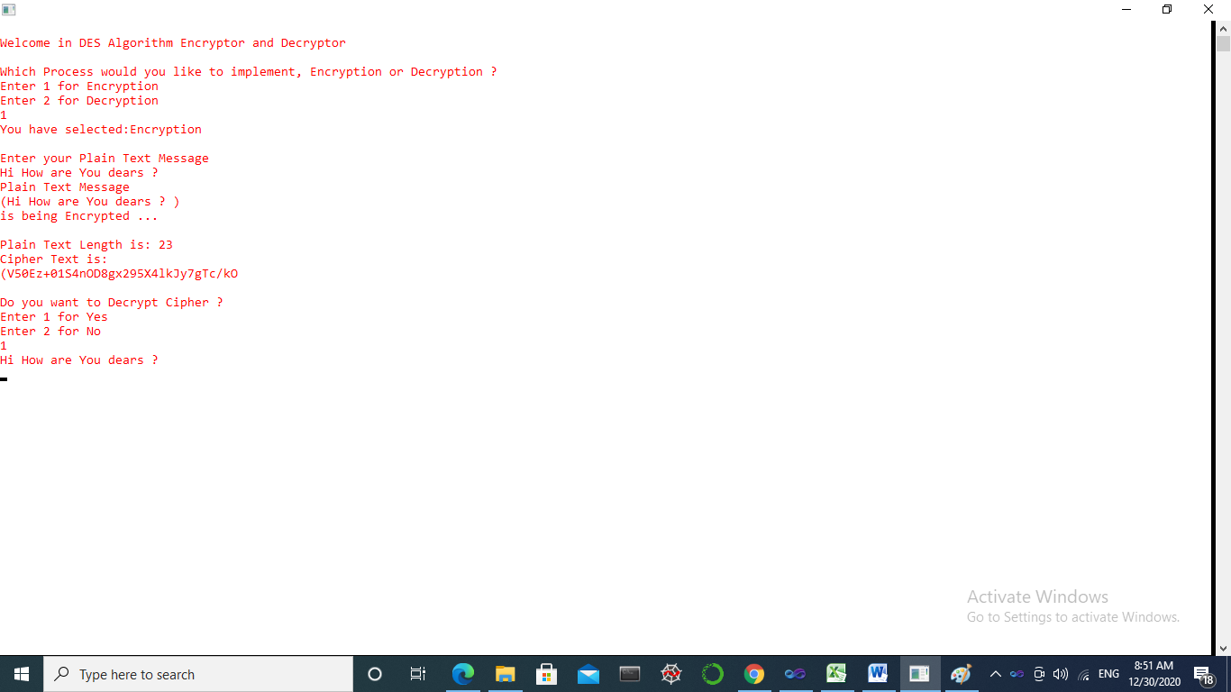

**Figure[9] display a question for the user about his intent to make a decryption of Cipher Text and then return the Plain Text upon user response.**

**Finally, Figure[10] displays a final message is printed for the user saying “good bye” and referring to System shut down.**

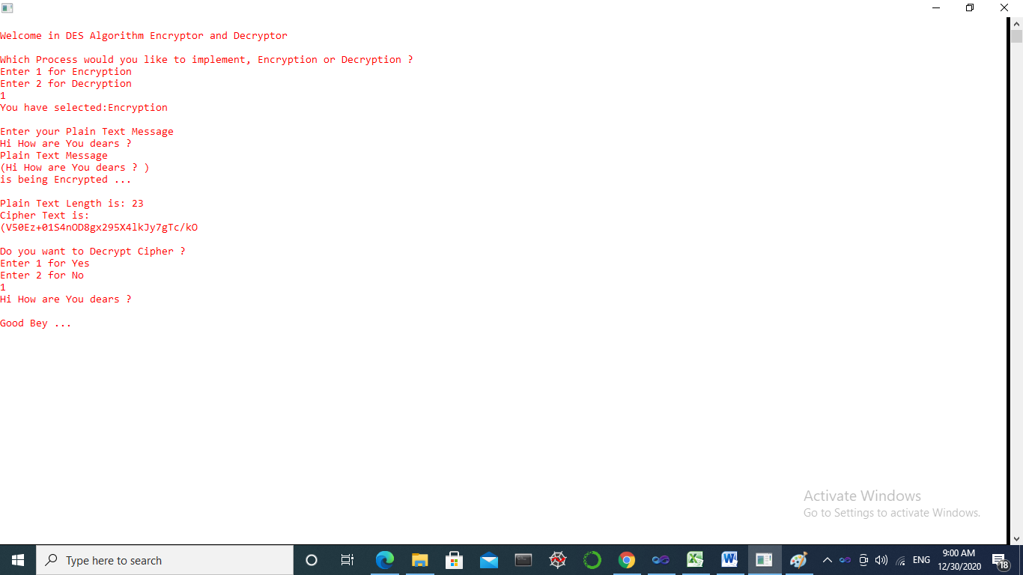

**Figure[10] illustrates a shut down message “good buy”**