Exam 1 – Make Up

Foundations of College Algebra

1. Find the square root.
$$\sqrt{16}$$

2. Simplify.
$$\sqrt{36}÷\sqrt{9}+4^{2}⋅7-18$$

3. Represent the shaded part of the group of circles with an improper fraction and a mixed number.



1. Write the mixed number as an improper fraction.
$$169\frac{2}{3}$$

2. List the factors of 62.
3. Find the prime factorization of the following number. Write any repeated factors using exponents.
$$700$$

4. Write the given fraction in simplest form.
$$\frac{784}{16}$$

5. There are 5280 feet in a mile. What fraction of mile is represented by 480 feet? Write your answer in simplest form
6. Multiply.
$$0⋅\frac{9}{4}$$

7. Multiply. Write the answer in simplest form.
$$1\frac{1}{6}⋅\frac{6}{35}$$

8. Divide. Write your answer in simplest form.
$$\frac{5}{21}÷\frac{25}{49}$$

9. Divide. Write your answer in simplest form.
$$5÷\frac{3}{11}$$

10. Find the LCM of the list of numbers.
$$12, 10$$

11. 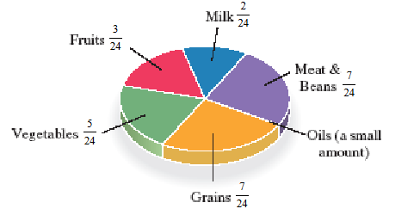Find a fractional part of a college student’s daily servings that should come from vegetables and fruits.
12. Write the fraction as an equivalent fraction with the given denominator.
$$\frac{2}{3}=\frac{}{60}$$

13. Add and simplify.
$$\frac{2}{36}+\frac{2}{45}$$

14. Subtract.
$$\frac{19}{24}-\frac{3}{4}$$

15. Evaluate the given expression.
$${\left(\frac{2}{3}\right)}^{3}$$

16. Perform the indicated operation.
$$5\frac{2}{9}+4\frac{10}{11}$$

17. Round $0.9684$ to the nearest thousandth.
18. Round $0.1397$ to the nearest thousandth.
19. Subtract.
$$900-3.7$$

20. 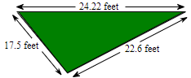A landscape architect is planning a border for a lower garden shaped like a triangle. The sides of the garden measure 17.5 feet, 24.22 feet, and 22.6 feet. Find the amount or border material needed.
21. 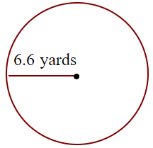Find the circumference of the circle given to the right in terms of $π.$ Then use the approximation 3.14 for $π$ and approximate the circumference.
22. Divide.

$$4÷0.02$$