Exam 2 – Make Up

Foundations of College Algebra

**Directions:** Answer the questions below. You can use a calculator, but not a cell phone calculator or a smartwatch. You are not allowed to use notes. Each question is worth 4 points each.

1. For the given proportion, find the unknown number $n$. Give your answer as a whole number or decimal.
$$\frac{n}{0.1}=\frac{0.04}{4}$$

2. A self-tanning lotion advertises that a 5-oz bottle will provide three applications. Jen found a great deal on a 17-oz bottle of the self-tanning lotion she had been using. Based on the advertising claims, how many applications of the self-tanner should Jen expect? Round your answer down to the nearest whole number.
3. One hundred adults were asked to name their favorite sport and the results are shown in the circle graph. What percent of adults preferred baseball or basketball?

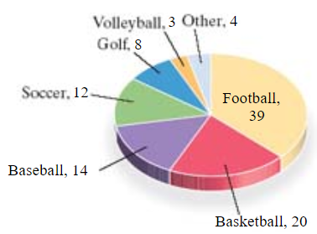

1. What number is 43% of 70? Write your answer as a whole number or a decimal.
2. A family paid $27,200 as a down payment for a home. If this represents 17% of the price of the home, find the price of the home.
3. In 1999, total revenue of a company from music sales and licensing was $14.8 billion. It was forecasted that this number would continue to drop until it reached $5.5 billion in 2014. Find this percent decrease in music revenue.
4. The sales tax if $128.40 on a stereo sound system of $1605. Find the sales tax rate.
5. A real estate agent earned a commission of $4,520 for selling a house. If his rate is 4%, find the selling price of the house.
6. A line-marking machine lays down lime powder to mark two equal foul lines on a playing field. If each line for this field measures 316 feet, how many feet of lime power will be deposited?
7. 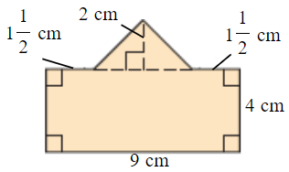­Find the area of the geometric figure.
8. Find the **exact** volume of a sphere with radius of 5 inches. Write your answer in terms of $π$. $$V=\frac{4}{3}πr^{3}$$
9. Find the square root. If the square root cannot be expressed as a whole number or fraction, then round to the nearest thousandth.
$$\sqrt{70}$$

10. Draw the triangle and find the length of the side not given. Round the missing side to the nearest thousandth as needed.
$$\text{leg}=15,\text{ leg}=23$$

11. Rewrite the inequality so that the inequality symbol points in the opposite direction and the resulting statement has the same meaning.
$$-15>-17$$

12. Insert $<$, $>$, or $=$ in the space to make the statement true.
$$\left|-4\right| \text{________}-3$$

13. Evaluate. $${\left(2.8\right)}^{2}$$
14. Simplify the given expression. Write your answer as an integer or a fraction. $$\frac{7+7\left(3+2\right)}{7^{2}+7}$$
15. Translate the following sentence into an equation.
$$\text{Nine}\text{ is not equal to }\text{five}\text{ divided by three.}$$

16. Evaluate $2x+y$ for $x=1$ and $y=-1$.
17. The lowest temperature ever recorded in Winter Haven was $-{14}^{∘}\text{F}$. The highest recorded temperature in Sundance was ${122}^{∘}\text{F}$ higher than the record low temperature. Find Sundance’s highest recorded temperature.
18. Simplify.
$$-17-\left(-14\right)+\left(-15\right)-18$$

19. Simplify the expression.
$$4^{2}-7⋅2$$

20. Evaluate the expression. $$\frac{-7^{2}+15}{-2}$$
21. Decide whether the given number is solution of the given equation. $$\frac{x-2}{6}=-9; -52$$
22. Simplify the expression using the distributive law. $$-\frac{1}{7}\left(7y+8\right)$$