Exam 3 – Make Up

Foundations of College Algebra

**Directions**: Solve the questions below. Show your work. You are allowed to use a calculator, but not notes, a cellphone, or a smartwatch.

1. Solve the equation.
$$-3\left(n-4\right)=7-12n$$

2. A 7-foot board is cut into two pieces. If one piece is $x$ feet long, express the other length in terms of $x$.
3. Solve the equation for $x$.
$\frac{x}{5}-1=-4$

4. Solve the equation for $x$.
$$3x+16=9x+22$$

5. Solve.
$$6\left(2y-1\right)-2\left(2y\right)=6$$

6. Solve the equation for $x$.
$$\frac{3}{10}x-\frac{1}{5}=-2$$

7. Using $x$ as the unknown number, write the statement below as an equation.

Four times a number, minus 4, is equal to three times the number, plus 7

1. A car rental agency advertised renting a car for $28.95 per day and $0.33 per mile. If Trevor rents this car for 3 days, how many whole miles can he drive on a $150 budget?
2. Solve the formula for the specified variable.

$Q=R+Rst$ for $t$

1. Graph the inequality on a number line.



$$2≤m$$

1. Solve the inequality. Write the solution set in set notation.
$$5\left(x+1\right)-4x≥-6$$

2. Complete the table of ordered pairs for the linear equation.

$$y=2x-13$$

|  |  |
| --- | --- |
| $$x$$ | $$y$$ |
| 0 |  |
|  | $$-9$$ |
| $$3$$ |  |

1. Graph the linear equation.

1. Graph the linear equation

1. 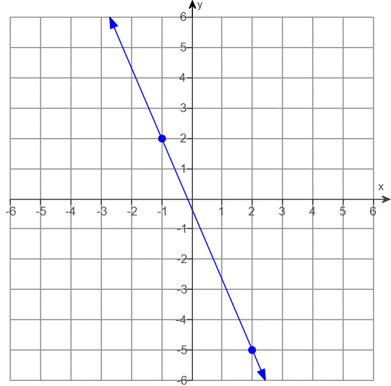Use the points shown on the graph to find the slope of the line.
2. Find the slope of the line.
$$y=5x-5$$

3. Write an equation of the line with the given slope, $m$, and $y$-intercept $(0,b)$.
$$m=-\frac{3}{4}, b=\frac{1}{2}$$

4. Given the following function, find $f(-2)$ and $f\left(0\right)$.

$$f\left(x\right)=x^{2}+4$$