Final Exam

College Algebra

**Directions:** Show all work and use three decimal places for all problems. (5 points each)

1. Mary Johnson weighed 145 lbs. in 1986 and weighed 190 lbs. in 2007. Find the rate of change in her weight between 1986 and 2007.
2. [**Bonus**]Does the data in the following tables determine a linear function, a quadratic function, or an exponential function? Explain your answer.

|  |  |  |  |  |
| --- | --- | --- | --- | --- |
| $$x$$ | 2 | 4 | 6 | 8 |
| $$y$$ | 9 | 21 | 41 | 69 |

|  |  |  |  |  |
| --- | --- | --- | --- | --- |
|  | 2 | 4 | 6 | 8 |
| $$y$$ | 8 | 128 | 2048 | 32768 |

1. 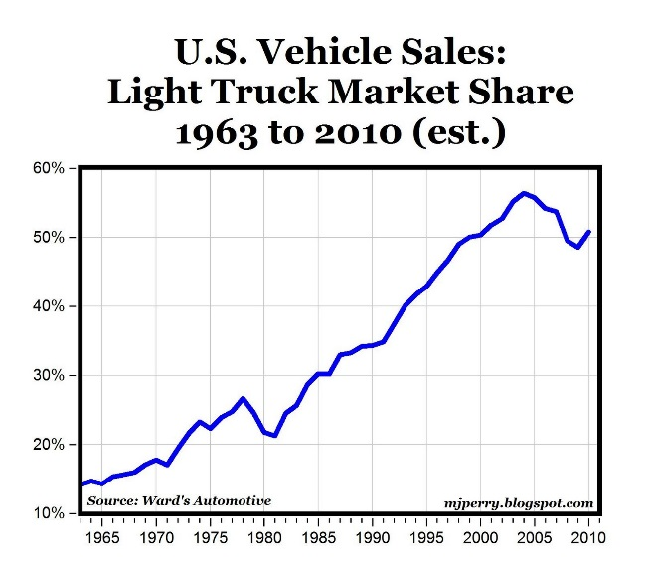Given the following function, answer the following:
   1. What was the percentage of light truck market share in 1970?
   2. What year did the percentage first reach 30%?
   3. What was the maximum percentage and when did that occur?
2. [**Bonus**]Given the linear function $3x + 4y = 156$ answer the following:
   1. What is the $x$-intercept?
   2. What is the $y$-intercept?
3. [**Bonus**] Give the slope and graph of the linear function $y = 3x + 25$. Your graph should include both intercepts.
4. Suppose the following table shows the value $B$, in billions of dollars, of new construction put in place in the United States during the year $t$*,*where $t = 0$ in 2000.

|  |  |  |  |  |
| --- | --- | --- | --- | --- |
| $t =$ year | 2 | 5 | 8 | 11 |
| $B =$ Value | 433.3 | 470.2 | 565.2 | 604.7 |

* 1. Calculate the average rate of change for 2008 – 2011 and interpret in terms of this problem.
  2. Express in function notation the value of new construction this year and calculate the value using the average rate of change from **part A**.

1. You have decided to open a t-shirt printing business and have $2000 to get started. A silk screening machine is available for $1400 and bulk t-shirts cost $1.90 each.
   1. Using function notation, construct a model that expresses the cost as a function of the number of t-shirts printed.
   2. Algebraically determine the number of t-shirts you can initially print.
2. The following table shows the United States Gross National Product (GNP), in trillions of dollars, during a specific year $t$. ($t = 0$ in 1995)

|  |  |  |  |  |  |
| --- | --- | --- | --- | --- | --- |
| $t=$ Year | 3 | 4 | 5 | 6 | 7 |
| $G=$ GNP | 7.78 | 8.31 | 8.85 | 9.11 | 9.44 |

* 1. Determine the equation of the linear **regression** line for the data set.
  2. Using the regression equation, when will the GNP be 16 trillion dollars?

1. Solve the following system of equations using matrices.
$$-2x+3y+8z=6 \\ y=4x-2z \\ x+y+z=12$$

2. The function below gives the number of passenger cars, *P*, in use worldwide in millions with *t* = 0 in 1970. $P = 11.823t + 198.714$
   1. Interpret the vertical intercept in terms of the problem.
   2. Interpret the slope in terms of the problem.
3. [**Bonus**] Given the function, find the vertex, x-intercept(s), and y-intercept.
4. [**Bonus**] Graph the function in Problem 11. Be sure to include all the important aspects of the graph.
5. [**Bonus**] The data provided below show the percent of persons in the United States withouthealth insurance for a given year. (Source: United States Census Bureau)

|  |  |
| --- | --- |
| Year | % Without Health Insurance |
| 2007 | 14.7 |
| 2008 | 14.9 |
| 2009 | 16.1 |
| 2010 | 16.3 |
| 2011 | 15.7 |
| 2012 | 15.4 |

* 1. Use matrices to calculate the quadratic equation to model the data using information from 2007, 2010 and 2012 where *t* is the number of years after 2007.
  2. According to the model obtained from **part A**, determine what percent of persons in the United States were without insurance in 2016.

1. [**Bonus**] A physician is administering a drug to a patient. The amount $D$ of the drug in the patient’s bloodstream $t$ hours after the injection of the drug is given in the following table.

|  |  |  |  |  |  |  |  |  |
| --- | --- | --- | --- | --- | --- | --- | --- | --- |
| $$t$$ | 0 | 1 | 2 | 3 | 4 | 5 | 6 | 7 |
| $$D$$ | 4.5 | 6.4 | 8.7 | 9.1 | 9.2 | 8.2 | 7.3 | 5.2 |

* 1. Determine the equation of the quadratic regression curve that fits the data set.
  2. According to the model from **part A**, calculate the maximum amount of the drug in the patient’s bloodstream and time of this maximum amount during this seven-hour period.

1. You deposit $100 into a savings account. The following table shows the balance $B$, in dollars, over the course of $t$ years.

|  |  |  |  |  |
| --- | --- | --- | --- | --- |
| $$t$$ | 0 | 1 | 2 | 3 |
| $$B$$ | 100.00 | 103.25 | 106.61 | 110.07 |

* 1. Algebraically determine the exponential function for the balance in the savings account.
  2. Express in function notation the amount of money in the account after 7 years, then calculate its value.

1. The table below shows the amount, in grams, of a substance as it decays over time in days.

|  |  |  |  |  |
| --- | --- | --- | --- | --- |
| $d$ = days | 3 | 6 | 9 | 12 |
| $A$ = Amount | 15.35 | 9.43 | 5.8 | 3.56 |

* 1. Determine the equation of the exponential **regression** curve that fits the data set
  2. According to this model, calculate when there will be 1 grams of the substance remaining.

1. [**Bonus**] Make a table of values and graph y = 2x. Include positive and negative values for x.
2. [**Bonus**] Solve the following equation algebraically.
$$e^{2x-4}+11=86$$

3. [**Bonus**] Solve the following equation algebraically.
$$-\frac{3}{2}\log\left(8x\right)=-4$$

4. An island with a population of 1.4 million people is growing at the rate of 2.2% per year.
   1. Write an equation for this growth in millions over time.
   2. Determine algebraically when the population will double.
5. [**Bonus**]
   1. Determine the inverse function of $f\left(x\right)=\frac{1}{2}(x-3)$.
   2. Given $f\left(x\right)=4x^{2}-8$ and $g\left(x\right)=\sqrt{x+8}$, calculate $f\left(g\left(x\right)\right)$.