Project 1

Liberal Arts Mathematics

# Introduction

For this project, we are going to compare several different methods for paying for a large purchase. This project will summarize several topics from Chapter 8. Directions for submitting your project are at the end.

# Setup

For this project, you will need to start by collecting some information. (Note: You cannot use the same information from the examples. Find your own product.)

1. Go to Aaron’s website (<https://aarons.com>) and search for an appliance or TV that **costs over $1000 and with a brand name that starts with the same letter as your last initial**. Record the following:
   1. The brand and model number.
   2. The 24-month total cost of ownership.
   3. The cash price.
   4. The monthly payment.

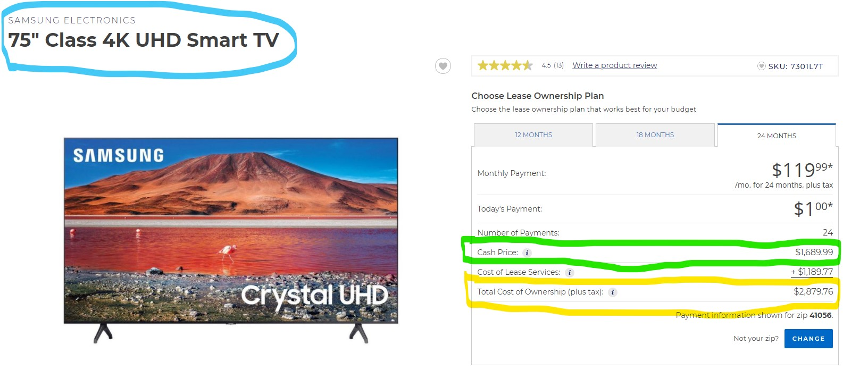

Aaron’s Website

1. Go to Walmart’s website (<https://walmart.com>) and find the same item. Record the price.

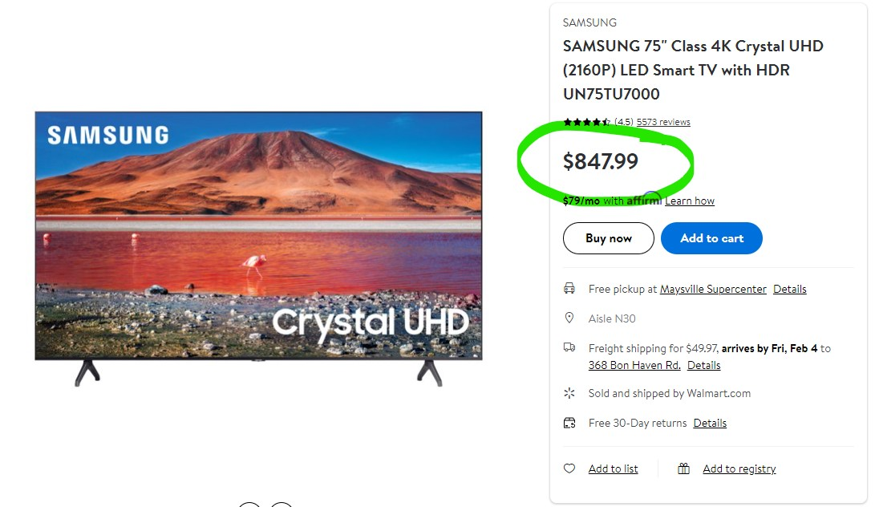

Walmart Website

1. Search for a credit card and record the APR. The Capital One Quicksilver card is shown below. For a variable APR use the lowest APR.

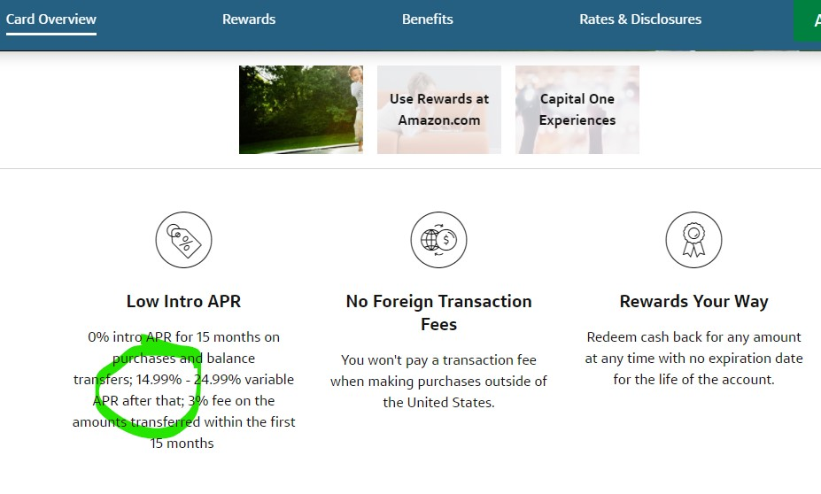

Capital One Website

# Analyzing Rent-to-Own

Now that we have our information, let’s begin to piece together the story our numbers tell. **All questions below are about the item you researched.**

1. Calculate the percent increase in price from the cash value of the item at Aaron’s and the total cost of ownership at Aaron’s. (That is use the cash value as the “old value” for the percent change formula and the total cost of ownership for the “new value”.)
2. What is the percent increase in price **per year** for the item? (Remember that the term of the lease is 24 months.)
3. Calculate the percent increase in price from the Walmart price and the total cost of ownership at Aaron’s.
4. What is the percent increase in price **per year** between the Walmart price and the total cost of ownership?
5. Compare your answers for questions 2 and 4 above to the credit card APR from the Setup. Write a couple of sentences explaining what you noticed comparing the numbers.

# Can We do Better?

For this section, we will investigate some other ways to pay for your item.

## Credit Card

1. Suppose you decided to buy your item at Walmart using a credit card and then pay down the balance like a mortgage. Use the formula for finding payments on an amortized loan to calculate the monthly payments. Use the Walmart price for the principle, the credit card APR for the interest rate, monthly payments, and 24 total payments.
2. Calculate the total of payments from part 1. (i.e. $24×\text{monthly payments}$).
3. How much more is the total of payments from part 2 than the Walmart price? How much less is the total of payments than the Aaron’s total cost of ownership? How does the total of payments compare to the cash price at Aaron’s? Write each answer as a complete sentence.

## Sinking Fund

1. Suppose you planned to put away money each month for the item. You have a savings account that earns 2% annual interest compounded monthly. (I know that is an unrealistic interest rate these days, but just go with it.) Use the formula for calculating payments for a sinking fund to find the monthly deposits. Use the Walmart price for the future value, 24 total payments, and the information from the savings account.
2. Calculate the total of the deposits from part 1. (i.e. $24×\text{monthly deposit}$)
3. How much more is the Walmart price than the total of deposits? How much more is the total cost of ownership at Aaron’s? Write each answer as a complete sentence.

## Lump Sum

1. Suppose you had enough cash to put in savings for two years. Use the compound interest formula to calculate the amount you would have to deposit at the start of two years so that the future value would match the Walmart price of your item. Use the same savings account information from the sinking fund examples.
2. How much more is the total of deposits from the sinking fund example that the initial deposit from this example? Write each answer as a complete sentence.

# Directions for Submitting Your Project

You may print this document and write your answers on it directly or work on your own notebook. Either way, scan your work as a single PDF document and e-mail the document to me. When deciding how much work to show, think of me as a person who does not believe you and you must convince me of the correct answer.

# License Information

This work is licensed under a Creative Commons Attribution-NonCommercial-ShareAlike 4.0 International License.