Lesson 19

Foundations of College Algebra

# Find the Slope of a Line from Two Points

## Definition – Slope of a Line

## The slope of a line of a line is $m=\frac{\text{rise}}{\text{run}}$.

## The rise measures the vertical change, and the run measures the horizontal change between two points on the line.

* The slope of the line through the two points $\left(x_{1},y_{1}\right)$ and $(x_{2},y_{2})$ is $$m=\frac{y_{2}-y_{1}}{x_{2}-x_{1}}.$$

## Examples

Find the slope of the line passing through the given points.

* $(8,5)$ and
* and

## The graph shows the x y coordinate plane. The x-axis runs from negative 3 to 6 and the y-axis runs from negative 3 to 2. A line passes through the points (0, 1) and (5, negative 2).

## The graph shows the x y coordinate plane. The x-axis runs from negative 8 to 1 and the y-axis runs from negative 1 to 4. A line passes through the points (negative 5, 1) and (0, 3).

## You Try It

Use the slope formula to find the slope of the line through the points.

1. $\left(1,2\right)$ and $\left(4,5\right)$
2. $\left(-2,-3\right)$ and $\left(-7,4\right)$
3. 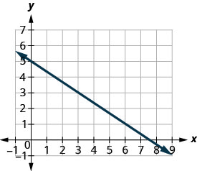

## Fact: Positive and Negative Slope

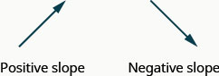

# Slopes of Horizontal and Vertical Lines

## Fact: Slopes of Horizontal and Vertical Lines

* The slope of a horizontal line, $y=b$, is $0$.
* The slope of a vertical line, $x=a$, is undefined.

## Examples

Find the slope of each line.

$x=8$

$y=-5$

## You Try It

Find the slope of each line.

$x=-4$

$y=7$

# Interpreting Slope

## You Try It

1. The ‘pitch’ of a building’s roof is the slope of the roof. Knowing the pitch is important in climates where there is heavy snowfall. If the roof is too flat, the weight of the snow may cause it to collapse. What is the slope of the roof shown?  
   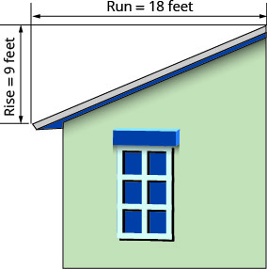
2. A local road rises 2 feet for every 50 feet of highway.
   1. What is the slope of the highway?
   2. The grade of a highway is its slope expressed as a percent. What is the grade of this highway?

# Use Slope-Intercept Form to Write an Equation of a Line

## Definition: Slope-Intercept Form

The **slope-intercept form** of an equation of a line with slope $m$ and $y$-intercept $(0,b)$ is $$y=mx+b.$$

## Examples

Identify the slope and $y$-intercept of the lines.

$y=\frac{2}{5}x-1$

$x+2y=6$

* Find the equation of the line.  
  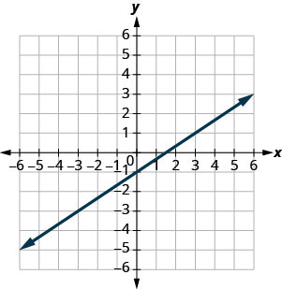

## You Try It

Identify the slope and $y$-intercpets of the lines.

$y=-\frac{4}{3}x+1$

$3x+2y=12$

1. Find the equation of the line.  
   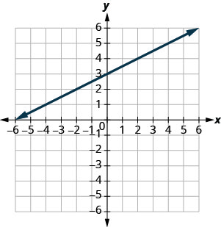

# Use Slope-Intercept Form to Graph a Line

## How To: Graph a Line Given a Point and the Slope

1. Plot the given point.
2. Use the slope formula $m=\frac{\text{rise}}{\text{run}}$ to identify the rise and the run.
3. Starting at the given point, count out the rise and run to mark the second point.
4. Connect the points with a line.

## Examples

Graph the line of the equation using its slope and $y$-intercept.

$y=-\frac{5}{2}x+1$

$4x-3y=12$

## You Try It

Graph the line of the equation using its slope and $y$-intercept.

1. 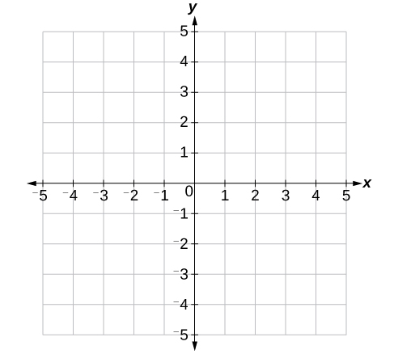
2. 

# Use Point-Slope Form to find the Equation of a Line

## Definition: Point-Slope Form

The **point-slope form** of an equation of a line with slope $m$ and containing the point $(x_{1},y_{1})$ is $$y-y_{1}=m\left(x-x_{1}\right).$$

## Examples

Find an equation of each line with the given slope that passes through the given point. Write the equation in the form $Ax+By=C$.

* $m=6$, point $\left(2,2\right)$
* $m=-\frac{3}{4}$, point $\left(8,-5\right)$

## You Try It

Find an equation of a line with the given slope that contains the given point. Write the equation in the form $Ax+By=C$.

1. $m=3$, point $(2,4)$
2. $m=\frac{2}{5}$, point $(10,3)$

# Use Point-Slope Form to Find an Equation from Two Points

## How To: Write an Equation Given Two Points

1. Use the slope formula to calculate the slope.
2. Use the point-slope form to write the equation.
3. Use algebra to write the equation in the required form.

## Examples

Find an equation of the line containing the given points. Write the equation in the form $Ax+By=C$  
.

* $\left(2,6\right)$ and $\left(5,3\right)$
* $(-5,-3)$ and $\left(4, -6\right)$

## You Try It

Find an equation of the line containing the given points. Write the equation in the form $Ax+By=C$  
.

1. $(2,7)$ and $(3,8)$
2. $(-2,8)$ and $\left(4,-6\right)$