Law of Cosines

Trigonometry

# Law of Cosines

## Fact – Law of Cosines

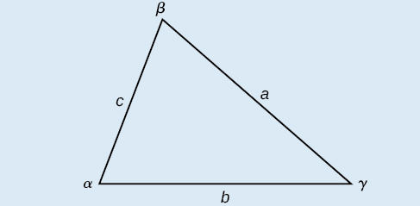

For triangles labeled as the triangle to the right, with angles $α$, $β$, and $γ$, and opposite corresponding sides $a$, $b$, and $c$, respectively, the Law of Cosines is given as three equations.

$$a^{2}=b^{2}+c^{2}-2bc⋅\cos{α}$$

$$b^{2}=a^{2}+c^{2}-2ac⋅\cos{β}$$

$$c^{2}=a^{2}+b^{2}-2ab⋅\cos{γ}$$

## Examples

For the following exercises, assume the angles and sides are as in the triangle above. Solve each triangle. Round to the nearest tenth.

1. $β={30}^{∘}$, $a=10$, $c=12$
2. $γ={41.2}^{∘}$, $b=6$, $c=7$
3. $a=20$, $b=25$, $c=18$
4. $a=108$, $b=132$, $c=160$

## You Try It

For the following exercises, assume the angles and sides are as in the triangle above. Solve each triangle. Round to the nearest tenth.

1. , ,
2. , ,
3. , ,
4. , ,