Law of Sines

Trigonometry

# Introduction

## Definition - Oblique Triangles

Any triangle that is not a right triangle is an **oblique triangle**.

The three oblique triangles we will study in this section are.

## Definition - Solving a Triangle

**Solving** a triangle means finding the measures of all angles and sides given incomplete information.

### ASA (angle-side-angle)

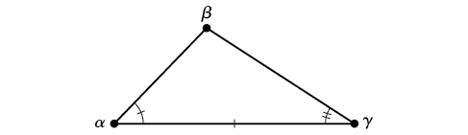

ASA Triangle

### AAS (angle-angle-side)

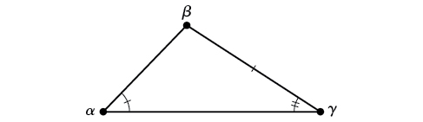

AAS Triangle

### SSA (side-side-angle)

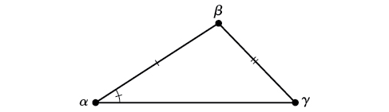

SSA Triangle

# Law of Sines

## Fact - Law of Sines

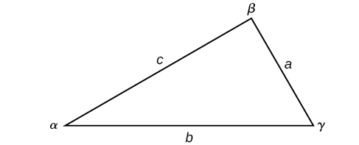

Oblique Triangle

Given a triangle with angles and opposite sides labeled as the triangle above, the ratio of the measurement of an angle to the length of its opposite side will be equal to the other two ratios of angle measure to opposite side. All proportions will be equal.

## Examples

For the following exercises, assume the angles are sides are as in the triangle above. Solve each triangle, if possible. Round each answer to the nearest tenth.

1. , ,
2. , ,
3. , ,
4. , ,

# The Ambiguous Case

## Possible Cases for SSA triangles

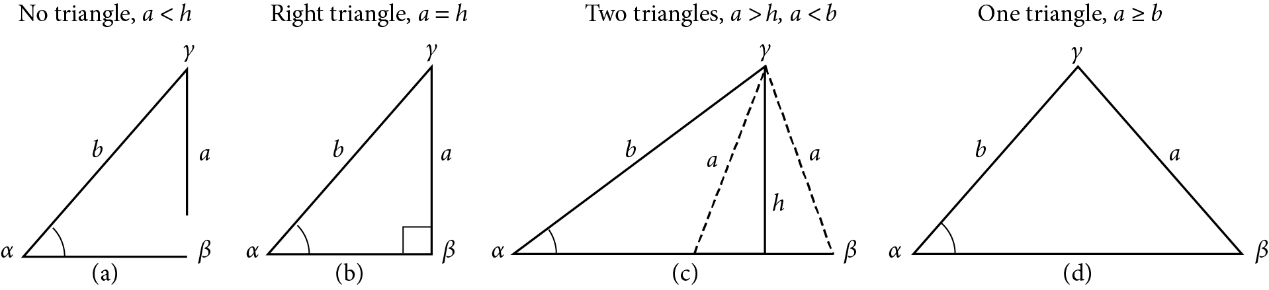

Comparison of SSA Triangles

## Examples

Determine whether there is no triangle, one triangle, or two triangles. Then solve each triangle, if possible. Round each answer to the nearest tenth.

1. , ,
2. , , .
3. , , .