Loan Payments with MobiOffice
Liberal Arts Mathematics

How to Calculate Loan Payments
Calculating loan payments can be difficult by hand. Since it is a common calculation for personal finance, Microsoft Excel and compatible spreadsheet programs have a function to do the calculations for us. We will go through one example of calculating a loan payment in detail.

Example
Calculate the monthly payments on a loan with principal $175,800, annual interest rate 4.73%, and a term of 25 years.

Solution
We will use MobiOffice on an Andoid tablet to solve the problem.
The formula we will use is “-PMT(r/12, 12*t, P)”, where r=0.0473, t = 25, and P=175800.
Step | Screen
Open the MobiOffice Suite. Click “Sheets” in the upper part of the screen. | 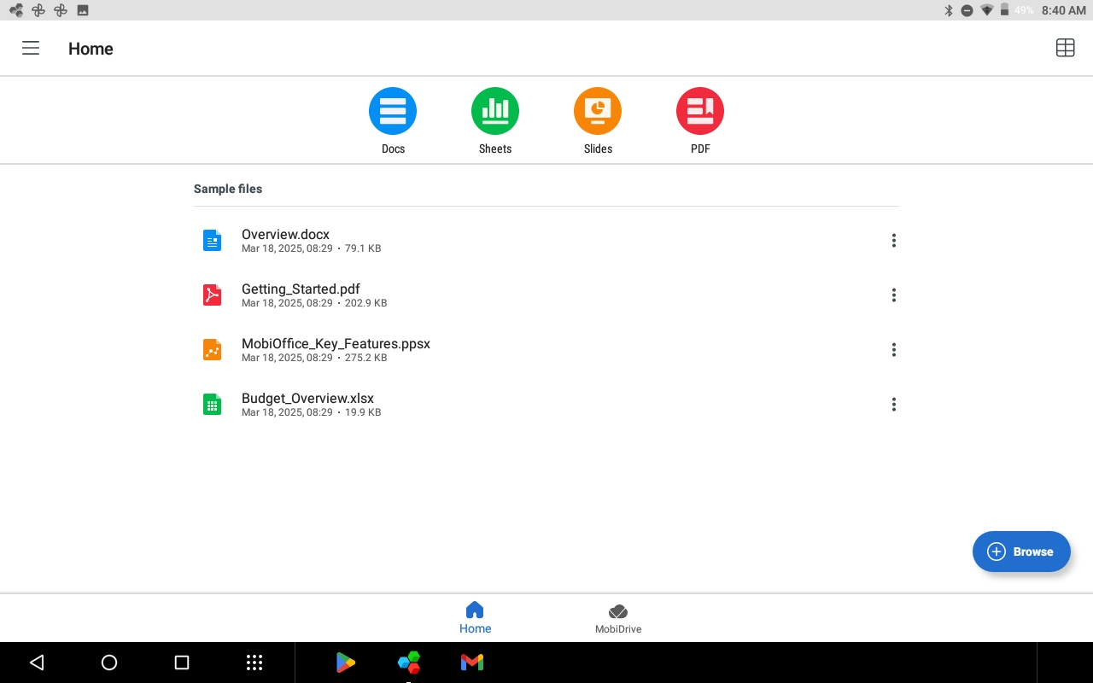
There are several different templates available. We are going to ignore them and create a blank spreadsheet. Click “Blank” in the upper part of the screen. | 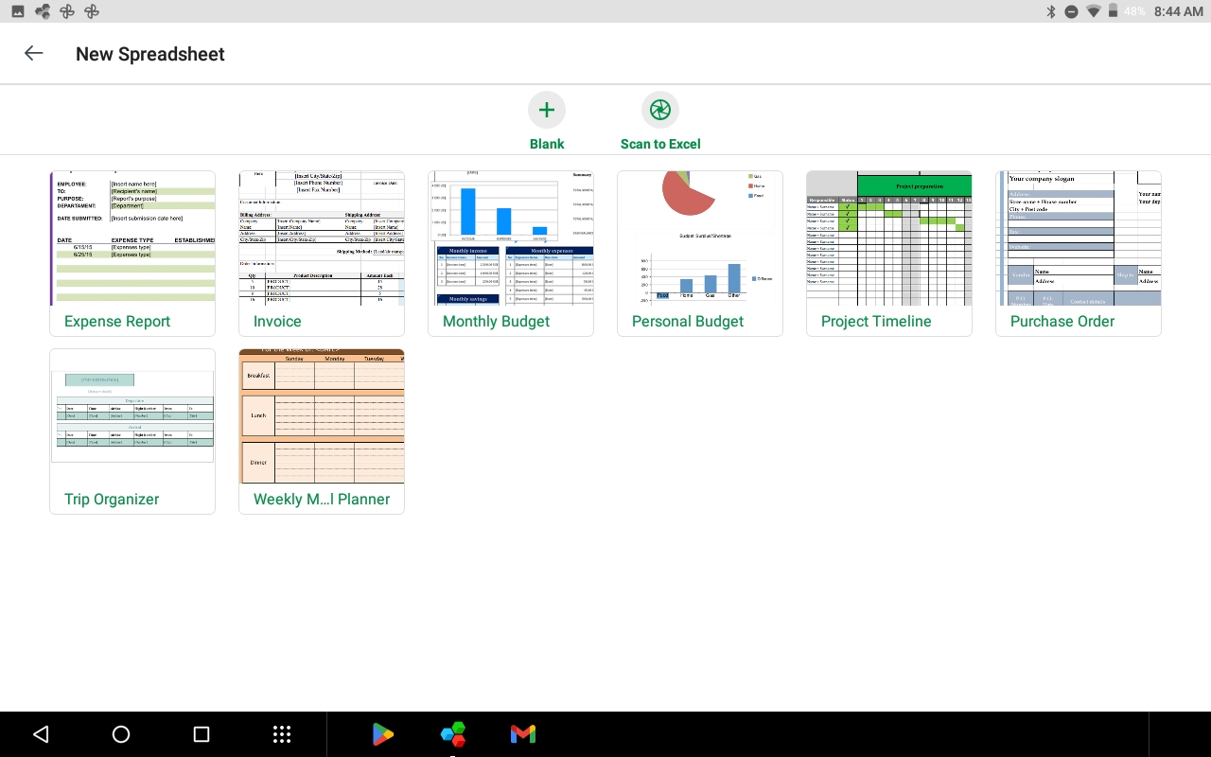
This is the starting point for a blank spreadsheet. The cells (the boxes that contain the data and formulas) are pretty small. Click “View” and then “Zoom” if you want to make them bigger. | 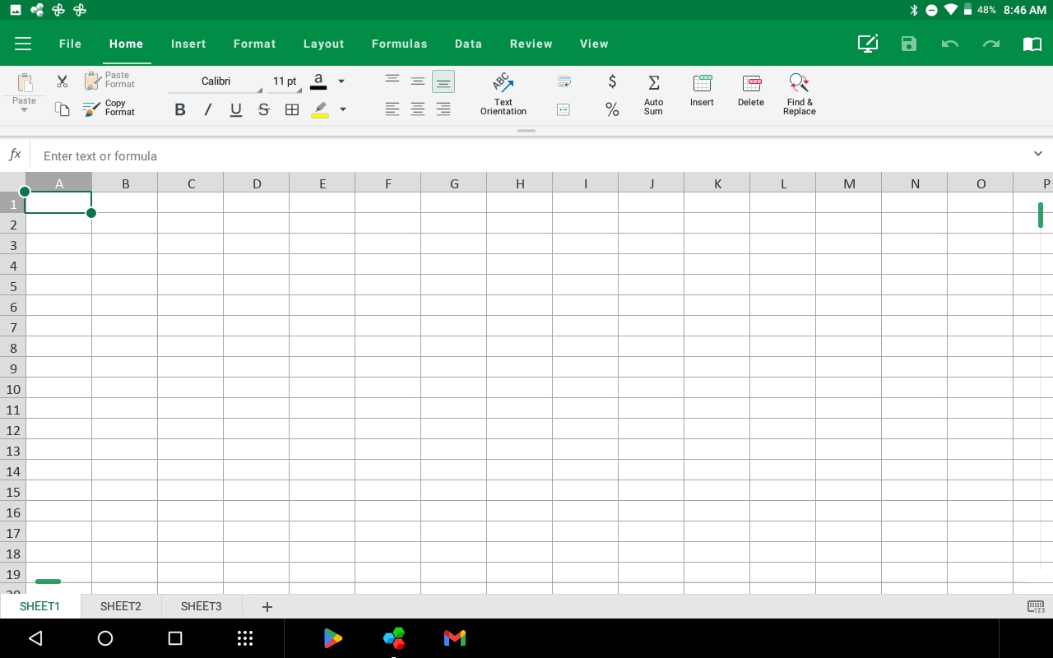
I set the zoom to 150%. | 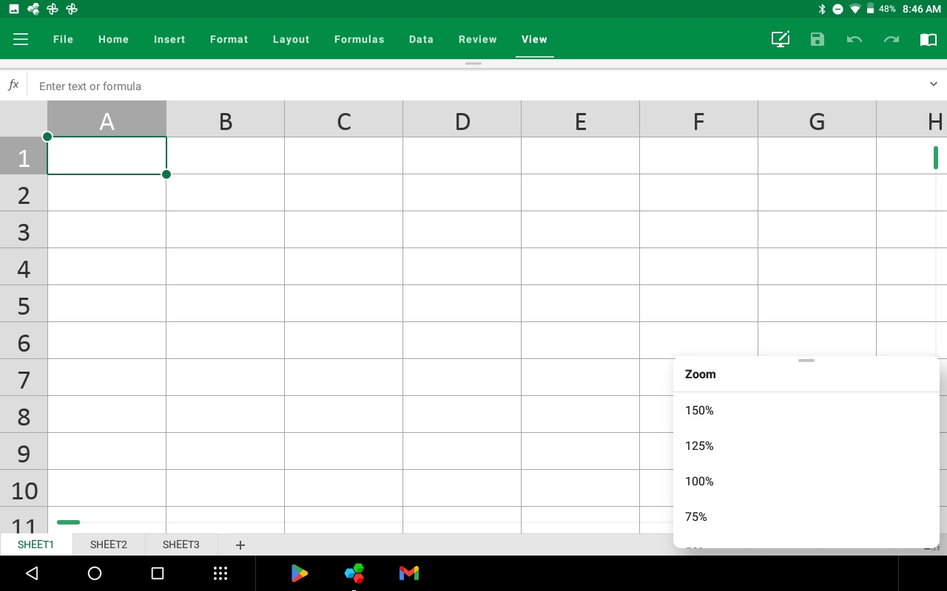
Click on the cell A1, that is the box in the upper-left. The keyboard should appear at this point. When you get here, you are ready to type in the formula. | 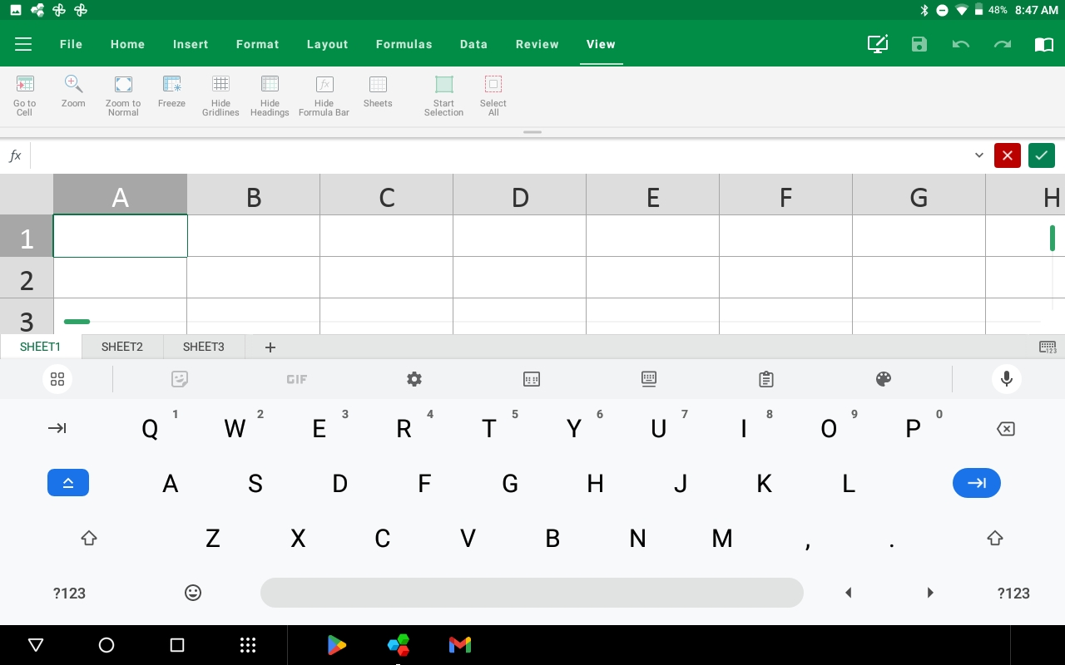
Start typing the formula by typing  “-pmt(0.0437/12,”  This part is the annual interest rate divided by 12 months in a year.  The “-” in the front is useful. The formula knows that you are paying out of your pocket, so it will make the payment negative. We just want to know the number, so we put a negative sign in front to change the answer back to positive. | 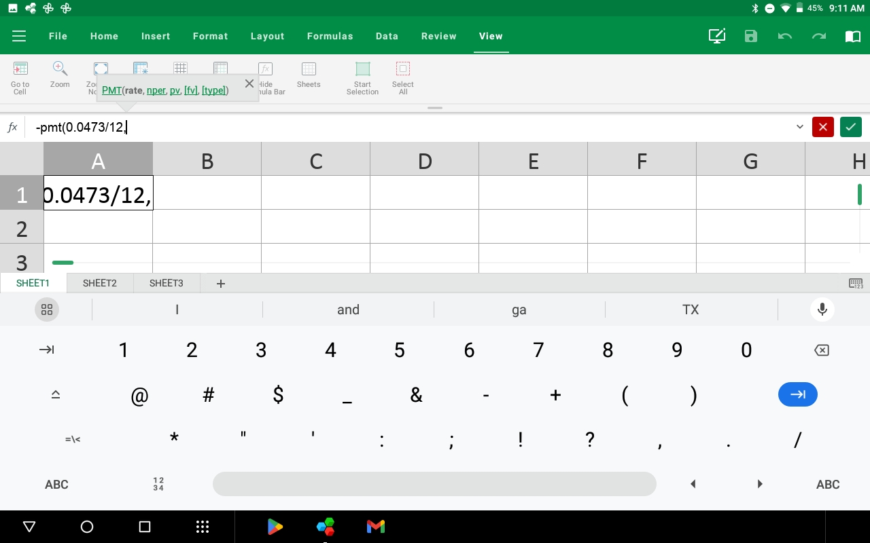
Continue the formula by typing “12*25,”  This part calculates the number of months. This is important because payments are made each month on the loan. | 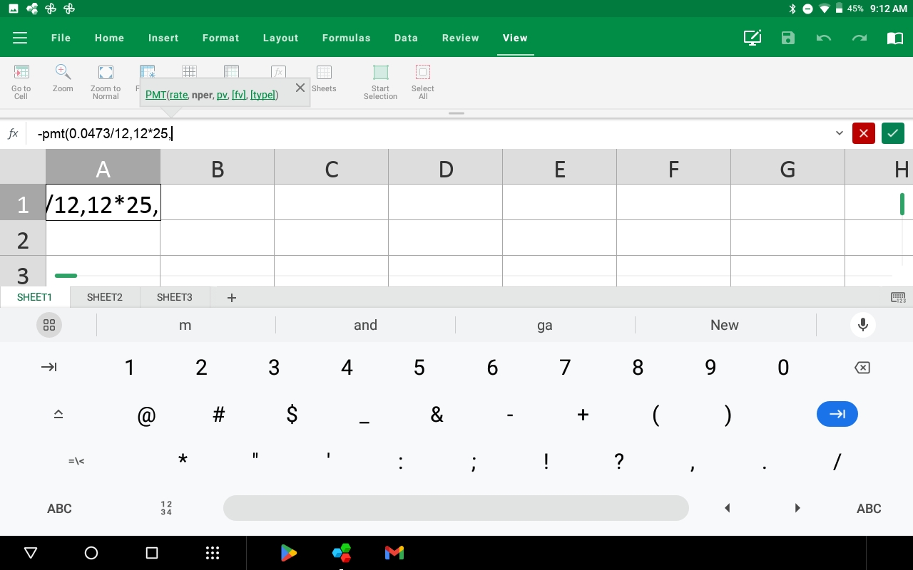
Finish by typing “175800)”  This is the principal of the loan. | 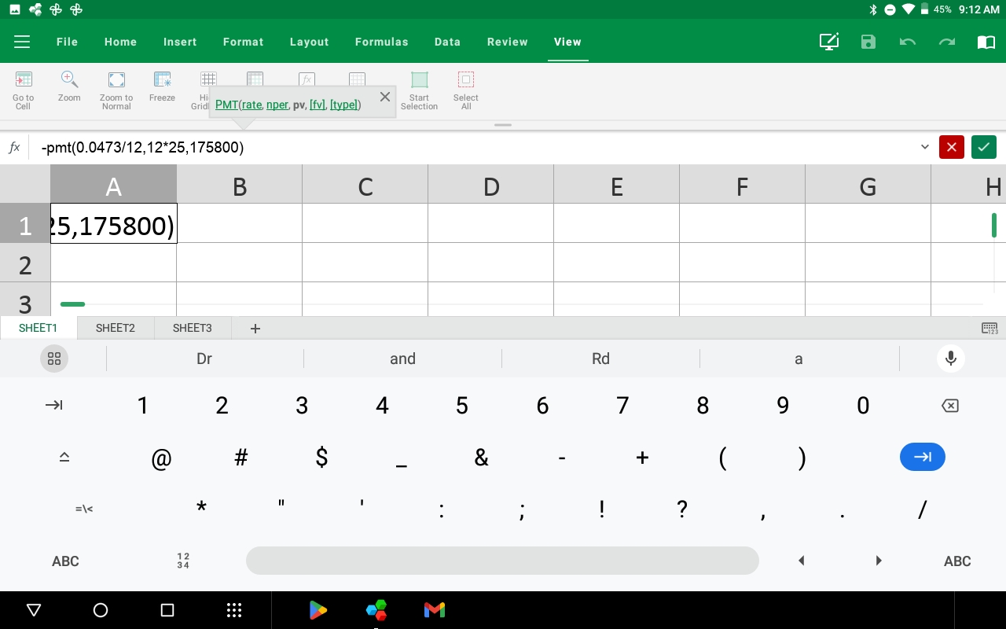
Click the green checkmark in the upper-right to tell MobiOffice to calculate the formula.  The monthly payment is $1,000.25. | 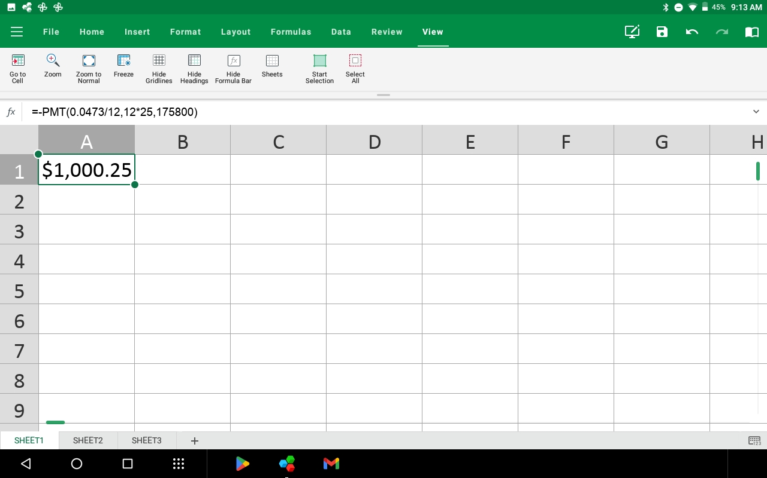
To do the other problems, click the cells below A1 and repeat the process with the new numbers. | 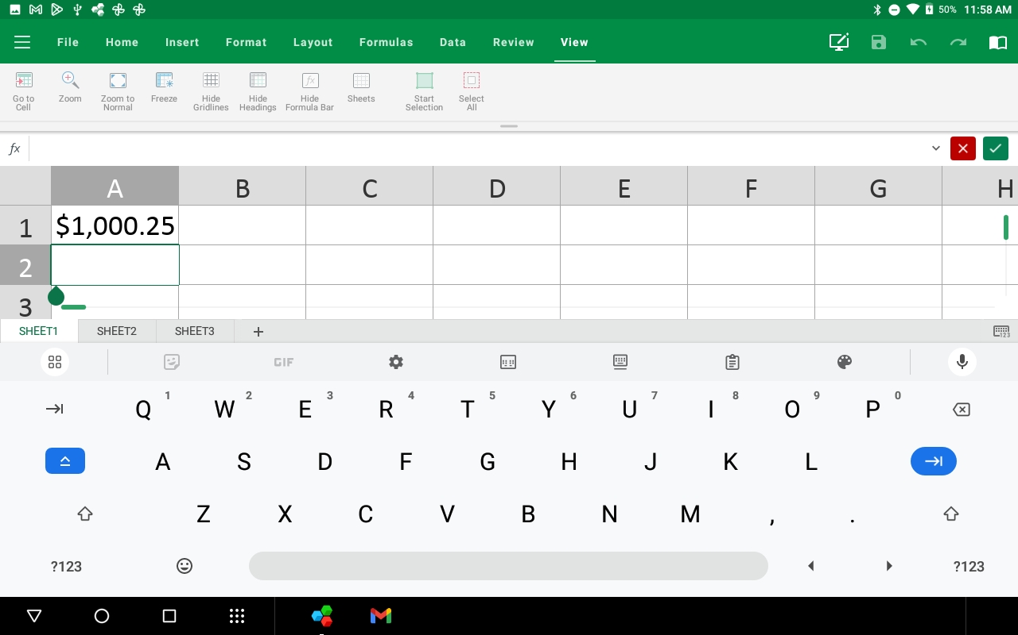
Once you have done all the problems, click “File” and “Save As”. You should save your work as an Excel Workbook. (This is the top option.) | 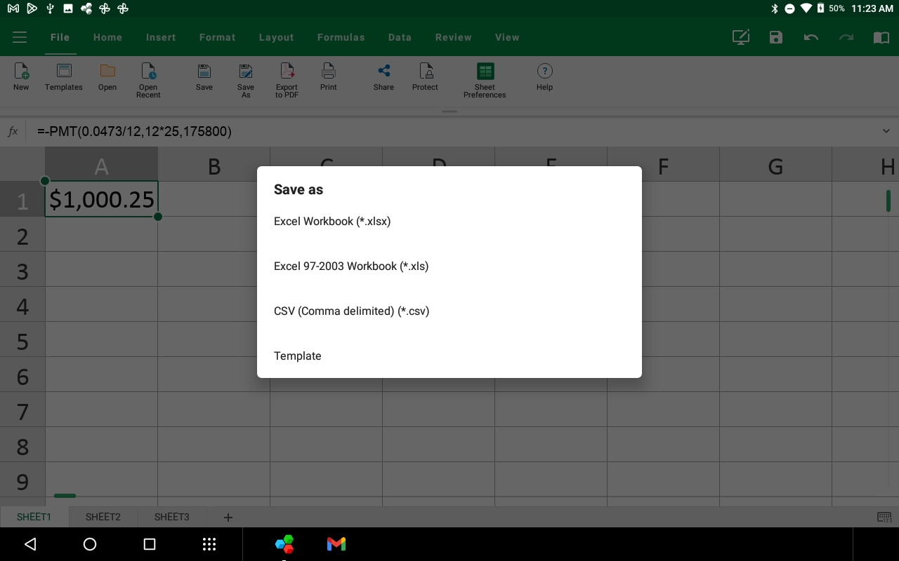
Type a file name and then click “Save”. Upload this file to Lantern in the appropriate assignment to submit your work. | 