Quadratic Regression
Detailed Example

Introduction

This example will work a complete example of performing a quadratic regression. Then, it will answer some follow up questions that are common from our textbook.

Data
The following data was collected by recording a video of a ball thrown in the air. The height of the ball at selected frames is recorded below.
Frame (t) | Height (h) in centimeters
1 | 12
5 | 30
9 | 52
13 | 67
17 | 78
21 | 83
25 | 84
29 | 82
33 | 73
37 | 62
41 | 47
45 | 28

Modeling the Data

Finding the Regression Equation
To find the regression equation, do the following steps. See the quick start guide for more information on the calculator steps.
- Enter the data.
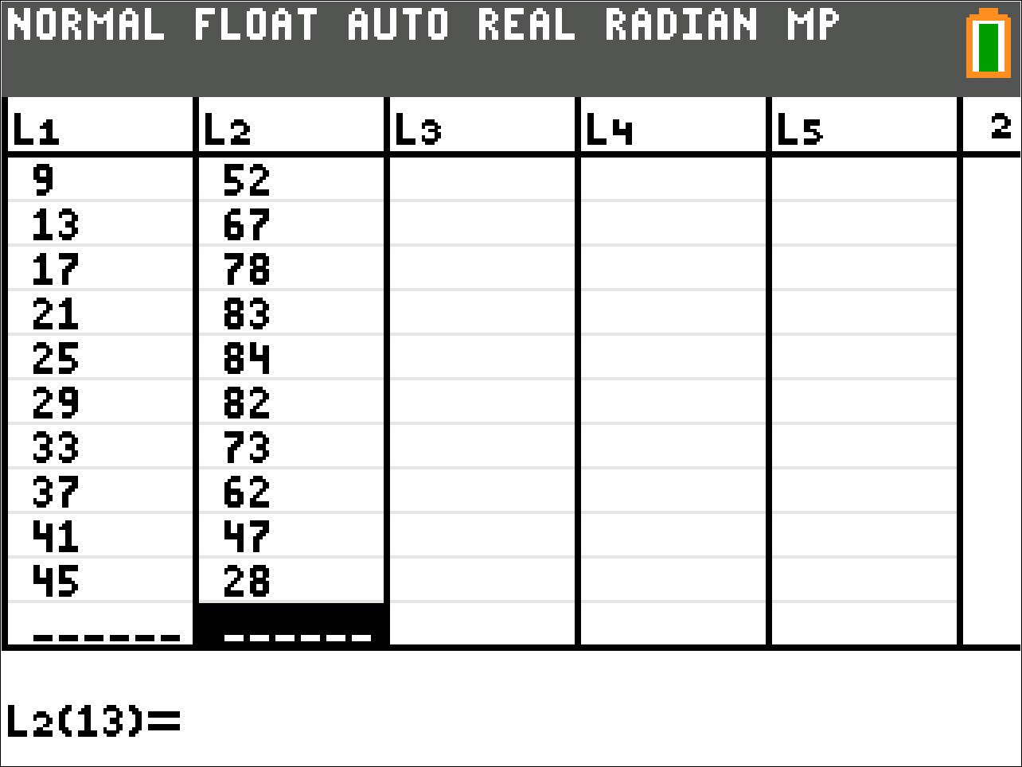
- Go to the quadratic regression menu. Notice that the menu says to store the regression equation in Y1. You will have to set that manually using VARS → Y-VARS → 1:Function… → 1:Y1.
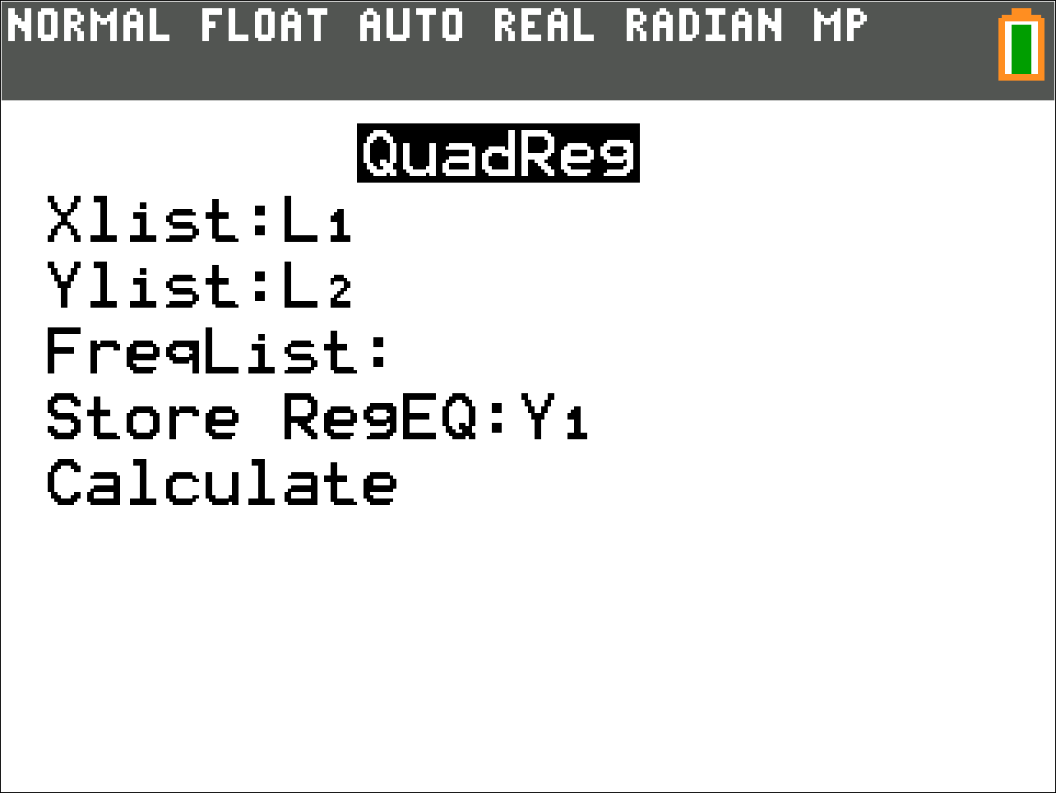
- You now have the regression equation.
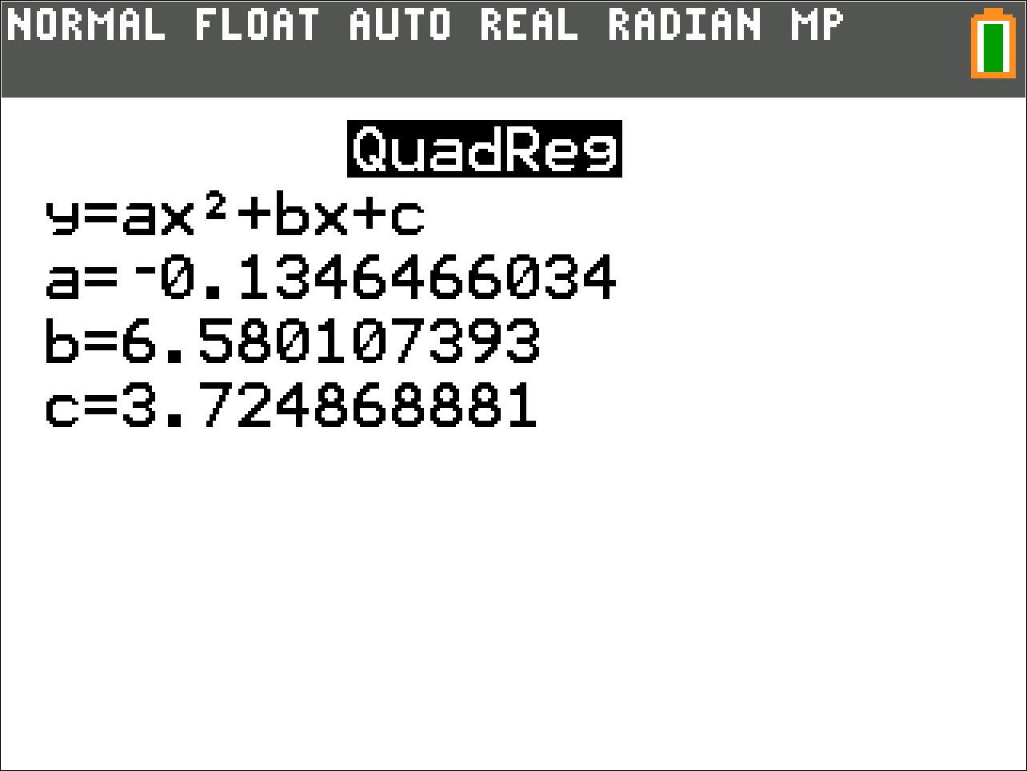

Check the Result
To check how closely the regression equation matches the data, we will plot the data and regression equation on the same graph.
- Turn on Stat Plot1.
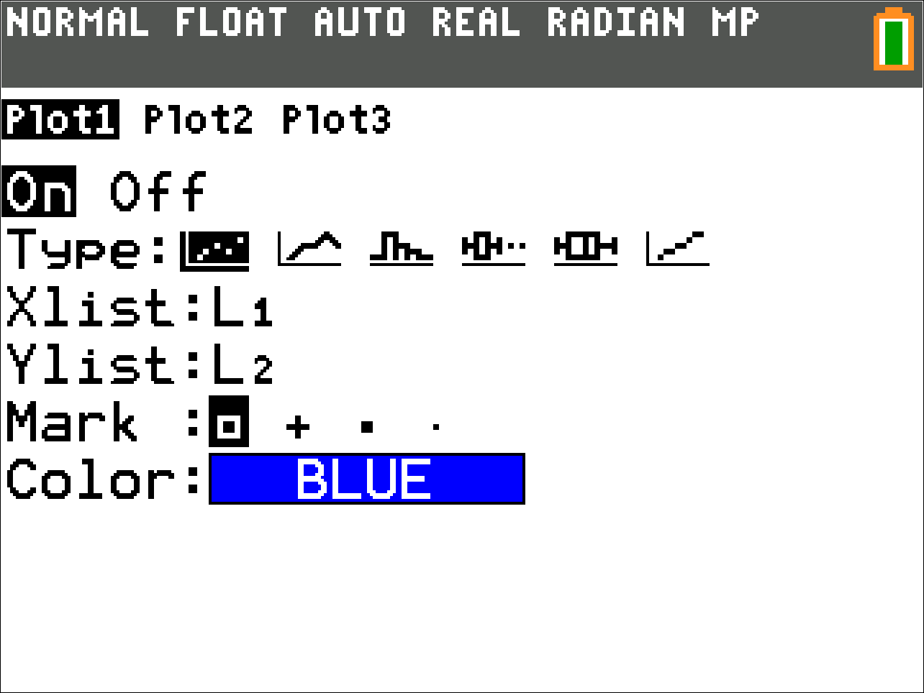
- Double-check that the equation was entered correctly.
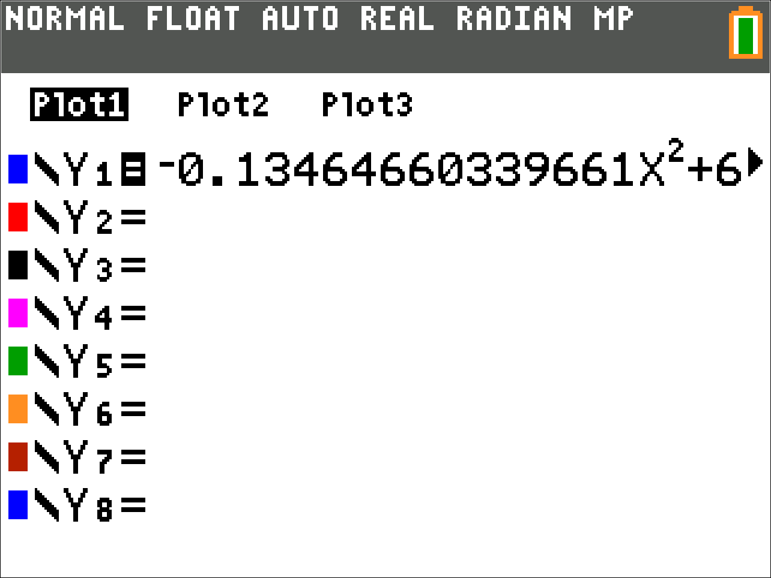
- Go to the Zoom menu and select 9:ZoomStat.
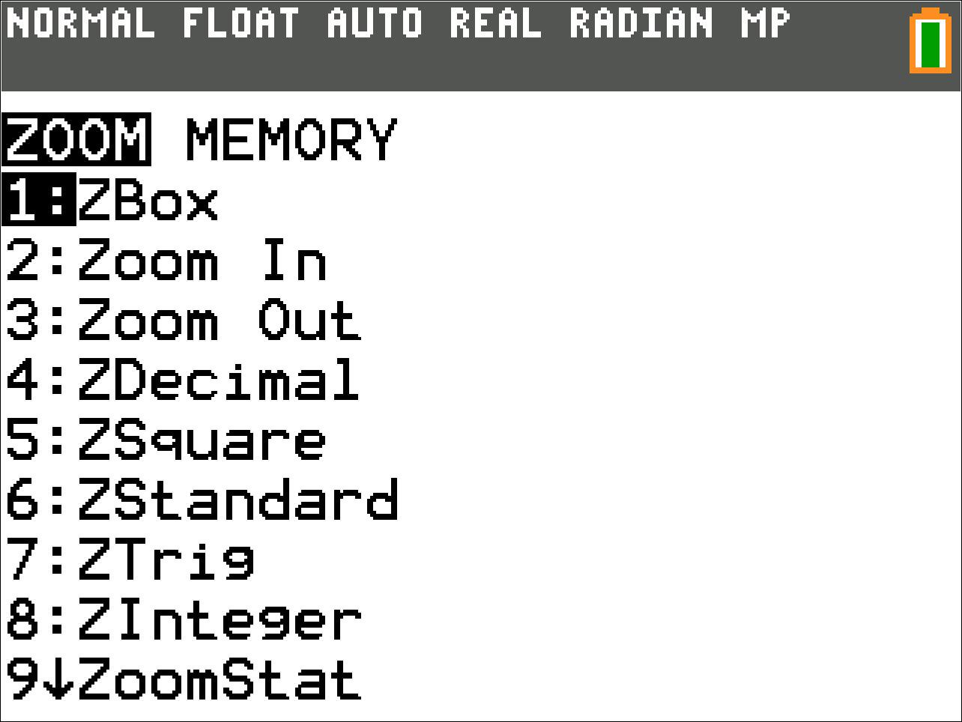
- The graph shows that the data and the regression equation are a close match.
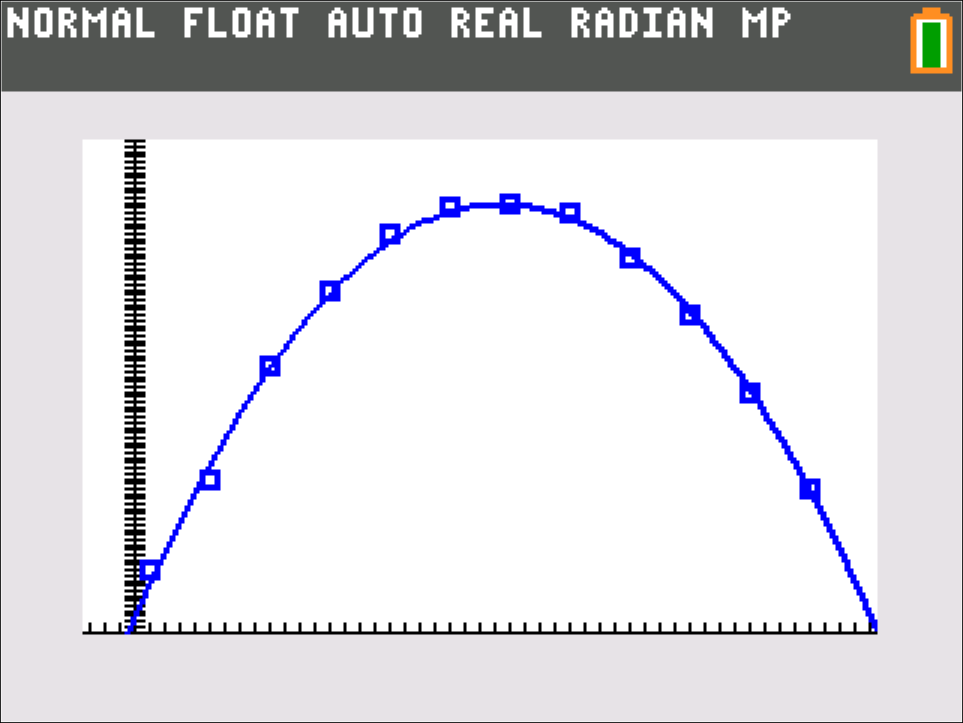

Going Further with the Equation
Now that we have the equation, we can answer all of our standard questions. We will rewrite the equation in terms of and for the rest of this example.

How to Get the Height from a Given Frame
To estimate the height from a given frame, substitute the frame number for .
Use the model to estimate the height in frame 11.
Step | Work
Substitute 11 into the formula of the function. | 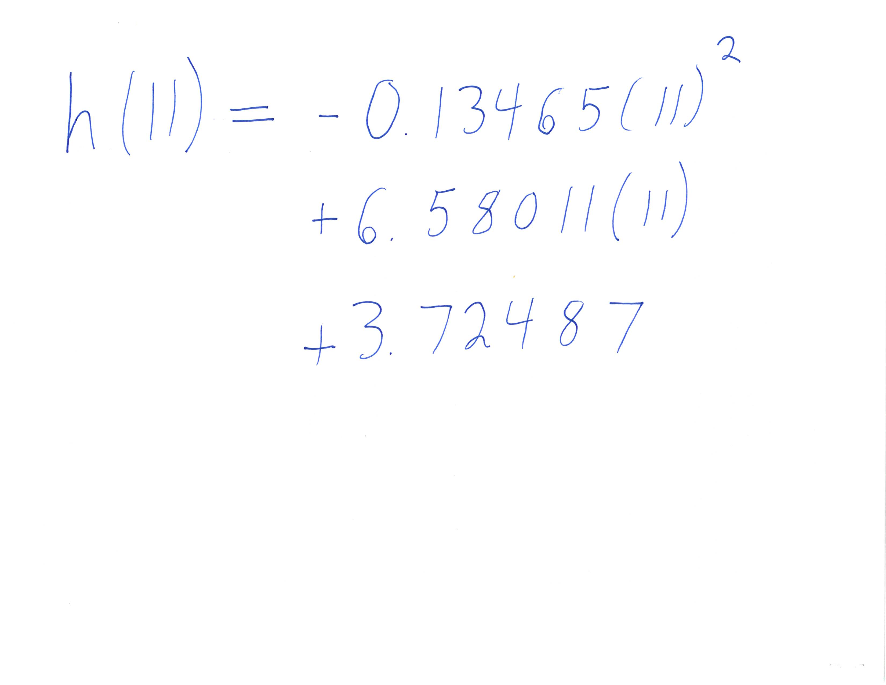
Simplify the exponent. | 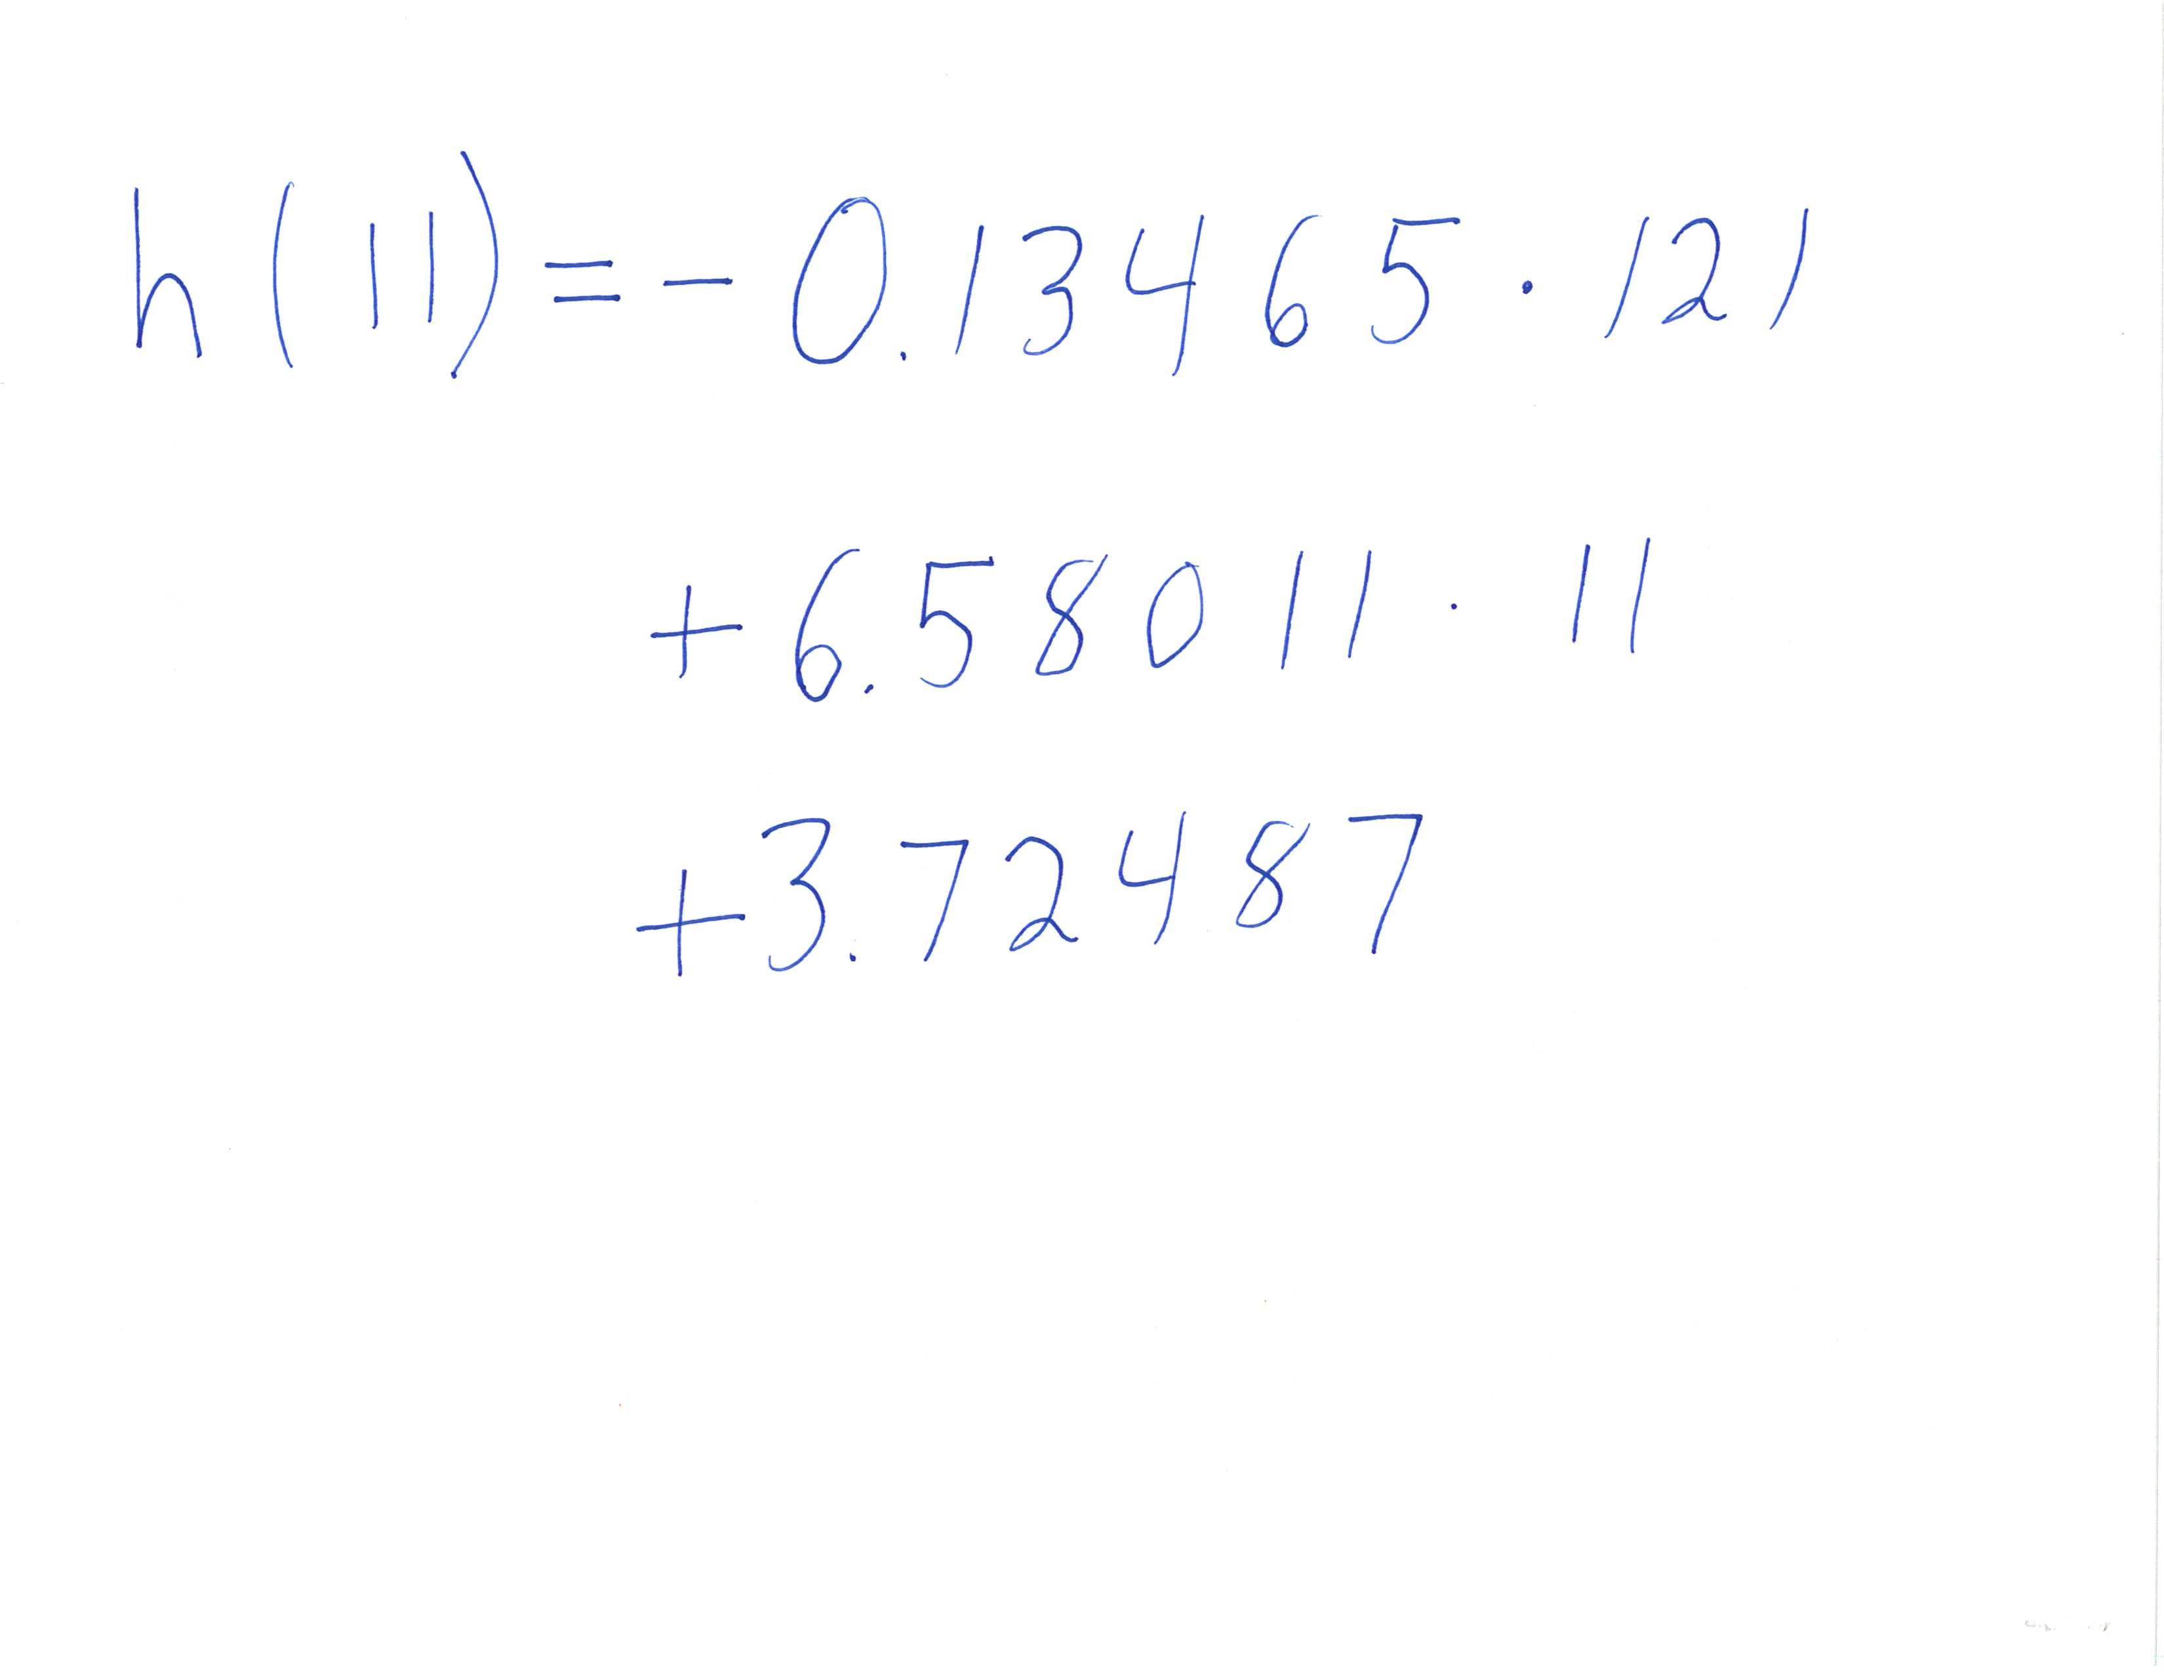
Perform both multiplications. | 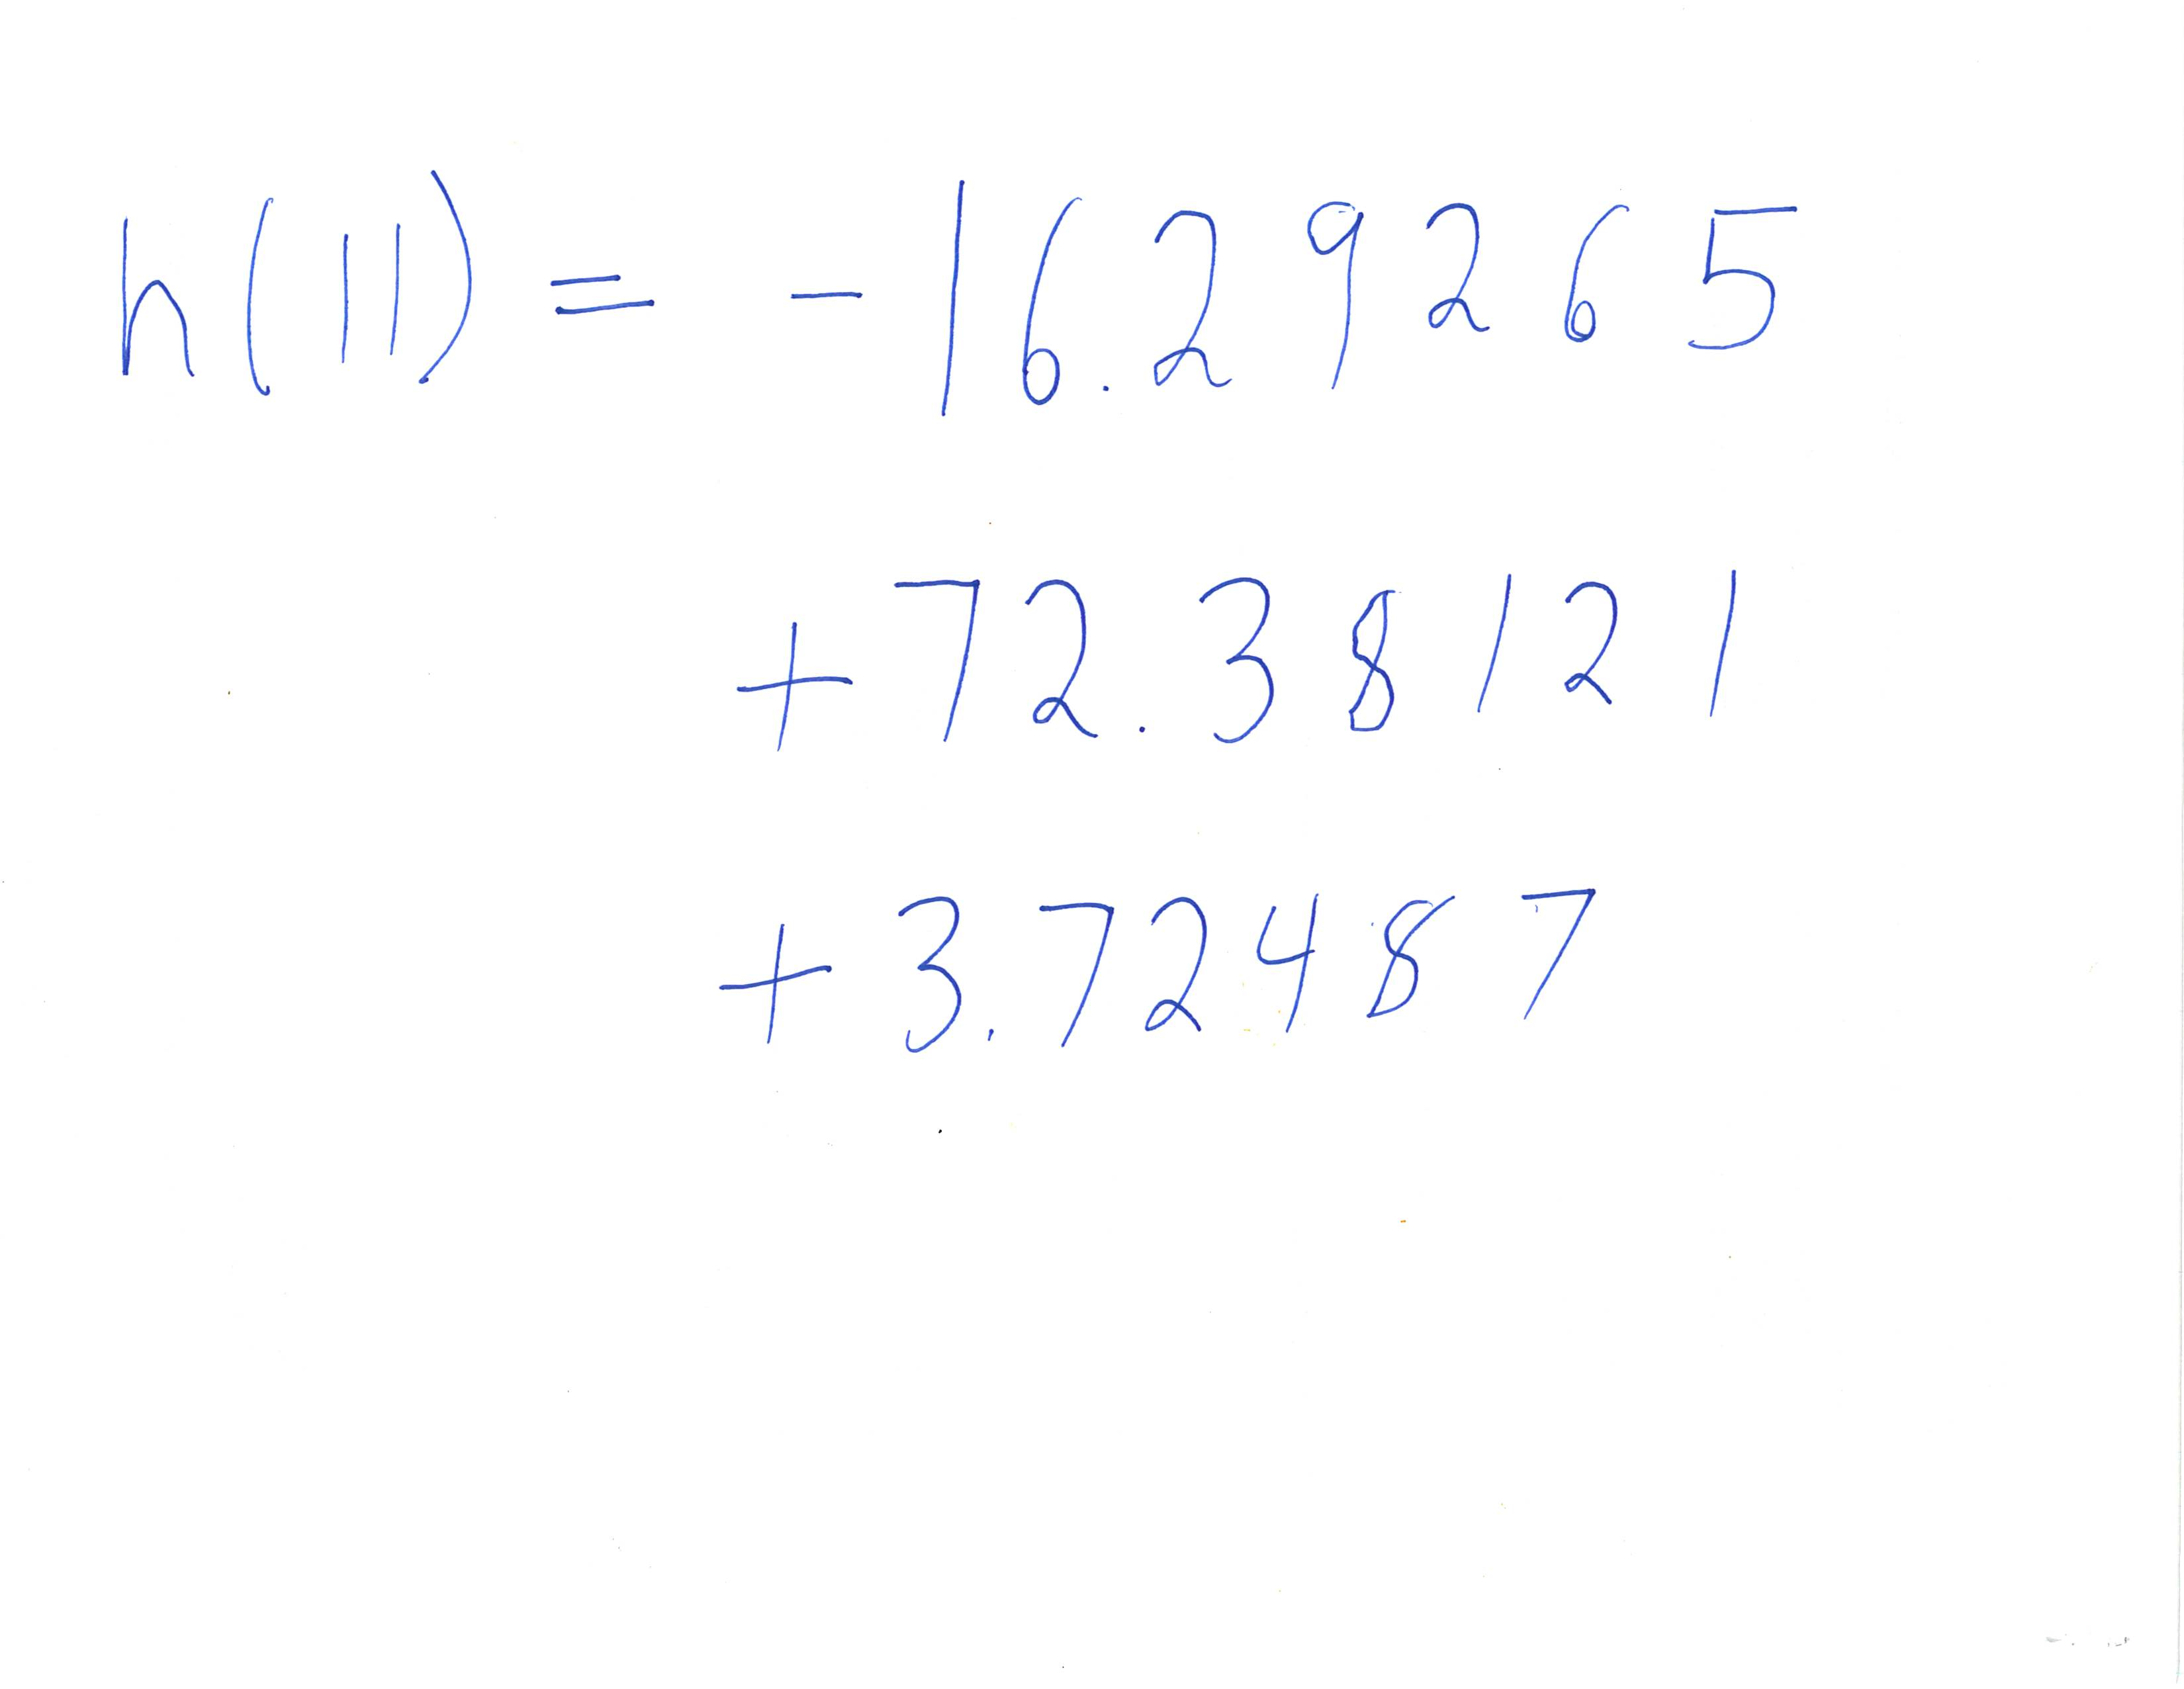
Perform the additions and subtractions. | 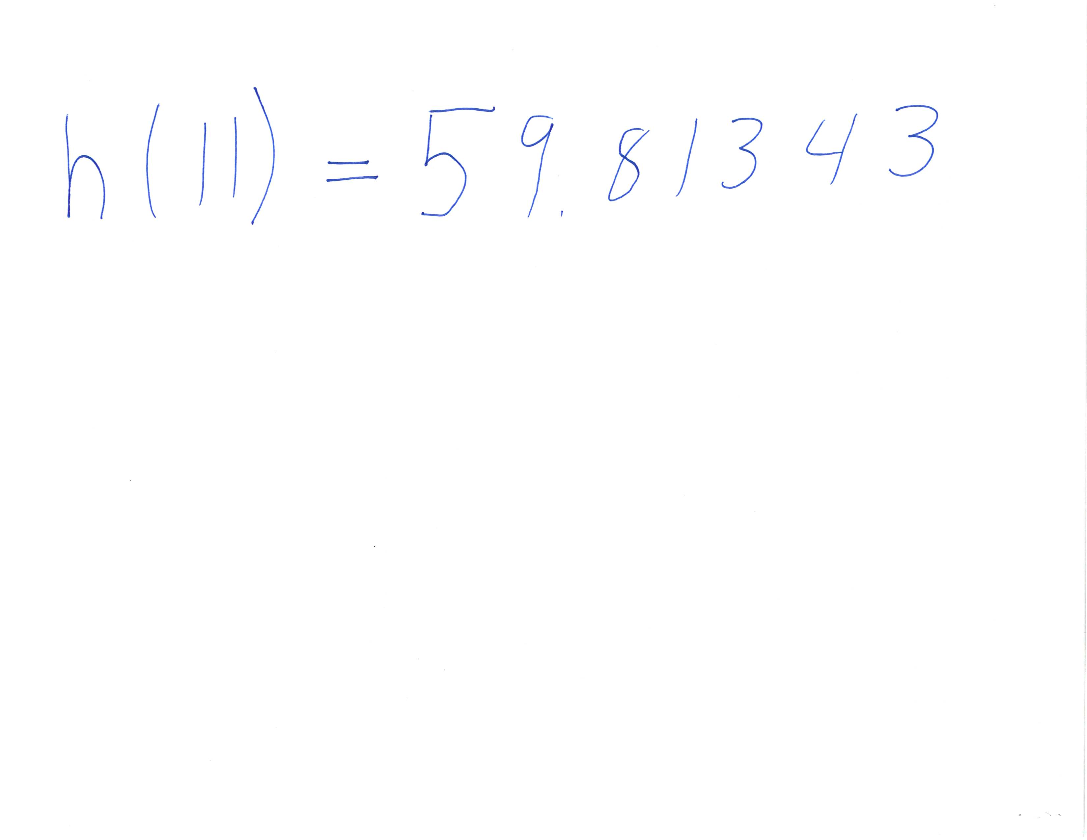
Round the answer to 59.8 cm.
Here is frame 11 for comparison.
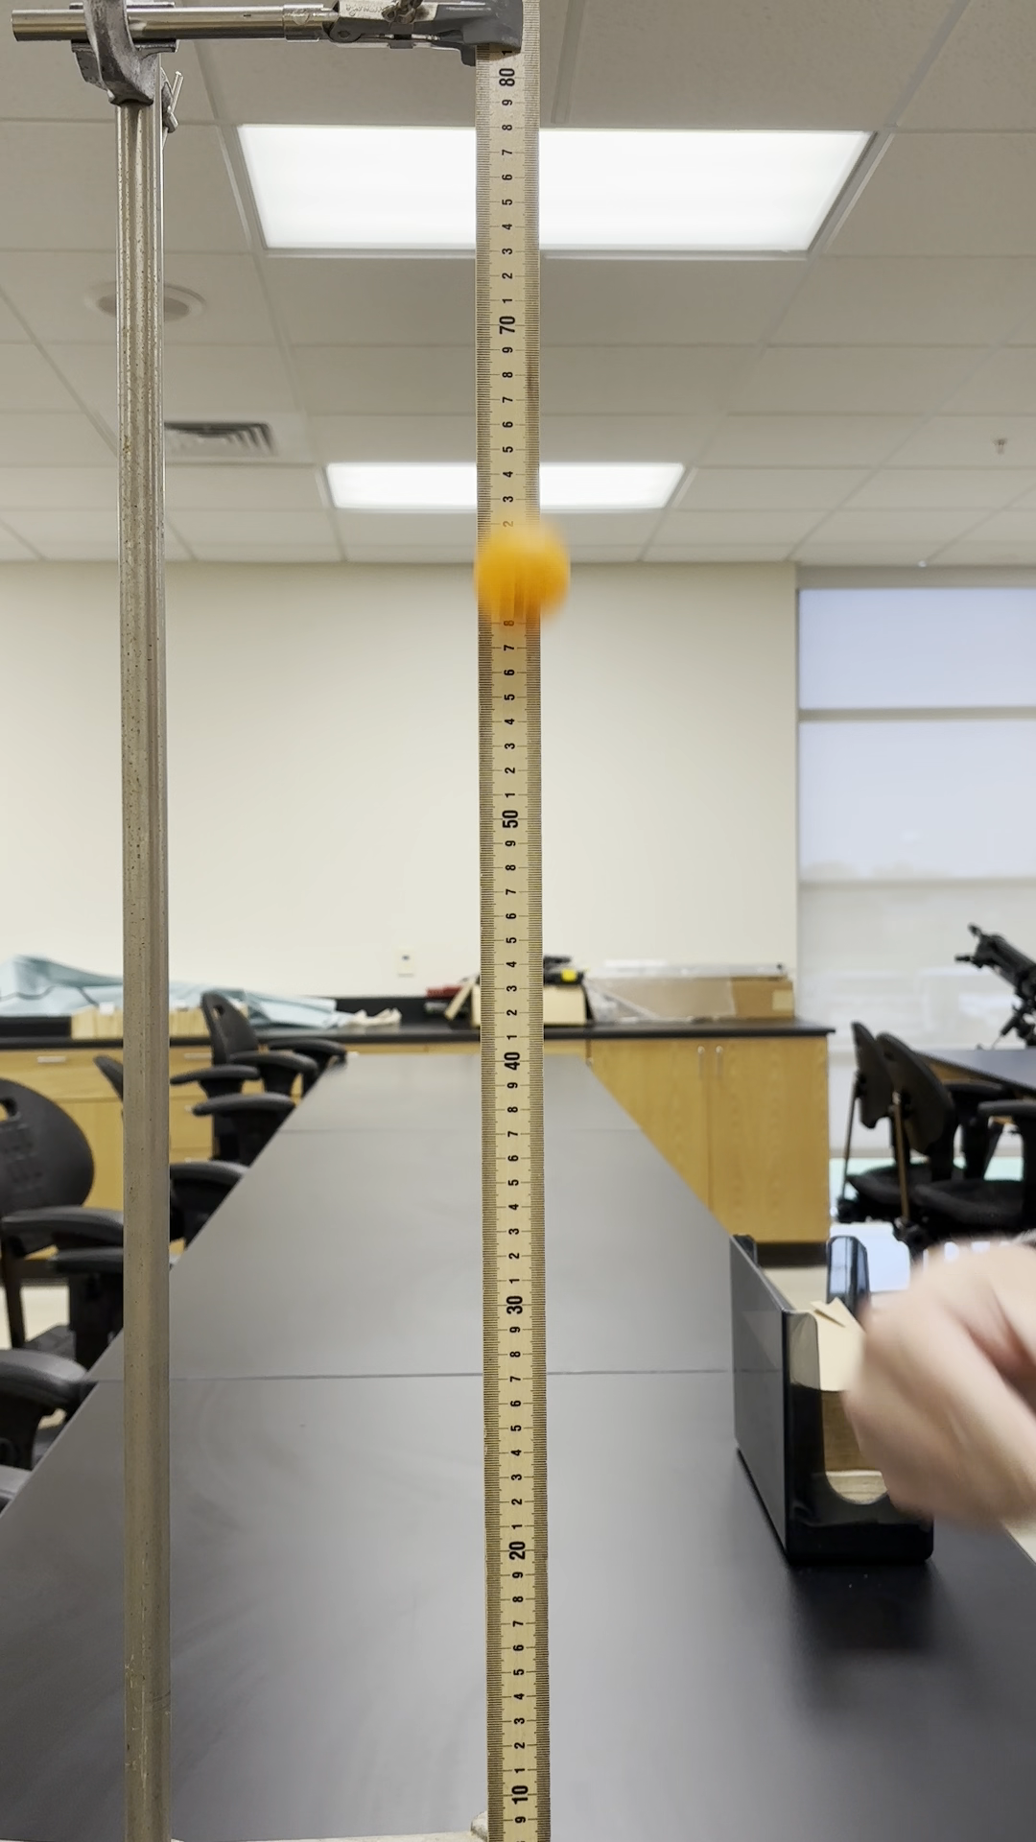

How to get the Frame from a Given Height
To estimate the frame where the ball is at a given height, substitute the height for and use the quadratic function to solve for .
Use the model to estimate the frames for which the height is 70 centimeters.
Step | Work
Set up the equation. | 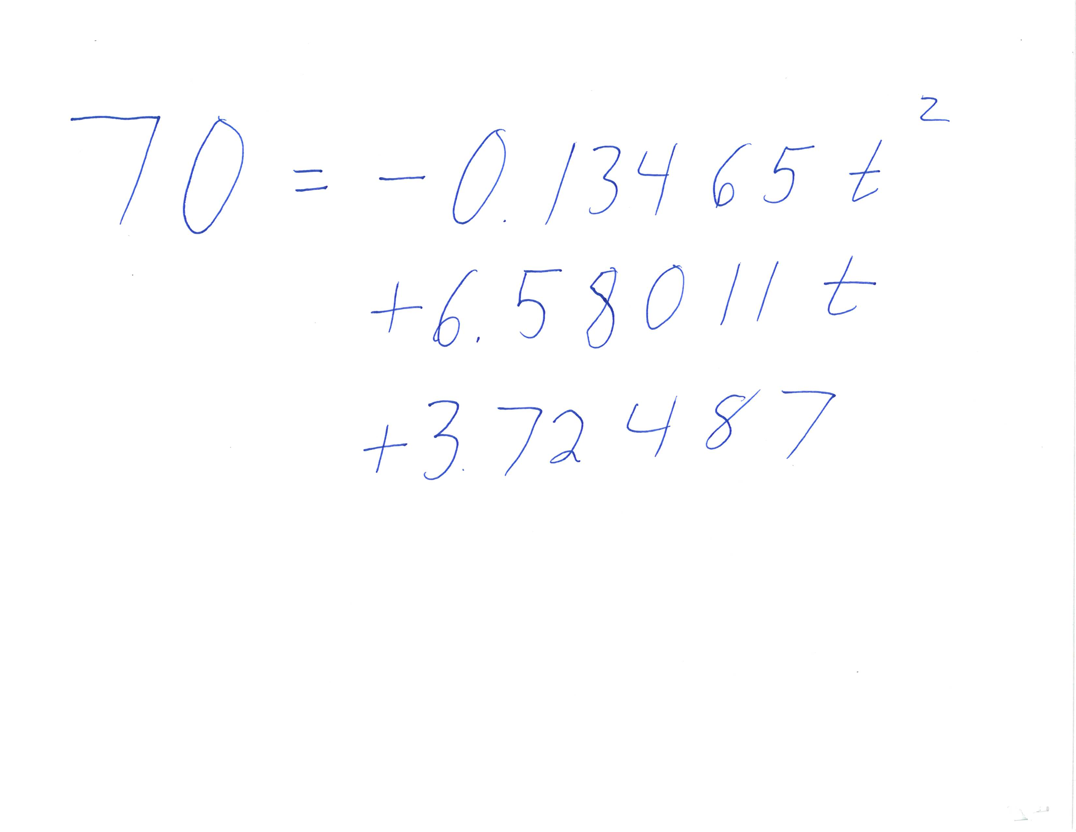
Subtract 70 from both sides so that one side of the equation is 0.  The parameters for the quadratic formula are easy to see: | 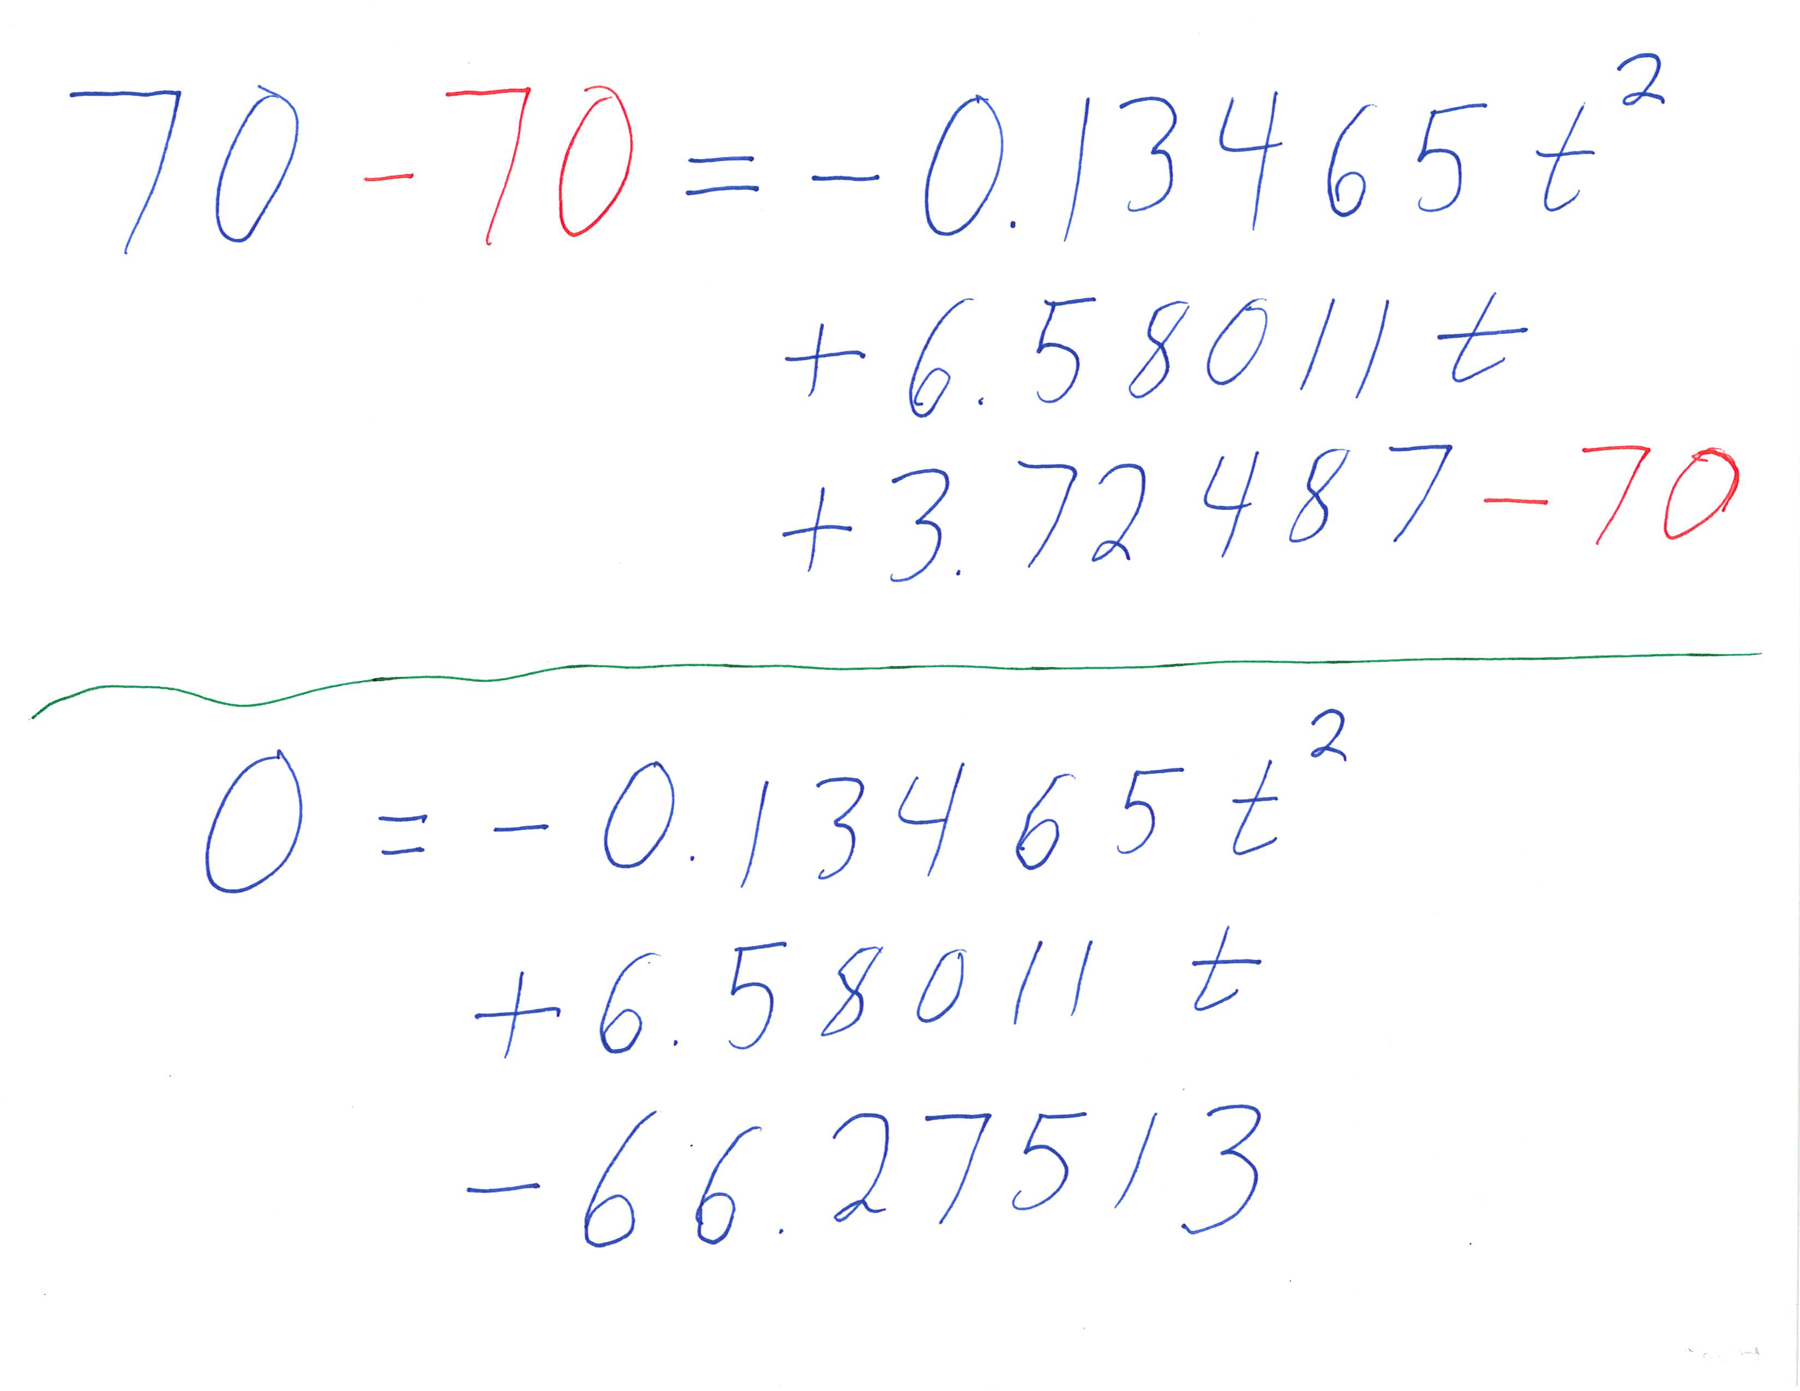
Substitute the values into the quadratic formula.  Simplify inside the square root. Because there is a positive value inside the square root, we know there will be two solutions. | 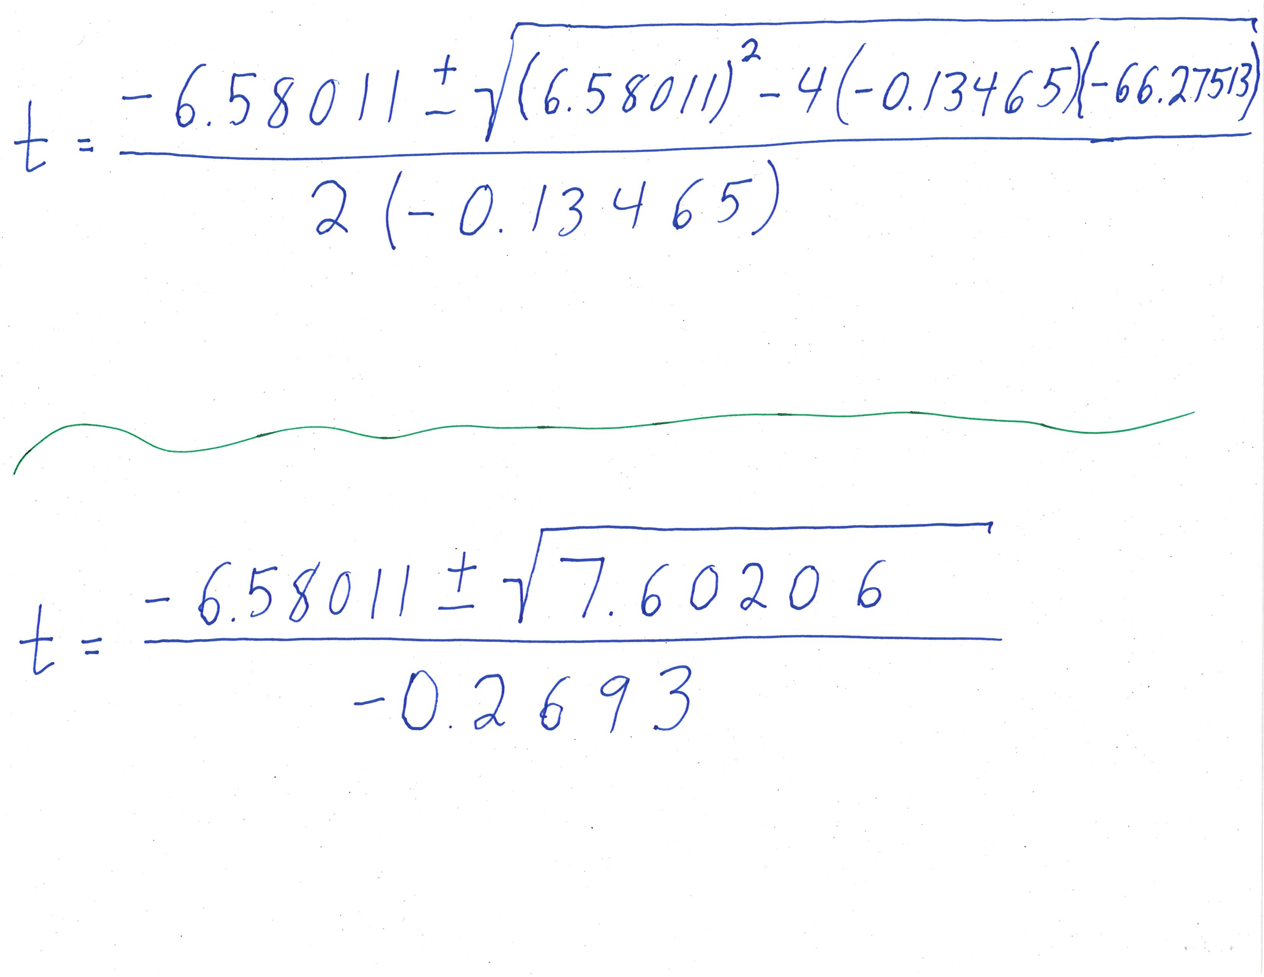
Simplify the square root.  There are two solutions. Calculate each solution separately. | 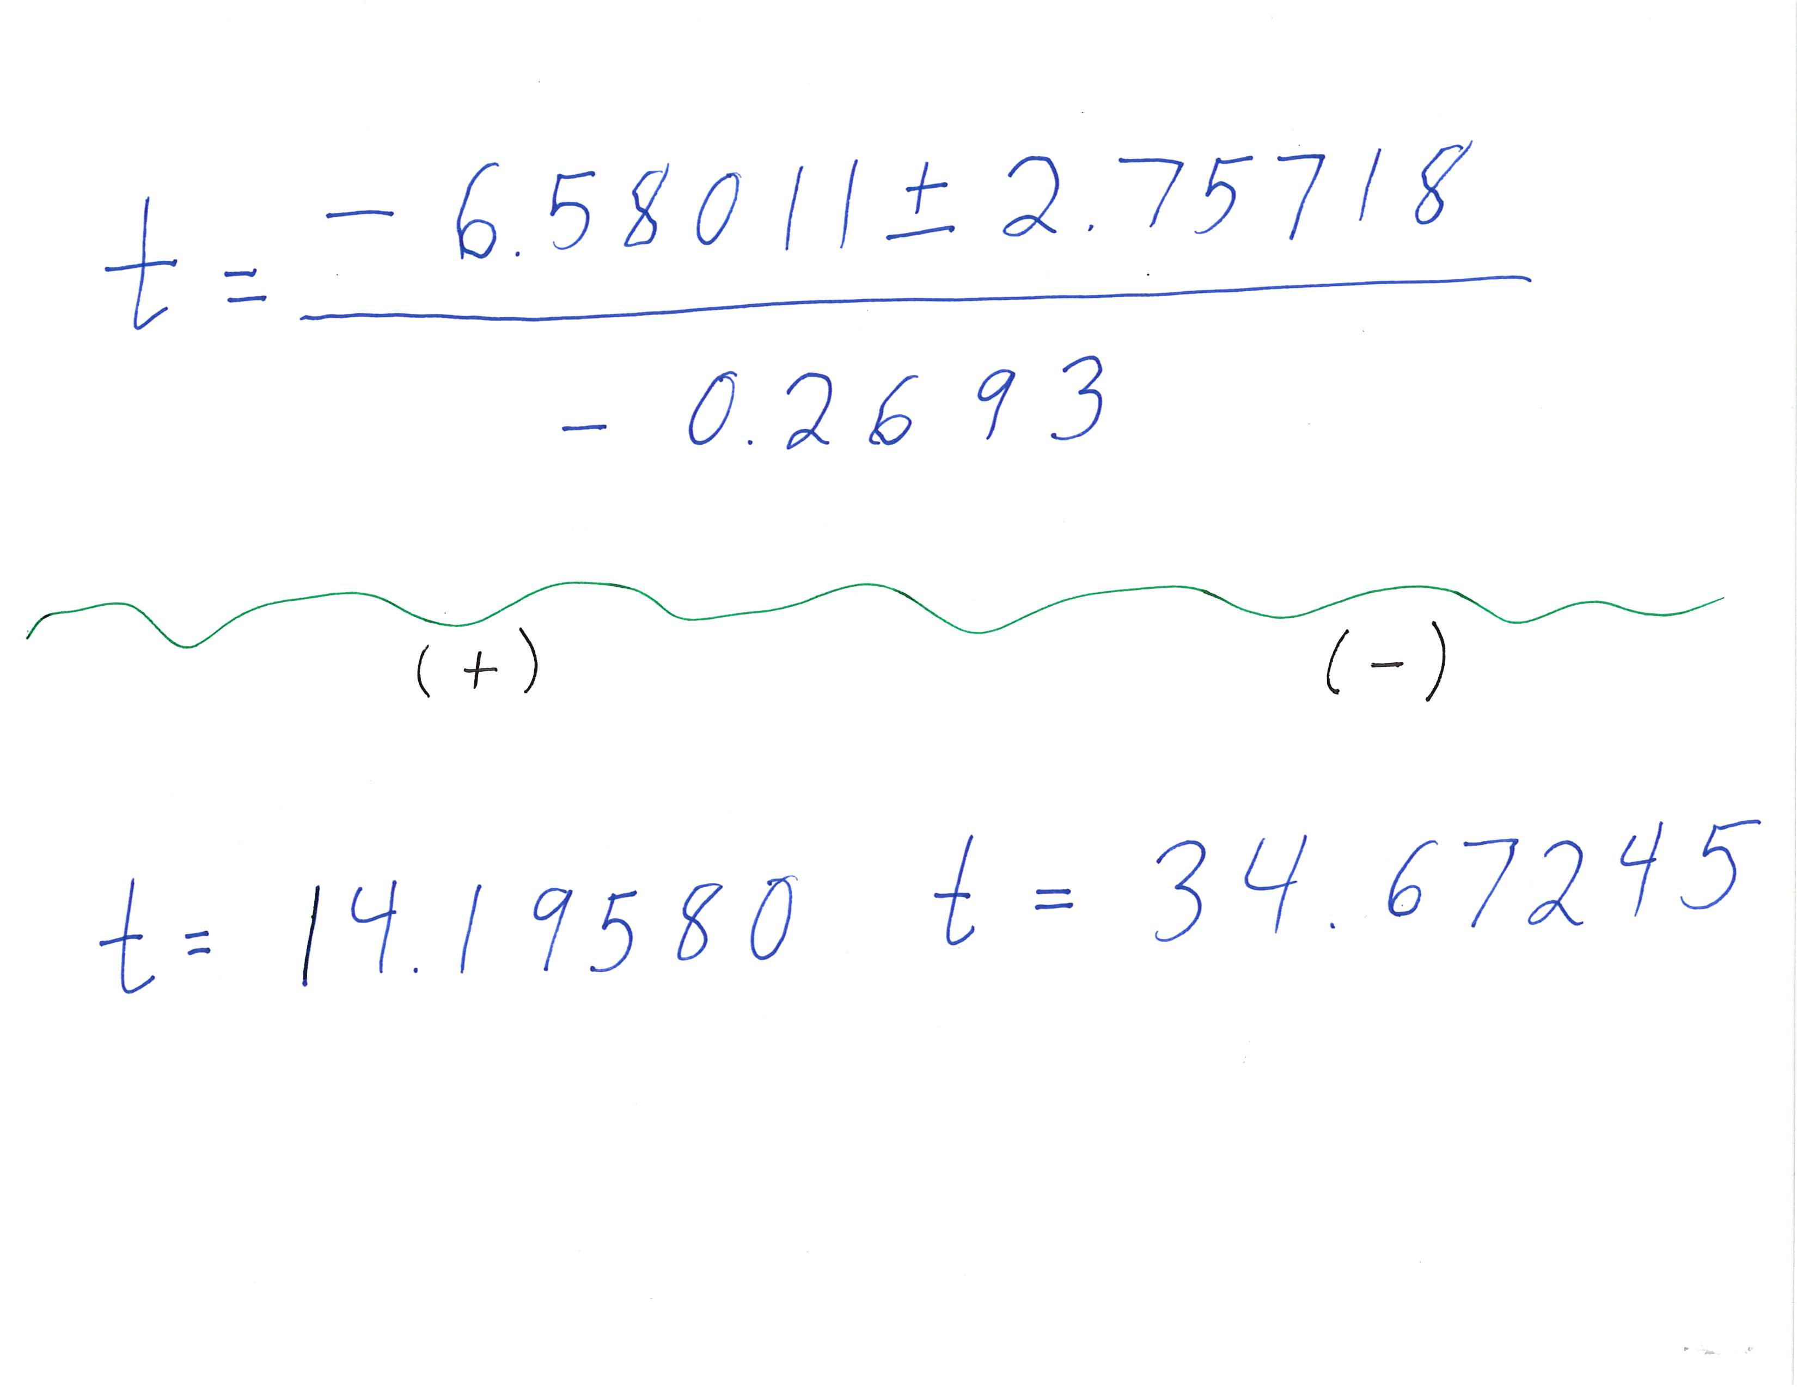

Round the answers to frame 14.2 and 34.7.
For reference, here are frames 14 and 35 from the video.

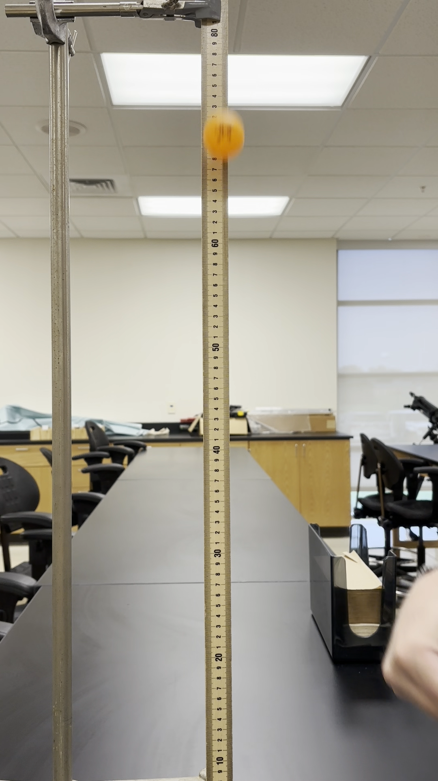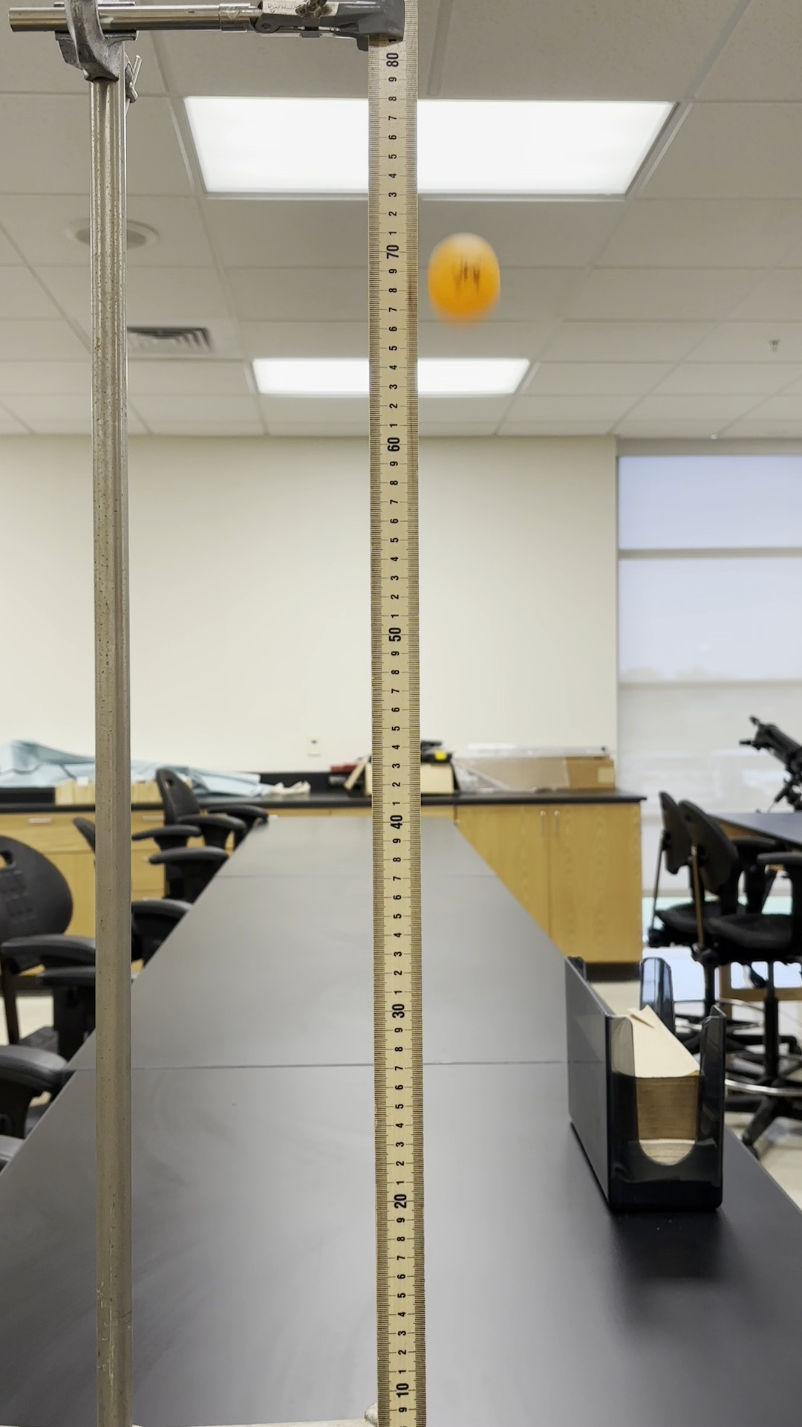

How to Estimate the Maximum Value of the Function
Use the vertex formula to calculate then the ball is at its highest.
Use the model to calculate when the ball is at its highest. What is the maximum height?
Step | Work
Substitute the parameters into the vertex formula.  Simplify the arithmetic. | 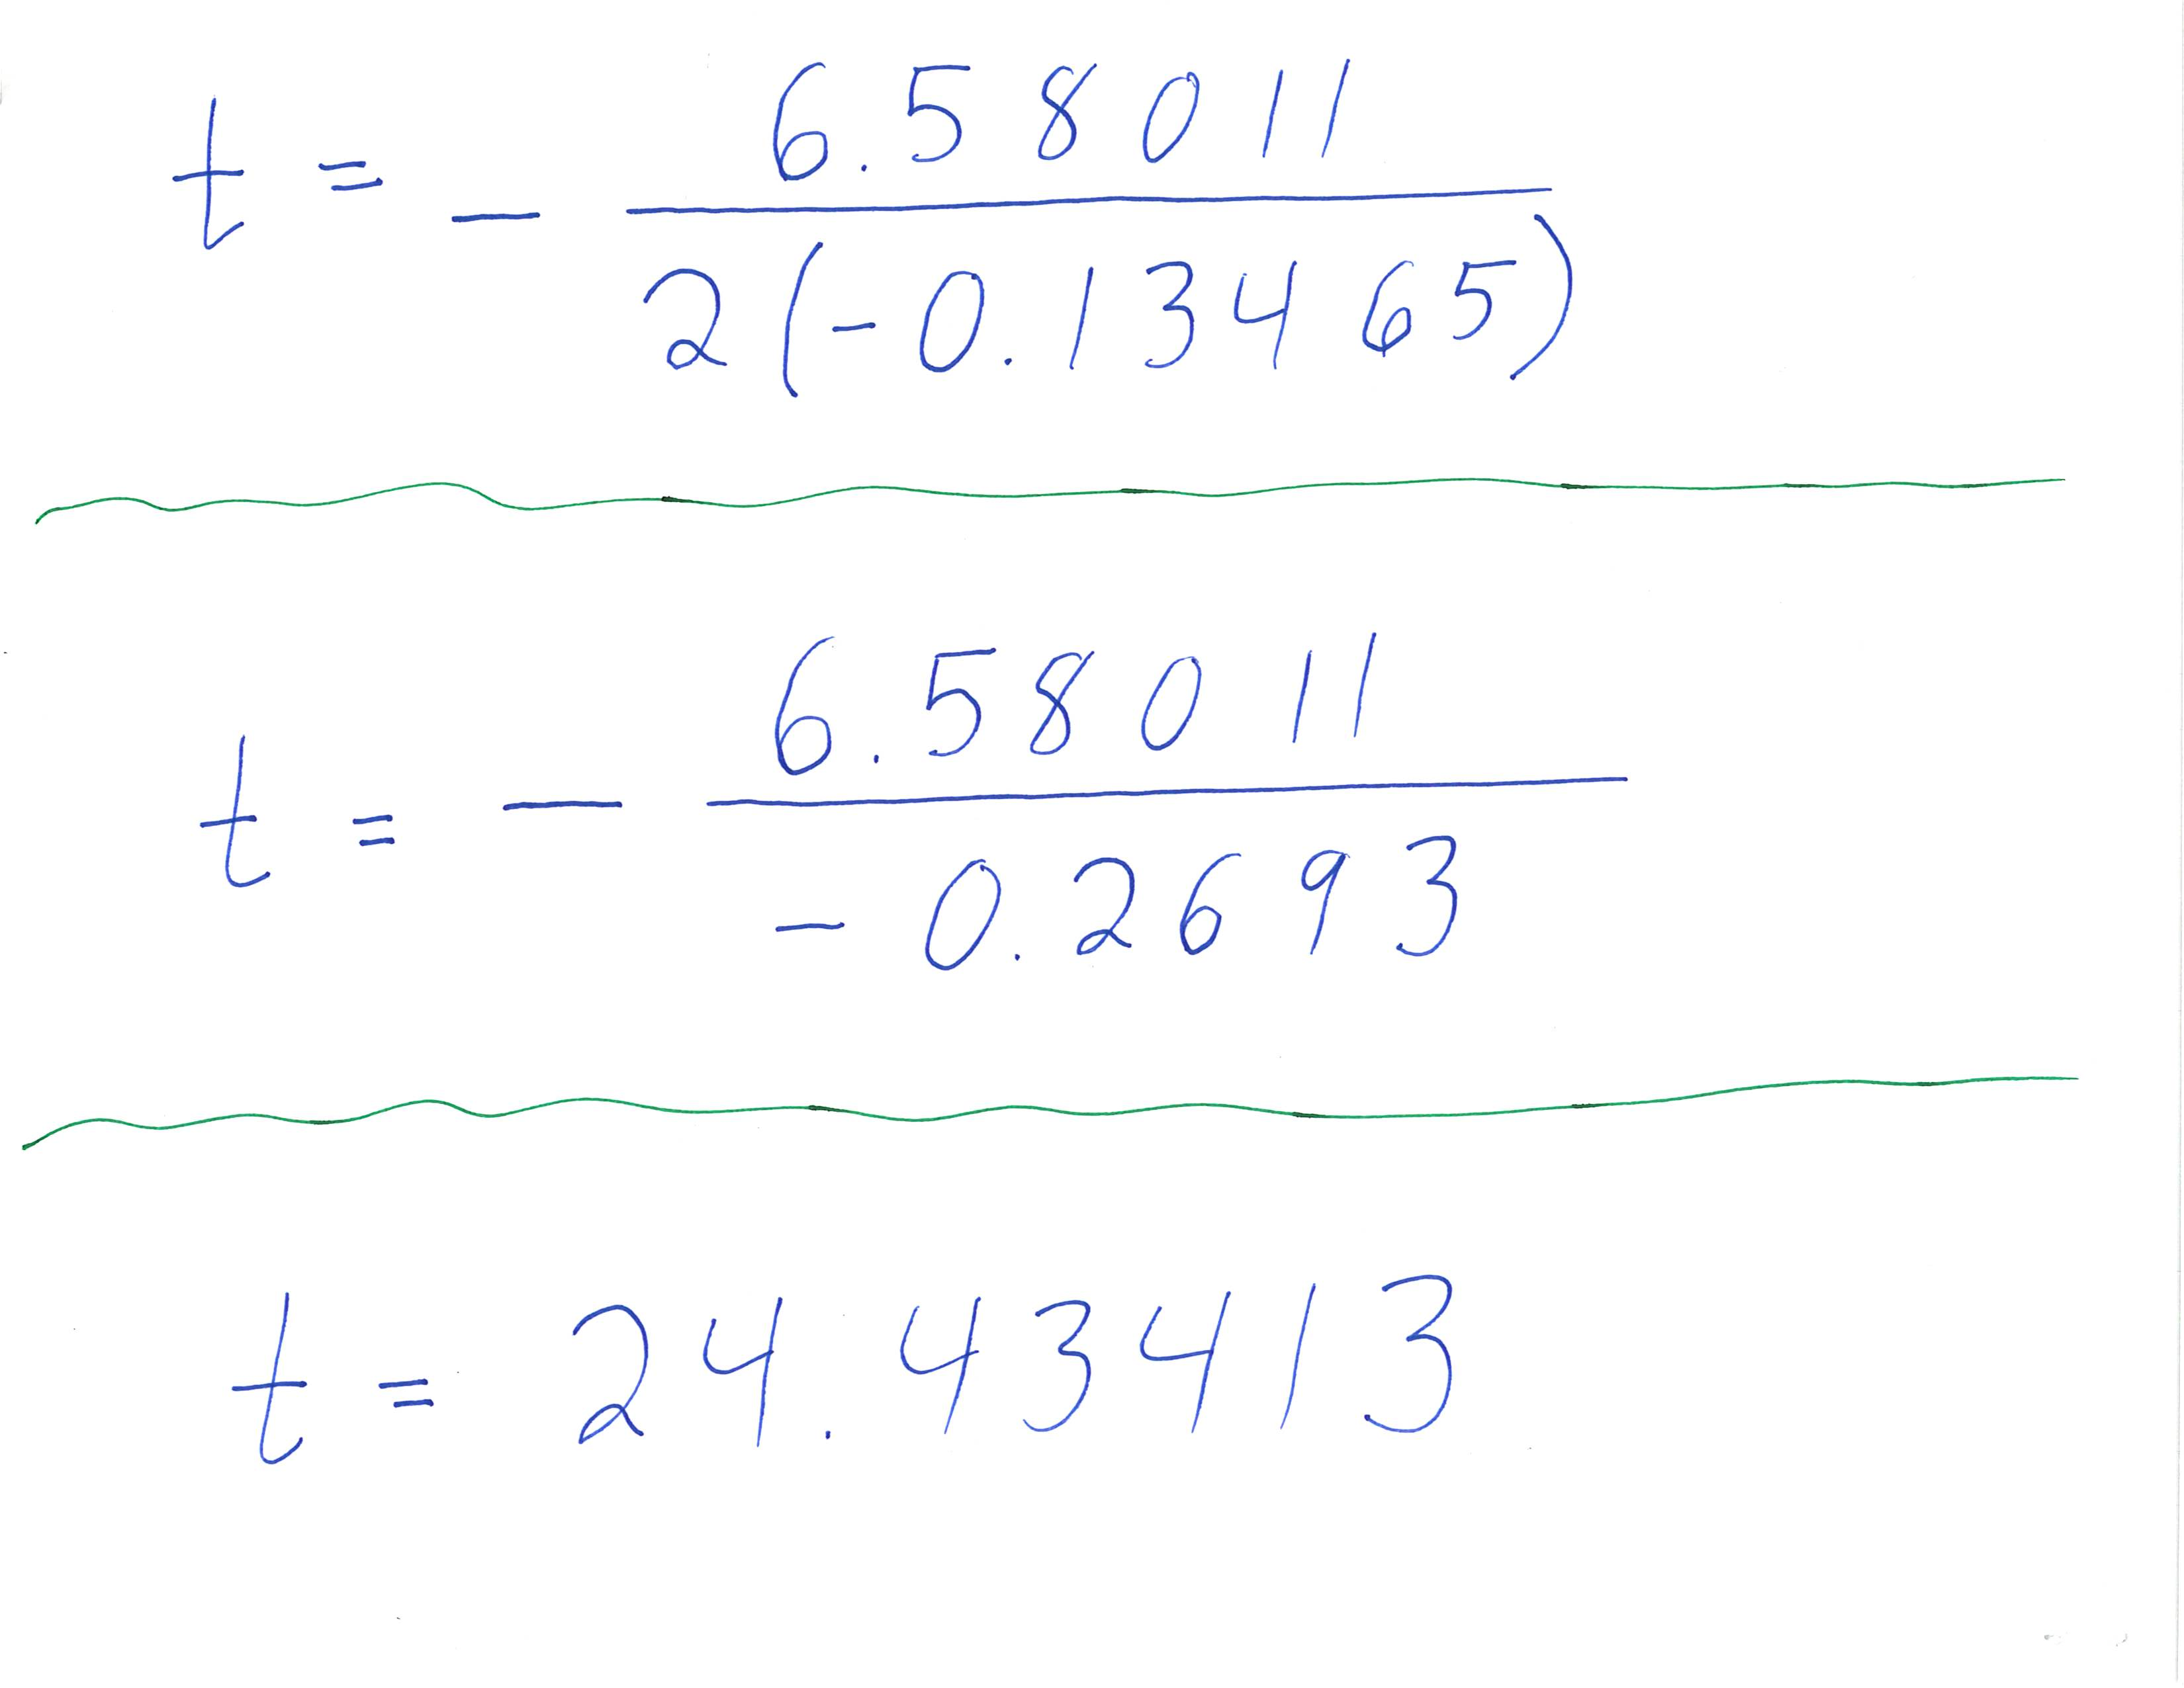
Round the frame to 24.4
Substitute 24.4 into the function  Simplify the arithmetic. | 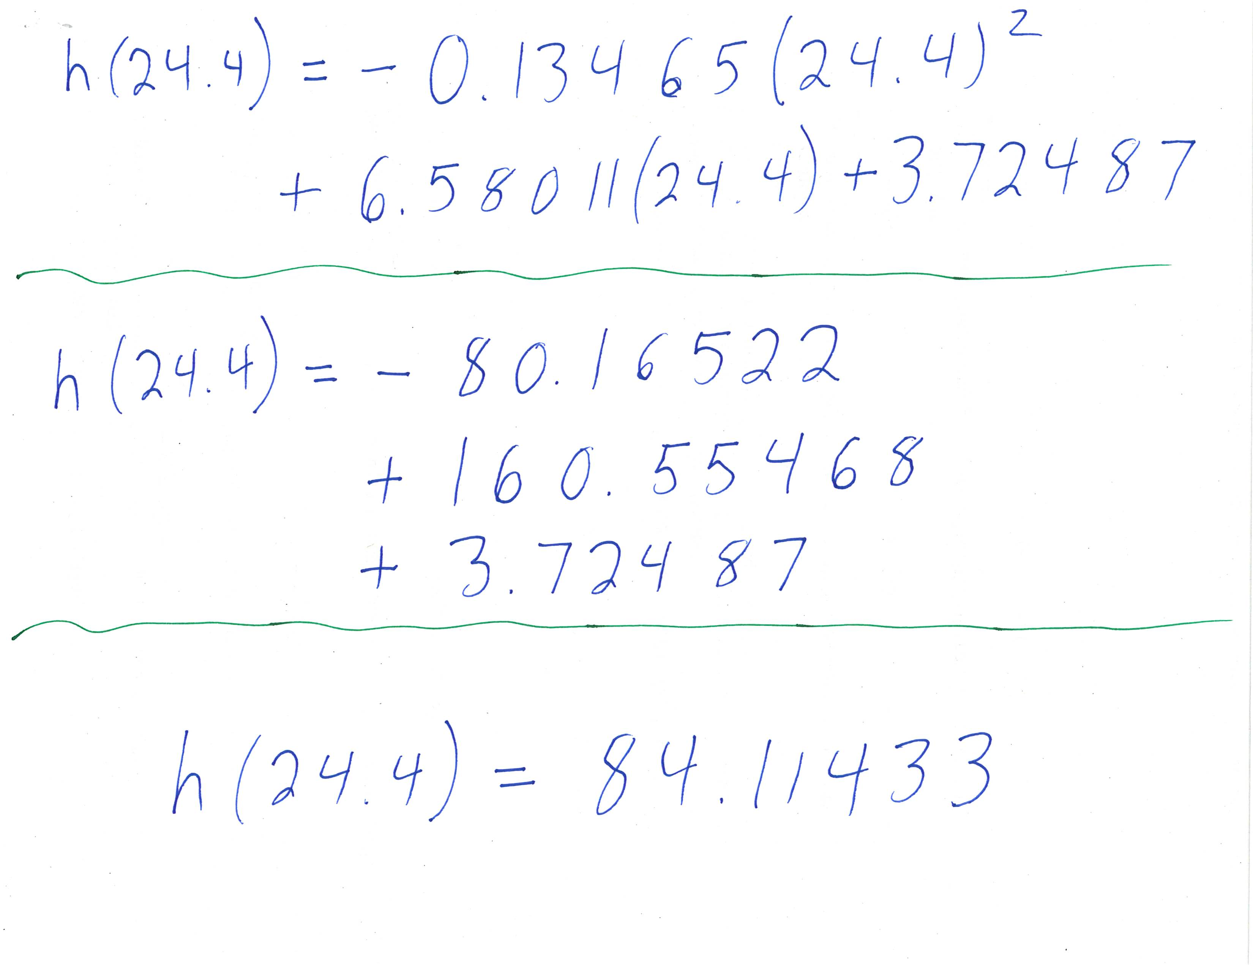
The maximum height is approximately 84.1 cm.
For reference, here is frame 24 of the video. The ball is just above the top of the frame.


