College Algebra Project 2
Algebra Boogaloo

Prologue
In the spring of 2023, I was regularly watching Dan Murrell’s box office recaps on YouTube called “Charts with Dan”. We were watching week-by-week to see if Avatar 2: The Way of Water would exceed the box office of Top Gun: Maverick. Through this discussion, I was able to create a method for pedicting future box office of a movie using an older movie as a reference. This method uses topics from this course. This project will go through this method step-by-step.

Act One
To start this project, we are going to need some data.
- Pick two movies, one that is a couple of years old, and one that is more recent. As an example, I will pick Rise of the Guardians and Red One. (You may not pick those movies.) Write your movies below.
Old Movie:
New Movie:
- Go to the website the-numbers.com and search for your movies. You will see a tab called “Box Office.”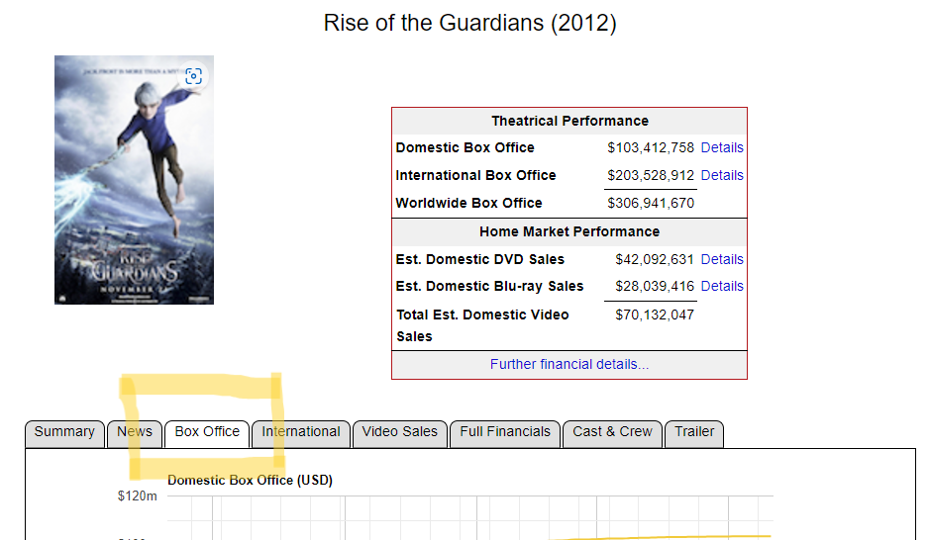
- Scroll down to “Daily Box Office Performance” on the “Box Office” page. The weekend days are highlighted in light pink. This means that Fridays are at the top of a sequence of pink rows. Record the total gross for the first 10 days the movie was in the theater. Start counting on the first Friday. Recored the data in millions of dollars and rounded to one decimal place. For Rise of the Guardians, the data is below.
Day | Total Gross (Millions of Dollars)
1 | 17.8
2 | 26.9
3 | 32.3
4 | 33.2
5 | 34.1
6 | 34.7
7 | 35.4
8 | 38.4
9 | 44.7
10 | 48.9
Record your data for the old movie and the new movie below.
Day | Old Movie Total Gross (Millions) | New Movie Total Gross (Millions)
1
2
3
4
5
6
7
8
9
10

