Solving Equations – Detailed Examples
  - College Algebra
Our calculators for this class can be used to solve equations. This will save us time when we want to focus on solving a word problem and understanding the meaning of the numbers we compute.

Resetting the Calculators
The first thing you want to do is reset the calculators.
Action | Calculator Screen
Press “Y=” on the upper left. There is some old work that we need to delete. | 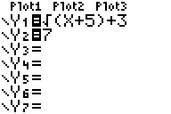
Press “CLEAR” and “ENTER” to delete the functions. Use the down arrow to go down to “Y2”. | 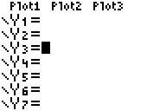
Reset the viewing window for the graphs. Press the “ZOOM” button. | 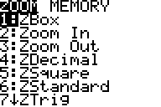
Press “6” to reset the viewing window.  The $x$-axis now goes between -10 and 10.  The $y$-axis now goes between -10 and 10.  This is a good starting point for all the problems. | 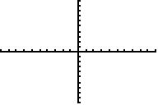
Now that we have the calculator reset, we are ready to solve equations.

Example 1
The first equation we will solve is $x^{2}+8x+15=0$.
The general strategy will be:
- Graph the function $y=x^{2}+8x+15$ on the calculator.
- Let the calculator tell us which points on the graph have $y=0$.
- The $x$-coordinate of these points are solutions to the equation.

Setting Up the Graph
Action | Calculator Screen
Press “Y=” in the upper left of the calculator. | 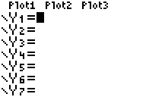
Type in the function X^2+8X+15 into Y1.  Remember to use the “X,T,$Θ$,n” button to type “X”. | 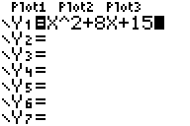
Press “GRAPH” in the upper left to see the graph. | 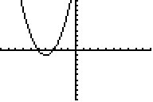
We can see the graph on the upper left now.
The graph crosses the $x$-axis in two places.
We want to find where the $y$-coordinates of the graph are $0$. The calculator has a built-in function to do that. We will start with the point on the right.

Calculate Where the Graph is Zero
Action | Calculator Screen
Press “2ND" and “TRACE” to enter the CALCULATE menu. | 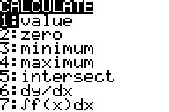
Press “2” to use the “zero” function. | 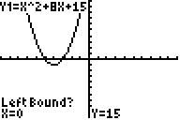
Use the left arrow to bring the crosshairs to the left of the right-most zero. | 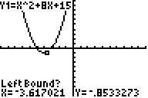
Press “ENTER” to lock the left endpoint in place. | 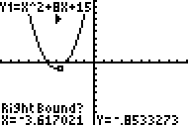
Use the right arrow to move the crosshair to the right. | 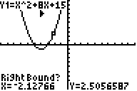
Press “ENTER” to lock the right endpoint in place. | 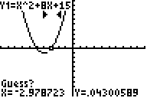
Use the left arrow to move the crosshair close to where the graph crosses the $y$-axis.  Press “ENTER” to start the calculator solving function. | 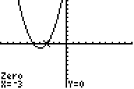
One of the two solutions to the equation is $x=-3$.

Knowledge Check
Repeat the steps to find the solution on the left. If you do it correctly, you should get $x=-5$.
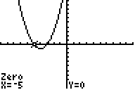

Example 2
The first equation we will solve is $\sqrt{x+3}=3x-1$.
The general strategy will be:
- Graph the functions $y=\sqrt{x+3}$ and $y=3x-1$ on the calculator at the same time.
- Let the calculator tell us the points where the graphs intersect.
- The $x$-coordinate of these points are solutions to the equation.

Setting Up the Graph
Action | Calculator Screen
Press “Y=”.  Clear out any old functions in your calculator. | 
Type “√(X+3)” for Y1.  Type “3X-1” for Y2.  Type “2ND" and “x²” to get the square root symbol. | 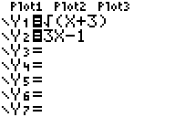
Press “GRAPH” to see the graphs. | 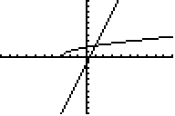
There are two graphs: one that is a slanting line, and the other is curving off to the right.
The graphs intersect at one point.
We will use the calculator’s intersection function to find the point of intersection.

Calculate the Intersection
Action | Calculator Screen
Press “2ND" and “TRACE” to enter the CALCULATE menu. | 
Press “5” to use the “intersect” function. | 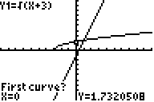
Press “ENTER” to select Y1 as the first function. | 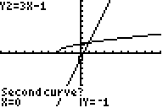
Press “ENTER” to select Y2 as the second function. | 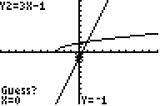
Press “ENTER” to use 0 as a guess. | 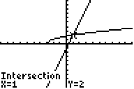
The point of intersection is $\left(1,2\right)$. We only need the $x$-coordinate of $x=1$ for the solution.

Conclusion
Here are two different methods to solve an equation on a calculator. These methods work for just about any equation you can think of.

