Linear Functions – Assignment
  - College Algebra
- Terry is skiing down a steep hill. Terry's elevation, $E(t)$, in feet after $t$ seconds is given by $E\left(t\right)=3000-70t$. Write a complete sentence describing Terry’s starting elevation and how it is changing over time.
- Jessica is walking home from a friend’s house. After 2 minutes she is 1.4 miles from home. Twelve minutes after leaving, she is 0.9 miles from home. What is her rate in miles per hour?
- Determine whether the function is increasing or decreasing.
$$g\left(x\right)=5x+6$$
- Determine whether the function is increasing or decreasing.
$$b\left(x\right)=8-3x$$
- Find the slope of the line that passes through the two given points.
$$\left(1,5\right) \text{and} \left(4,11\right)$$
- Find the slope of the line that passes through the two given points.
$$\left(-1,4\right) \text{and} \left(5,2\right)$$
- Write an equation for the line graphed.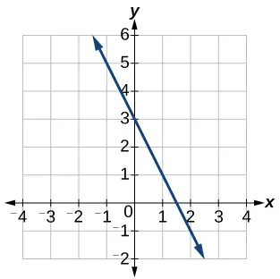
- Write an equation for the line graphed.
