Hypothesis Testing with One Sample
Statistics

Hypothesis Test

Steps to Perform the Test
- State the null hypothesis. :
- State the alternative hypothesis. :
- In words, CLEARLY state what your random variable or represents.
- State the distribution to use for the test.
- What is the test statistic?
- What is the p-value? In one or two complete sentences, explain what the p-value means for this problem.
- Use the previous information to sketch a picture of this situation. CLEARLY, label and scale the horizontal axis and shade the region(s) corresponding to the p-value.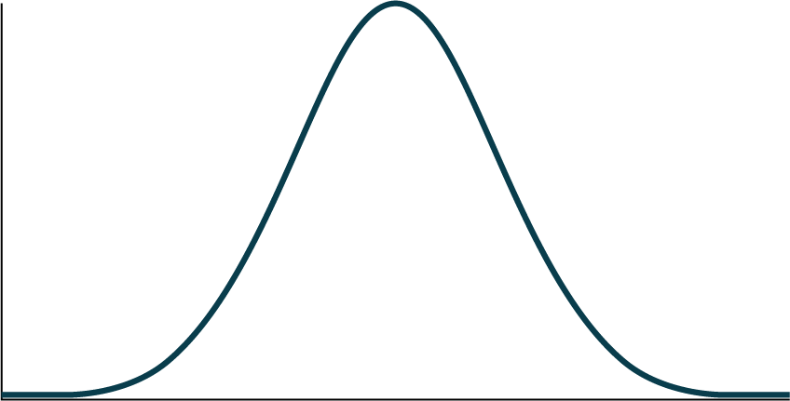
- Indicate the correct decision (“reject” or “do not reject” the null hypothesis), the reason for it, and write an appropriate conclusion, using complete sentences.
  - Alpha:
  - Decision:
  - Reason for decision:
  - Conclusion:

Additional Conclusion from the Sample

Confidence Intervals
- Construct a 95% confidence interval for the true mean or proportion. Include a sketch of the graph of the situation. Label the point estimate and the lower and upper bounds of the confidence interval.

