Combinations
Detailed Examples

Main Ideas
- Combinations are as easy to setup as permutations. There are extra steps, but the patterns are similar.
- The hard part of calculating combinations by hand is canceling the numbers in the bottom of the fraction (the denominator).

Example 7.9
Compute the following:

Step | Work
Write out the permutation in the top of the fraction. | 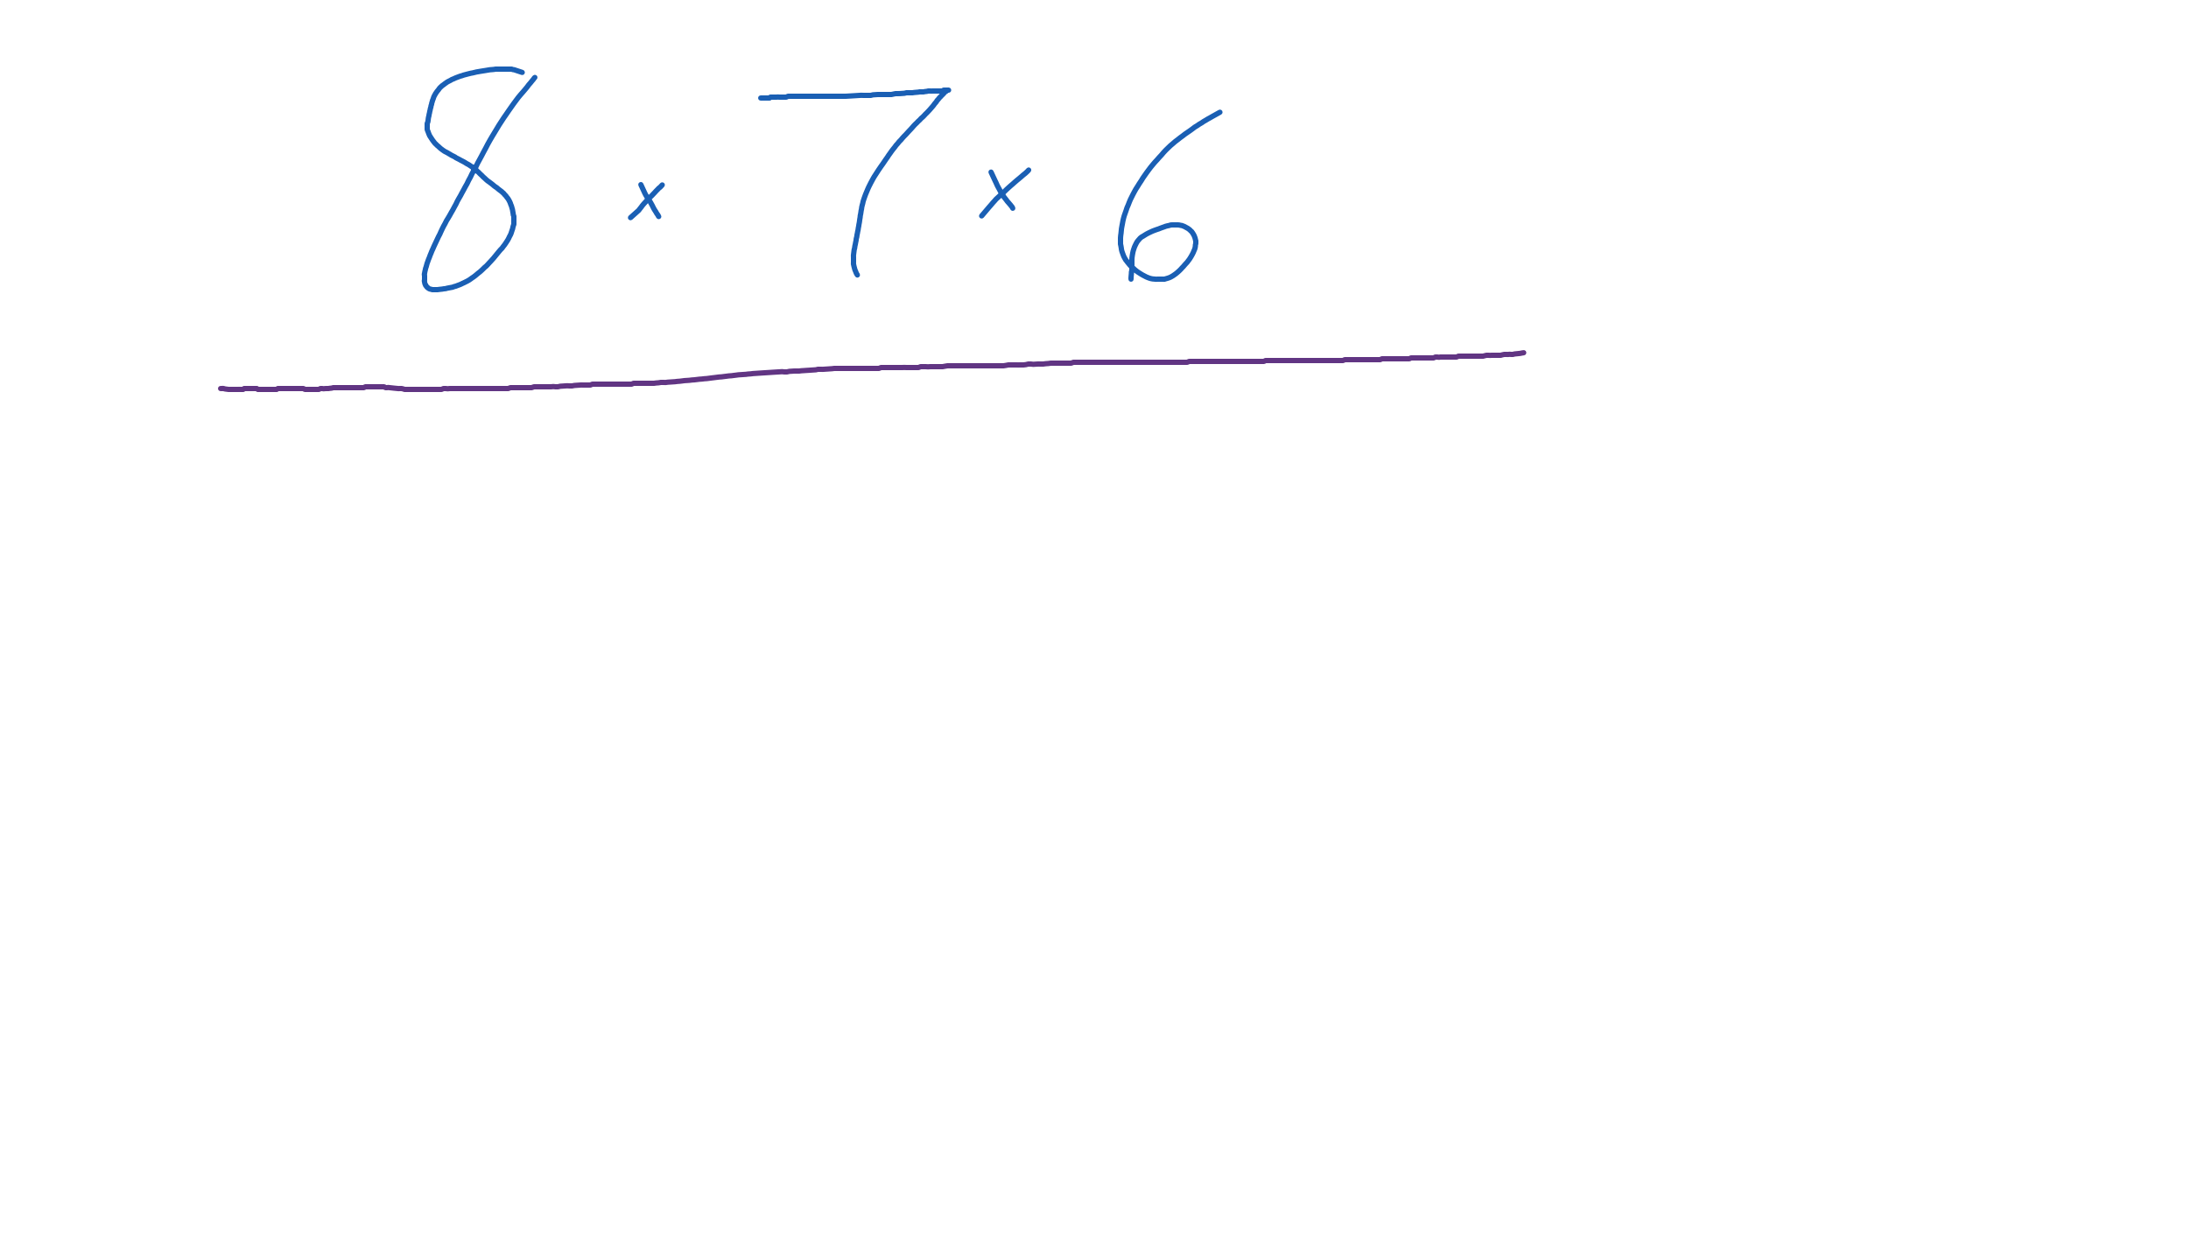
Write out in the bottom of the fraction. | 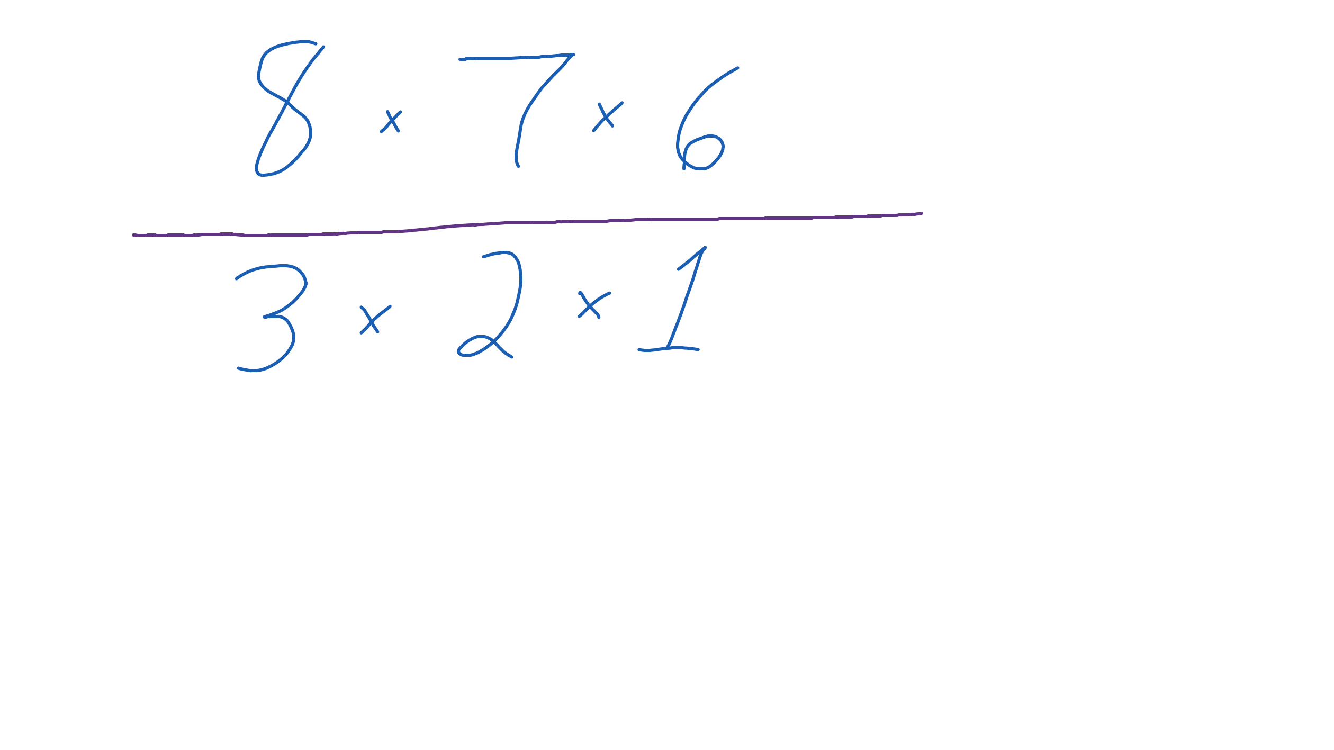
Cancel the 3 in the bottom by dividing it into the 6 in the top. 6 divided by 3 is 2. The 2 stays in the top of the fraction. | 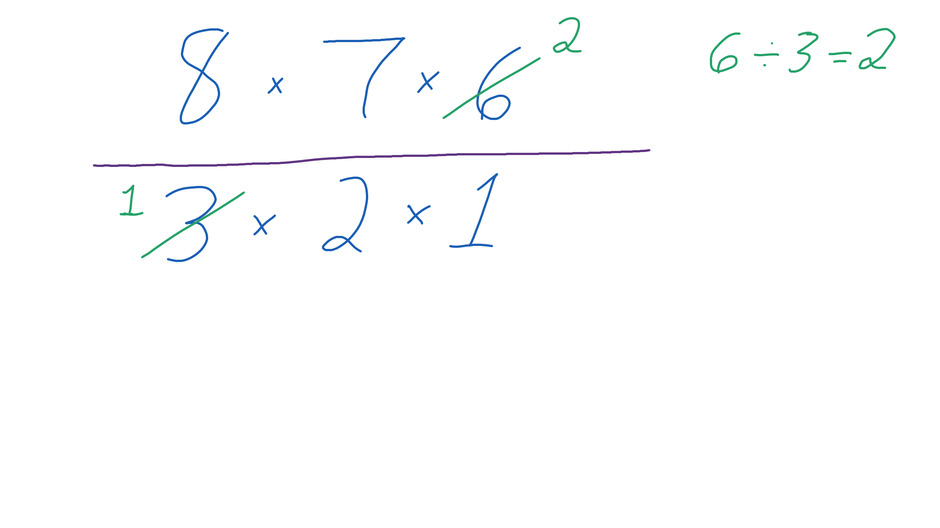
Cancel the 2 in the bottom by dividing it into the 8 in the top. 8 divided by 2 is 4. The 4 stays in the top of the fraction.  There are only 1’s left in the bottom. That means we can just ignore it. | 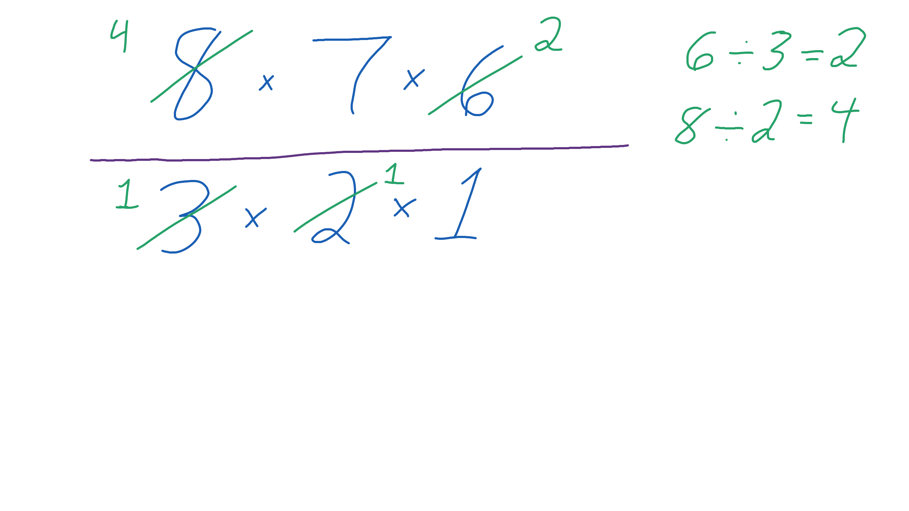
Multiply . | 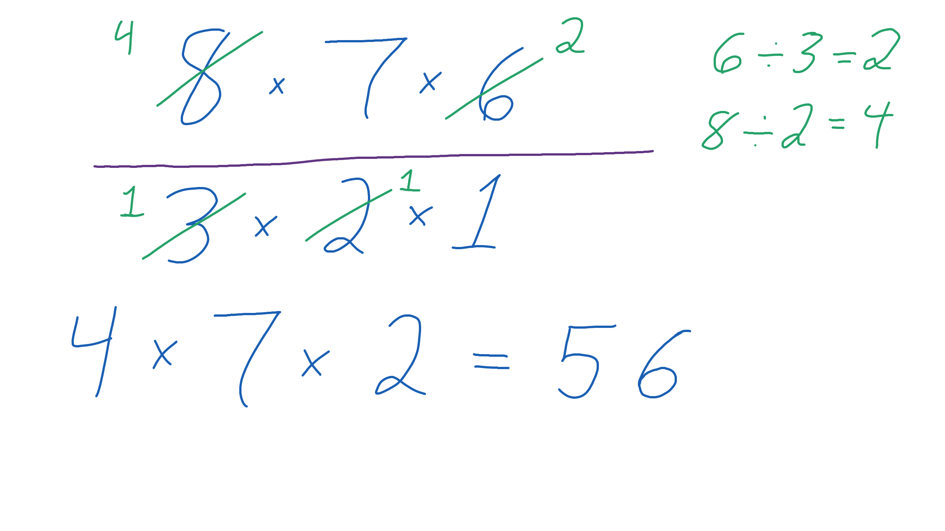
Our answer is .
Step | Work
Write out the permutation in the top of the fraction. | 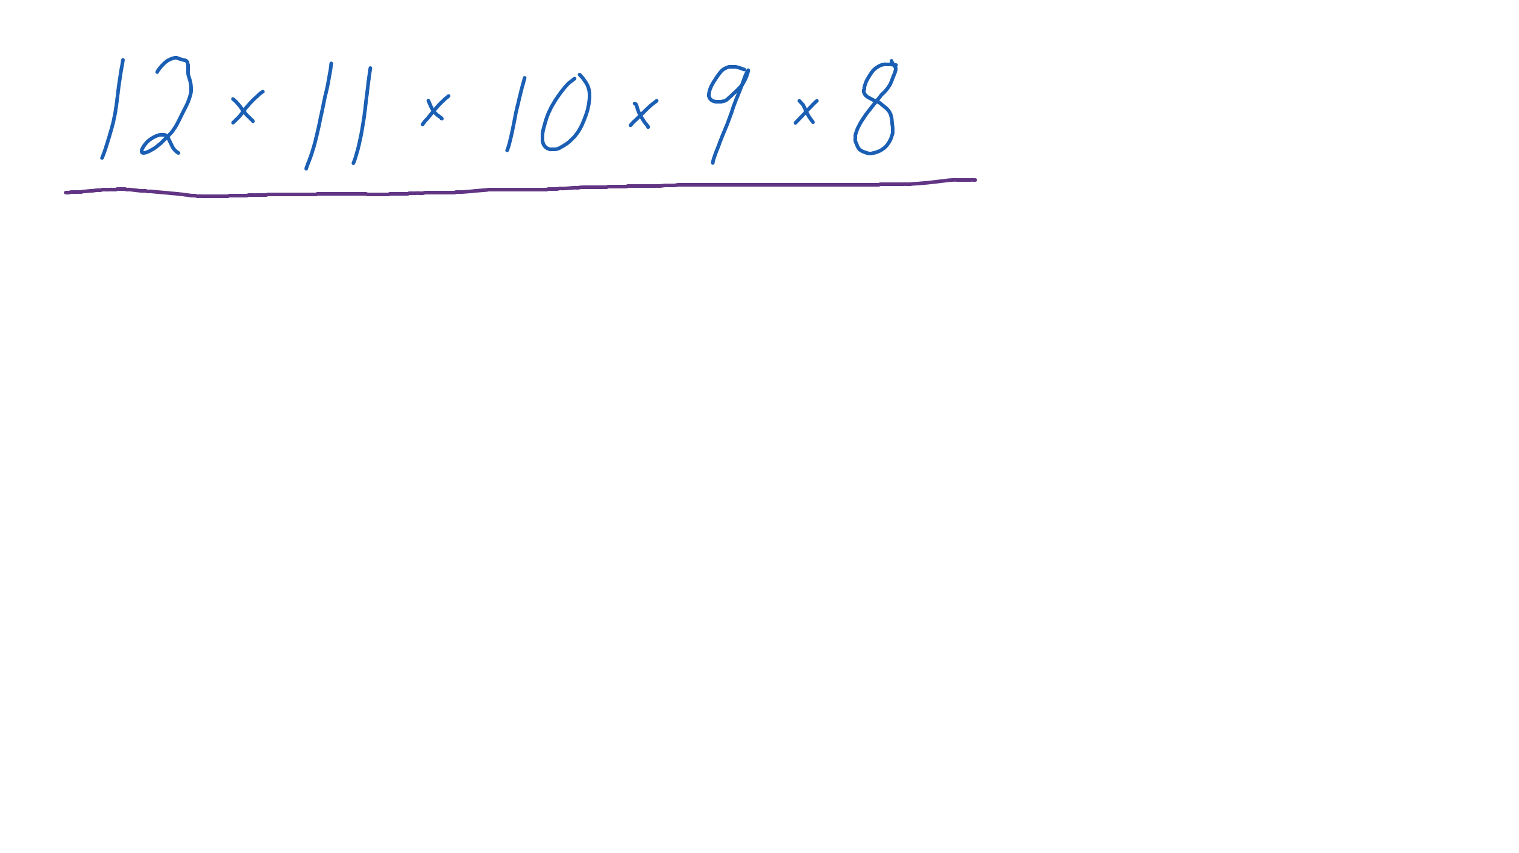
Write out in the bottom of the fraction. | 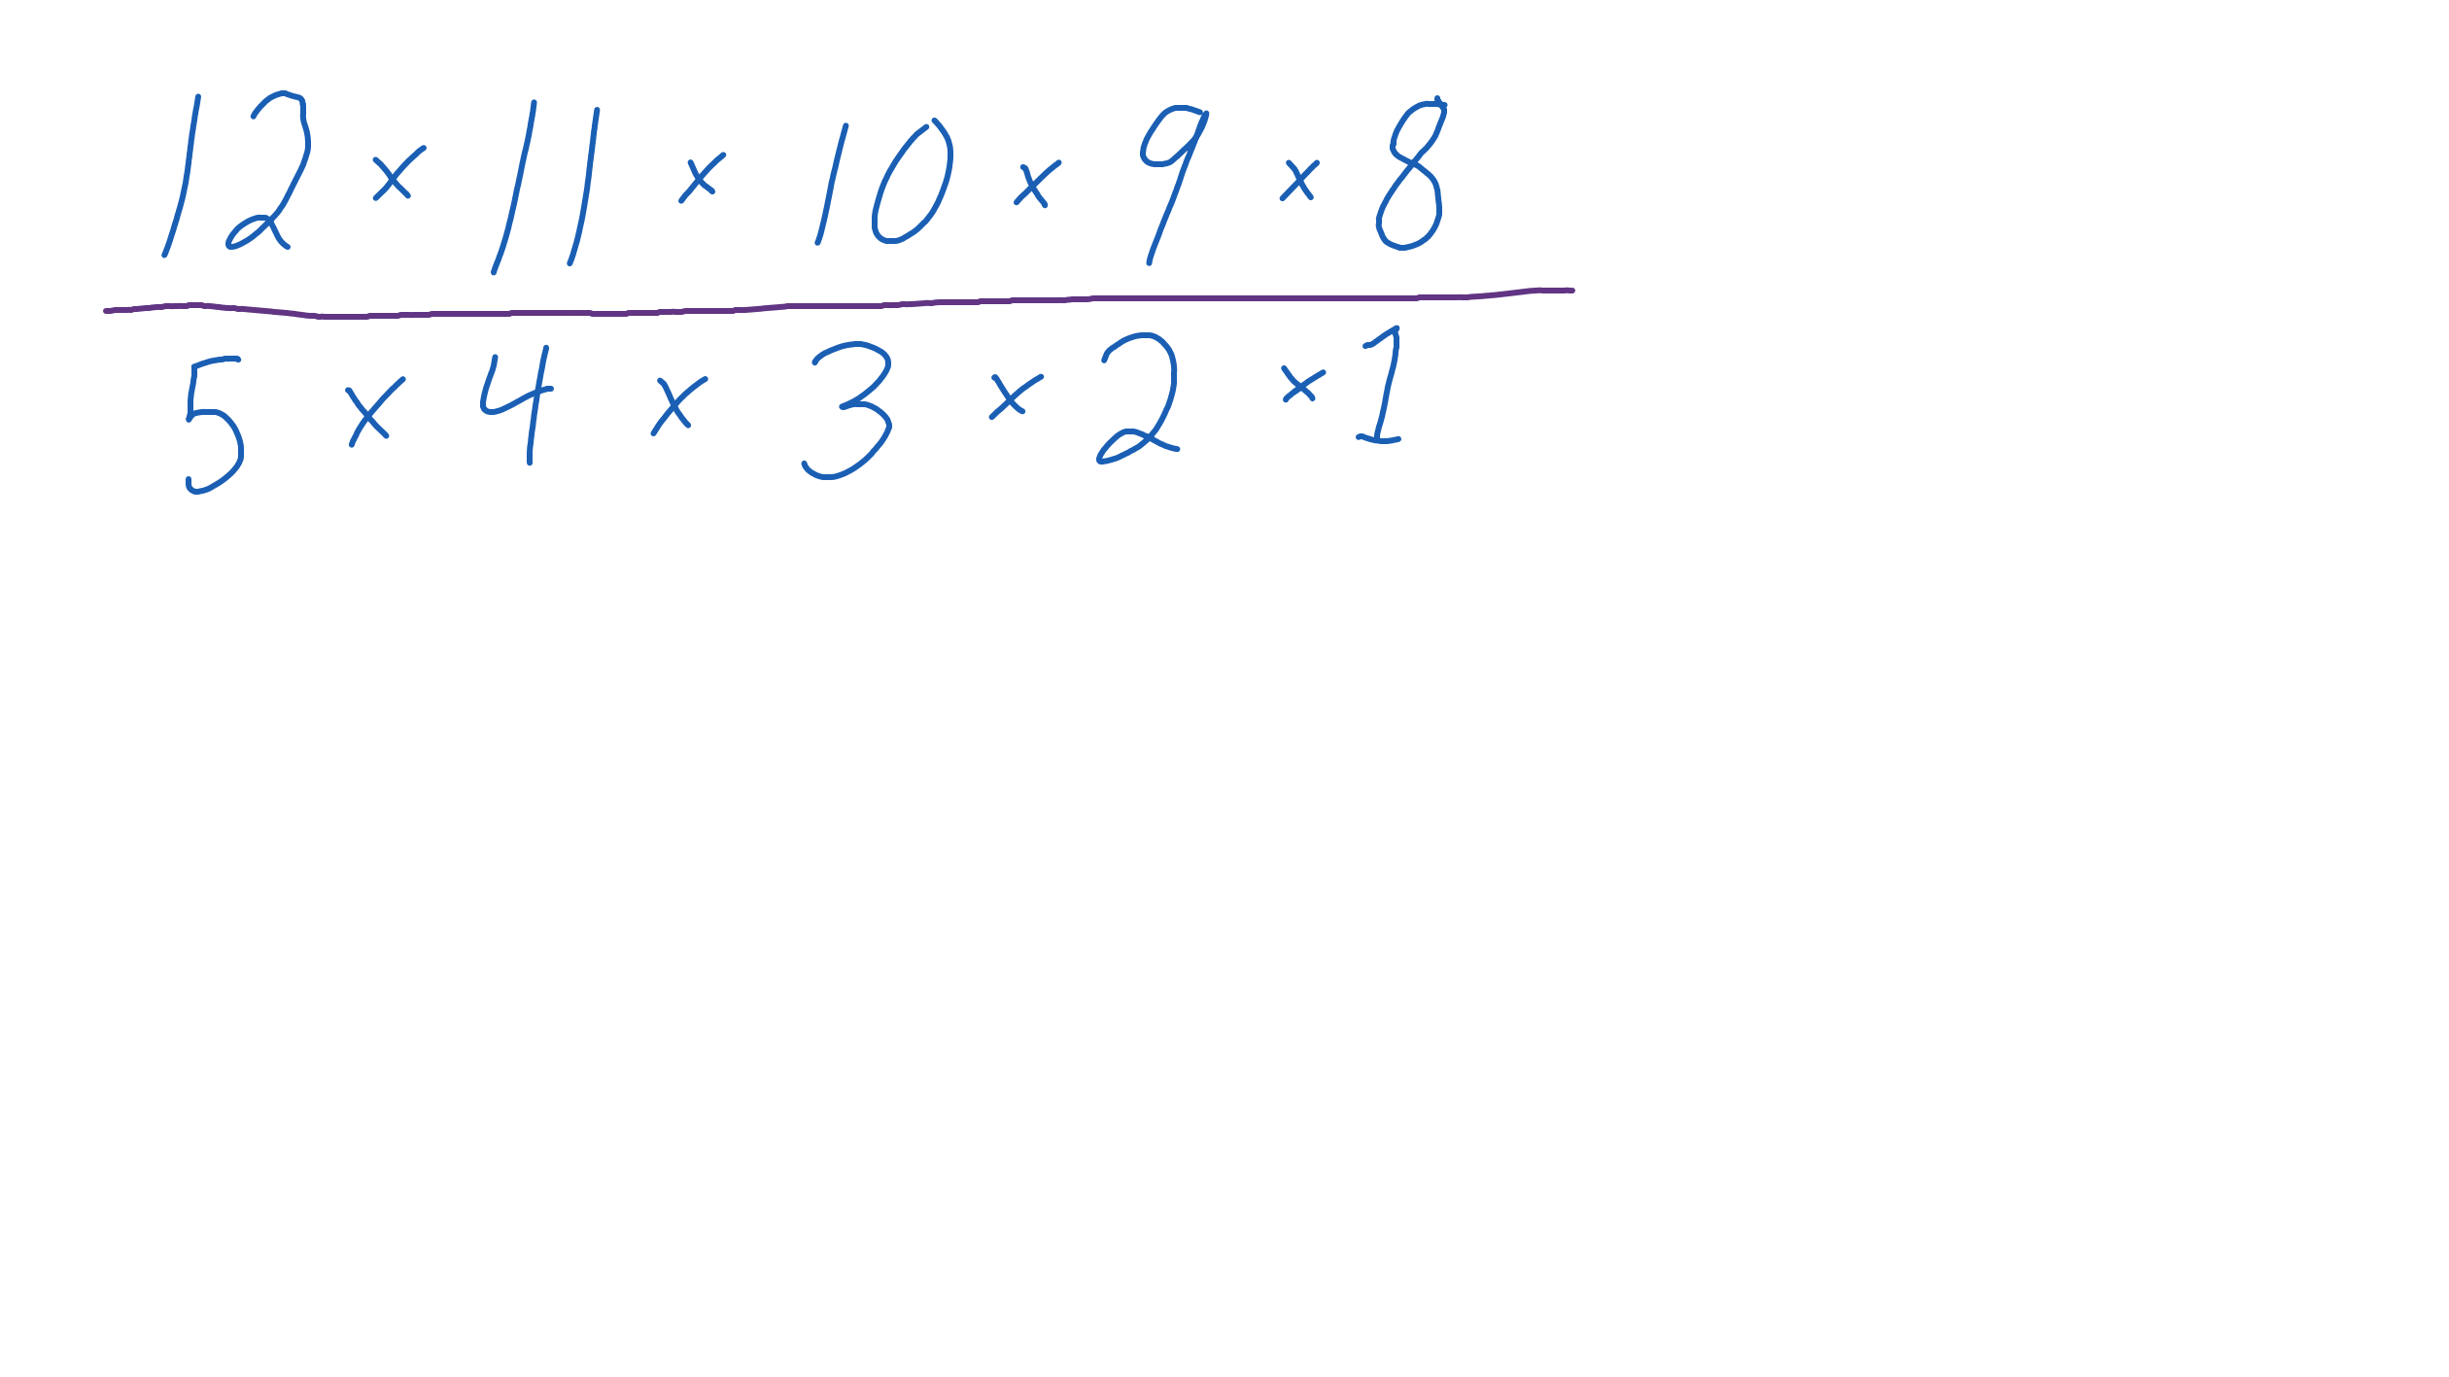
Cancel the 5 in the bottom by dividing it into the 10 in the top. 10 divided by 5 is 2. The 2 stays in the top of the fraction. | 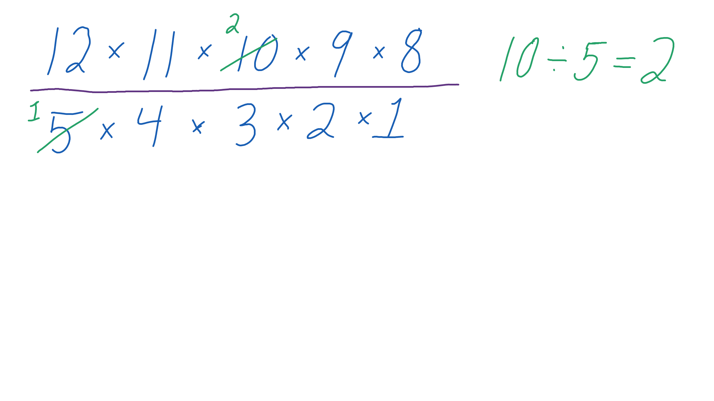
Cancel the 4 in the bottom by dividing it into the 12 in the top. 12 divided by 4 is 3. The 3 stays in the top of the fraction. | 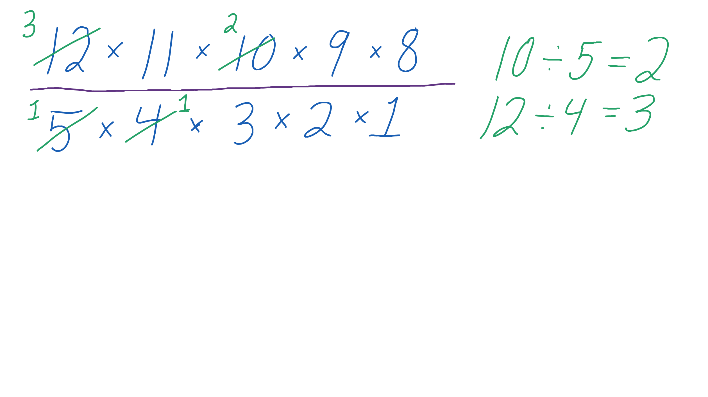
Cancel the 3 in the bottom by dividing it into the 9 in the top. 9 divided by 3 is 3. The 3 stays in the top of the fraction. | 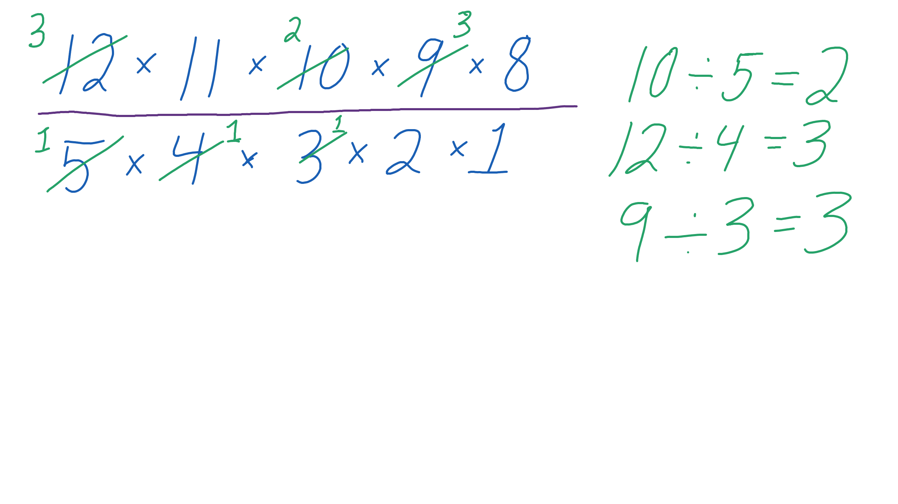
Cancel the 2 in the bottom by dividing it into the 8 in the top. 8 divided by 2 is 4. The 4 stays in the top of the fraction.  There are only 1’s left in the bottom. That means we can just ignore it. | 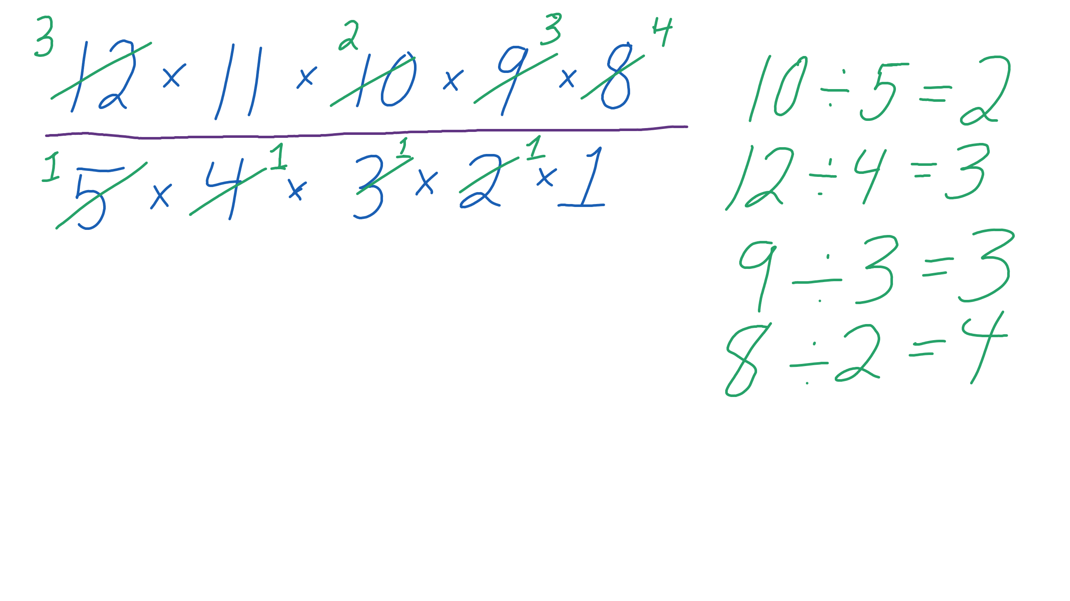
Multiply . | 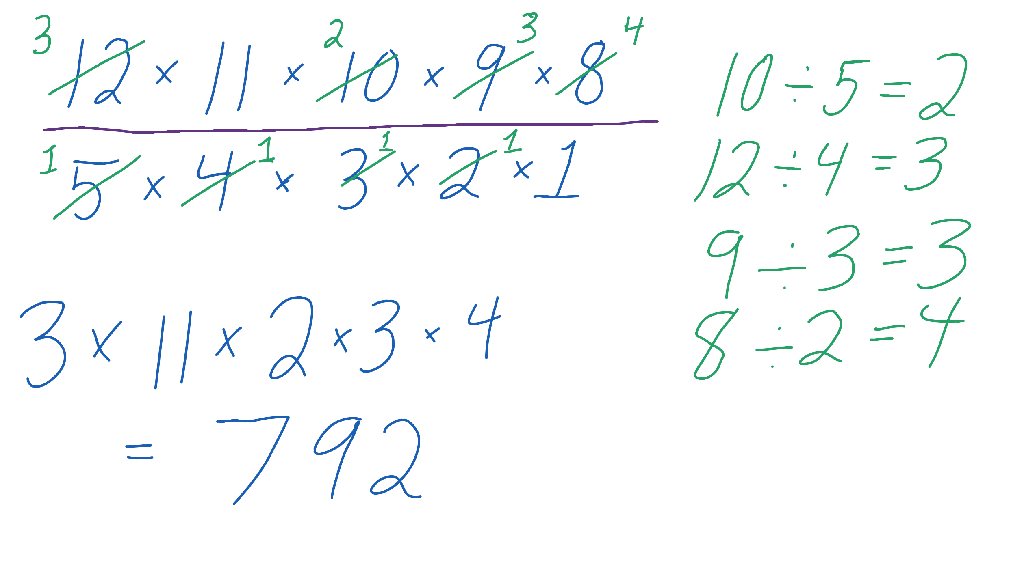
Our answer is .
Step | Work
Write out the permutation in the top of the fraction. | 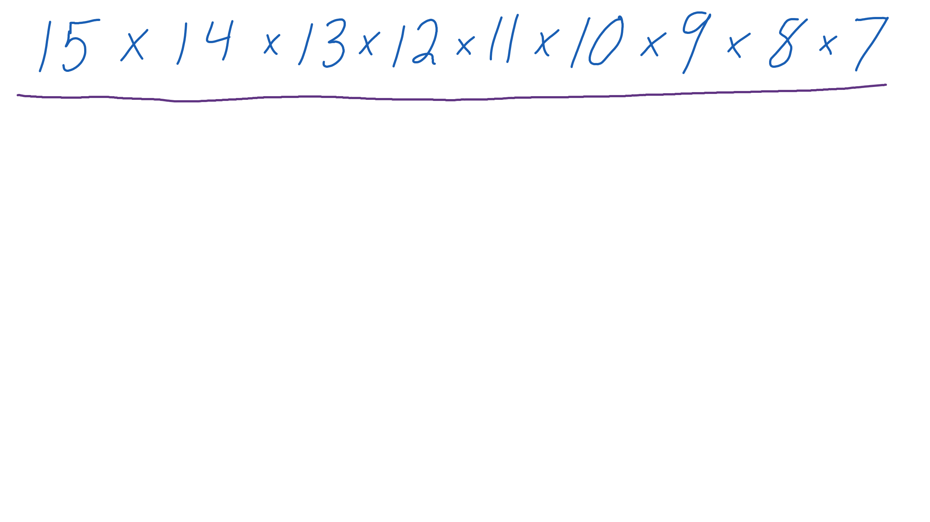
Write out in the bottom of the fraction. | 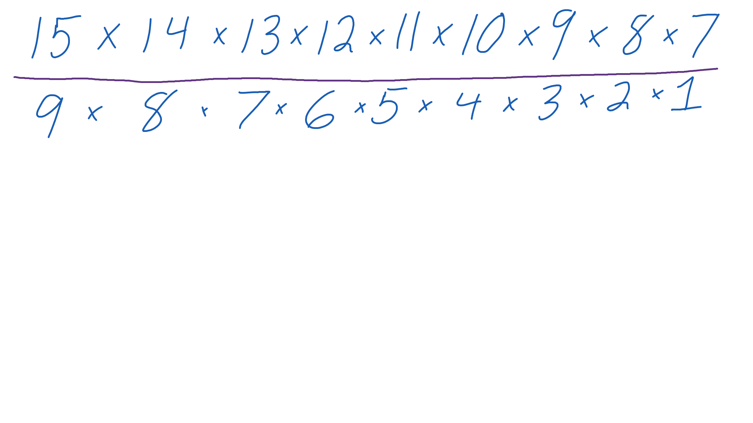
Cancel out 9, 8, and 7 from the denominator with the matching 9, 8, and 7 from the numerator. | 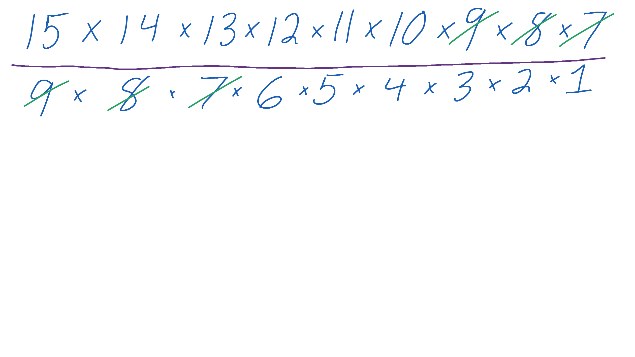
Cancel the 6 in the bottom by dividing it into the 12 in the top. 12 divided by 6 is 2. The 2 stays in the top of the fraction. | 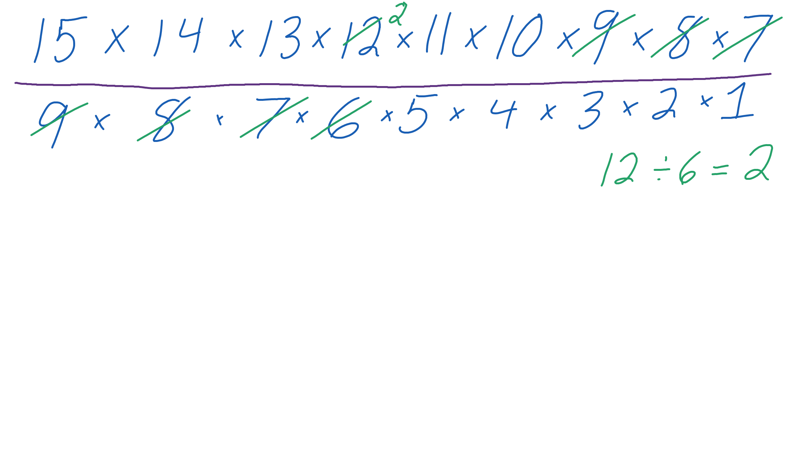
Cancel the 5 in the bottom by dividing it into the 10 in the top. 10 divided by 5 is 2. The 2 stays in the top of the fraction. | 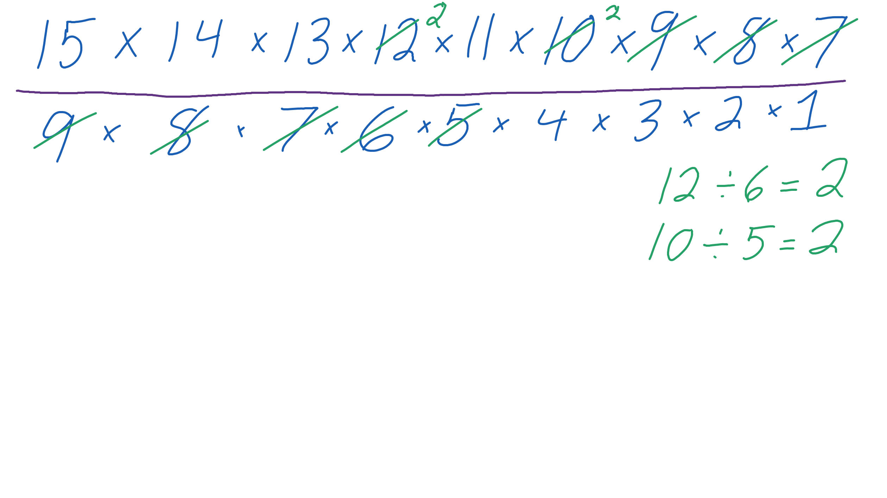
Cancel the 4 in the bottom by dividing it into the two 2’s in the top. | 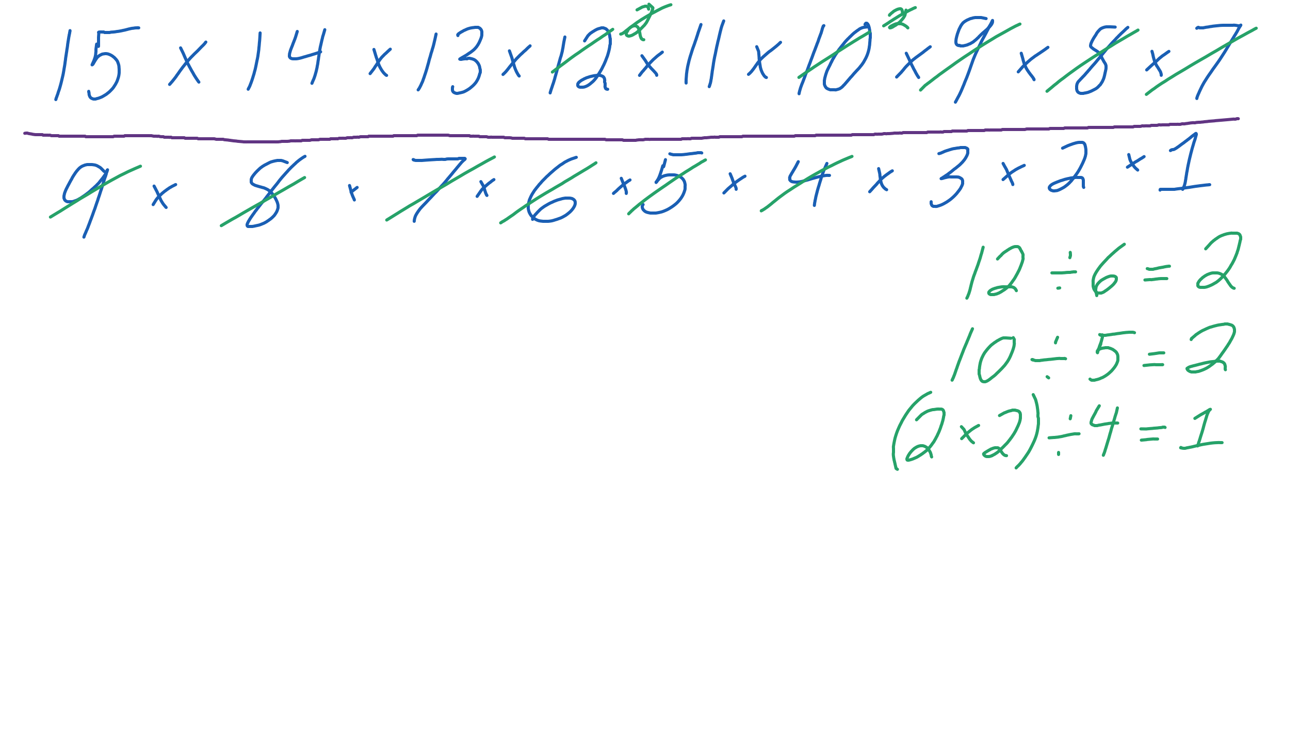
Cancel the 3 in the bottom by dividing it into the 15 in the top. 15 divided by 3 is 5. The 5 stays in the top of the fraction. | 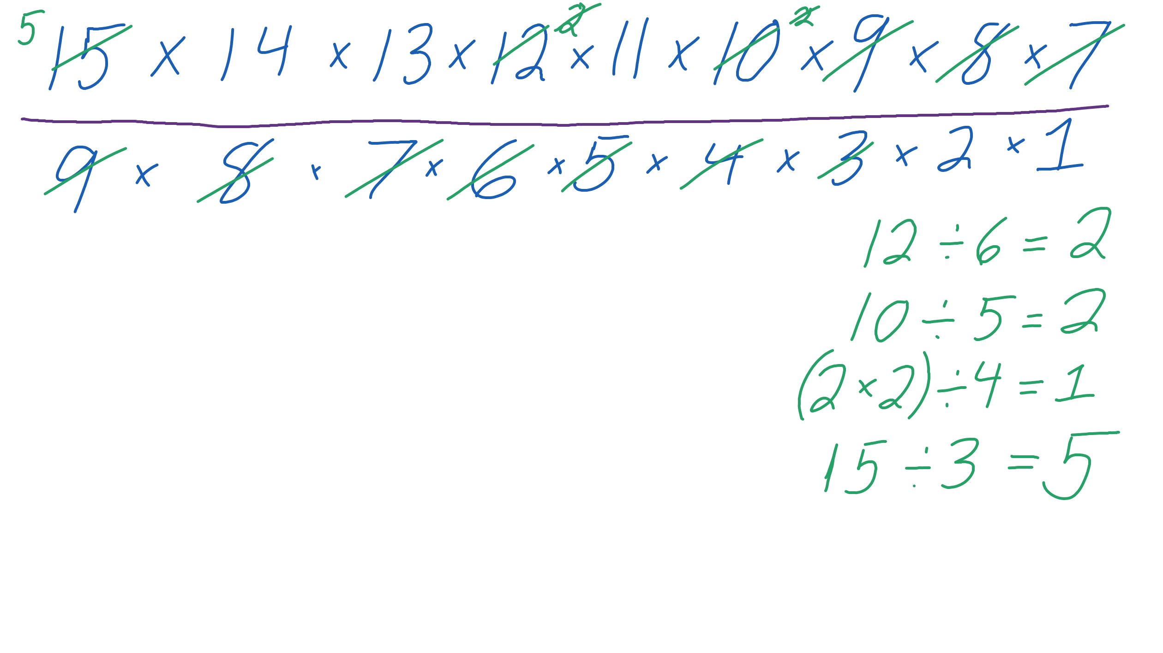
Cancel the 2 in the bottom by dividing it into the 14 in the top. 14 divided by 2 is 7. The 7 stays in the top of the fraction.  There are only 1’s left in the bottom. That means we can just ignore it. | 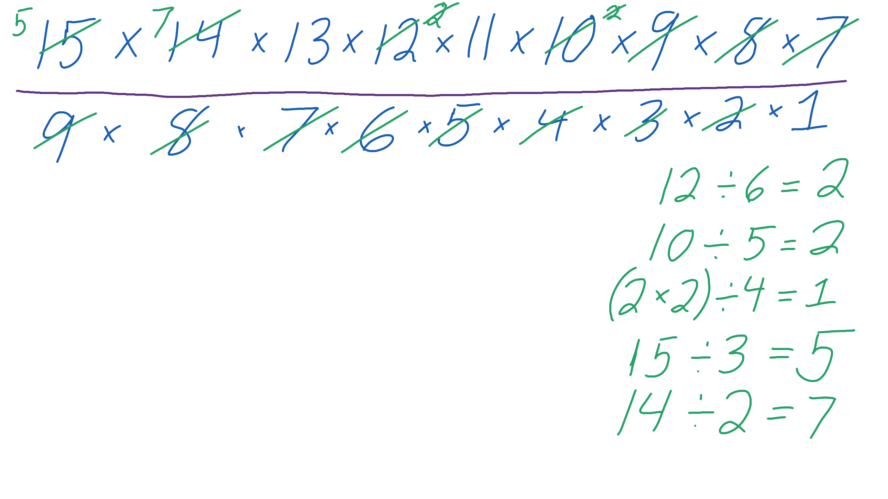
Multiply . | 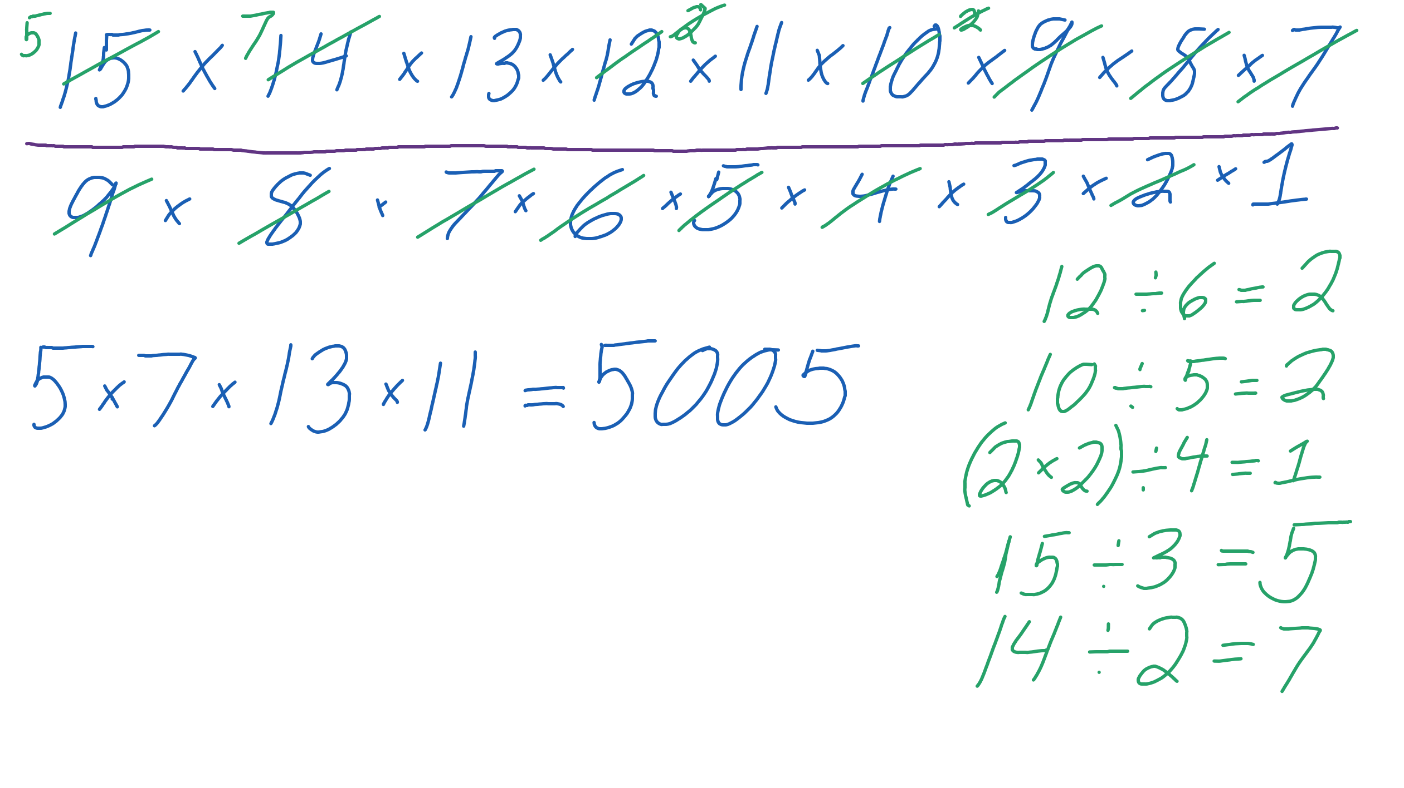
Our answer is .

