Logarithms
College Algebra

Main Ideas
- The common logarithm of is the exponent to which you must raise 10 to get .
- The natural logarithm of is the exponent to which you must raise to get .
- There are several applications of logarithms.
- We will use logarithms later in the course to solve exponential functions.

Common Logarithms

Definition – Common Logarithm
For a positive number , define the common logarithm of to be to be the number where .

How To – Approximate the Common Logarithm of a Number on a TI Graphing Calculator
Calculate the common logarithm of a number by pressing the LOG button followed by the number. Close the parentheses and press ENTER.
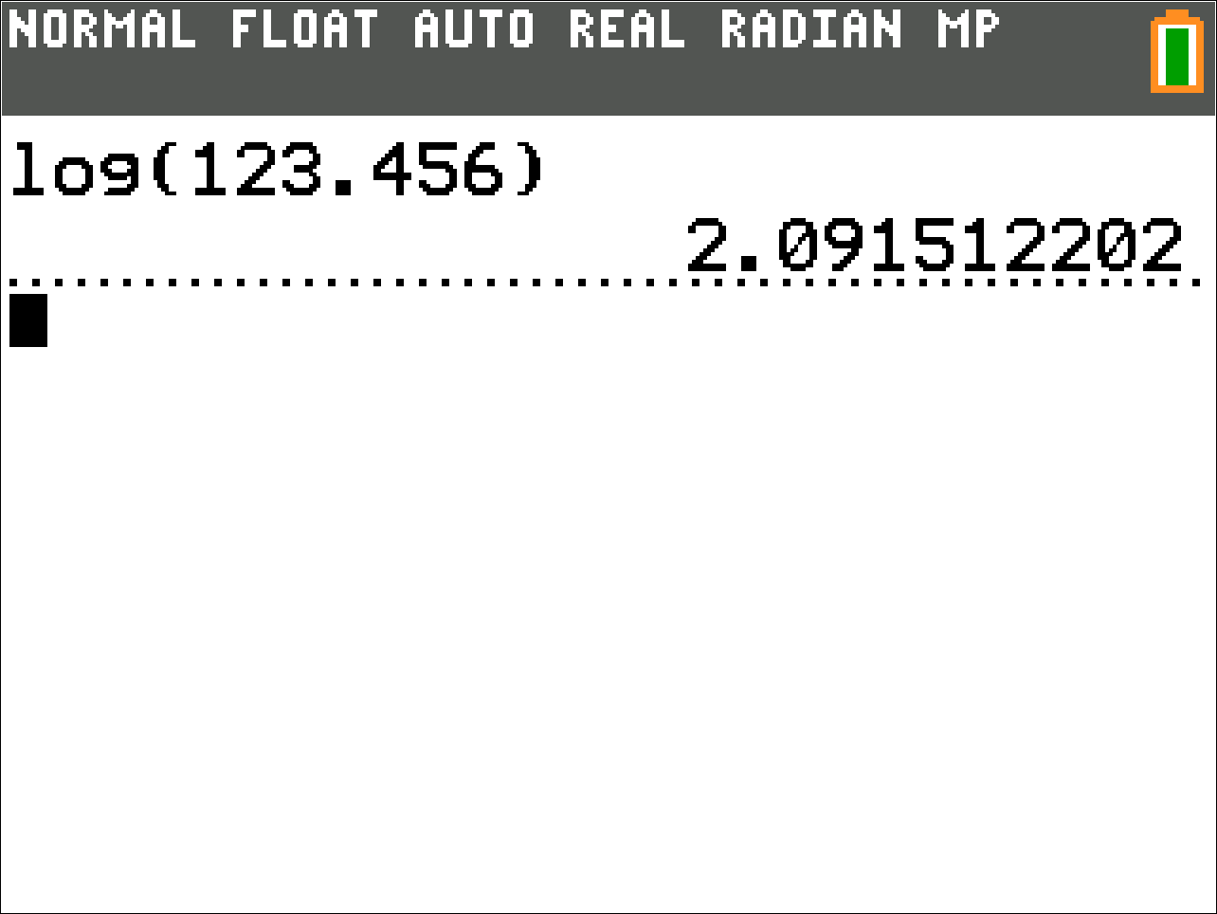

Natural Logarithms

Definition – Natural Logarithm
The number is a constant like in mathematics. For a positive number , define the natural logarithm of to be to be the number where .

How To – Approximate the Common Logarithm of a Number on a TI Graphing Calculator
Calculate the natural logarithm of a number by pressing the LN button followed by the number. Close the parentheses and press ENTER.
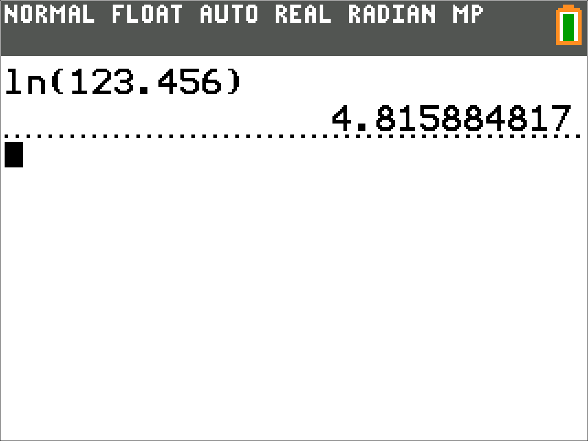

Note
The constant is a number that is useful in Calculus. That is the reason it appears in so many science classes.

