The Multiplication Rule for Counting
Detailed Examples

Introduction
Using the Multiplication Rule for Counting can look difficult at first. The key is to follow the following steps.
- Determine how many decisions must be made for each step of the problem. Write a slot for each decision.
- Fill in the number of possibilities for each decision in the corresponding slot. Work on each decision one at a time.
- Multiply the numbers in each slot. The product is your answer.
These problems can have large numbers for answers.

Examples

Example 7.2
The University Combinatorics Club has 31 members: 8 seniors, 7 juniors, 5 sophomores, and 11 first-years. How many possible 4-person committees can be formed by selecting 1 member from each class?
Step | Work
Write four slots, one each for: seniors, juniors, sophomores, and first-years. | 
Fill in the slots: 8 for the seniors, 7 for the juniors, 5 for the sophomores, and 11 for the first-years. | 
Multiply the numbers in each slot. | 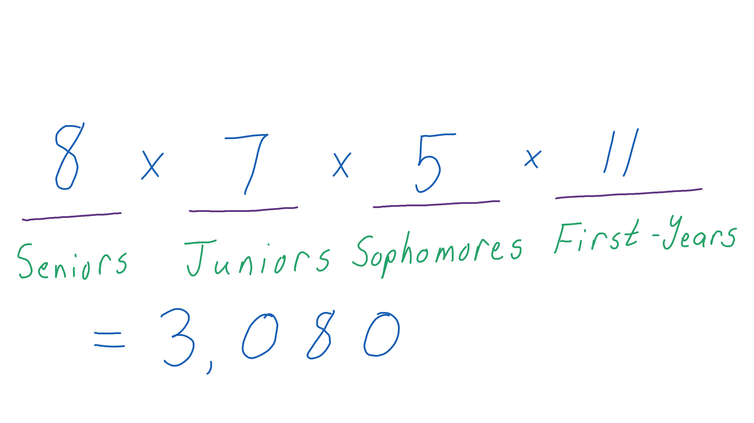
The answer is 3,080 ways to pick people for the committee.

Example 7.3
The standard license plates for vehicles in a certain state consist of 6 characters: 3 letters followed by 3 digits. There are 26 letters in the alphabet and 10 digits (0 through 9) to choose from. How many license plates can be made using this format?
Step | Work
Write six slots: three for the three letters and three for the numbers. | 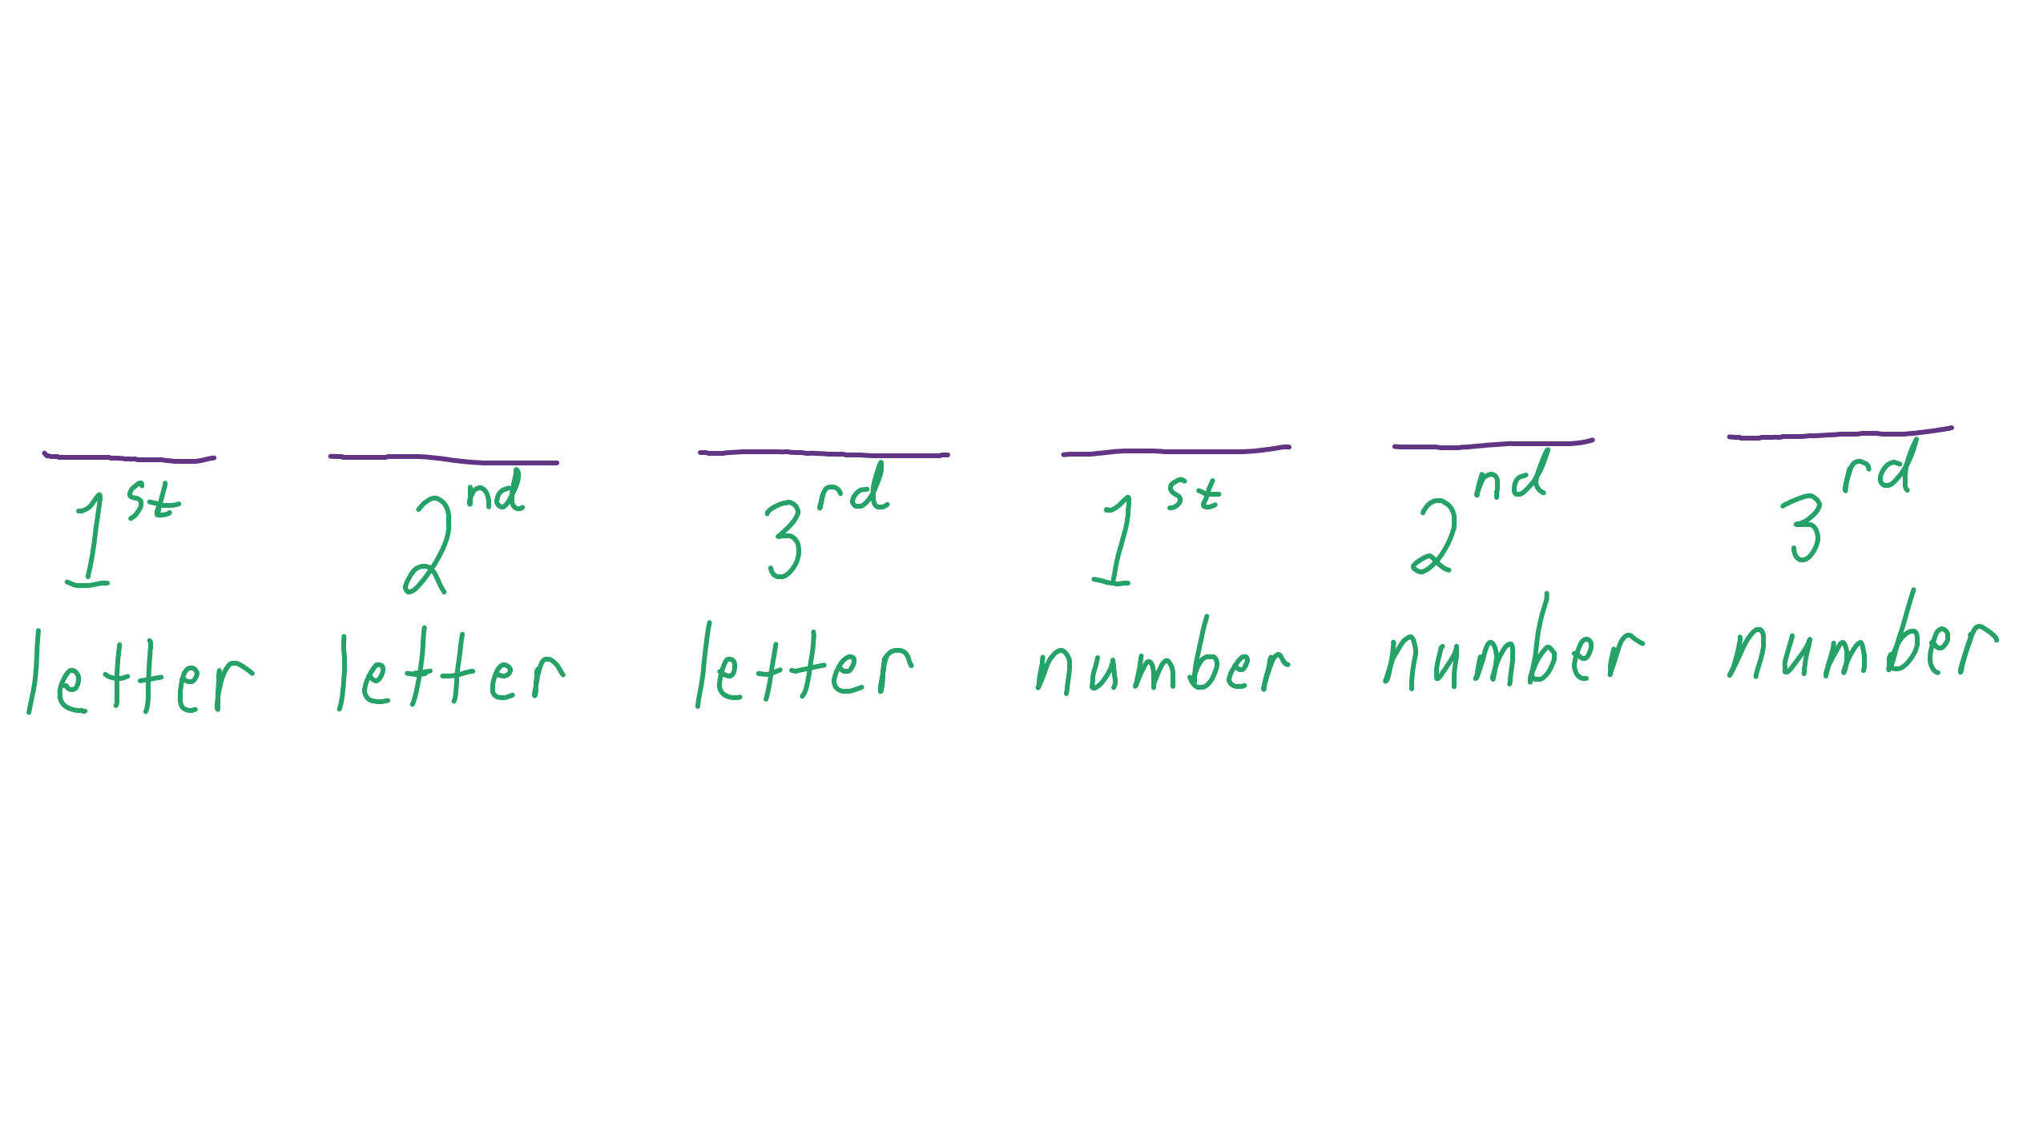
Fill in the slots. The first three slots are 26, which is the number of letters. The last three slots are 10, which is the number of digits. | 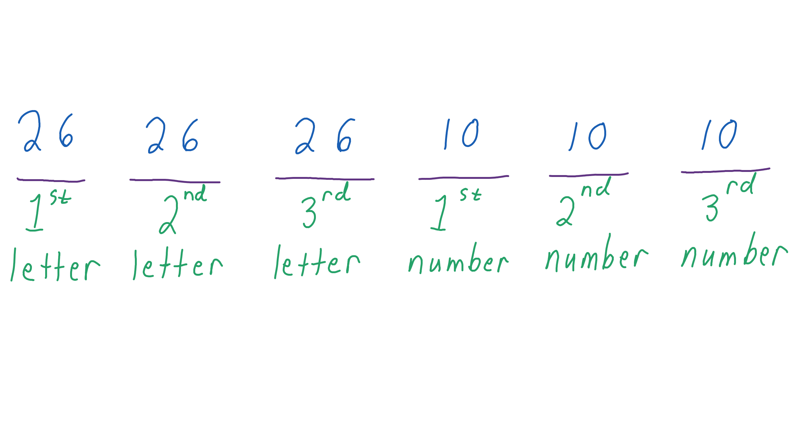
Multiply the numbers in each slot. | 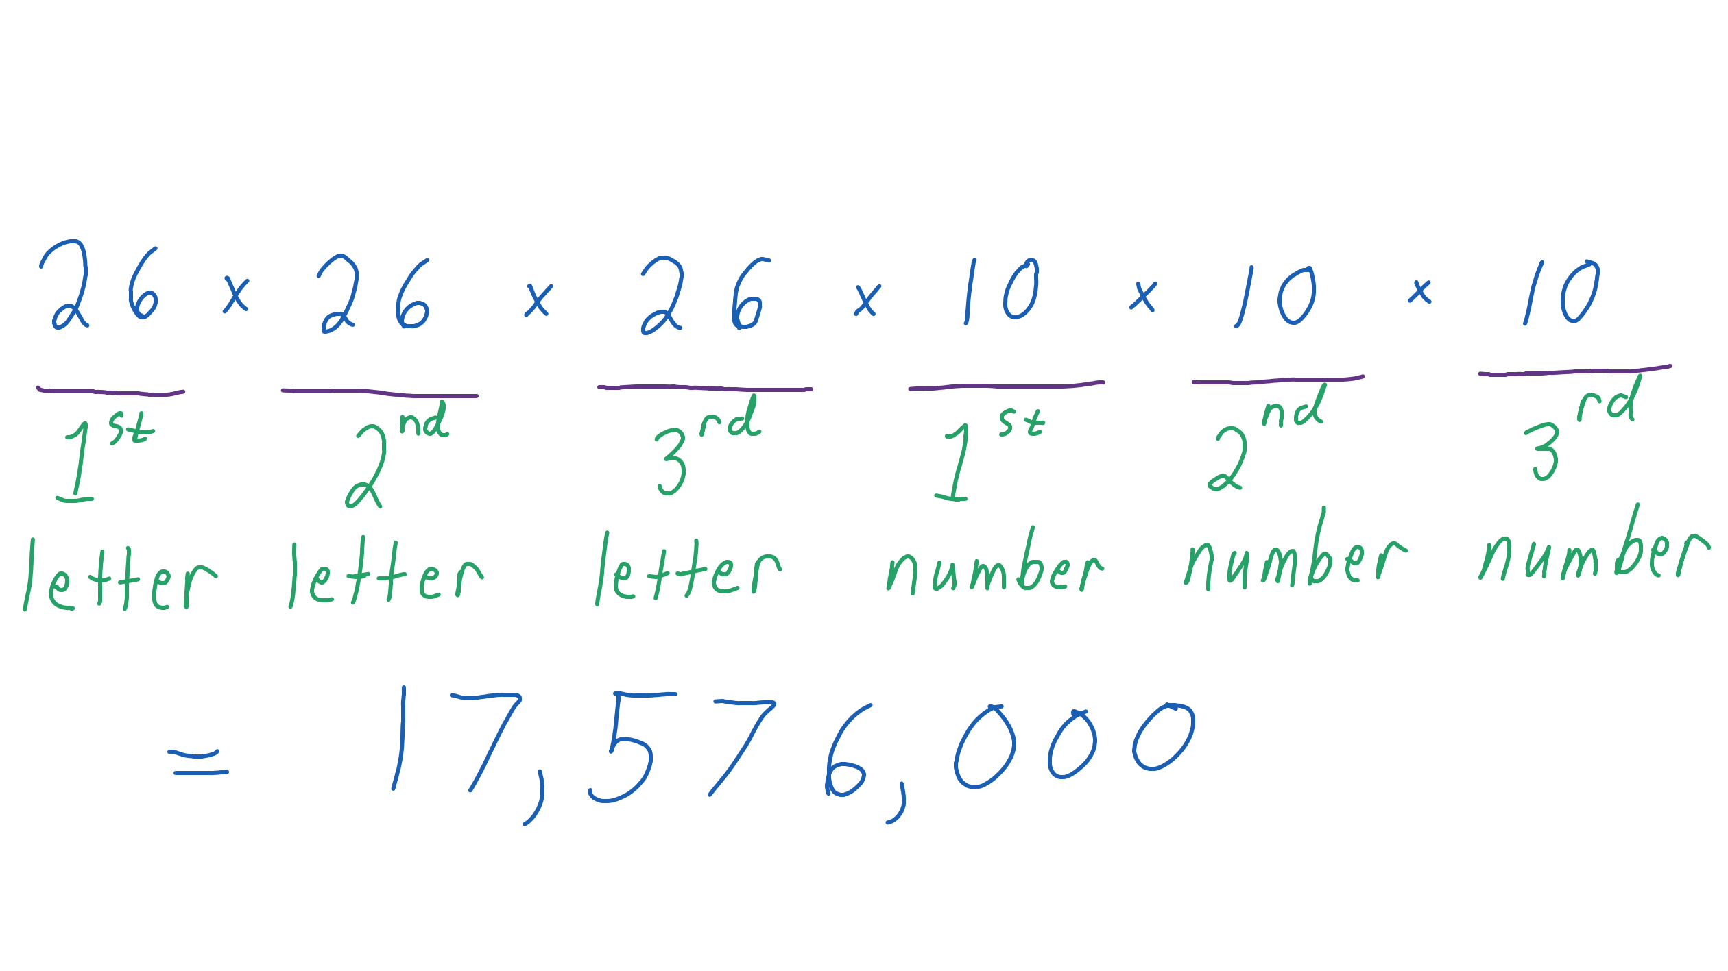
The number of possible license plates is 17,576,000. For a large state, having this many possibilities is good so you will not run out of plates.

