Permutations
Detailed Examples

Main Ideas
Permutations are easy to calculate. The easiest way is to remember the multiplication rule for counting and using the permutation pattern. The formula for permutations makes this harder than it needs to be.

Example 7.6
Find the following numbers:
- The number of permutations of 12 objects taken 3 at a time
- The number of permutations of 8 objects taken 5 at a time
- The number of permutations of 32 objects taken 2 at a time
Steps | Work
Start with a slot diagram. Because there are three objects, use three slots. | 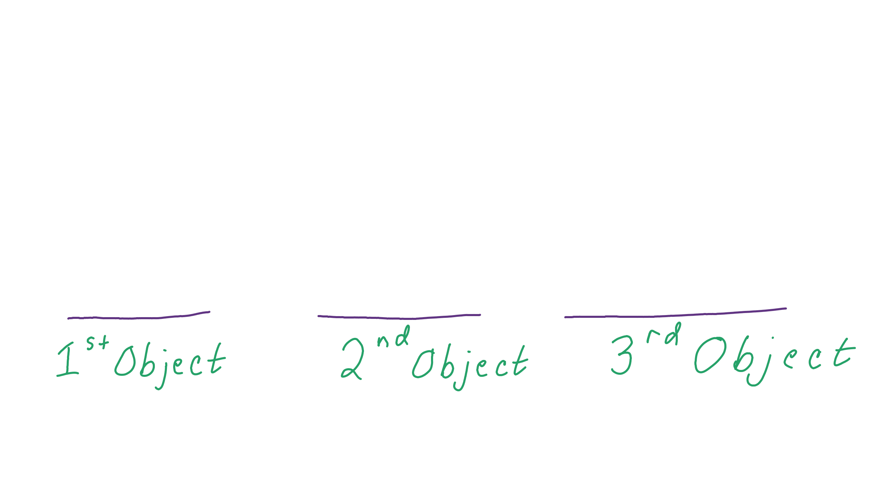
There are 12 possibilities for the first choice. Put a 12 in the first slot. | 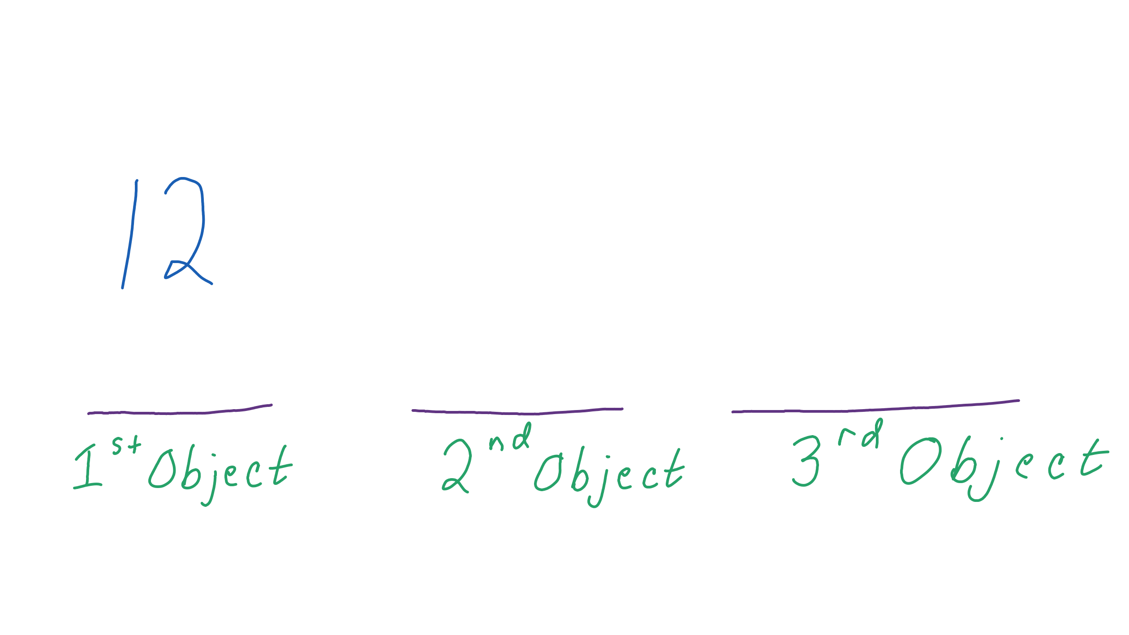
There are 11 possibilities for the second objects. That is because we chose one of the 12 objects in the first step. Put an 11 in the second slot. | 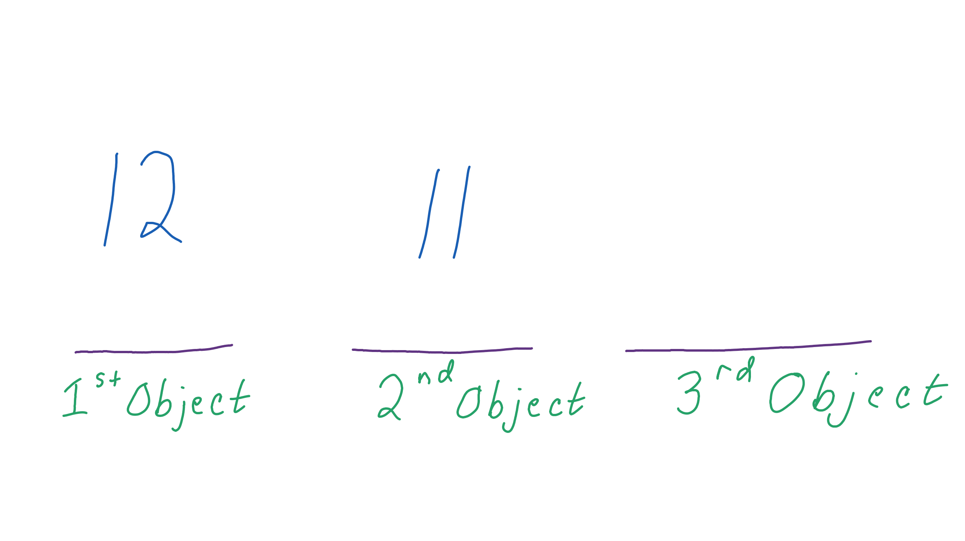
Fill the remaining slots with decreasing numbers. | 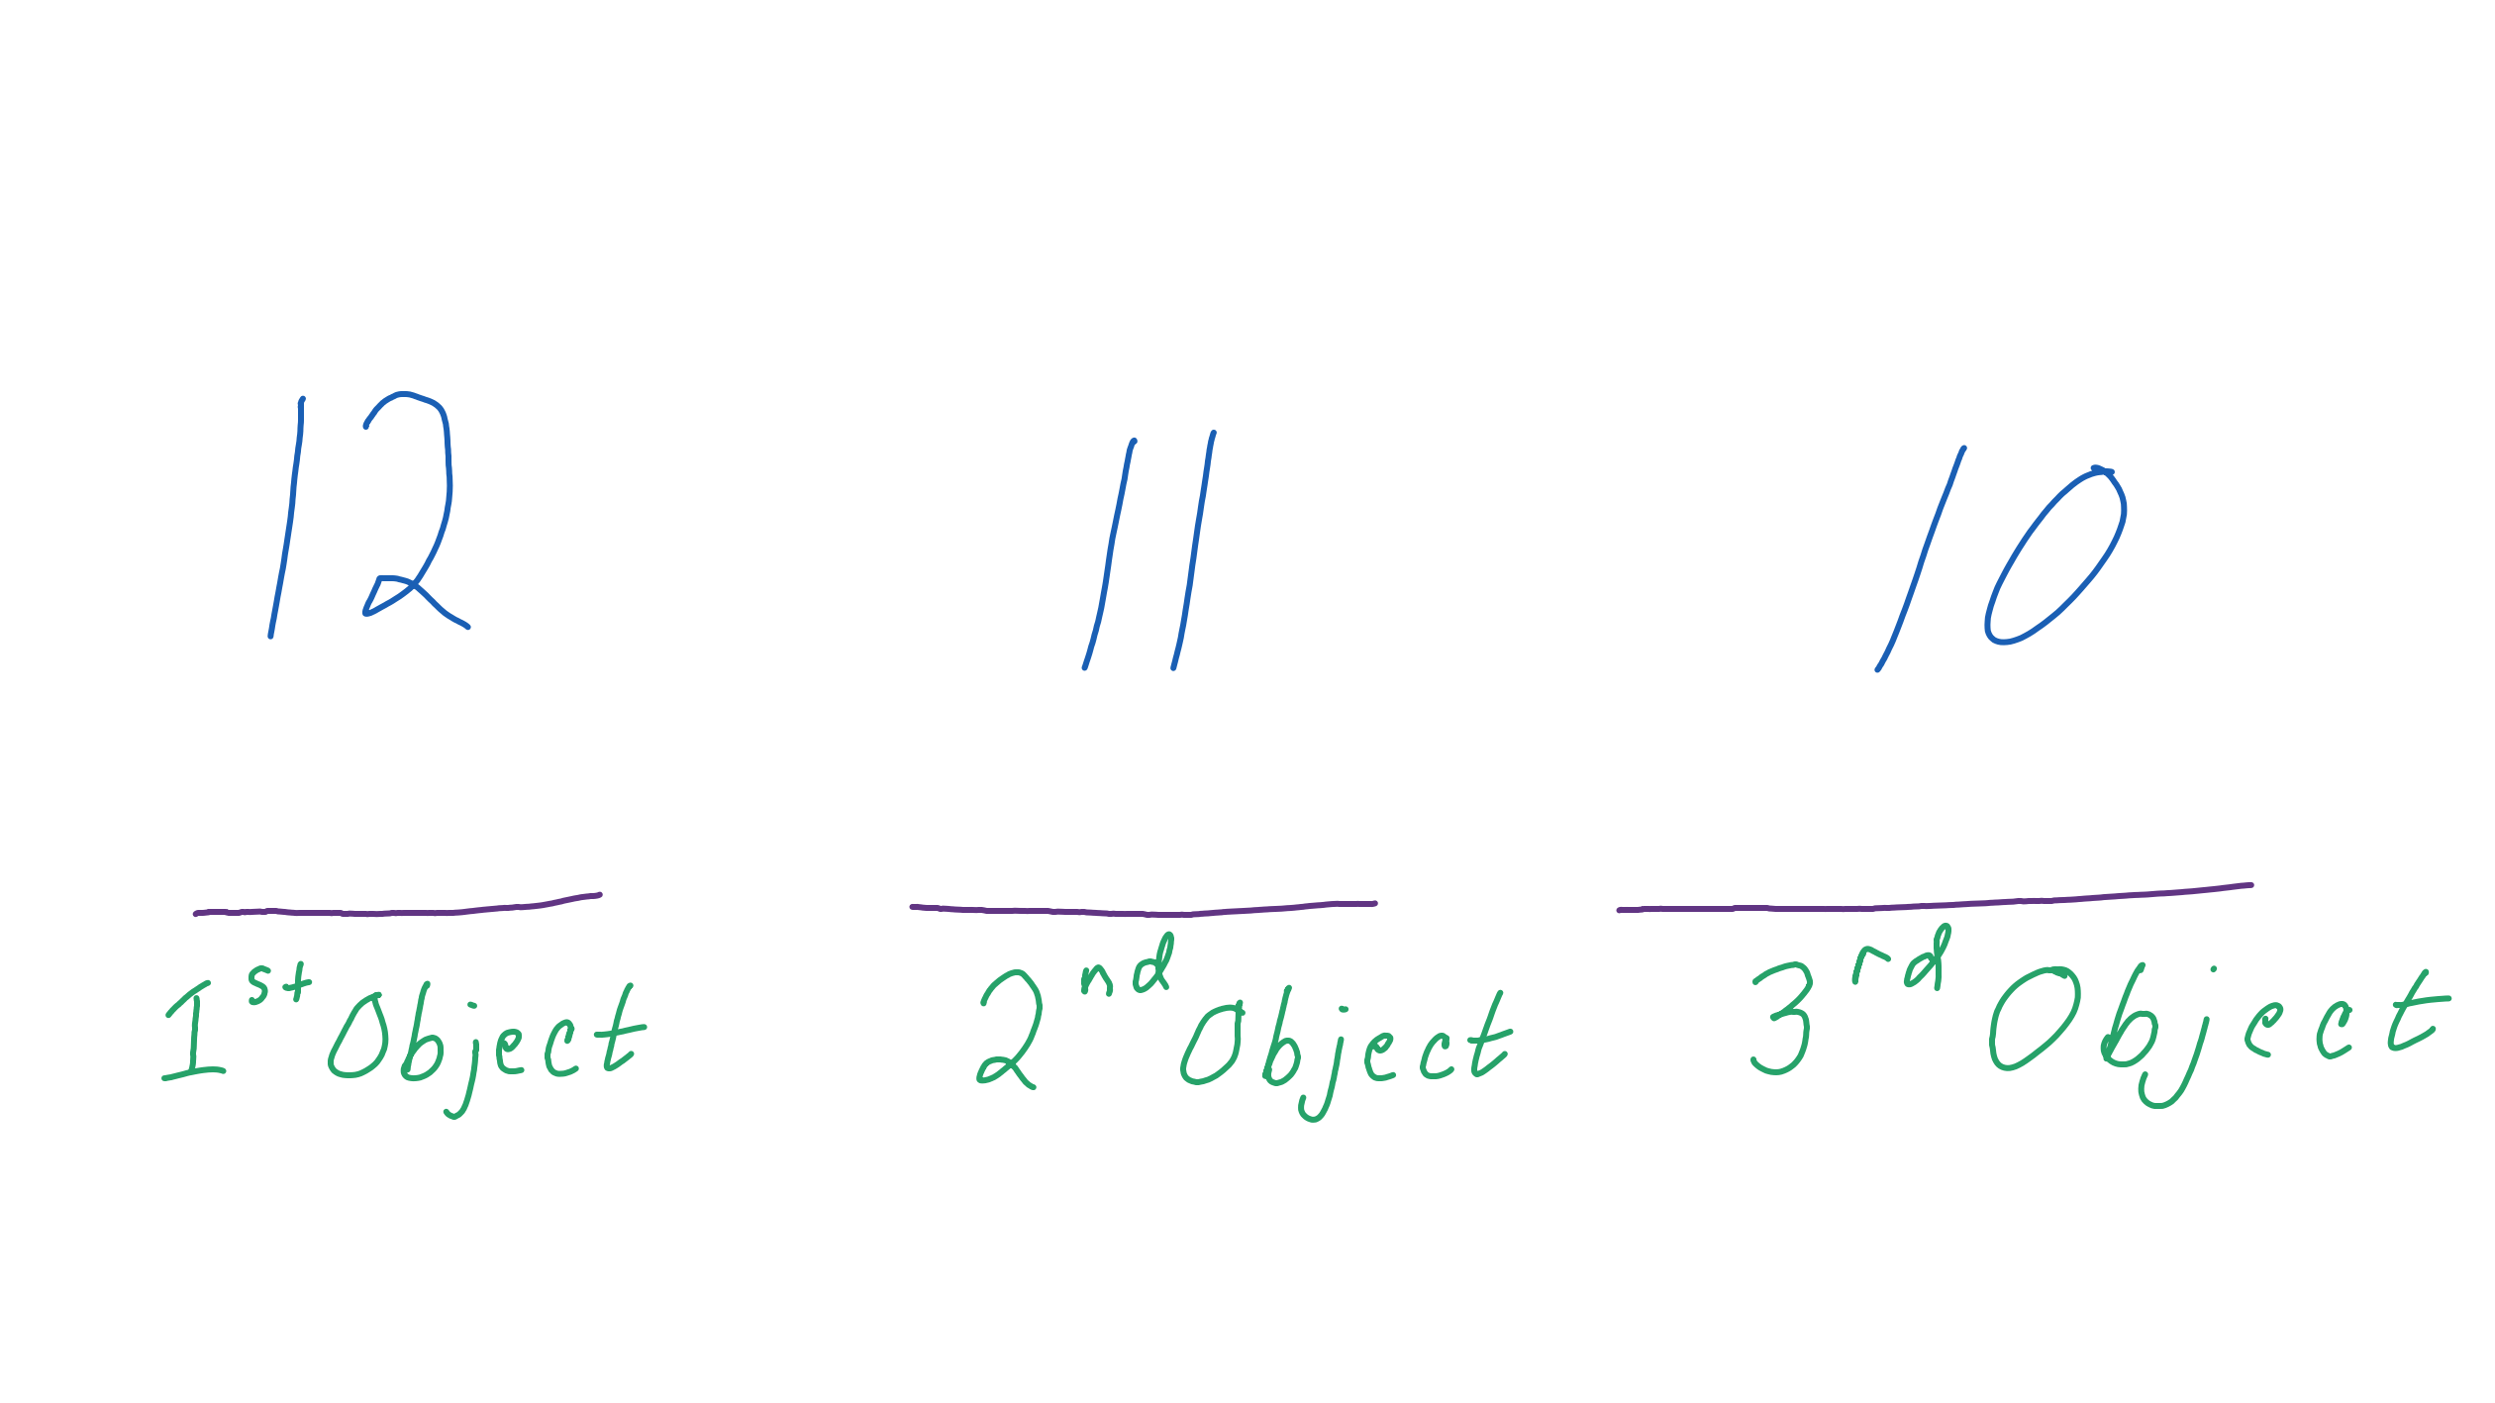
Multiply the numbers. | 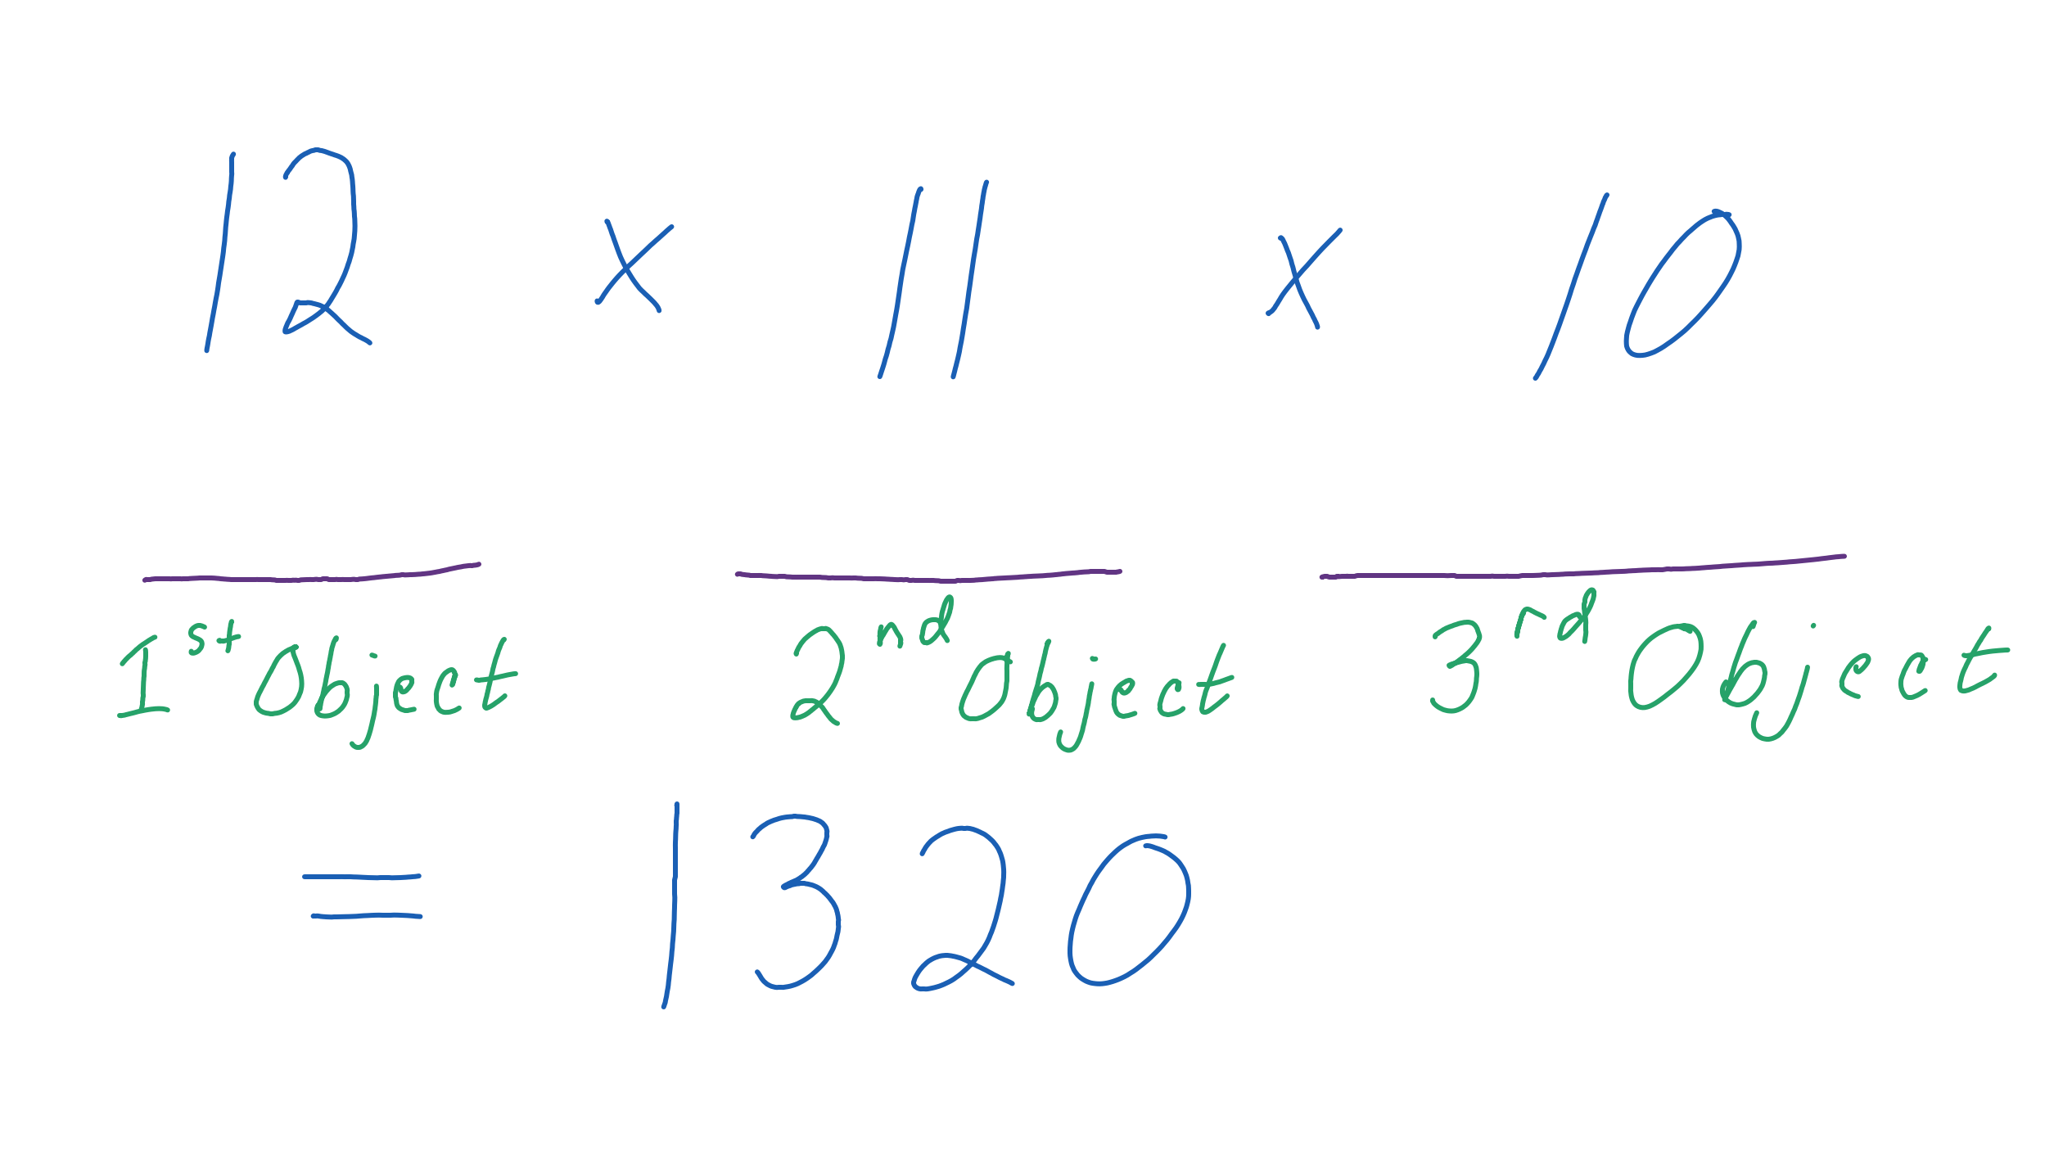
The number of permutations of 12 objects taken 3 at a time is 1,320. Our notation for this permutation is .
Steps | Work
Start with a slot diagram. Because there are five objects, use five slots. | 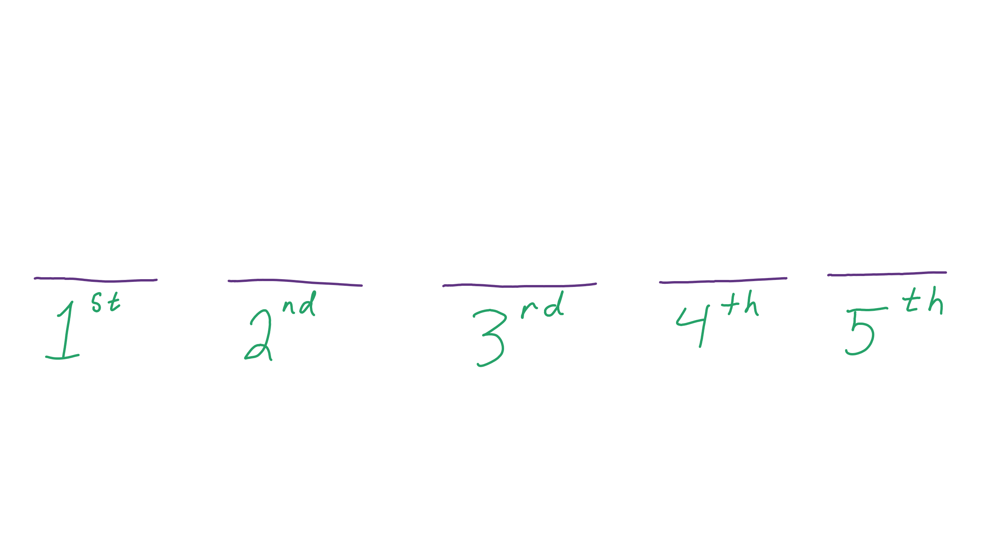
There are 8 possibilities for the first choice. Put an 8 in the first slot. | 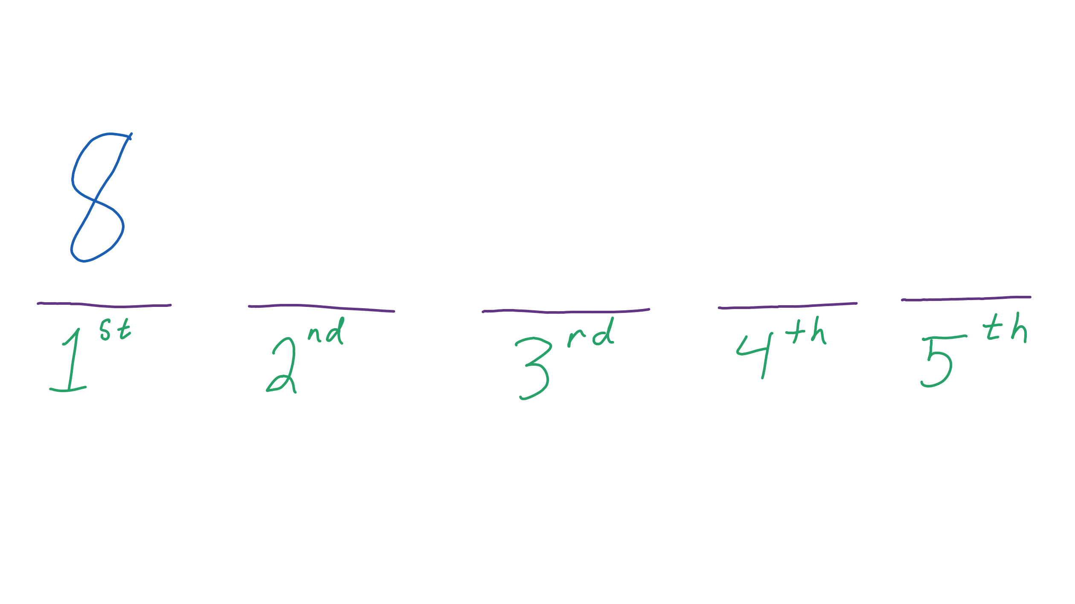
There are 7 possibilities for the second objects. That is because we chose one of the 8 objects in the first step. Put a 7 in the second slot. | 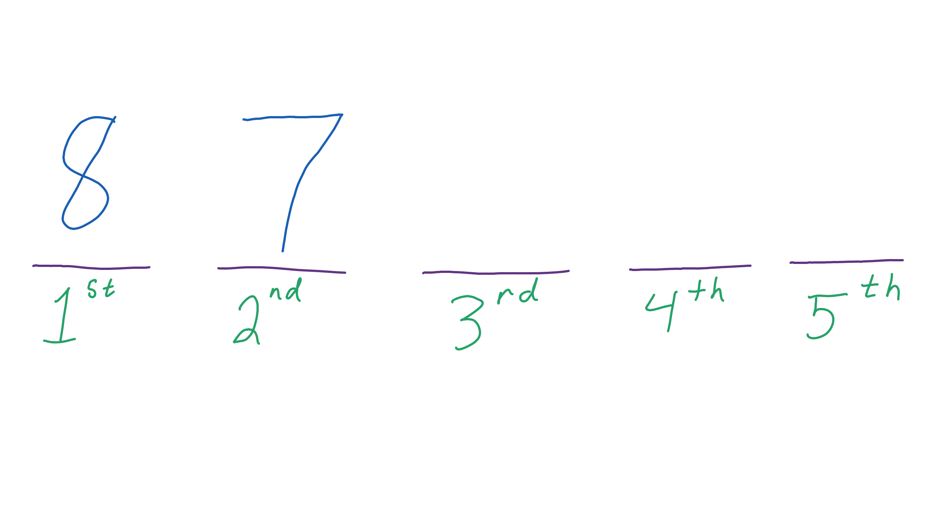
Fill the remaining slots with decreasing numbers. | 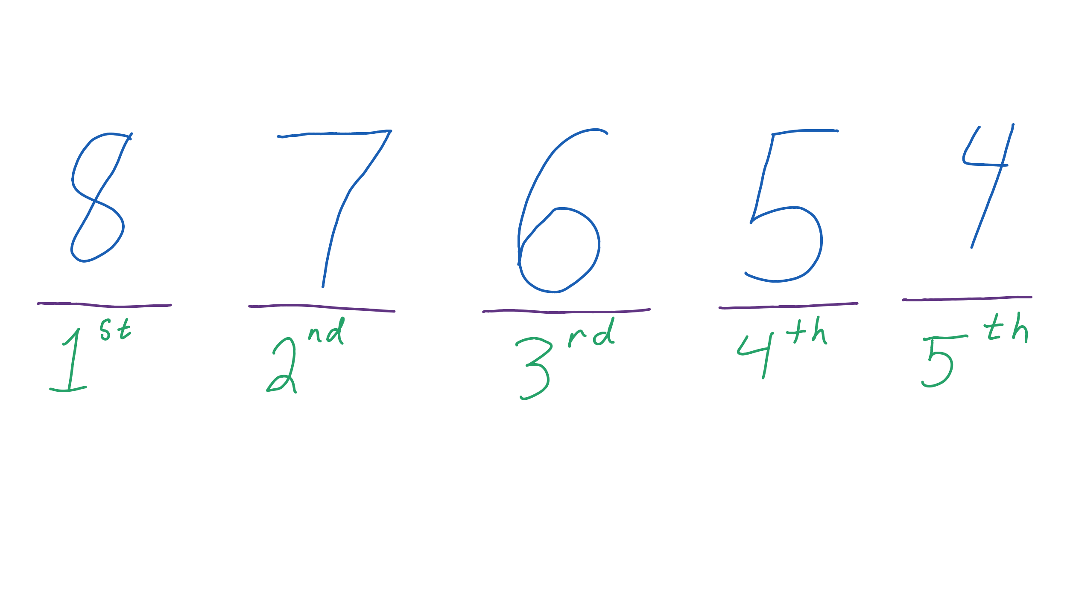
Multiply the numbers. | 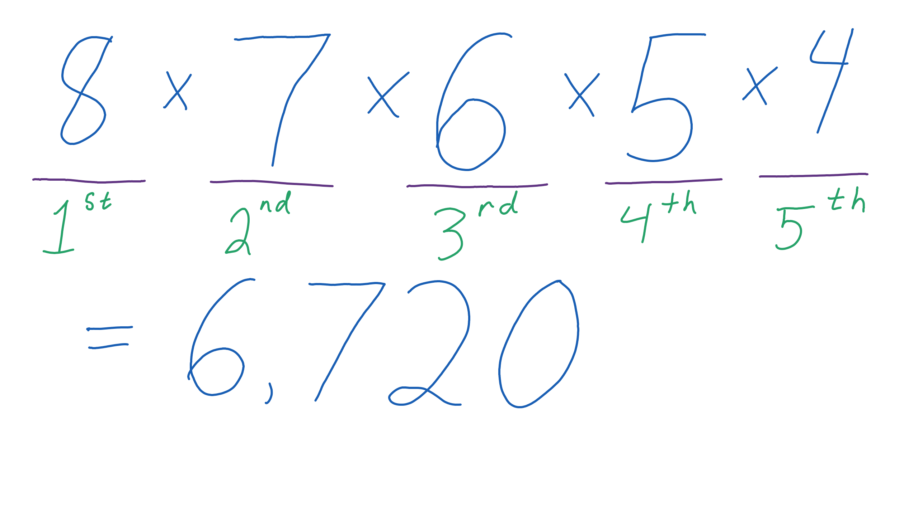
The number of permutations of 8 objects taken 5 at a time is 6,720. Our notation for this permutation is .
Steps | Work
Start with a slot diagram. Because there are three objects, use three slots. | 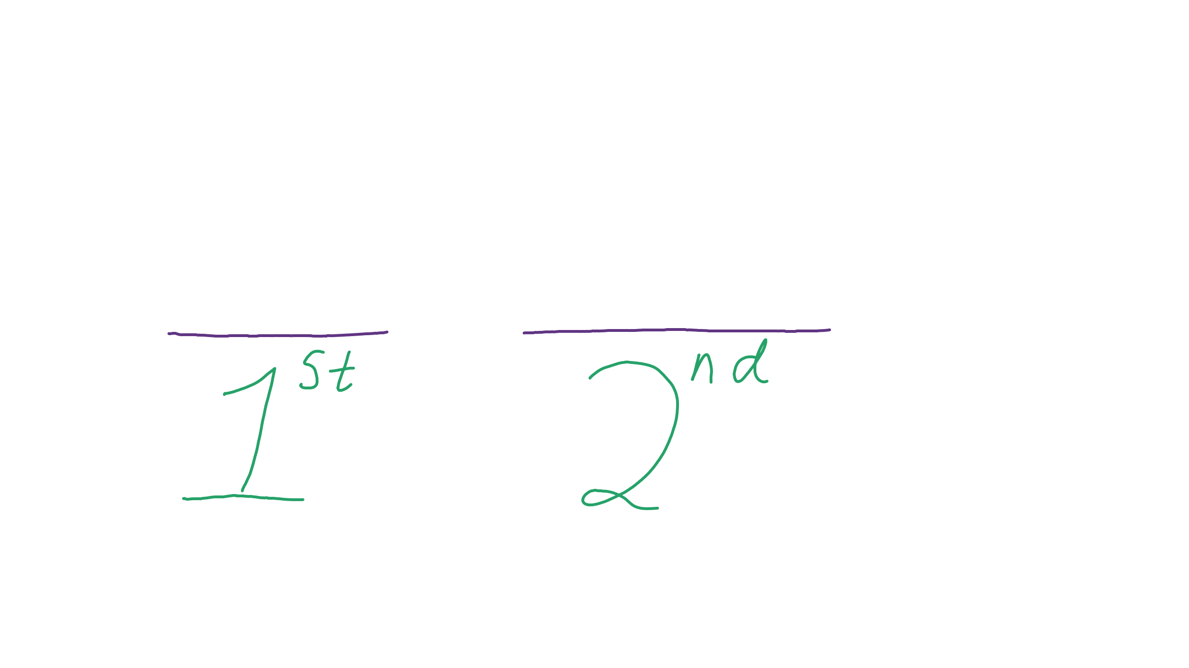
There are 32 possibilities for the first choice. Put a 32 in the first slot. | 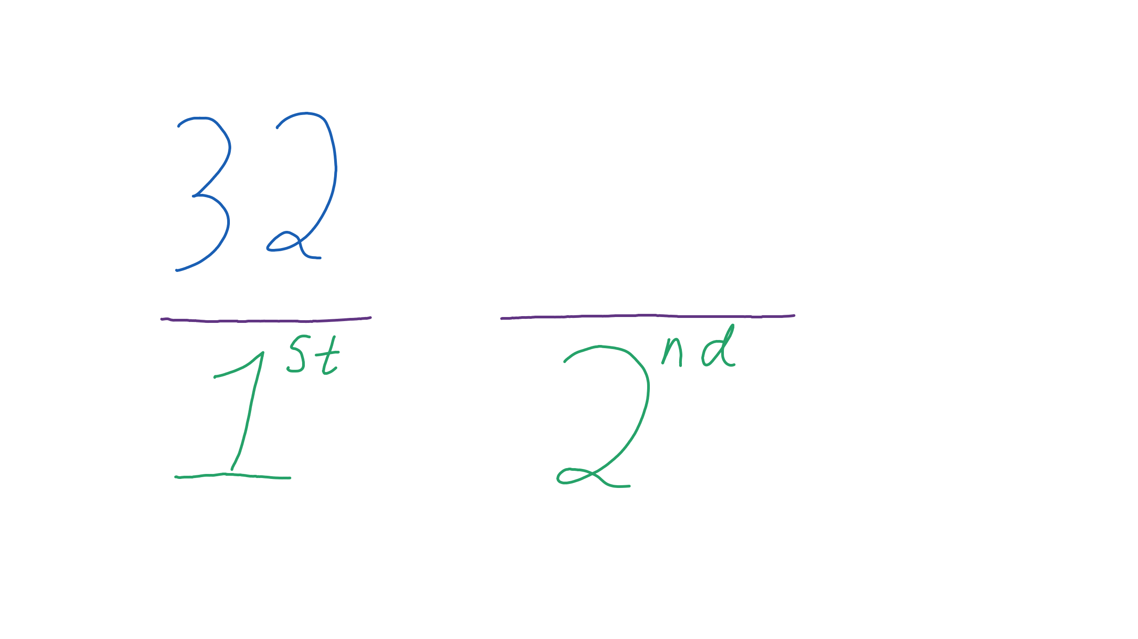
There are 31 possibilities for the second objects. That is because we chose one of the 32 objects in the first step. Put a 31 in the second slot. | 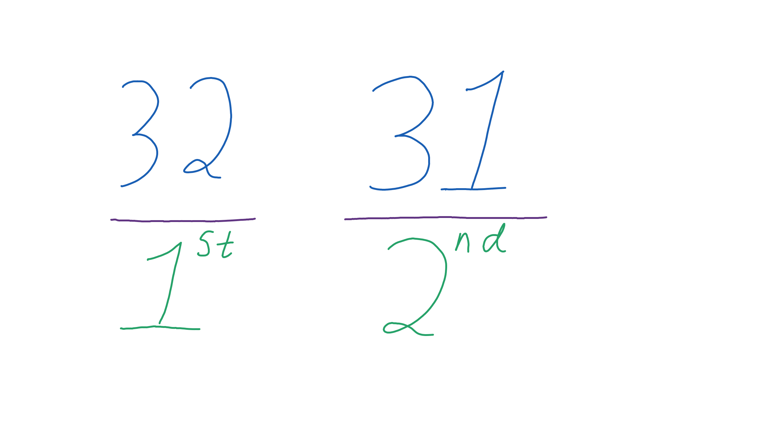
Multiply the numbers. | 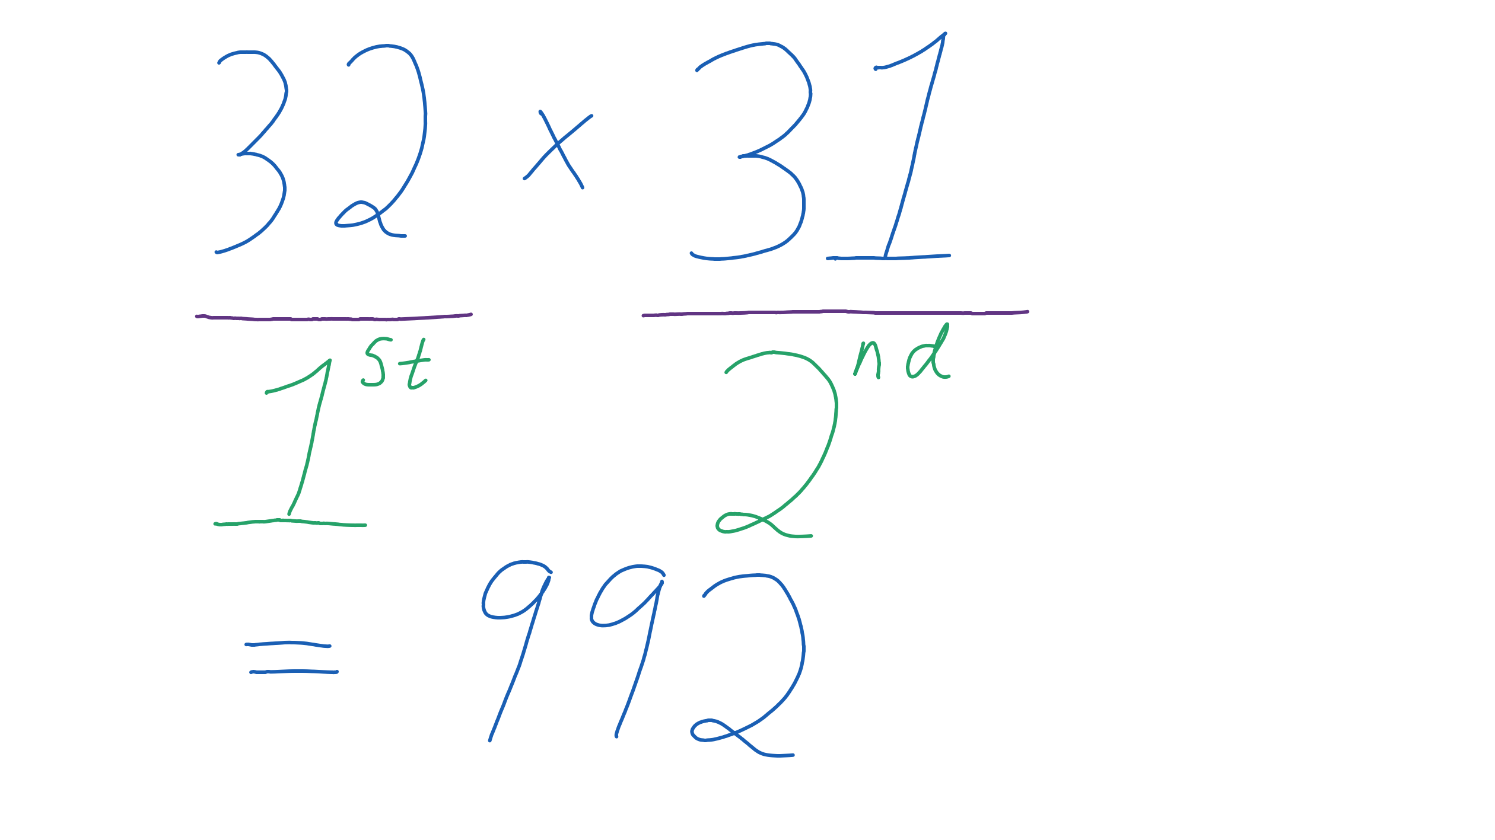
The number of permutations of 32 objects taken 2 at a time is 992. Our notation for this permutation is .

