Points, Lines, and Planes
Liberal Arts Mathematics

Assignment Text
Answer the following problems from Section 10.1 of the textbook: 1-4, 19, 20.
For reference, the text of the problems are duplicated below.
Use this graph for the following exercises.
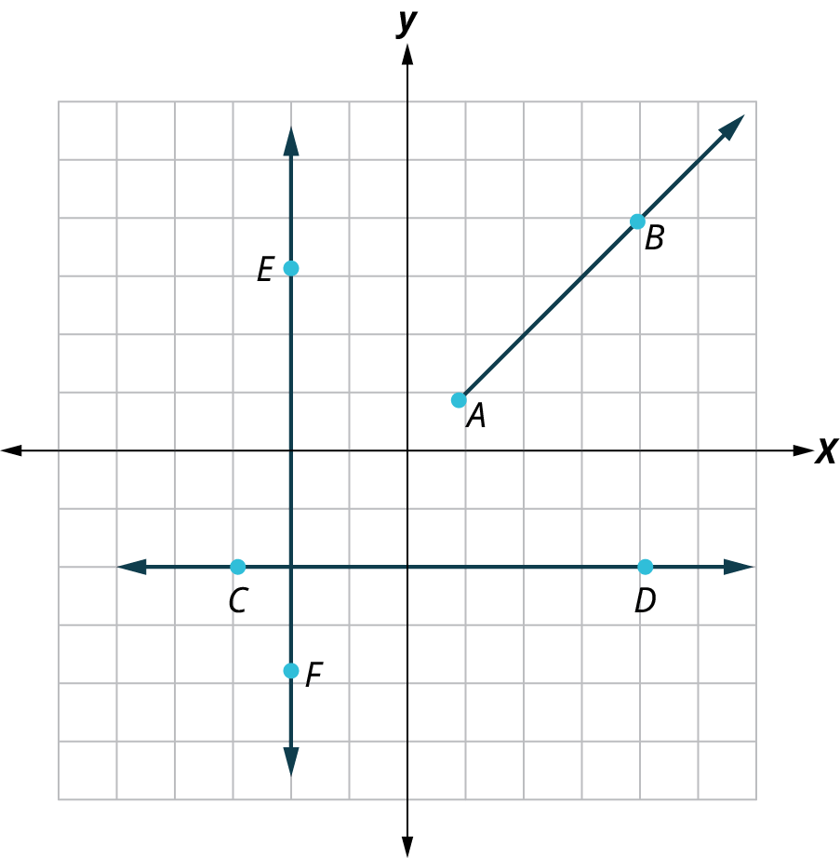
1. Identify the kind of line passing through the points A and B.
2. Identify the kind of line passing through the points C and D.
3. Identify all sets of parallel lines.
4. Identify all sets of perpendicular lines.
Use the given figure for the following exercises.
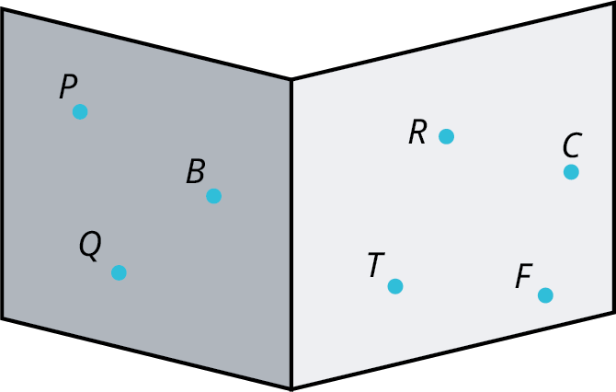
19. Describe the lighter plane (right) in the drawing.
20. Describe the darker plane (left) in the drawing.

Answer Key
1. A ray.
2. A line.
3. No parallel lines.
4. The lines CD and EF are perpendicular.
19. Plane CFRT
20. Plane BPQ

Student Feedback Templates
#1 should be a ray (starts at A and goes through B in one direction forever.)
#2 should be a line (goes through C and D in both directions forever.)
#3 should be “no parallel lines” (there isn’t a pair of lines going in the same direction)
#4 should be lines CD and EF (the lines intersect at right angles)
#19 should be plane CFRT (it is what it is)
#20 should be plane PBQ (it is what it is)

