Starting analysis shows that there are total 1200 users in one data set i.e takehome_users.csv’
And 8823 users in another data set i.e 'takehome_user_engagement.csv’.
We can observe that there is mismatch between number of users. 3177 users are missing.
Next important step was finding out the ‘adopted users’ from the dataset. This was used as a target class in the users dataset. It was found that 18.77 percent of the users are ‘adopted’ users.

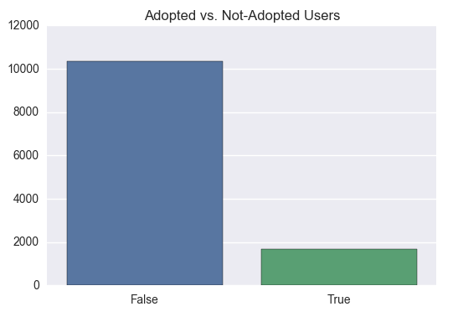

Fig 1 : Adopted vs Non-Adopted Users

After getting this basic information from the datasets, few features were removed / dropped from the dataframe , as they were not predictive in nature. Finally after removing such features, these features kept for the analysis :

- creation_source,
- opted_in_to_mailing_list,
- enabled_for_marketing_drip,
- org_id and the
- target class.

Random Forest algorithm was applied with 10 decision trees. Testing the random forest classifier, ~81.66% accuracy was obtained on the test set with a True TPR of 88.27%, False TPR of 74.77%, True FPR of 25.23%, and False FPR of 11.73%. We see that balancing the target class has helped in creating a valid model.

From the fig 2, it can be seen that the organization ID was the most predictive feature for

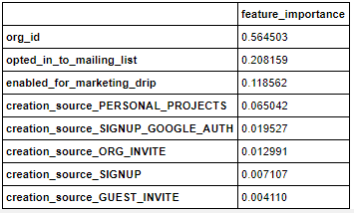
Fig 2 : Feature importance table

determining future user adoption, and this was followed by whether a user opted in to the marketing email list, whether a user was enabled for marketing email drip, whether the user was invited to join another user’s personal workspace as a way of account creation, and then the remaining four avenues of account creation

