**Purpose**

This lab is designed to give you practice:

* Using multiple activities.
* Passing data from one activity to another.
* Loading different layouts for portrait and landscape orientation.
* Saving application state.

**Part 1**

Do the exercise shown at the end of the Power Point slideshow on Multi-screen apps.

Upload a text file to Canvas in which you will report the results of your exercise.

**Part 2: Pig Game, version 3**

In this lab you will modify your app to use two activities:

1. An opening screen that displays instructions and asks the players for their names. It will have a “New Game” button that launches the second activity.
2. The UI for game-play (similar to the main activity in the previous lab). The up button on the second activity will take the user back to the opening screen.

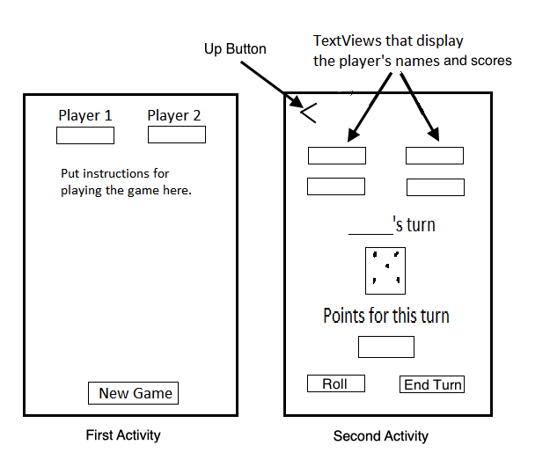

* Create both portrait and landscape versions of the UIs for both activities.
* The game should still have all the features of the previous version, including the ability to save game state.
* Zip the project and upload it to Canvas, or submit a link to the Git repository for your source code.