# CTS2456C GPA 9: Git and GitHub

In this assignment we will complete the following tasks:

• Use the Windows Command Prompt application to create a local Git repository (repo)

• Commit files to the local repo

• Sync the local repo to a new remote repo in your GitHub account

• Modify a file in the local repo, commit the change, and push the change to the remote GitHub

repo

### Assignment Prerequisites

• A Windows system with Git installed (the Horizon system meets this prerequisite)

• A GitHub account, preferably associated with your FSCJ student email address

• Access to GPA1A Submission (download from Canvas)

• Access to GPA1B Submission (download from Canvas)

## Instructions

Follow the steps listed here to complete this assignment. **Note that if you are doing this assignment on**

**the Horizon system, you need to complete the first six steps up to and including "Push your local repo**

**to the GitHub repo" before you log off from the system, otherwise you will lose your work.**

1. Create a new local Git repo.

o Open a Windows command prompt app, navigate to your Documents folder, create a

new folder with the name of your course and assignment (e.g. CTS2456CRepo),

navigate to that folder, then run “git init .” (don’t forget the dot). Here are the

commands to execute; replace <youruser> with your Windows user ID:

C:\> c:

C:\> cd \users\<youruser>\Documents

C:\Users\<youruser>\Documents> mkdir CTS2456C9Repo

C:\Users\<youruser>\Documents> cd CTS2456CRepo

C:\Users\<youruser>\Documents\CTS2456CRepo> git init .

2. Copy the GPA1A AND GPA1B files to your local

repo folder created in Step 1.

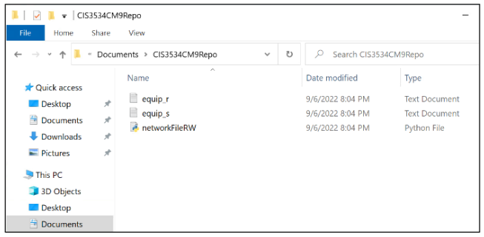

3. Create a README.md file in your repo folder which describes the repo – you should include the

purpose of the file. You can use any text editor, but your file must be named README.md (md is short for “markdown”).

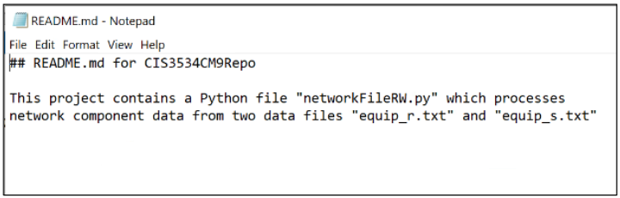

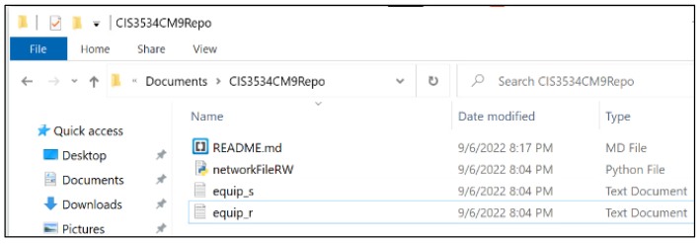

4. Use "**git add .**" to add (“stage”) your files to the local repo, then commit them with a descriptive

commit message (don’t forget the dot). Use "git status" to verify the repo status after each

operation.

**git add .**

**git status**

**git commit -m "first commit for all project files"**

**git statu**s

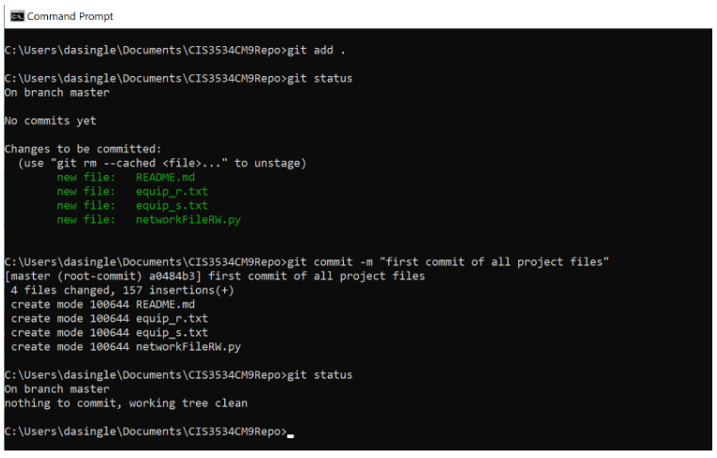

5. Create a new GitHub repo using the same name as the local repo.

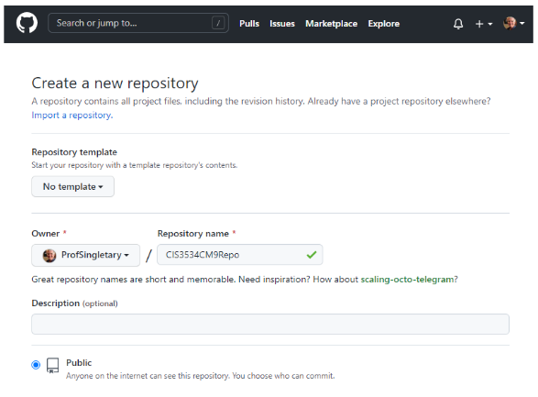

6. Push your local repo to the GitHub repo (you may be prompted to authenticate to GitHub in a

browser during the push step).

**git remote add origin <your GitHub repo URL>**

**git branch -M main**

**git push -u origin main**

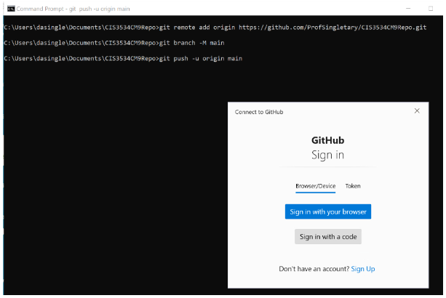

**At this point if you are working on the Horizon system you can log off without losing your**

**work as it has been safely stored on GitHub.**

If you have not logged off and wish to continue working on this project, move directly to step 7.

If you have logged off and need to recreate your local repo, log on and open a new Windows

command prompt app, navigate to your Documents folder and execute the following command

(replace <github userid> with your GitHub user ID, and use the repo name of your remote repo

if it is not CTS2456C9Repo. This will replicate your remote repo in a folder with the same

name.

**git clone https://github.com/<github userid>/CTS2456CRepo**

7. Modify the GPA1A file in your local repo in some way. Add a slide or add some text, just make a change.

8. Run git diff and note the differences between the original file and the modified file.

**git diff GPA1A.pptx**

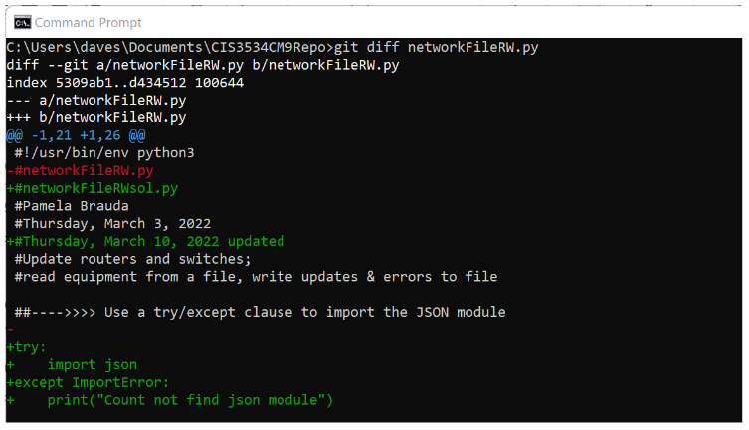

9. Check the status of your local repo, verify the change is seen, then stage your modified file to the

local repo and check the status again.

**git status**

**git add .**

**git status**

10. Commit your modified file to the local repo with a descriptive commit message.

**git commit -m "your commit message" GPA1A.ppt**

11. Push your local repo to the GitHub repo.

**git push**

12. Invite your instructor to your GitHub repo as a collaborator.

On your GitHub repo, go to Settings:



Then go to **Collaborators** and **Add people** *(Use the GitHub user name provided by your*

*instructor):*

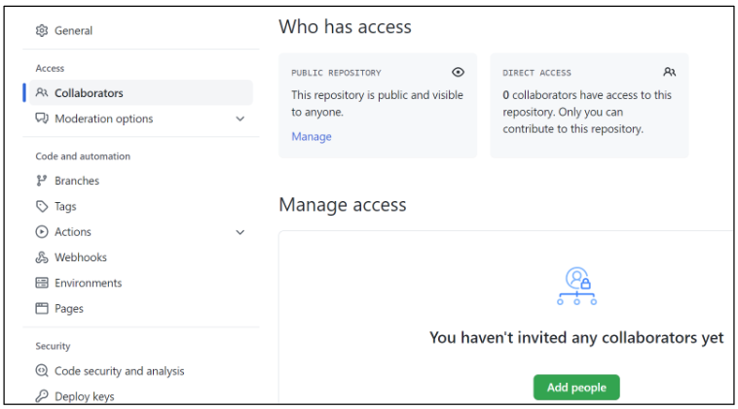

13. Return to **GPA 9 in Canvas** and use the **Text Entry** option to submit your **GitHub user name** and

**link to your repo** to confirm assignment completion. **This step must be completed in order to**

**receive credit for this assignment.**